Solution for problem 1 :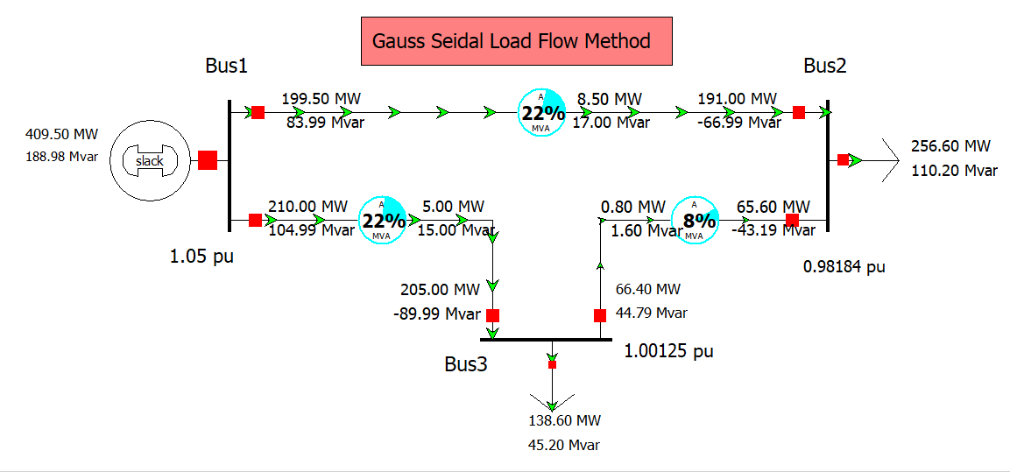
Impedence in per unit on 100 MVA base
Solution for problem 2 :
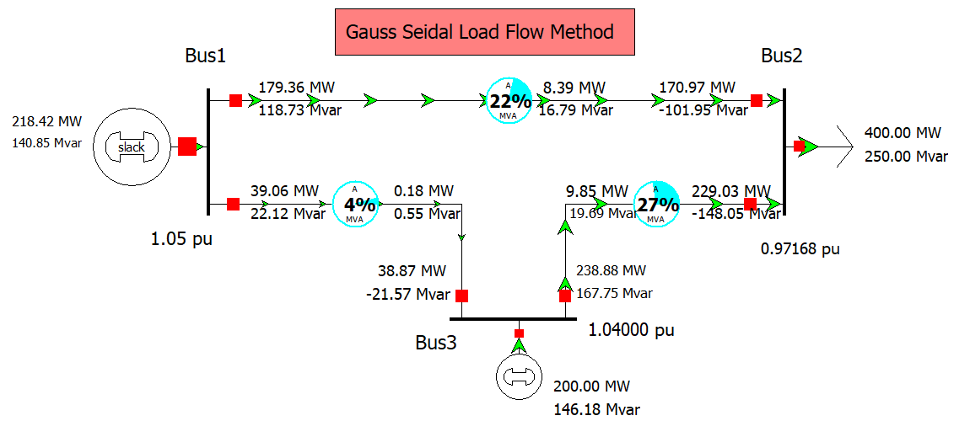
Impedence in per unit on 100MVA base

