Solution for problem 3:

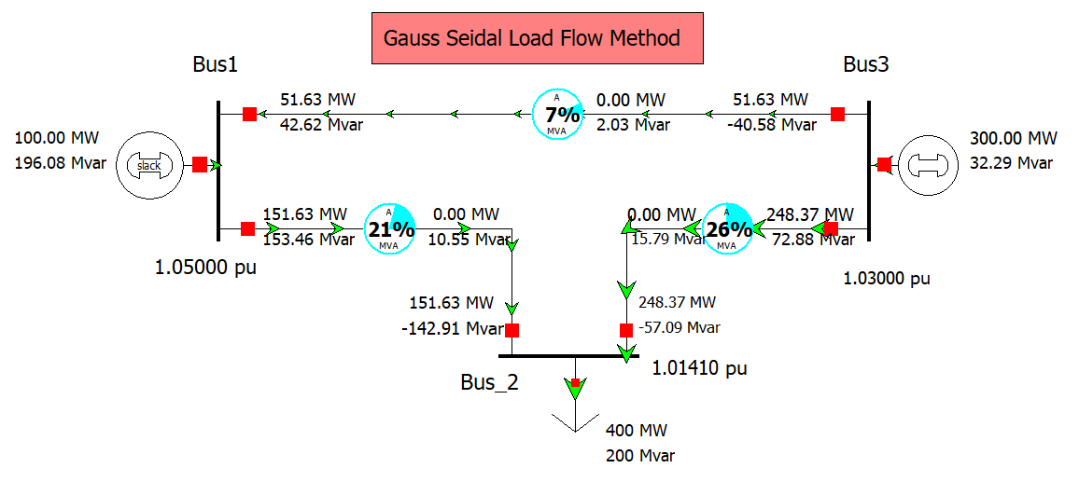

Impedence in per unit on 100 MVA base

