## 

## **Façade pattern Assignment**

**Three Examples**

**Sir Arsalan Qureshi**

Submitted By:

Nusrat waheed

SP17-MSCS-0012

## **Example 1:**

## **Façade Pattern - Example**

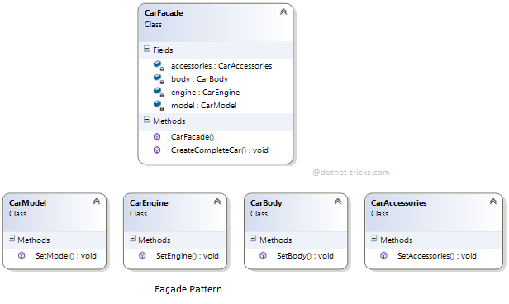

## **Example 2:**

## **Façade Pattern - Example**

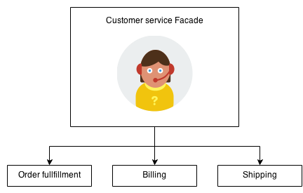

## **Example 3:**

## **Façade Pattern – Example**

