SQL

1. SELECT firstname, lastname, phonenumber, fulladdress
FROM studentpersonal
WHERE bloodgroup="O+" or bloodgroup = "A-";

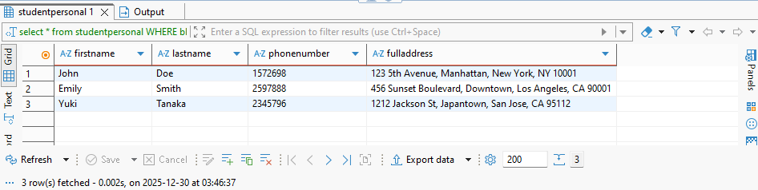

2. SELECT d.departmentname, d.departmentcode, s.subjecttitle

FROM
departments d
INNER JOIN
subjects s
ON d.departmentCode = s.departmentCode
WHERE
s.subjectCode = 'EE201';



3. select bloodgroup , count(*) as Number_of_people
from studentpersonal
group by bloodgroup having count(*)>= 2;

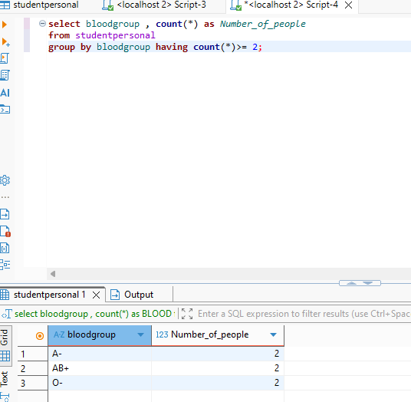

4. select
a.firstname,
a.lastname,
b.subjectTitle

from studentpersonal a
join
studentacademic c
on a.studentId = c.studentId
join
subjects b
on c.departmentCode = b.departmentCode
where
c.departmentCode = 'CS101'

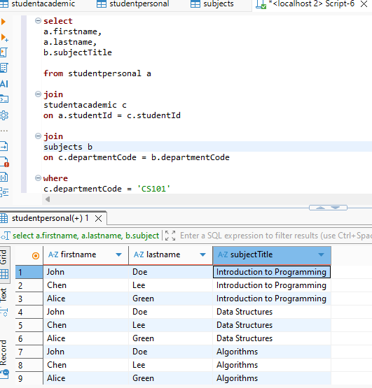

5. select
sum(t.totalSemesterFees)
from studentacademic t
join
departments d
on t.departmentCode = d.departmentCode
where t.departmentCode = 'CS101'

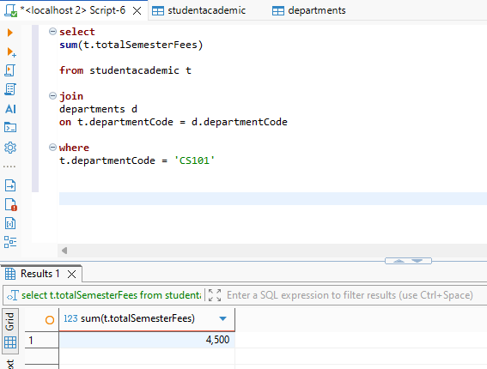

6. update studentacademic
set totalSemesterFees = totalSemesterFees * 1.10
where departmentCode = 'CS101';

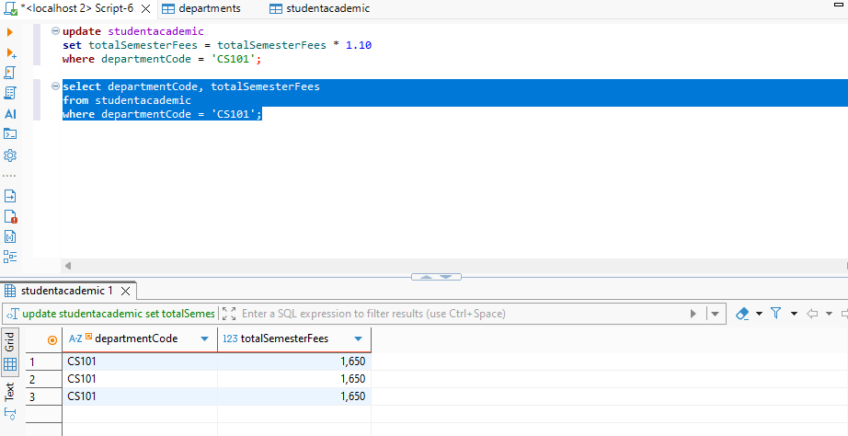

7. select
m.firstname as student_firstname,
m.lastname as student_lastname,
u.firstname as teacher_firstname,
t.Designation as teacher_designation
from studentacademic n
join studentpersonal m
on n.studentId = m.studentId
join teacheracademic t
on n.departmentCode = t.departmentCode
join teacherpersonal u
on t.teacherId = u.teacherId
where n.departmentCode='CS101' and t.departmentCode='CS101'

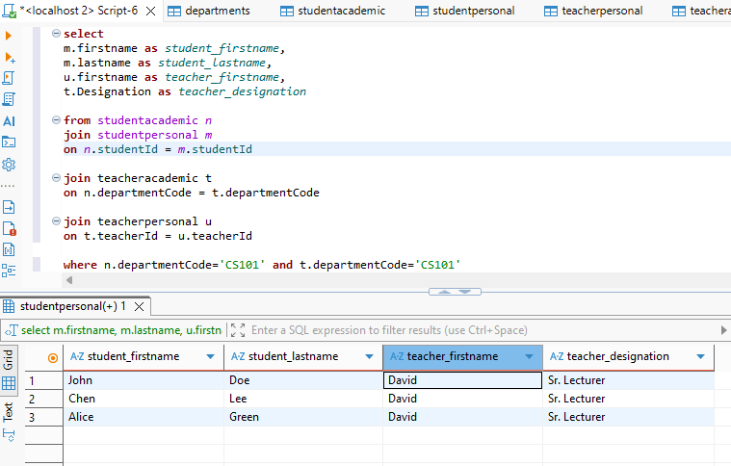
8. Select
s.firstname as StudentFirstName,
t.lastname as TeacherLastName,
s.city as City
from studentpersonal s
join teacherpersonal t
on s.city = t.city;

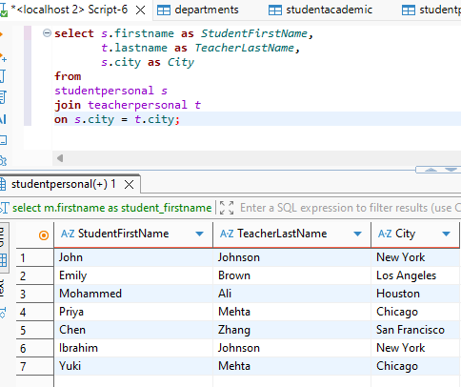

9. select
y.firstname,
y.lastname,
y.email,
z.subjectCode,
z.subjectTitle

from courses x
join studentpersonal y
on x.studentId = y.studentId

join subjects z
on x.subjectCode = z.subjectCode

where z.subjectTitle = 'Algorithms'

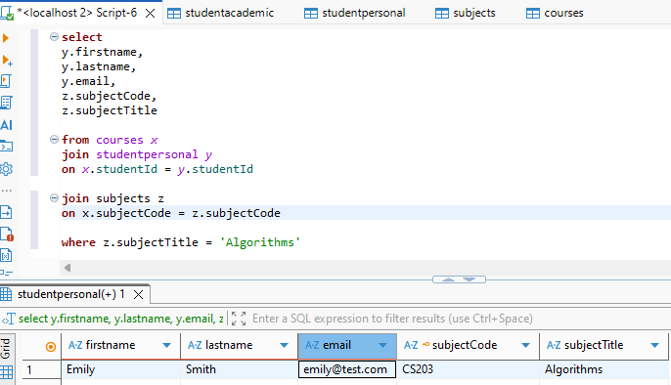

10. update teacheracademic
set Designation = case
when Designation = 'Lecturer' then 'Sr. Lecturer'
when Designation = 'Sr. Lecturer' then 'Associate Professor'
else Designation
end;

select *
from teacheracademic

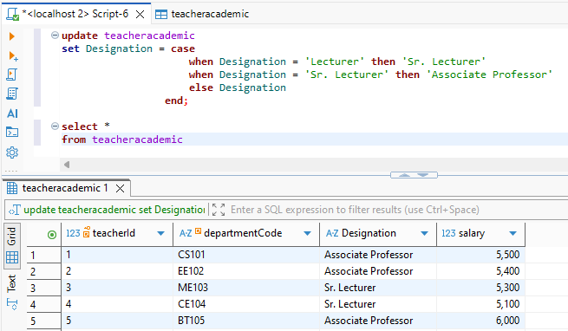

11. select tp.firstname, tp.lastname, ta.salary
from teacherpersonal tp
join teacheracademic ta
on tp.teacherId = ta.teacherId
where ta.salary = ( select max(salary) from teacheracademic where salary<(select max(salary) from teacheracademic ));

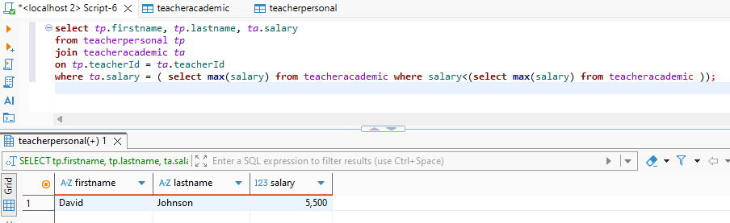

12. select
p.firstname as Teacher_firstname,
p.lastname as Teacher_lastname,
q.firstname as Student_firstname,
q.lastname as Student_lastname,
q.city as Student_city,
s.departmentCode as Department

from teacheracademic a
join teacherpersonal p
on a.teacherId = p.teacherId

join studentacademic s
on a.departmentCode = s.departmentCode

join studentpersonal q
on s.studentId = q.studentId

where a.salary = ( select max(salary) from teacheracademic where salary<(select max(salary) from teacheracademic ));
