**Name:** Muhammad Rizwan Khaild

**Section:** BSCS-6A

**Email:** mkhalid.bscs16seecs@seecs.edu.pk

**The first program is to get some output:**

#include <stdio.h>

#include <stdlib.h>

int main()

{

printf(" Welcome to CS110!!!\n Hellow Friends!!!");

getchar();

return EXIT_SUCCESS;

}

**The output will be as follow:**

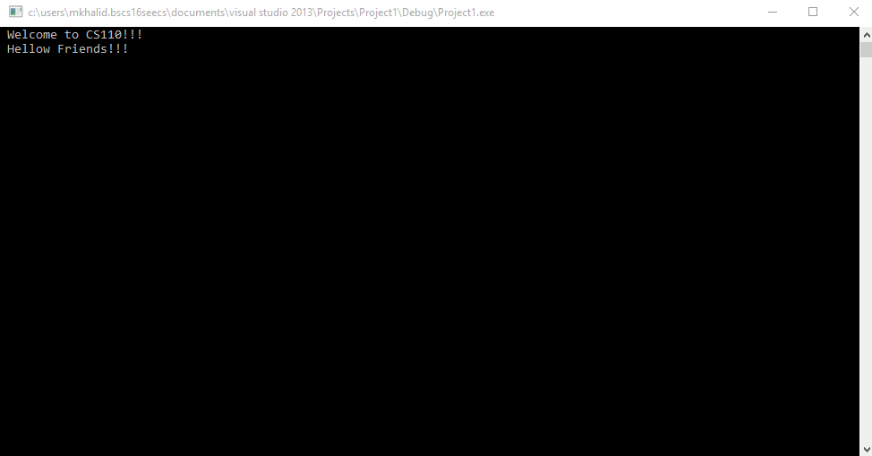

**The program to calculate distance between two points is:**

#include <stdio.h>

#include <stdlib.h>

#include <math.h>

int main()

{

double x1, y1, x2, y2,

a, b, distance;

x1 = 1;

y1 = 5;

x2 = 4;

y2 = 7;

a = x2 - x1;

b = y2 - y1;

distance = sqrt(a*a + b*b);

printf("The distance between the two points is %.3f", distance);

getchar();

return EXIT_SUCCESS;

}

**The output will be as follow:**

