**Name:** Muhammad Rizwan Khalid

**Setion:** BSCS-6A

**Task 1:** Comments and Slashes

// Name: Muhammad Rizwan Khalid, Date= 5 October, 2016

// Double slashes are used to add comments. These comments are used to describe the each step in our lengthy programs.

// Any thing written ahead the slashes is ignored by the compile and is not being executed.

#include <stdlib.h>

#include <stdio.h>

int main()

{

// A comment, this is so you can read your program later.

// Anything after the // is ignored by C/C++/Java.

printf( "I could have code like this.\n" ); // and the comment after is ignored.

/* Want to use C-style to comment */

/* You can even write comments

spanning multiple lines

using the C-style */

// You can also use a comment to "disable" or comment out a piece of code:

// printf( "This won't run.\n" );

printf( "This will run.\n" );

system("pause");

return EXIT_SUCCESS;

}

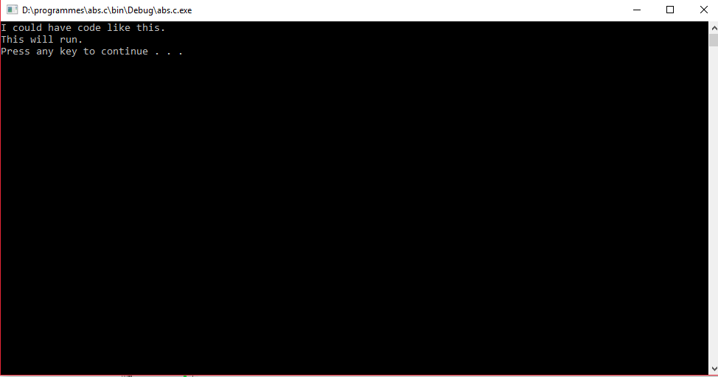

**Task 2:** **Indentation**

/********************************************************

* Printing -- program to print out some text. *

* *

* Author: <Muhammad Rizwan Khalid> *

********************************************************/

#include <stdlib.h>

#include <stdio.h>

int main()

{

printf( "Testing, testing,\n" );

printf( "one two three.\n\n" );

printf( "How much output\n\n" );

printf( "will there be?\n" );

getchar();

return EXIT_SUCCESS;

}

/********************************************************

* Question. *

* How many lines of output are produced (including blank lines)? *

* *

* Answer. *

* <Six lines are produced as input inclusive of blank lines.> *

********************************************************/

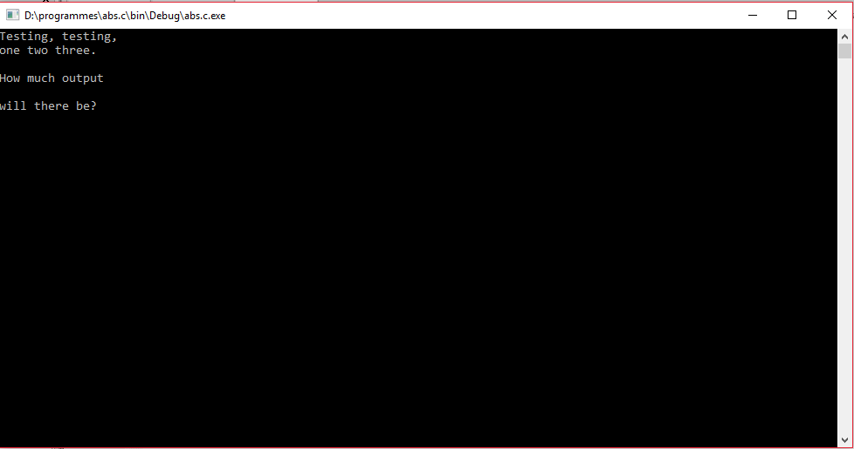

**Task 3: Print statement 1**

/* Printing -- program to print out some text. *

* *

* Author: <Muhammad Rizwan Khlaid>. *

********************************************************/

#include <stdlib.h>

#include <stdio.h>

int main()

{

printf( "C is fun!\n");

printf( "The string \"\" is an empty message.\n");

printf( "\\'\"\\\\\"\n");

getchar();

return EXIT_SUCCESS;

}

/********************************************************

* Question. *

* What output is produced by the code? *

* *

* Answer. *

* <The output is as follow:

C is fun!

The string "" is an empty message

\'"\\"> *

********************************************************/

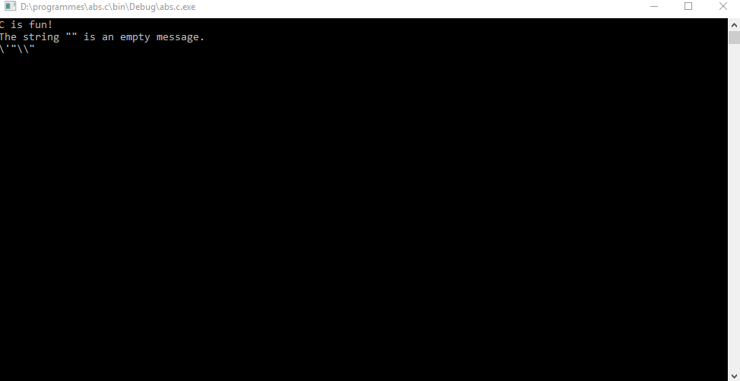

**Task 3: Escape sequences:**

#include <stdio.h>

#include <stdlib.h>

int main()

{

printf("A \"Qouted\" String is\n");

printf("'much' better if you learn\n");

printf("the rule of \"escape sequences.\"\n\n");

printf("Also, \"\" represents an empty string.\n");

printf("Don't forget : use \\\" instead of \" !\n ");

printf("'' is not same as \"");

getchar();

return 0;

}

**Its output will be as follow:**

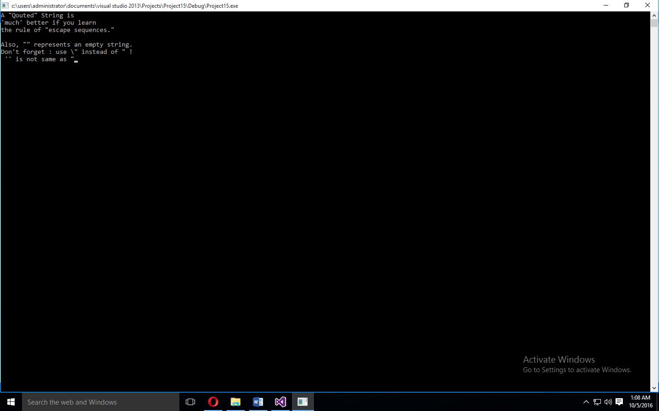

**Task 4 letter to yourself:**

#include <stdio.h>

#include <stdlib.h>

int main()

{

printf("+------------------------------------------------------+\n");

printf("| Pakistan post ####### |\n");

printf("| ####### |\n");

printf("| M.Rizwan Khalid ####### |\n");

printf("| H.No:672/5-G miilat chowk ####### |\n");

printf("| bukhari colony, Multan |\n");

printf("| _ _ _ _ _ _ |\n");

printf("| |_|_|_|_|_|_| |\n");

printf("| Postal Code |\n");

printf("+------------------------------------------------------+\n");

getchar();

return 0;

**output will be as follow:**

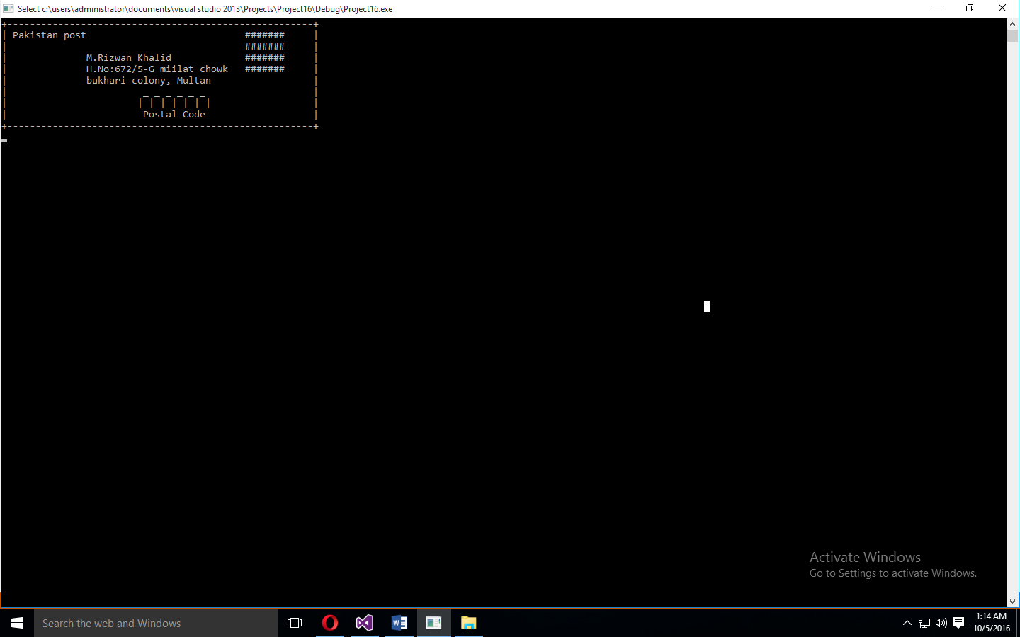

**Task 5 Your Initials**

#include <stdio.h>

#include <stdlib.h>

int main()

{

printf("For the name Rizwan kahlid....\n");

printf("RRRRRRRRRRRR k K\n");

printf("R R k K\n");

printf("R R K K\n");

printf("R R K K\n");

printf("R R K K\n");

printf("RRRRRRRRRRRR K K\n");

printf("R R K K \n");

printf("R R K K\n");

printf("R R K K\n");

printf("R R K K\n");

printf("R R K K\n");

printf("R R K K\n");

printf("R R K K\n");

getchar();

return 0;

}

**Output will be as follow:**

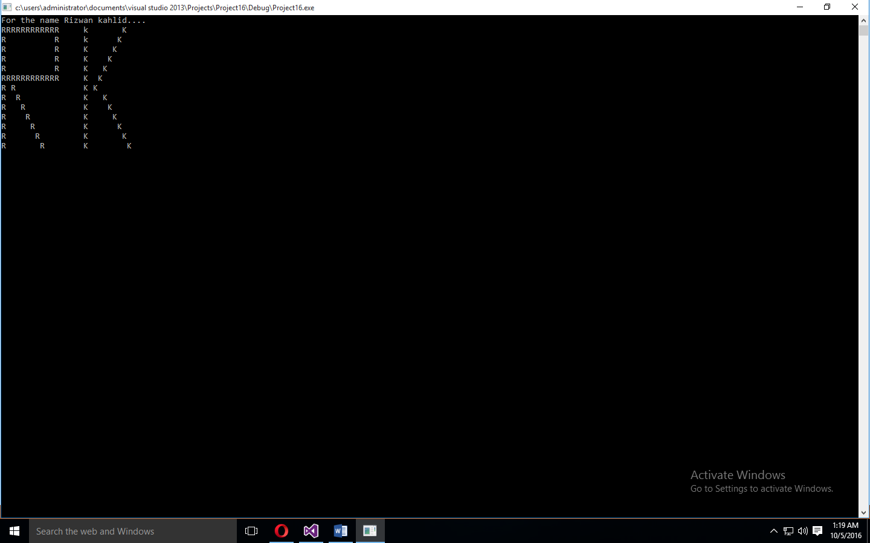

**Task 6 Math and percentage ( first part)**

/********************************************************

* Math -- program to do some math. *

* *

* Author: <Muhammad Rizwan Khalid>. *

********************************************************/

#include <stdlib.h>

#include <stdio.h>

int main()

{

// this statement display the string given.

printf( "I will now count my chickens:\n" );

// these statements will do calculation and show the result as number of hens.

printf( "Hens %d\n", ( 25 + 30 / 6 ) );

printf( "Roosters %d\n", ( 100 - 25 * 3 % 4 ) );

//this statement again displays the given string.

printf( "Now I will count the eggs:\n" );

//this statement will display the result of calcution.

printf( "%d\n", 3 + 2 + 1 - 5 + 4 % 2 - 1 / 4 + 6 );

//this statement will show the given string

printf( "Is it true that 3 + 2 < 5 - 7?\n" );

//in this statement there is a question and will display the result whether it is true or false

printf( "%s\n", ( ( 3 + 2 < 5 - 7 ) ? "true" : "false" ) );

//these statement will add the numbers and will display the given strin

printf( "What is 3 + 2? %d\n", ( 3 + 2 ) );

printf( "What is 5 - 7? %d\n", ( 5 - 7 ) );

printf( "Oh, that's why it's false.\n" );

printf( "How about some more.\n" );

// these statement again compute the number and display the results whether the condition is true or false.

printf( "Is it greater? %s\n", ( ( 5 > -2 ) ? "true" : "false") );

printf( "Is it greater or equal? %s\n", ( ( 5 >= -2 ) ? "true" : "false") );

printf( "Is it less or equal? %s\n", ( ( 5 <= -2 ) ? "true" : "false") );

getchar();

return EXIT_SUCCESS;

}

/********************************************************

* Question. *

* Notice the math seems "wrong"? There are no fractions, only whole numbers. *

* Find out why by researching what a "floating point" number is. *

* *

* Answer. *

*< Here in c we have used int function which displays the whole number. if we replace the int by float and place %f in print funtion then compiler will show the result in decimal points.> *

********************************************************/

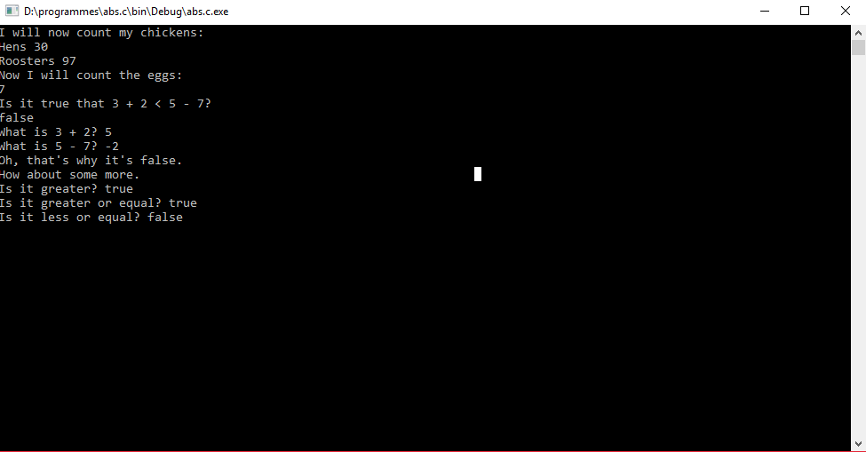

**Task 6 Math and percentage (adding float part):**

/********************************************************

* Math -- program to do some math. *

* *

* Author: <Muhammad Rizwan Khalid>. *

********************************************************/

#include <stdlib.h>

#include <stdio.h>

int main()

{

printf( "I will now count my chickens:\n" );

printf( "Hens %f\n", ( 25.00 + 30.00 / 6.00 ) );

printf( "Roosters %f\n", ( 100.00 - 25.00 * 3.00 ) );

printf( "Now I will count the eggs:\n" );

printf( "%f\n", 3.00 + 2.00 + 1.00 - 5.00 + 4.00 - 1.00 / 4.00 + 6.00 );

printf( "Is it true that 3.00 + 2.00 < 5.00 - 7.00?\n" );

printf( "%s\n", ( ( 3.00 + 2.00 < 5.00 - 7.00 ) ? "true" : "false" ) );

printf( "What is 3 + 2? %f\n", ( 3.00 + 2.00 ) );

printf( "What is 5 - 7? %f\n", ( 5.00 - 7.00 ) );

printf( "Oh, that's why it's false.\n" );

printf( "How about some more.\n" );

printf( "Is it greater? %s\n", ( ( 5.00> -2.00 ) ? "true" : "false") );

printf( "Is it greater or equal? %s\n", ( ( 5.00 >= -2.00 ) ? "true" : "false") );

printf( "Is it less or equal? %s\n", ( ( 5.00 <= -2.00 ) ? "true" : "false") );

getchar();

return EXIT_SUCCESS;

}

