**Task 1: Variables and printing: -**

/* Name: Muhammad Rizwan Khalid

Class: BSCS-6A

Reg No.: 00000180459

*/

// Here we are including libraries which include predefined built in functions.

#include <stdlib.h>

#include <stdio.h>

// This the main function of the program.

int main(void)

{

int

/* Here we are declaring different types of variables. These variables are of typ integer meaning that they can store whole numbers no decimal.

In programming a variable is nothing more than a name for something so you can

use the name rather than repeating work done*/

cars

, drivers

, passengers

, cars_not_driven

, cars_driven;

/* Here again we are declaring different types of variable but these variable are of type float or decimal not whole no. If we initialize them

a whole number or integer then by defaul in output the integet appear as float number upto six decimal points.*/

float

space_in_a_car

, carpool_capacity

, average_passengers_per_car;

// In this step we are initializing the variable cars with value 100.

cars = 100;

// In this step we are again initializing the variable with floating number 4.0 as it is a floating variable.

space_in_a_car = 4.0;

// Again initializing the variable with value of 30

drivers = 30;

// Initializing the variable passenger with value 90

passengers = 90;

/* This is an expression through which we compute the value stored in variables cars and drivers

and then initializing the main variable with resultant vaue*/

cars_not_driven = cars - drivers;

// Here we are assigning the value stored in variable driver to variable cars_driven.

cars_driven = drivers;

// Here we are doing the evaluation of expression and the assigning the result to variable carpool_capacity.

carpool_capacity = cars_driven * space_in_a_car;

// Same as above.

average_passengers_per_car = passengers / cars_driven;

/* Through this statement we get the out writtten in string and %d will be replaced by the value stored in variable cars.

%d is used to giver integer as output.*/

printf("There are %d cars available.\n", cars);

// This statement will give the output written is the quotation marks and %d will be replaced by the value stored in variable drivers.

printf("There are only %d drivers available.\n", drivers);

// This statement will give the output written in qoutation marks thereby replacing the %d with the value of car_not_driven.

printf("There will be %d empty cars today.\n", cars_not_driven);

/* This statement will give the output written in qoutation mark and %f will be replaced by the value stored in variable carpool_capacity.

%f is used to give output in float numbers with the default of six decimal places however we can restrict the decimal point by

writting .x after %. x is the decimal point upto which we want to restrict the decimal points.*/

printf("We can transport %.1f people today.\n", carpool_capacity);\

// This statement will give the output written is the quotation marks and %d will be replaced by the value stored in passengers.

printf("We have %d to carpool today.\n", passengers);

// This statement will give the output written in qoutation mark and %f will be replaced by the value stored in variable.

printf("We need to put about %.1f in each car.\n", average_passengers_per_car);

getchar();

return EXIT_SUCCESS;

}

/* Q: What is floating point?

Answer: This is number with decimal points. In c language we use function float to assign or to get output in decimal points

Q: I used 4.0 for space_in_a_car, but is that necessary? What happens if it’s just 4?

Answer: If we use just 4 in this program then output will not be effected. Because in printf statement we used %f to convert the

whole number into float.

*/

**Output: -**

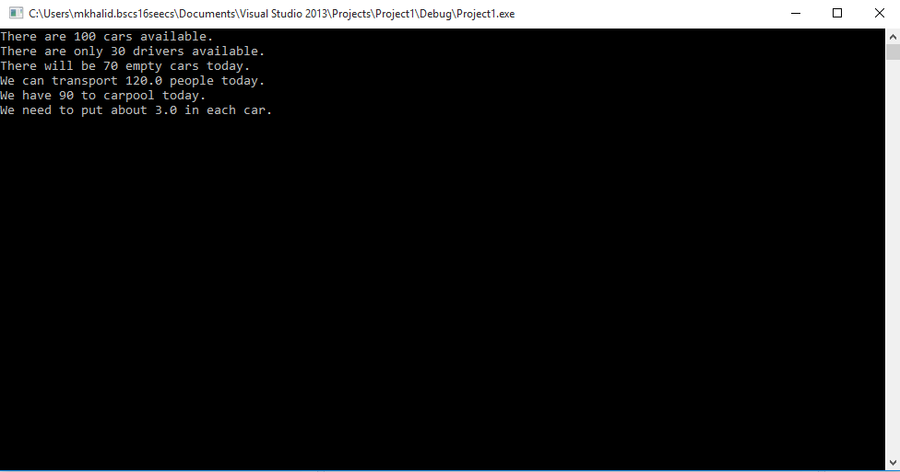

**Task 2: More variables and printing: -**

#include <stdlib.h>

#include <stdio.h>

int main( void )

{

char Name[] = "Muaz Hashmi";

char Eyes[] = "Brown";

char Teeth[] = "White";

char Hair[] = "Black";

int Age = 30; // not a lie

int Height = 70; // inches

int Weight = 170; // lbs

float Height2;

float Weight2;

Height2 = Height * 2.54; // Conversion of inches to centimeters.

Weight2 = Weight * 0.453592;// Conversion of pounds to kgs.

printf( "Let's talk about %s.\n", Name );

printf( "He's %d inches ( or %.1f cm ) tall .\n", Height, Height2 );

printf( "He's %d pounds ( or %.4f kg ) heavy.\n", Weight, Weight2 );

printf( "Actually, that's not too heavy.\n" );

printf( "He's got %s eyes and %s hair.\n", Eyes, Hair );

printf( "His teeth are usually %s depending on the coffee.\n", Teeth );

// This line is tricky; try to get it exactly right.

printf( "If I add %d, %d, and %d I get %d.\n"

, Age, Height, Weight

, (Age + Height + Weight) );

getchar();

return EXIT_SUCCESS;

}

**Output: -**

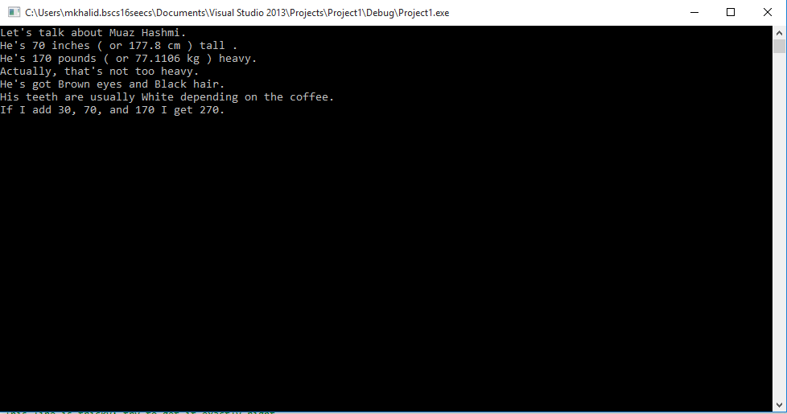

**Task 3: Using variables: -**

#include <stdio.h>

#include <stdlib.h>

int main()

{

int lab = 3;

float exp = 2.71828;

char subject[] = "Computer Science";

printf("This is lab %d.\n", lab);

printf("e is close to %.5f\n", exp);

printf("I am learnig a bil about %s.\n", subject);

getchar();

return 0;

}

**Output: -**

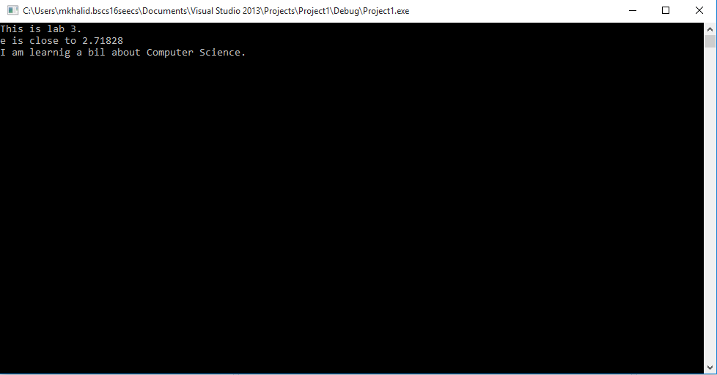

**Task 4: Still Using Variables: -**

#include <stdio.h>

#include <stdlib.h>

int main()

{

char Name[] = "Muhammad Rizwan Khalid";

int year = 2020;

printf("My name is %s and I'll graduate in %d.", Name, year);

getchar();

return 0;

}

**Output: -**

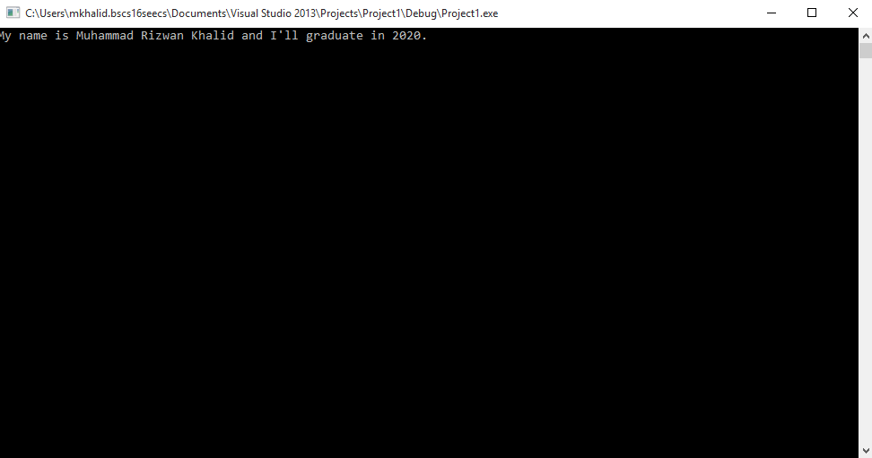

**Task 5: Your Schedule: -**

**#include <stdlib.h>**

**#include <stdio.h>**

**int main()**

**{**

**char subject1[] = "Fundamental of Computer programing";**

**char subject2[] = "Fundamental of ICT";**

**char subject3[] = "Discrete Mathematics";**

**char subject4[] = "Calculus-I";**

**char subject5[] = "Islamic Studies";**

**char subject6[] = "Communication and Interpersonal skills";**

**char teacher1[] = "Mr. Anis";**

**char teacher2[] = "Ms. Aleena ";**

**char teacher3[] = "Mr. Adnan";**

**char teacher4[] = "Mr. Nadeem";**

**char teacher5[] = "Mr. TBA";**

**char teacher6[] = "Mr. Usman";**

**printf("+------------------------------------------------------------+\n");**

**printf("|1| %s | %s |\n", subject1, teacher1);**

**printf("|2| %s | %s|\n", subject2, teacher2);**

**printf("|3| %s | %s |\n", subject3, teacher3);**

**printf("|4| %s | %s |\n", subject4, teacher4);**

**printf("|5| %s | %s |\n", subject5, teacher5);**

**printf("|6| %s | %s |\n", subject6, teacher6);**

**printf("+------------------------------------------------------------+\n");**

**getchar();**

**return 0;**

**}**

**Output: -**

