**Muhammad Rizwan Khalid**

**BSCS-6A**

**180459**

**Task #1: Asking Questions:**

#define _CRT_SECURE_NO_WARNINGS

#include <stdlib.h>

#include <stdio.h>

int main()

{

int age;

int h1, h2;

float weight;

printf( "How old are you? ");

scanf( "%d", &age );

printf("How many feet tall are you?");

scanf("%d", &h1);

printf("And how many inches?");

scanf("%d", &h2);

printf( "How much do you weigh? ");

scanf( "%f", &weight );

printf( "So you're %d old, %d'%d\" tall and %.1f heavy.\n", age, h1, h2, weight );

getchar();

getchar();

return EXIT_SUCCESS;

}

**Output:**

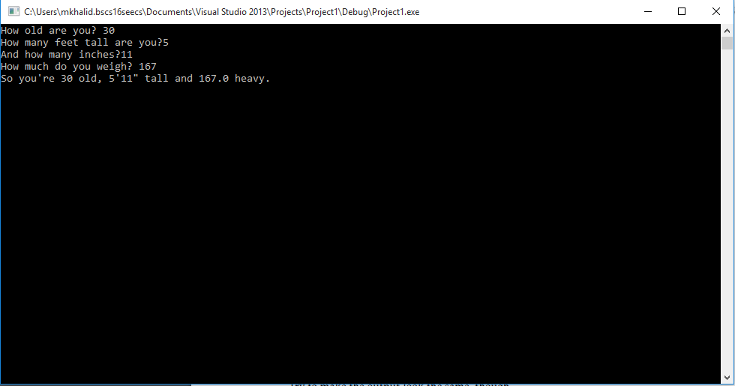

**Task #2: Name, Age, and Salary:**

#define _CRT_SECURE_NO_WARNINGS

#include <stdlib.h>

#include <stdio.h>

int main()

{

char name[20];

int age;

float salary;

printf("Hello. What is your name?");

scanf("%s", name);

printf("Hi, %s! How old are you?", name);

scanf("%d", &age);

printf("How much do you make, %s?", name);

scanf("%f", &salary);

printf("%.2f! I hope that's per hour and not per year!\n", salary);

system("pause");

return EXIT_SUCCESS;

}

**Output:**

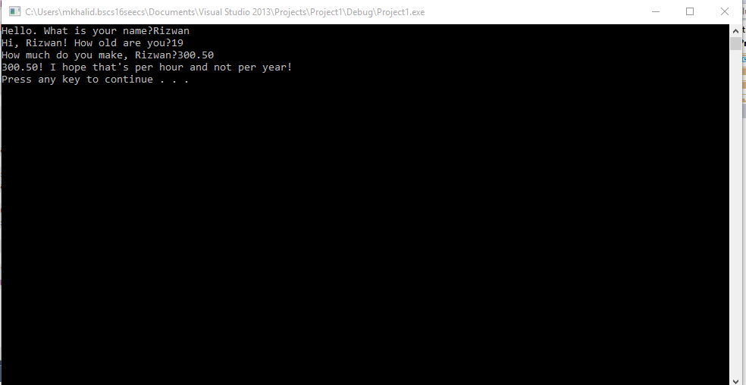

**Task #3: More User Input of Data:**

#define _CRT_SECURE_NO_WARNINGS

#define MAX_STRING_LENGTH 80

#include <stdlib.h>

#include <stdio.h>

int main()

{ char name1[20], name2[20];

int smester, id;

char login[MAX_STRING_LENGTH];

float gpa;

printf("First name : ");

scanf("%s", name1);

printf("Last name : ");

scanf("%s", name2);

printf("Smester :");

scanf("%d", &smester);

printf("Student ID : ");

scanf("%d", &id);

printf("Login : ");

scanf("%s", &login);

printf("GPA ( 0.0 - 4.0 ) : ");

scanf("%f", &gpa);

printf("Your Information :\n ");

printf(" Login : %s\n", login);

printf(" ID : %d\n", id);

printf(" Name : %s, %s\n", name1, name2);

printf(" GPA : %.2f\n", gpa);

printf(" Smester : %d\n", smester);

system("pause");

return EXIT_SUCCESS;

}

**Output:**

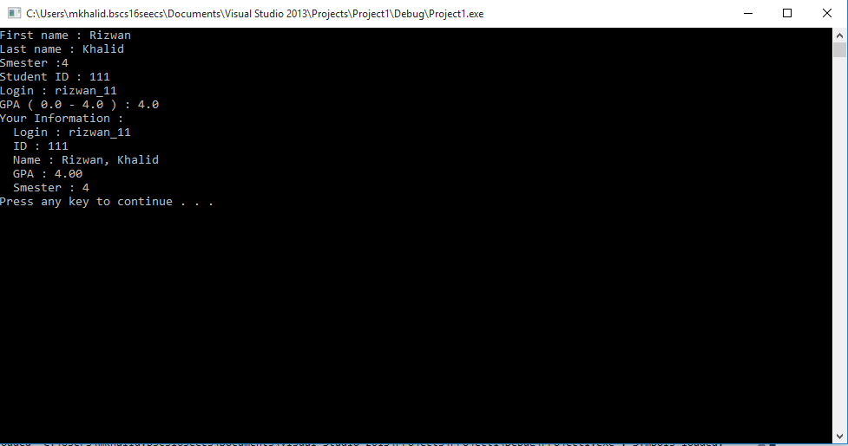

**Task #4: Age in Five Years:**

#define _CRT_SECURE_NO_WARNINGS

#include <stdlib.h>

#include <stdio.h>

int main()

{

char name[20];

int age, age1, age2;

printf("What is your name : ");

scanf("%s", name);

printf("Hi, %s! How old are you?", name);

scanf("%d", &age);

age1 = age + 5;

age2 = age - 5;

printf("In five years you will be %d years old.\n", age1);

printf("And five years ago you were %d.\n", age2);

system("pause");

return EXIT_SUCCESS;

}

**Output:**

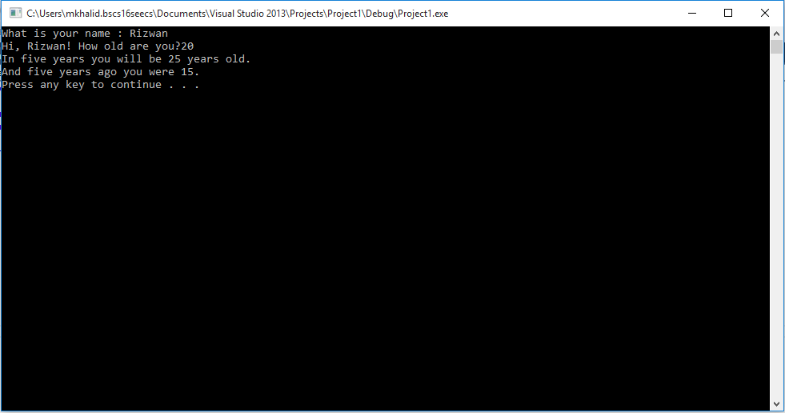

**Task #5: A Dumb Calculator:**

#define _CRT_SECURE_NO_WARNINGS

#include <stdlib.h>

#include <stdio.h>

int main()

{

float n1, n2, n3, exp;

printf("Enter your first number : ");

scanf("%f", &n1);

printf("Enter your first number : ");

scanf("%f", &n2);

printf("Enter your first number : ");

scanf("%f", &n3);

exp = (n1 + n2 + n3) / 2;

printf("(%.1f + %.1f +%.1f)/2 is.... %.1f\n", n1, n2, n3, exp);

system("pause");

return 0;

}

**Output:**

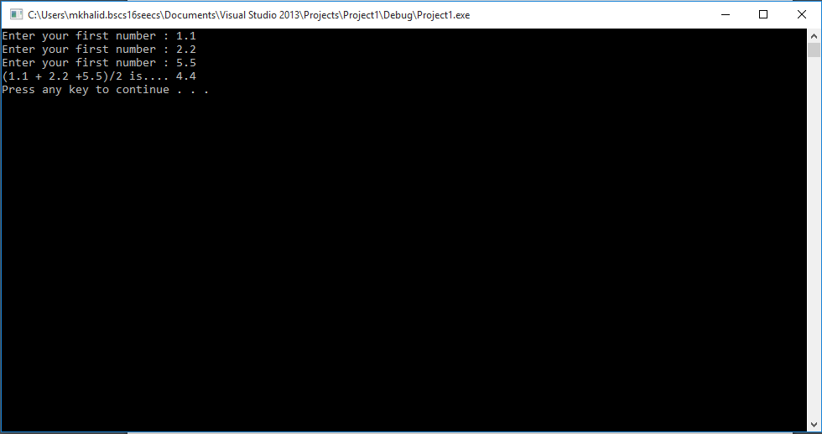

**Task #6: BMI Calculator:**

#define _CRT_SECURE_NO_WARNINGS

#include <stdlib.h>

#include <stdio.h>

int main()

{

int height, weight;

float height1, weight1, bmi;

printf("Your Height (inches) : ");

scanf("%d", &height);

printf("Your Weight (pounds) : ");

scanf("%d", &weight);

weight1 = weight / 2;

height1 = height / 39.37;

bmi = (weight1) / (height1*height1);

printf("Your BMI is %.1f", bmi);

system("pause");

return 0;

}

**Output:**

