**Muhammad Rizwan Khalid**

**BSCS-6A**

**180459**

**TASK: 01: Modified What If: -**

/*Name: Muhammad Rizwan Khalid

Class: BSCS-6A

Reg.No: 180459*/

#include <stdio.h>

#include <stdlib.h>

int main()

{

int zombies = 30;

int robots = 20;

int baby = 0;

if (robots < zombies)

{

printf("Too many zombies! The baby is doomed! \n");

}

if (robots > zombies)

{

printf("Not many zombies! The baby is saved! \n");

}

if (baby == 0)

{

printf("The human race is extinct!\n");

printf("The zombies starve to death!\n");

}

if (baby != 0)

{

printf("The zombies are crazy for some brains!\n");

}

system("pause");

return EXIT_SUCCESS;

}

/*Question1: What do you think the if does to the code under?

Answer: If evaluated the condition under it and checks whether the condition is true or not.

If the condition is true then the statement under it is executed. If the condition under it

is false then it skips the statement under it and does not process the statement under it.

Question2: What is the purpose of curly braces in the if statement?

Answer: If statement by defaul process single statement under it if there are no curly braces.

Curly braces are added so that if statement evaluate and process more than one statement and

instruction enclosed in the curly braces.

*/

**Output:**

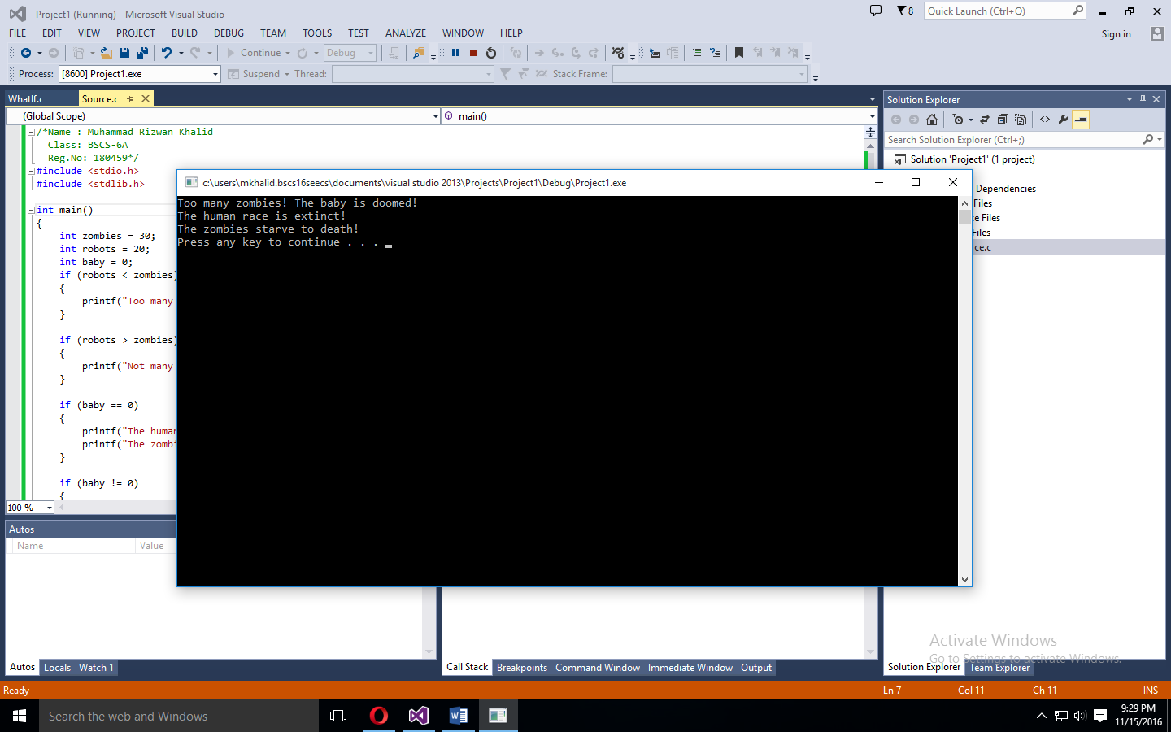

**Task: 02: How old are you:-**

/*Name : Muhammad Rizwan Khalid

Class: BSCS-6A

Reg.No: 180459*/

#include <stdio.h>

#include <stdlib.h>

int main()

{

int age;

char name[10];

printf("Hey, What's your name?");

scanf_s("%s", name);

printf("\n\nOk, %s, How old are you?", name);

scanf_s("%d", &age);

if (age < 16)

{

printf("\nYou can't vote, %s\n", name);

}

if (age < 18)

{

printf("You can't drive, %s\n", name);

}

if (age < 25)

{

printf("You can't contest for election, %s\n", name);

}

if (age >= 25)

{

printf("You can do anything that's legal, %s\n", name);

}

system("pause");

return EXIT_SUCCESS;

}

**Output:**

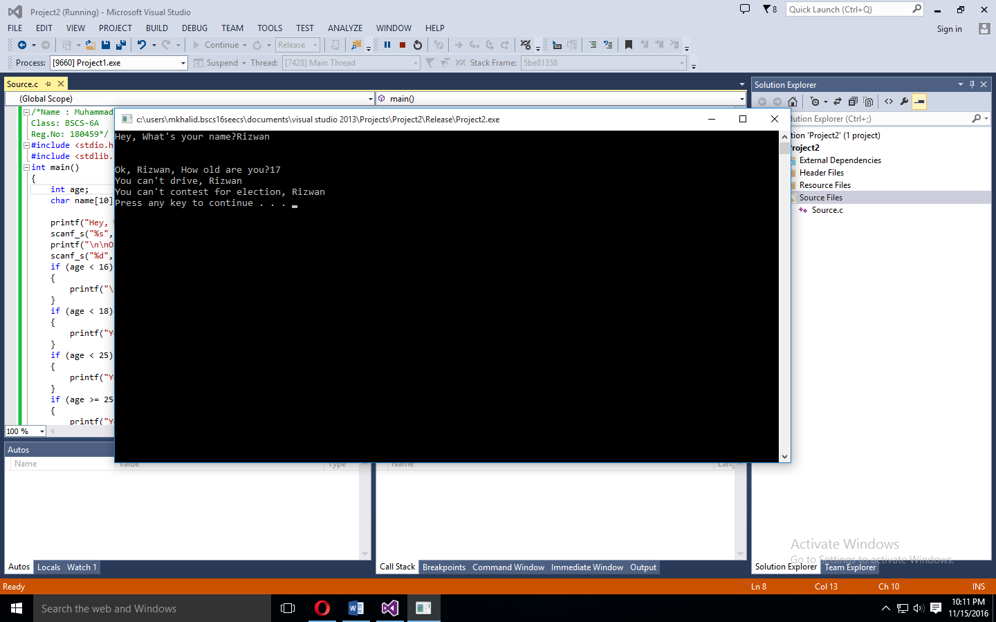

**Task: 03: Else and If:-**

/*Name : Muhammad Rizwan Khalid

Class: BSCS-6A

Reg.No: 180459*/

#include <stdio.h>

#include <stdlib.h>

int main()

{

int temp = 30;

if (temp < 32)

{

printf("Water is in solid ice state.\n");

}

if (temp < 212)

{

printf("Water is in liquid water state.\n");

}

else

{

printf("Water is in gaseous steam state.\n");

}

system("pause");

return EXIT_SUCCESS;

}

/*Question1: What do you think else if and else are doing?

Answer: Basically else refers to nearest if. The statements under else will only be executed,

if the condition enclosed inside if is false. Else if checks the previous condition, if the

condition is false then else if impose anothe condition and evalutes the condition.

Question2:Remove the else part at the beginning of the else if statement. What difference does

that make? Why?

Answer: When we remove else part at the beginnig of the else if statement then both the printf statements

will be executed. It is because when else if was there then the second printf was not executing because else

make it do so meaning if the condition above it is false only then it will execute

*/

**Output:-**

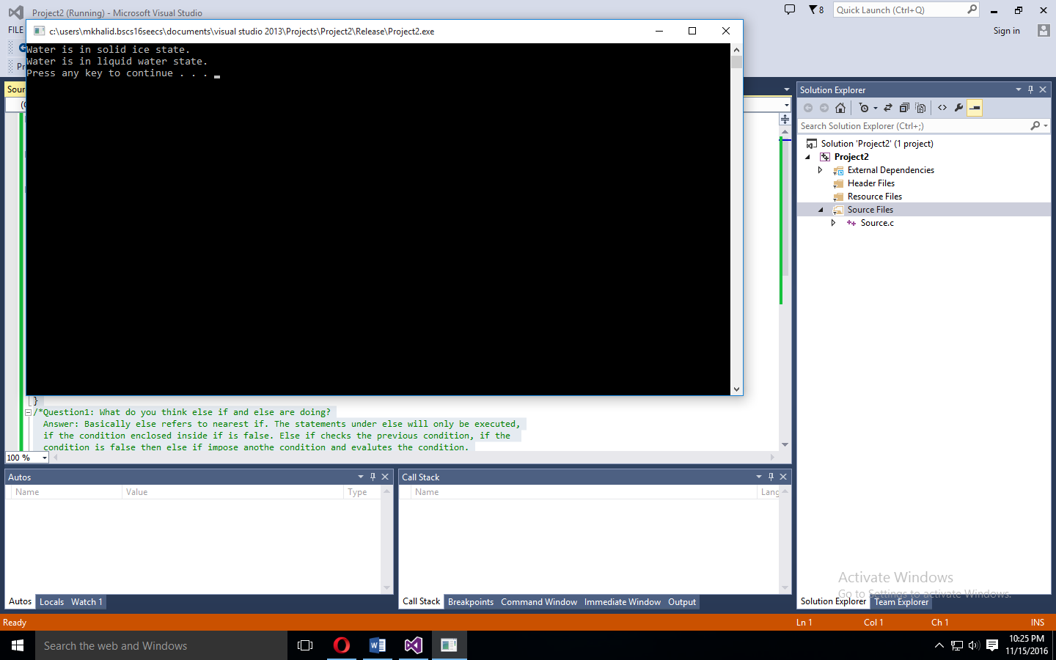

**Task: 05: How old are you, specifically:-**

/*Name : Muhammad Rizwan Khalid

Class: BSCS-6A

Reg.No: 180459*/

#include <stdio.h>

#include <stdlib.h>

int main()

{

int age;

char name[10];

printf("Hey, What's your name?");

scanf_s("%s", name);

printf("\n\nOk, %s, How old are you?", name);

scanf_s("%d", &age);

if (age < 16)

{

printf("\nYou can't drive, %s\n", name);

}

if (age == 16 || age == 17)

{

printf("You can drive but not vote, %s\n", name);

}

if (age >= 18 && age <= 24)

{

printf("You can vote but not rent a car, %s\n", name);

}

if (age >= 25)

{

printf("You can do pretty much anything, %s\n", name);

}

system("pause");

return EXIT_SUCCESS;

}

**Output:-**

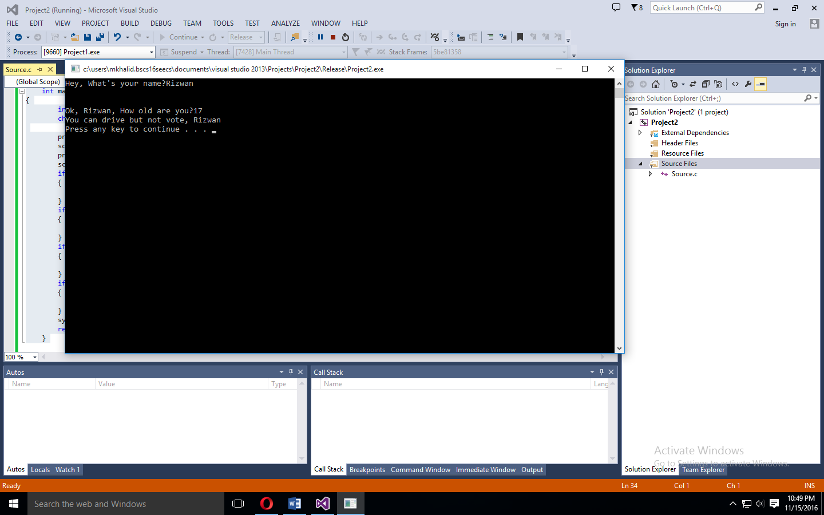

**Task: 06: Space Boxing:-**

/*Name : Muhammad Rizwan Khalid

Class: BSCS-6A

Reg.No: 180459*/

#include <stdio.h>

#include <stdlib.h>

int main()

{

float weight;

int planet;

printf("Please enter your current earth's weight:");

scanf_s("%f", &weight);

printf("\n\nI have information for the following planets:\n");

printf("\t1. Mercury 2. Venus 3. Earth\n");

printf("\t4. Moon 5. Mars 6. Jupiter\n");

printf("\t7. Saturn 8. Uranus 9. Neptune\n\n");

printf("Which planet are you visitg:");

scanf_s("%d", &planet);

if (planet == 1)

{

weight = weight * 0.378;

printf("\n\nYour weight would be %.3f kilograms on that planet\n", weight);

}

if (planet == 2)

{

weight = weight * 0.907;

printf("\n\nYour weight would be %.3f kilograms on that planet\n", weight);

}

if (planet == 3)

{

weight = weight * 1;

printf("\n\nYour weight would be %.3f kilograms on that planet\n", weight);

}

if (planet == 4)

{

weight = weight * 0.165;

printf("\n\nYour weight would be %.3f kilograms on that planet\n", weight);

}

if (planet == 5)

{

weight = weight * 0.377;

printf("\n\nYour weight would be %.3f kilograms on that planet\n", weight);

}

if (planet == 6)

{

weight = weight * 2.364;

printf("\n\nYour weight would be %.3f kilograms on that planet\n", weight);

}

if (planet == 7)

{

weight = weight * 0.910;

printf("\n\nYour weight would be %.3f kilograms on that planet\n", weight);

}

if (planet == 8)

{

weight = weight * 0.889;

printf("\n\nYour weight would be %.3f kilograms on that planet\n", weight);

}

if (planet == 9)

{

weight = weight * 1.125;

printf("\n\nYour weight would be %.3f kilograms on that planet\n", weight);

}

system("pause");

return EXIT_SUCCESS;

}

**Output:-**

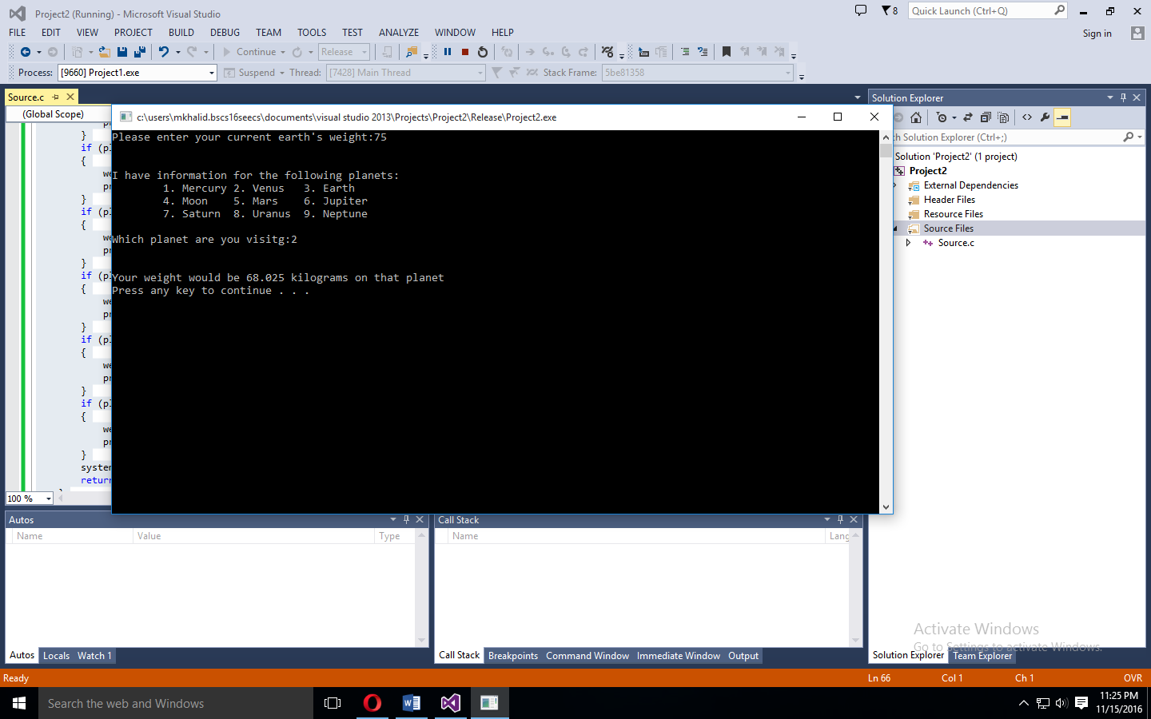

**Task: 07: A little quiz: -**

/*Name : Muhammad Rizwan Khalid

Class: BSCS-6A

Reg.No: 180459*/

**#include <stdio.h>**

**#include <stdlib.h>**

**int main()**

**{**

**int a, b, c, d;**

**char choice;**

**printf("Are you ready for a Quiz (Y/N)?\n");**

**scanf("%c", &choice);**

**if(choice == 'Y' || choice == 'y' )**

**{**

**printf("Q1. What is the capital of Pakistan?\n");**

**printf("\t1. Lahore\n");**

**printf("\t2. Karachi\n");**

**printf("\t3. Islamabad\n");**

**scanf("%d", &a);**

**if(a == 3)**

**{**

**b=1;**

**printf("That's Right.\n");**

**}**

**else**

**{**

**b=0;**

**printf("That's Wrong.\n");**

**}**

**printf("Q2) Can you store the value 3.147 in a variable of type int?\n");**

**printf("\t1) yes.\n");**

**printf("\t2) no.\n");**

**scanf("%d", &a);**

**if (a == 2)**

**{**

**c=1;**

**printf("That's the right answer!\n");**

**}**

**else**

**{**

**c=0;**

**printf("Sorry , 3.147 is a floating -point. type int can only store numbers.\n");**

**}**

**printf("Q3) What is the result of 2+6/3?\n");**

**printf("\t11\n");**

**printf("\t4\n");**

**printf("\t8/3\n");**

**scanf("%d", &a);**

**if (a == 2)**

**{**

**d=1;**

**printf("That's right.\n");**

**}**

**else**

**{**

**d=0;**

**printf("That's wrong.\n");**

**}**

**printf("Overall, you get %d out of 3 correct.\n", b+c+d);**

**printf("Thanks for playing'\n");**

**}**

**else**

**{**

**printf("Ok as You Wish!\n");**

**}**

**return 0;**

**}**

**Output:-**

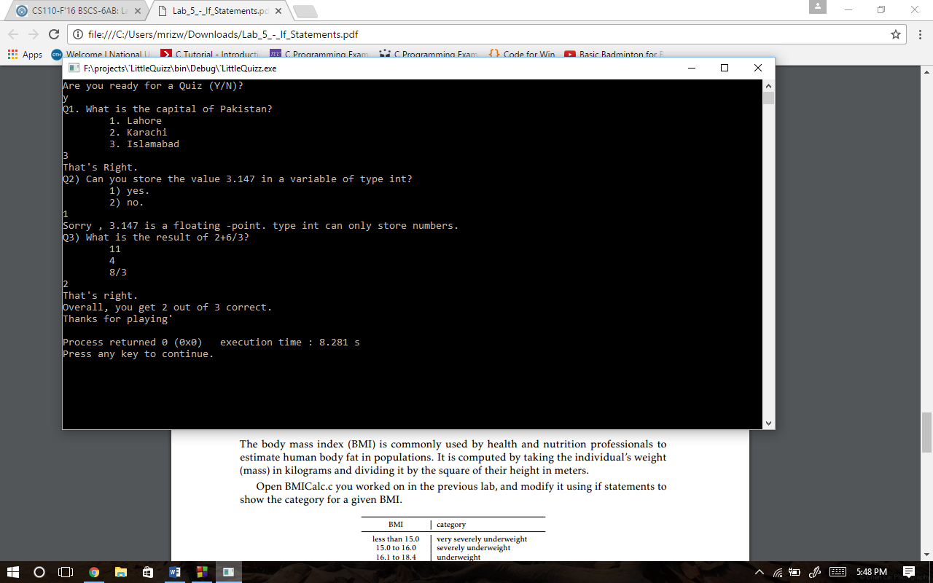

**Task: 8: BMI Categories: -**

**/*Name : Muhammad Rizwan Khalid**

**Class: BSCS-6A**

**Reg.No: 180459*/**

**#include <stdio.h>**

**#include <stdlib.h>**

**int main()**

**{**

**float weight, height, bmi;**

**printf("Enter Your Weight in Kilograms:");**

**scanf("%f", &weight);**

**printf("Enter Your Height in Meters:");**

**scanf("%f", &height);**

**bmi = (weight)/(height*height);**

**printf("\nYour BMI is %.3f.\n", bmi);**

**if (bmi < 15.0)**

**printf("BMI Category: Very Severely Underweight.\n");**

**if (bmi >= 15.0 && bmi <= 16.0)**

**printf("BMI Category: Severely Underweight.\n");**

**if (bmi >= 16.1 && bmi <= 18.4)**

**printf("BMI Category: Underweight.\n");**

**if (bmi >= 18.5 && bmi <= 24.9)**

**printf("BMI Category: Normal Weight\n");**

**if (bmi >= 25.0 && bmi <= 29.9)**

**printf("BMI Category: Overweight.\n");**

**if (bmi >= 30.0 && bmi <= 34.9)**

**printf("BMI Category: Moderately Obese.\n");**

**if (bmi >= 35.0 && bmi <= 39.9)**

**printf("BMI Category: Severely Obese.\n");**

**if (bmi > 40)**

**printf("BMI Category: severely (or \"morbidly\") obese.\n");**

**return 0;**

**}**

**Output: -**

