**Task: 01: Do-While Swimming:**

#define _CRT_SECURE_NO_WARNINGS

#include <stdio.h>

#include <stdlib.h>

int main()

{

char guestName1[] = "HAMZA";

char guestName2[] = "ILSA";

int totalNights;

int nightsSpent;

double totalCost;

printf("How many nights do you plan to stay? ");

scanf("%d", &totalNights);

printf("\nTotal planned stay: %d nights.\n", totalNights);

printf("%s travels to Chitral....\n\n", guestName1);

nightsSpent = 0;

totalCost = 0.0;

while (nightsSpent < totalNights)

{

printf("%s spends a night.\n", guestName1);

nightsSpent++;

totalCost += 1500.0;

printf("\tNights spent: %d\n", nightsSpent);

printf("\tNights left: %d\n", totalNights - nightsSpent);

}

printf("\nTotal cost of stay: Rs. %.2f\n", totalCost);

printf("\nTotal planned stay: %d nights.\n", totalNights);

printf("%s travels to Chitral....\n\n", guestName2);

nightsSpent = 0;

totalCost = 0.0;

do

{

printf("%s spends a night.\n", guestName2);

nightsSpent++;

totalCost += 1500.0;

printf("\tNights spent: %d\n", nightsSpent);

printf("\tNights left: %d\n", totalNights - nightsSpent);

} while (nightsSpent < totalNights);

printf("\nTotal cost of stay: Rs. %.2f\n", totalCost);

system("pause");

return EXIT_SUCCESS;

}

/*Question: Run the program, and type in 3 for the number of nights. Do Hamza and Ilsa stay for

the same number of nights? Put your answer in a comment.

Answer: Both Hamza and ilsa stay for the same number of nights (3 nights) when we input 3.

Question: Run the program again, but this time enter 0 for the total vacation. What changes?

Answer: This time when we enter 0 then Hamza travel to chitral without having stay there. while

that of Ilsa she stays there for a night getting a cost of 1500.

Question: Does Hamza check the total vacations, or does he just drive to Chitral?

Answer: Hamza just travels to chitral.

Question: What is the difference between a while loop and a "do-while" loop?

Answer: While loop checks the condition and then execute its body while that of do-while loop

it executes the statements under do and then check for while condition. So we can say that while

loop is a pretest while do-while loop is a posttest.

Question: One of these loops is sometimes called a "pre-test loop", and the other is called a

"post-test loop". Which one is which?

Answer: while loop is a pretest while do-while loop is posttest.*/

**Output: -**

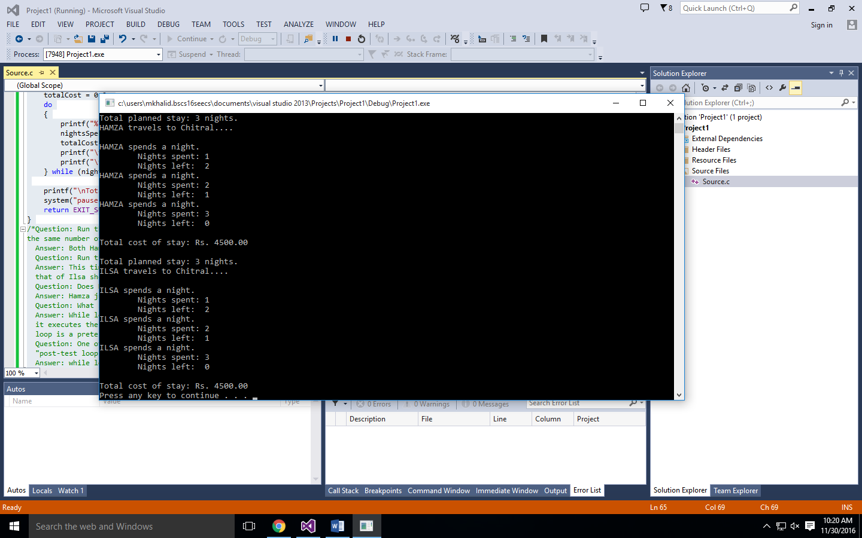

**Task: 02: Flip Again?**

#define _CRT_SECURE_NO_WARNINGS

#include <stdio.h>

#include <stdlib.h>

#include <string.h>

#include <time.h>

int FlipCoin() {

int result = 1 + rand() % 2;

return result == 1;

}

int main()

{

srand (time(NULL));

char again;

char coin[] = "";

do

{

int flip = FlipCoin();

if ( flip == 1 )

strcpy( coin, "HEADS" );

else

strcpy( coin, "TAILS" );

printf( "You flip a coin and it is... %s\n", coin );

printf( "Would you like to flip again (y/n)? " );

scanf( " %c", &again );

}

while (again == 'y');

return EXIT_SUCCESS;

}

/*Question:What happens if you delete what you added in step 1? Change the line back to just

char again; Does the program still work? Why or why not?

Answer: if we undo the process done in step 1 then the program is still running this is because

initially when while loop was there it was checking the condition (if the again = 'y'). That's

why it was not working then. But wehn we chaged it to do while then this execute the instruction

under do in which we assign the value of again by getting input from the user.*/

**Output: -**

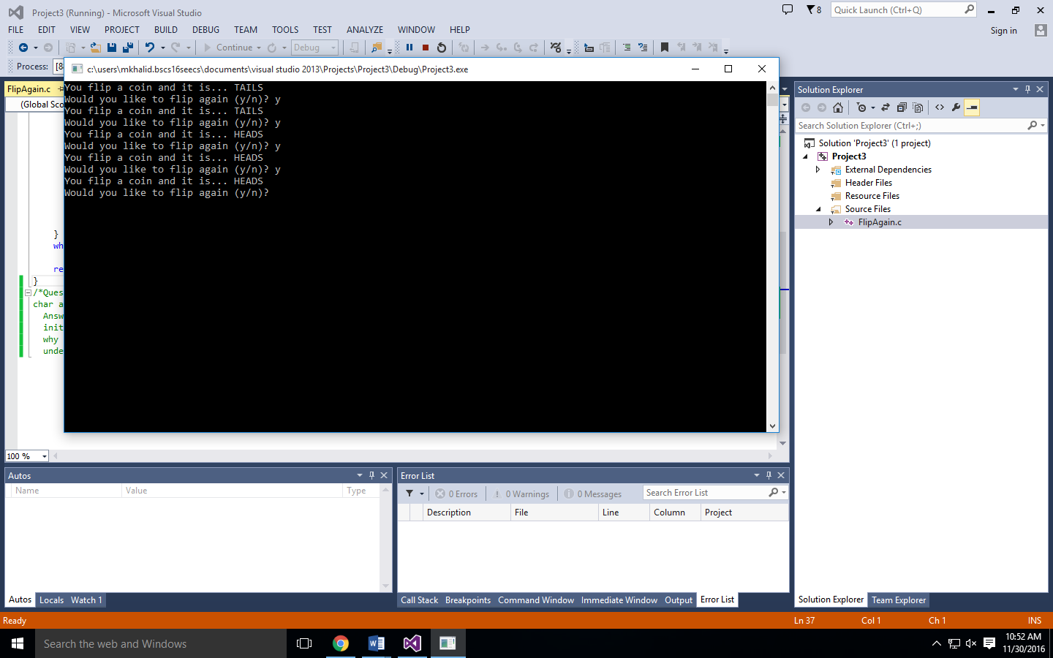

**Task: 03: Shorter Double Dice: -**

#include <stdio.h>

#include <stdlib.h>

#include <time.h>

int main()

{

int a, b, c;

srand(time(NULL));

do

{

a = rand() % 6 + 1;

b = rand() % 6 + 1;

c = a + b;

printf("HERE COMES THE DICE!\n\n");

printf("Roll #1: %d\n", a);

printf("Roll #2: %d\n", b);

printf("The total is %d!\n", c);

} while (a != b);

system("pause");

return 0;

}

**Output:**

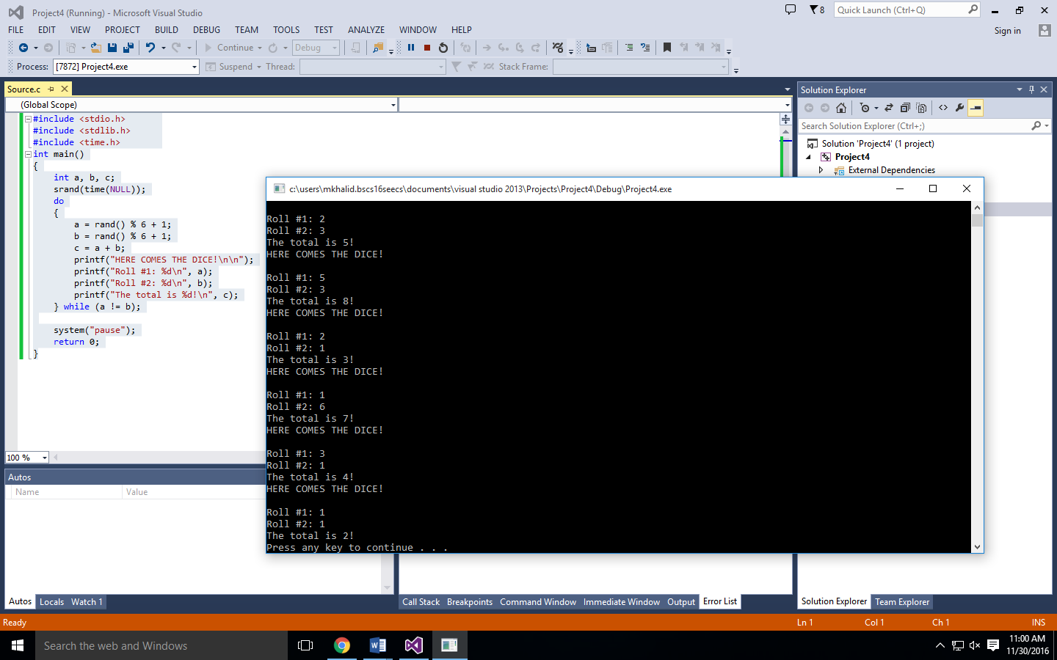

**Task #4: Again with the Number-Guessing: -**

#include <stdio.h>

#include <stdlib.h>

int main()

{

int a, tries = 0;

printf("I have chosen a number between 1 and 10. Try to guess it out.\n");

printf("Your Guess : ");

scanf_s("%d", &a);

tries++;

do

{

printf("This is incorrect. Guess again.\n");

printf("Your Guess : ");

scanf_s("%d", &a);

tries++;

} while (a != 6);

printf("That's right! You Guessed it.\n");

printf("It only took you %d tries.\n", tries);

system("pause");

return EXIT_SUCCESS;

}

**Output: -**

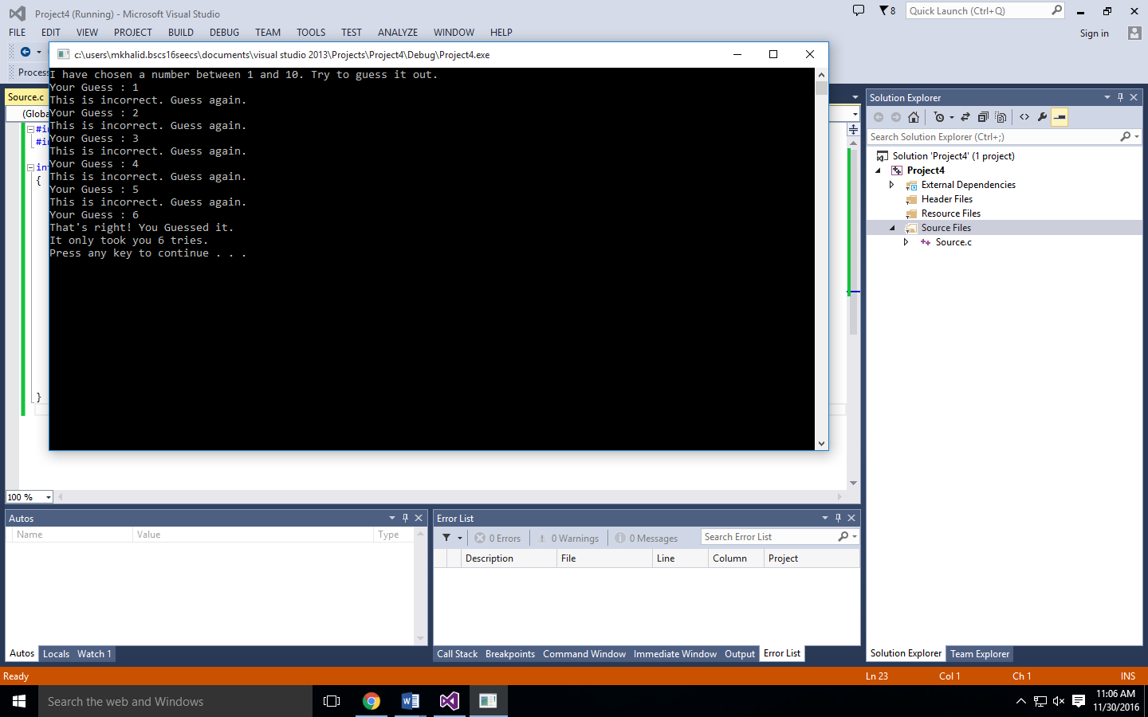

**Task: 05: Square Root: -**

#include <stdio.h>

#include <stdlib.h>

#include <math.h>

int main()

{

int a;

float b;

do

{

printf("SQUARE ROOT!\n");

printf("Enter a number: ");

scanf_s("%d", &a);

b = sqrt(a);

if (a < 0)

{

printf("You cannot take the square root of negative number.\n");

}

else

printf("The square root of %d is %f\n", a, b);

} while (1);

system("pause");

return 0;

}

**Output: -**

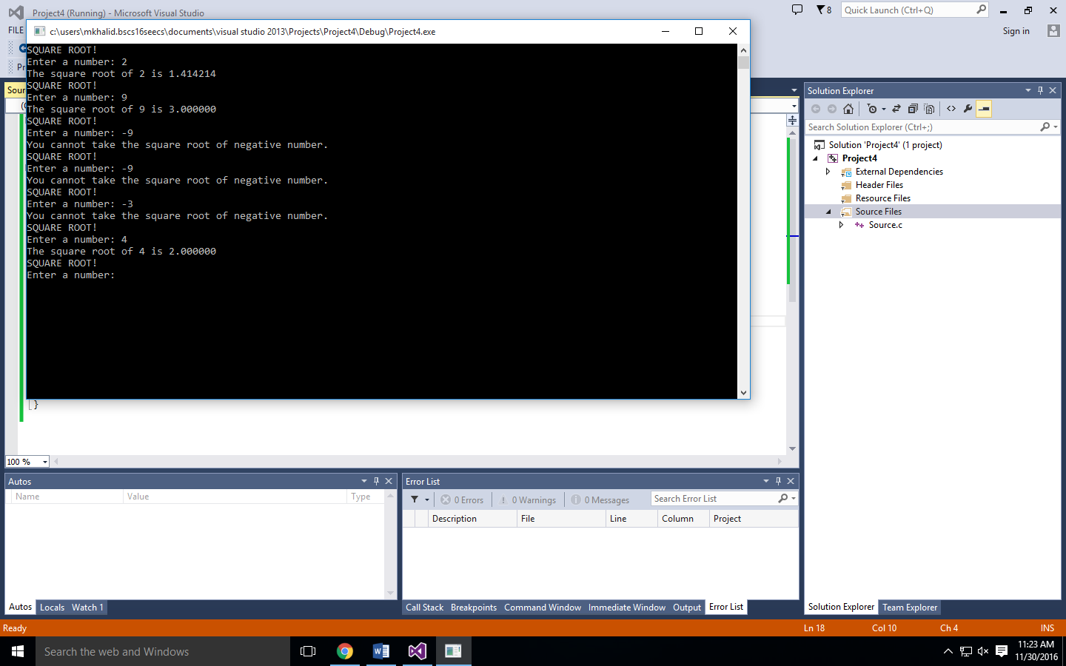

**Task: 06: Right triangle Checker: -**

#include <stdio.h>

#include <stdlib.h>

int main()

{

int FirstSide, SecondSide, ThirdSide;

printf("Enter First side of a Triangle: ");

scanf("%d", &FirstSide);

printf("First Side is %d\n", FirstSide);

printf("Enter Second side of a Triangle: ");

scanf("%d", &SecondSide);

printf("Second side is %d\n", SecondSide);

if (SecondSide < FirstSide)

{

do

{

printf("The second side of triangle is less than the first side\n");

printf("Enter Second side of a Triangle: ");

scanf("%d", &SecondSide);

printf("Second side is %d\n", SecondSide);

} while (SecondSide < FirstSide);

}

printf("Enter third side of a triangle: ");

scanf("%d", &ThirdSide);

printf("Third side is %d\n", ThirdSide);

if (ThirdSide < SecondSide)

{

do

{

printf("The third side of triangle is less than the second side\n");

printf("Enter Third side of a Triangle: ");

scanf("%d", &ThirdSide);

printf("Second side is %d\n", ThirdSide);

} while (SecondSide < FirstSide);

}

if (ThirdSide * ThirdSide == FirstSide * FirstSide + SecondSide * SecondSide)

{

printf("The Triangle is a Right angle Triangle!!\n");

}

else

printf("The triangle is not a right angle triangle!!\n");

system("pause");

return 0;

}

**Output: -**

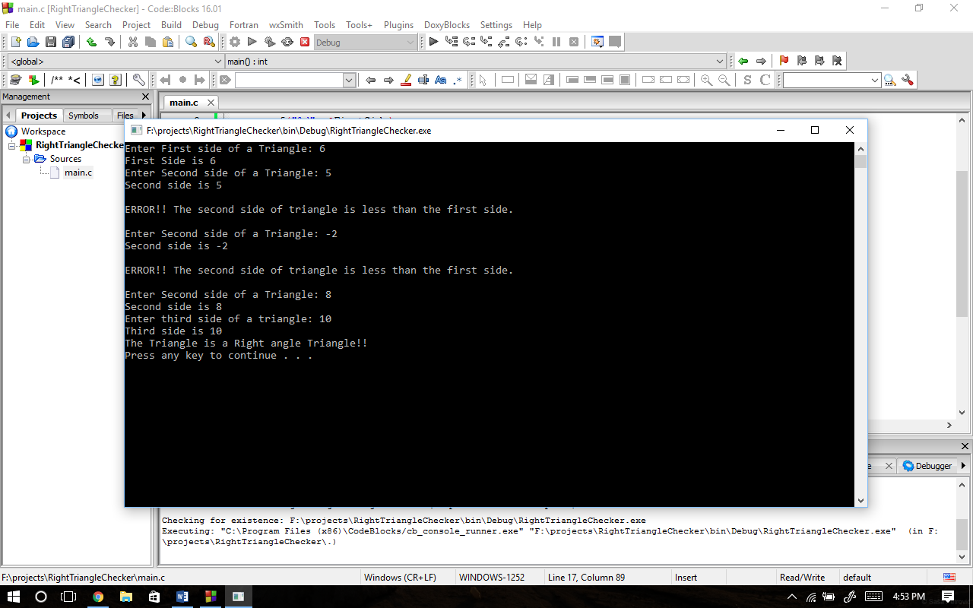

**Task: 07: Collatz Conjecture: -**

#include <stdio.h>

#include <stdlib.h>

int main()

{

int n, count = 1;

printf("Enter any number to generate the sequence:");

scanf("%d", &n);

printf("%d ", n);

while (n != 1)

{

if(n % 2 == 0)

{

n = n / 2;

printf("%d ", n);

count++;

}

else if (n % 2 == 1)

{

n = (3 * n) +1;

printf("%d ", n);

count++;

}

else if (n==1)

{

count++;

goto end;

}

}

end:

printf("\nThe cycle length is %d \n", count);

return 0;

}

**Output: -**

