**Lab_08: For Loop**

Name: Muhammad Rizwan Khalid

Class: BSCS-6A

Reg.No: 180459

**Task: 01: Counting with for loop: -**

#define _CRT_SECURE_NO_WARNINGS

#include <stdio.h>

#include <stdlib.h>

#include <string.h>

int main()

{

char message[80];

printf("Type in a message , and I'll display it five times.\n");

printf("Message: ");

gets(message);

for (int n = 2; n <= 10 ; n = n + 2 )

{

printf("%d. %s\n", n, message);

}

system("pause");

return EXIT_SUCCESS;

}

/*Question: What does n=n+1 do?

Answer: n=n+1 increment the value of n each time the loop is executed until n<=5. If we remove n=n+1

then there will be no increment so that it will always satisfies n<=1.Loop will perform infinitely.

Question: What does n=1 do?

Answer:n=1 initialize the loop. if we remove the n=1 then there will be no initialization of loop variable

and loop will not execute.

*/

**Output: -**

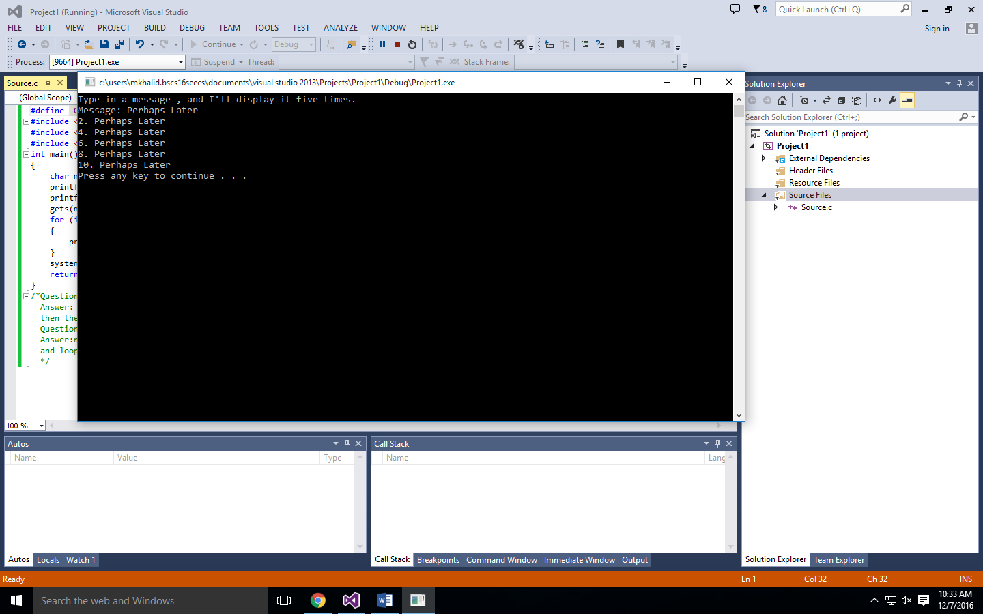

**Task: 02: Eight Times:**

#define _CRT_SECURE_NO_WARNINGS

#include <stdio.h>

#include <stdlib.h>

#include <string.h>

int main()

{

char message[80];

printf("Type in a message , and I'll display it five times.\n");

printf("Message: ");

gets(message);

for (int n = 1; n <= 8 ; n = n + 1 )

{

printf("%d. %s\n", n, message);

}

system("pause");

return EXIT_SUCCESS;

}

**Output: -**

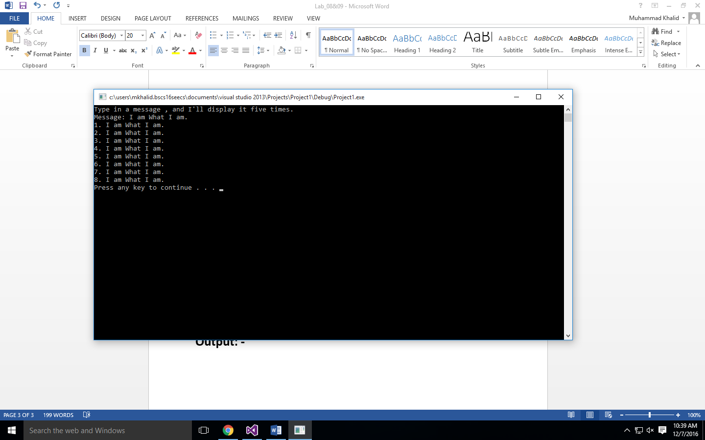

**Task: 03: Counting Machine Revisited: -**

#define _CRT_SECURE_NO_WARNINGS

#include <stdio.h>

#include <stdlib.h>

int main()

{

int i, count, increment;

printf("Count from: ");

scanf("%d", &i);

printf("Count to: ");

scanf("%d", &count);

printf("Count by: ");

scanf("%d", &increment);

for (int j = i; j <= count; j = j + increment)

{

printf("%d ", j);

}

printf("\n");

system("pause");

return 0;

}

**Output: -**

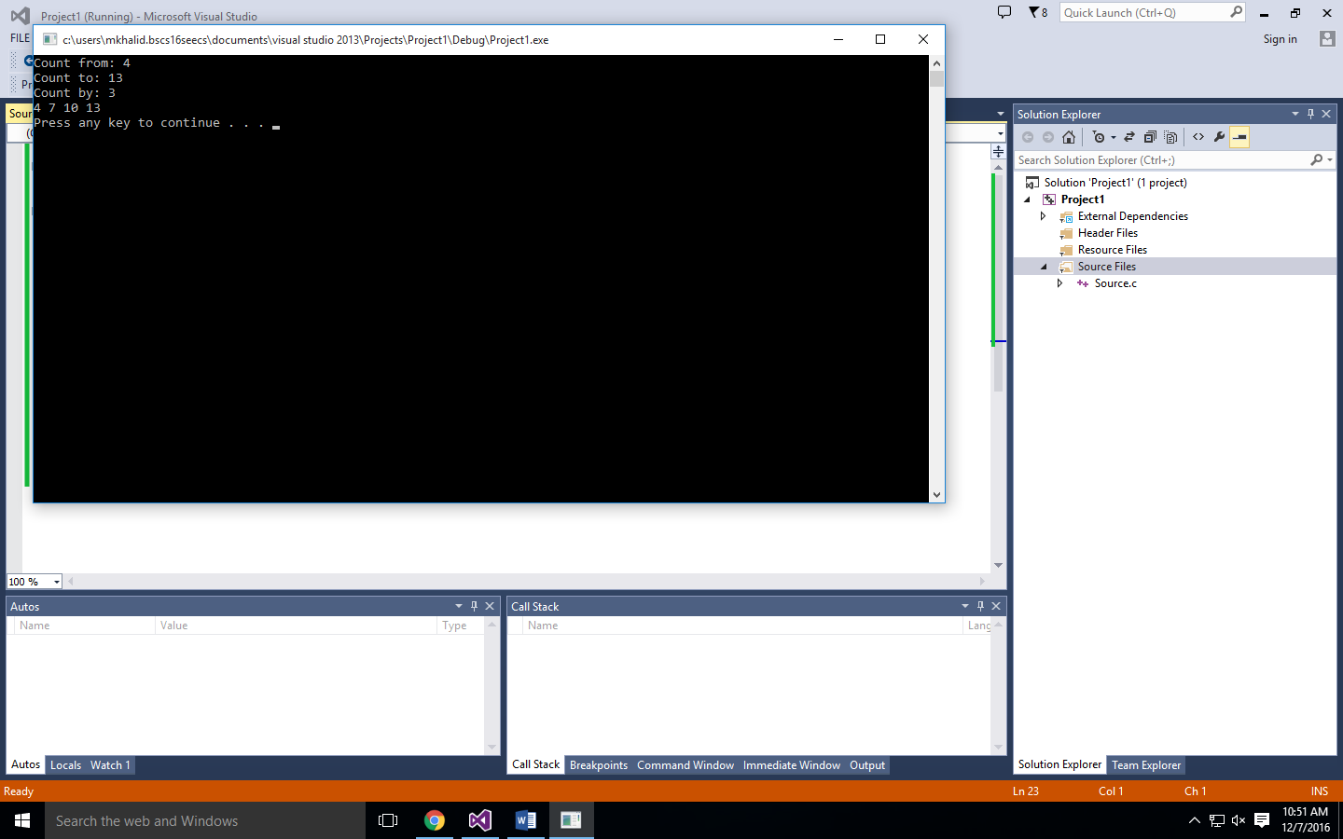

**Task: 04: Counting by Halves:**

#define _CRT_SECURE_NO_WARNINGS

#include <stdio.h>

#include <stdlib.h>

int main()

{

float x;

printf("x\n---------\n");

for (x = -10.0; x <= 10.0; x = x + 0.5)

{

printf("%0.1f\n", x);

}

system("pause");

return 0;

}

**Output:**

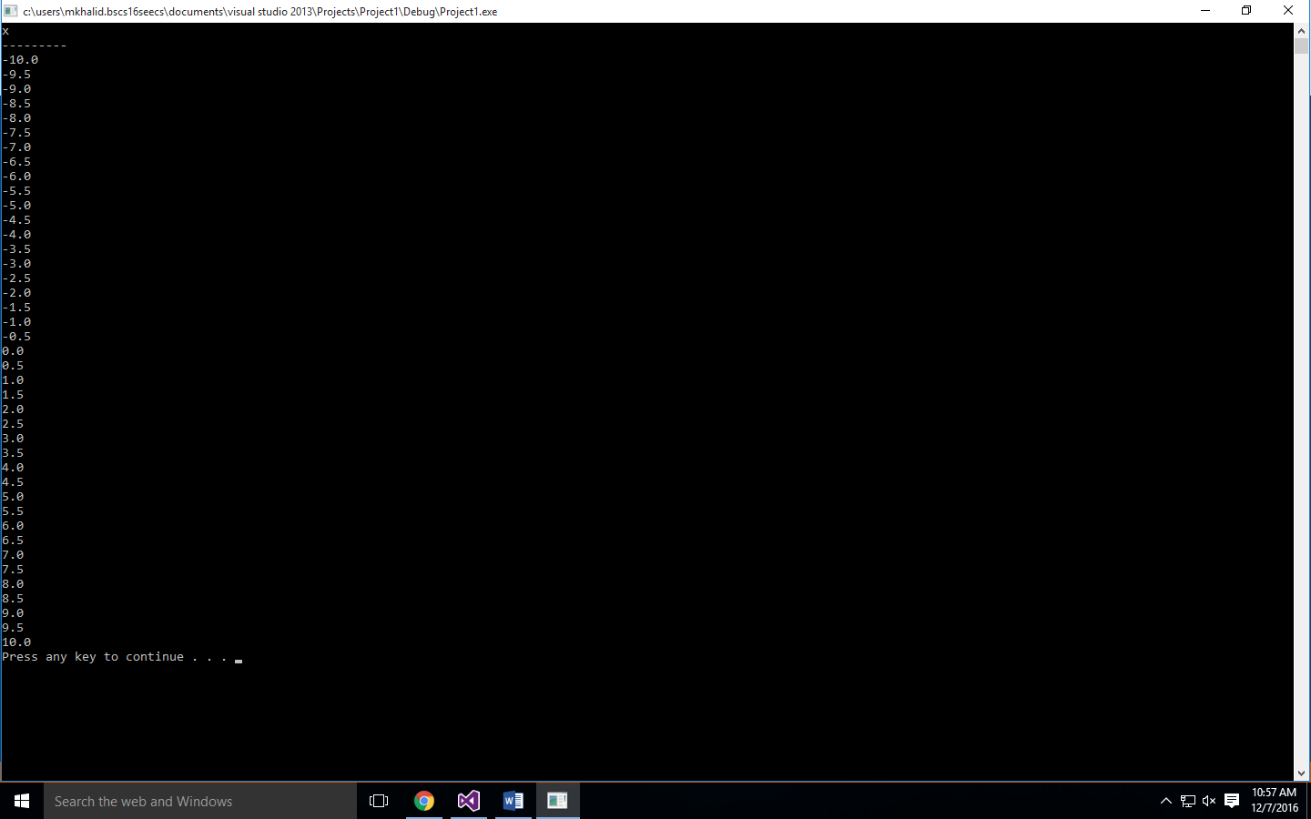

**Task: 05: Xs and Ys: -**

#define _CRT_SECURE_NO_WARNINGS

#include <stdio.h>

#include <stdlib.h>

int main()

{

float x, y;

printf("x y\n---------------\n");

for (x = -10.0; x <= 10.0; x = x + 0.5)

{

y = x * x;

printf("%.1f %.2f \n", x, y);

}

system("pause");

return 0;

}

**Output: -**

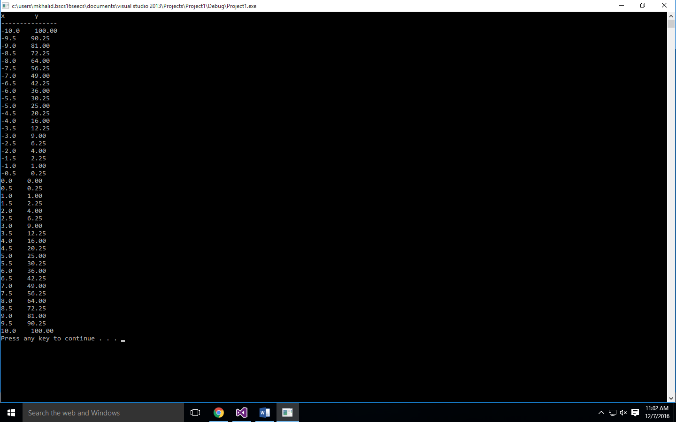

**Task: 06: Noticing Even: -**

#define _CRT_SECURE_NO_WARNINGS

#include <stdio.h>

#include <stdlib.h>

void main()

{

int a = 0;

for (a = 1; a <= 20; a++)

{

if (a % 2 == 0)

{

printf("%d <\n", a);

}

else

{

printf("%d\n", a);

}

}

system("pause");

}

**Output: -**

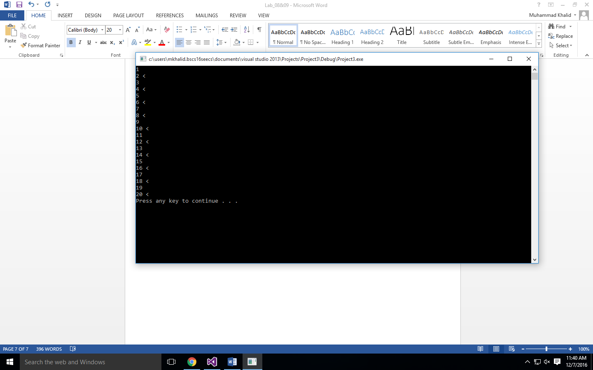

**Task: 07: FizzBuzz: -**

#define _CRT_SECURE_NO_WARNINGS

#include <stdio.h>

#include <stdlib.h>

void main()

{

for (int a = 1; a <= 100; a++)

{

if (a % 3 == 0 && a % 5 == 0)

printf("FizzBuzz\n");

else if (a % 3 == 0)

printf("Fizz\n", a);

else if (a % 5 == 0)

printf("Buzz\n", a);

else

printf("%d\n", a);

}

system("pause");

}

**Output: -**

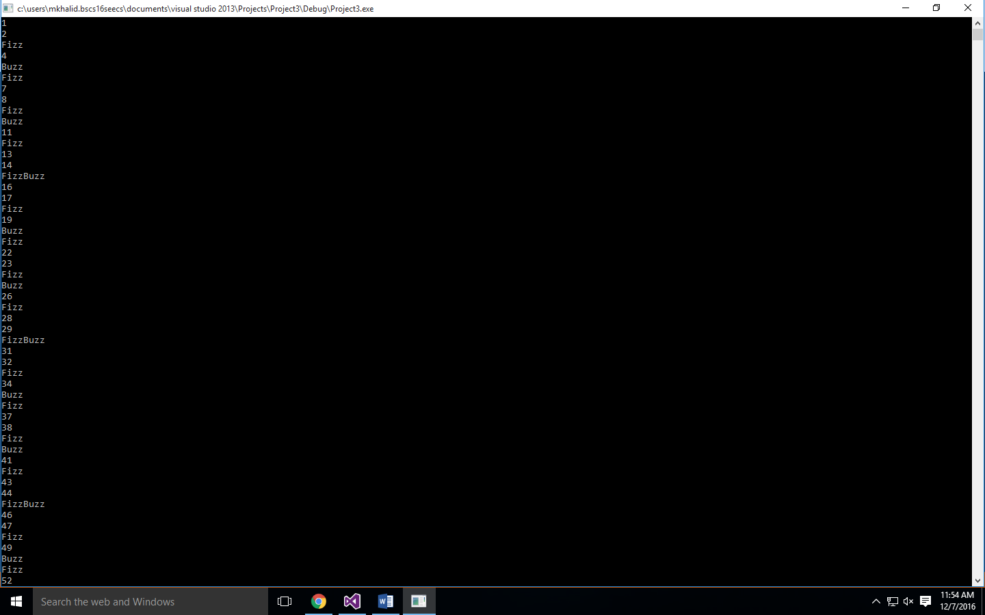

**Task: 08: Letter at a Time: -**

#include <stdio.h>

#include <stdlib.h>

#include <string.h>

int main()

{

char message[100];

printf( "What is your message? " );

gets( message );

printf( "\nYour message is %d characters long.\n", strlen(message) );

printf( "The first character is at position 0 and is '%c'.\n", message[0] );

int lastpos = strlen(message) - 1;

printf( "The last character is at position %d and is '%c'.\n", lastpos, message[lastpos] );

printf( "\nHere are all the characters, one at a time:\n" );

for ( int i=0; i<strlen(message); i++ )

{

printf( "\t%d - '%c'\n", i, message[i] );

}

int Vowel_count = 0;

for ( int i=0; i<strlen(message); i++ )

{

char letter = message[i];

if ( letter == 'a' || letter == 'A' || letter == 'e' || letter == 'E' || letter == 'i' || letter == 'I' || letter == 'o' || letter == 'O' || letter == 'u' || letter == 'U' )

{

Vowel_count++;

}

}

printf( "\nYour message contains the Vowel letter %d times.\n", Vowel_count );

system("pause");

return 0;

}

/*Question: The for loop is defined so that it repeats as long as i < strlen(message). Try changing it

to <=. What happens? Answer in a comment, then change it back.

Answer: When we change i < strlen(message) to i <= stlrlen(message) then the loop will execute one extra

time and give us '' this character at the end.

Question: If a string variable contains the value "box", what is its length? What is the position of

the last character (the ’x’)?

Answer: If a string variable contains "box" then its length will be 3 while the position of x will be 2.

*/

**Output: -**

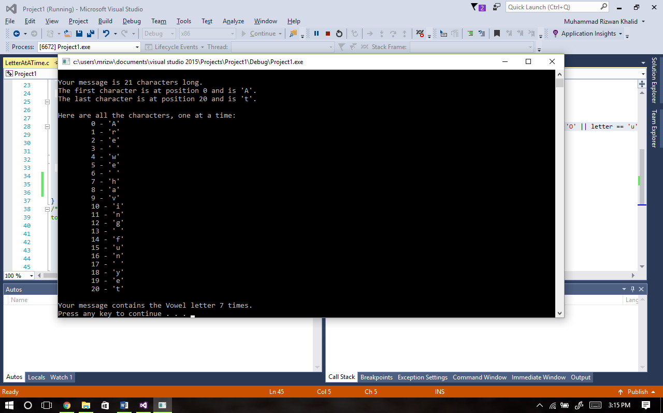

**Task: 09: Adding Values with for loop: -**

#define _CRT_SECURE_NO_WARNINGS

#include <stdio.h>

#include <stdlib.h>

int main()

{

int Number, sum = 0;

printf("Number: ");

scanf("%d", &Number);

for (int i = 1; i <= Number; i++)

{

printf("%d ", i);

sum = sum + i;

}

printf("\nThe sum is %d\n", sum);

system("pause");

return 0;

}

**Output: -**

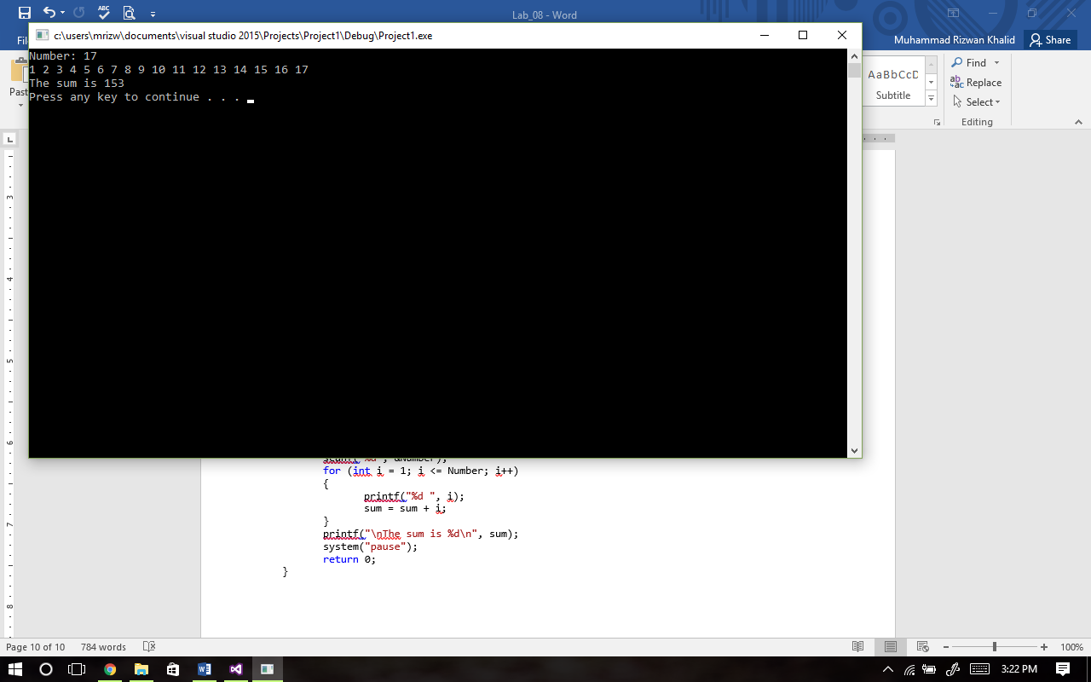

**Task: 10: Baby Blackjack: -**

#define _CRT_SECURE_NO_WARNINGS

#include <stdio.h>

#include <stdlib.h>

#include <time.h>

int main()

{

srand(time(NULL));

int a = rand() % 10 + 1;

int b = rand() % 10 + 1;

int sum_P = a + b;

printf("Baby BlackJack!\n");

printf("Your drew %d and %d.\n", a, b);

printf("Your total is %d.\n", sum_P);

a = rand() % 10 + 1;

b = rand() % 10 + 1;

int sum_D = a + b;

printf("The dealer has %d and %d.\n", a, b);

printf("Dealer's sum is %d.\n", sum_D);

if (sum_D > sum_P)

printf("Dealer wins!\n");

else

printf("You Win.\n");

system("pause");

return 0;

}

**Output: -**

