**Lab_09: Nesting Loops**

Name: Muhammad Rizwan Khalid

Class: BSCS-6A

Reg.No: 180459

**Task: 02: Nesting Loops: -**

#define _CRT_SECURE_NO_WARNINGS

#include <stdio.h>

#include <stdlib.h>

int main()

{

// this is #1 - I'll call it "CN"

for (int n = 1 ; n <= 3; n++)

{

for (char c = 'A'; c <= 'E'; c++)

{

printf("%d %c\n", n, c);

}

}

printf("\n\n");

// this is #2 - I'll call it "AB"

for (int a = 1; a <= 3; a++)

{

for (int b = 1; b <= 3; b++)

{

printf("%d-%d ", a, b);

}

printf("\n");

/* your code comes here!!! */

}

system("pause");

return EXIT_SUCCESS;

}

/*Question: Look at the first set of nested loops ("CN"). Which variable changes faster? Is it the

variable controlled by the outer loop (c) or the variable controlled by the inner loop

(n)?

Answer: Inner Loop (n) changes faster because for one increment of outer there are three increments

for inner loop.

Question: Change the order of the loops so that the "c" loop is on the inside and the "n" loop is on

the outside. How does the output change?

Answer: The output changes in such a way that each number is followed by first five capital alphabets.

Question: Look at the second set of nested loops ("AB"). Add newline (\n) at the end of printf()

statement. How does the output change?

Answer: The output changes in such a way that the horizontal data is converted into a vertical data.

Question: Add a printf("\n") statement after the close brace of the inner loop (the "b" loop), but

still inside the outer loop. How does the output change?

Answers: The output changes in such a way that horizontal data is converted into horizontal rows and

vertical columns*/

**Output: -**

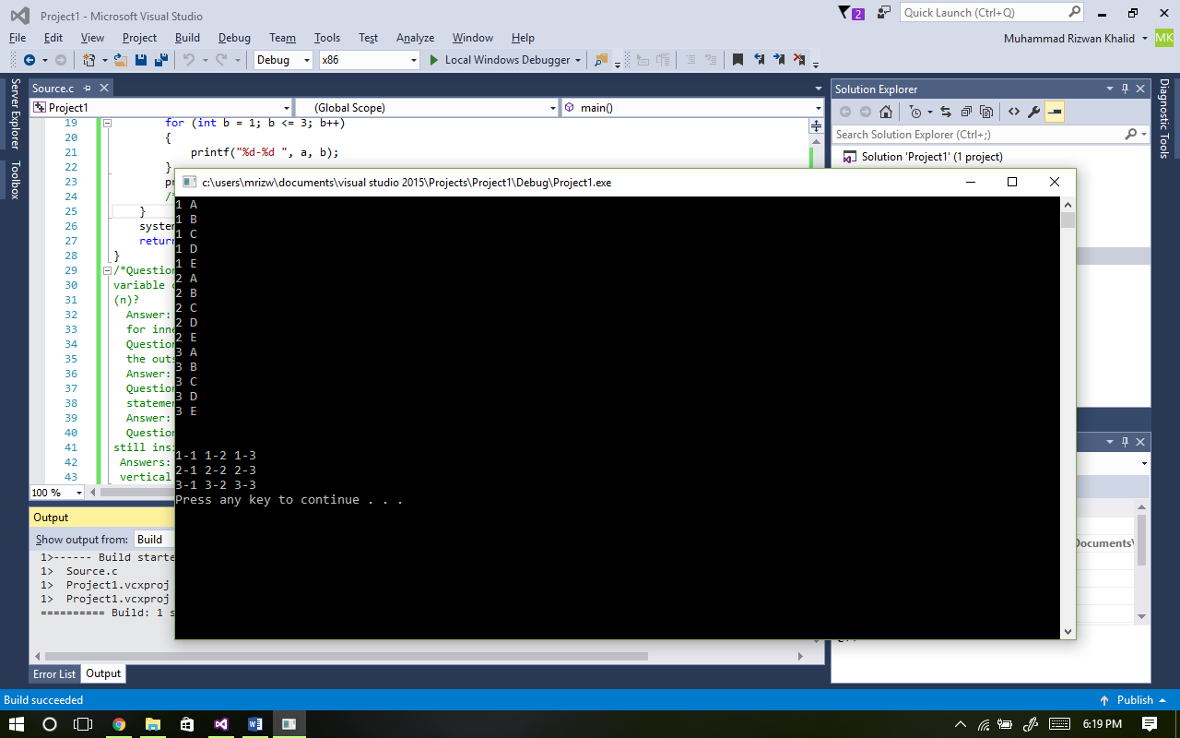

**Task: 03: Odometer Loops: -**

#define _CRT_SECURE_NO_WARNINGS

#include <stdio.h>

#include <stdlib.h>

#include <time.h>

void delay(int);

int main()

{

int a;

printf("Which Base (2-10)?");

scanf("%d", &a);

for (int thous = 0; thous<a; thous++)

{

for (int hund = 0; hund<a; hund++)

{

for (int tens = 0; tens<a; tens++)

{

for (int ones = 0; ones<a; ones++)

{

printf(" %d%d%d%d\r", thous, hund, tens, ones);

delay(10);

}

}

}

}

printf("\n");

system("pause");

return EXIT_SUCCESS;

}

void delay(int milliseconds)

{

long pause;

clock_t now, then;

pause = milliseconds * (CLOCKS_PER_SEC / 1000);

now = then = clock();

while ((now - then) < pause)

now = clock();

}

**Output: -**

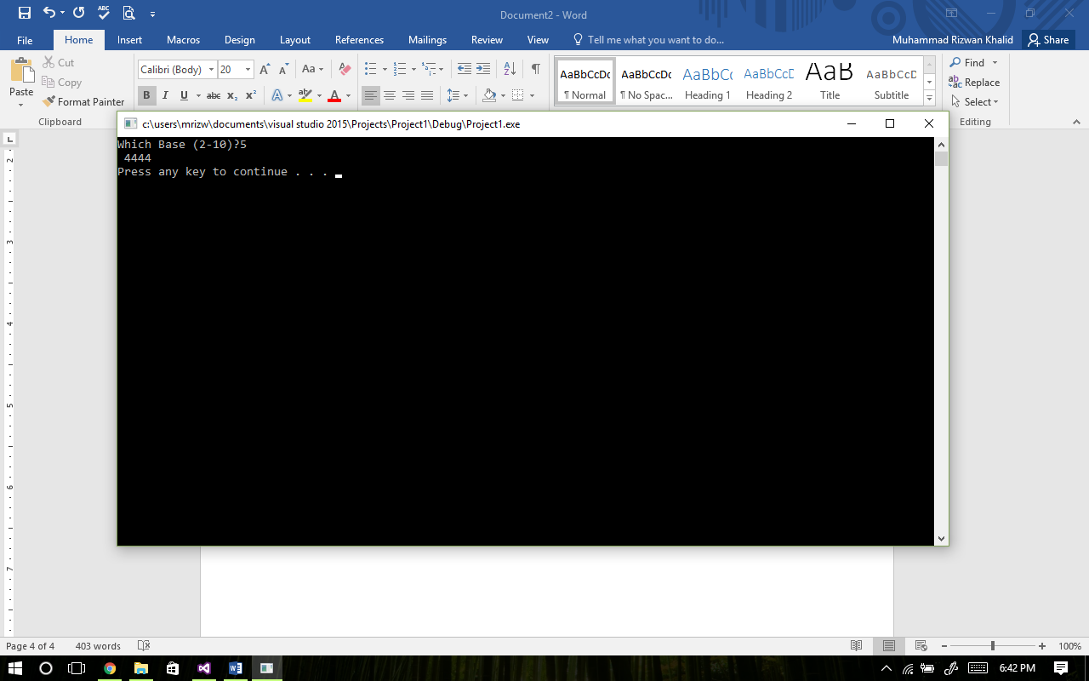

**Task: 04: Basic Nested Loops: -**

#define _CRT_SECURE_NO_WARNINGS

#include <stdio.h>

#include <stdlib.h>

int main()

{

for (int a = 0; a <= 5; a++)

{

for (int b = 0; b <= 5; b++)

{

printf("(%d , %d) ", a, b);

}

printf("\n");

}

system("pause");

return EXIT_SUCCESS;

}

**Output: -**

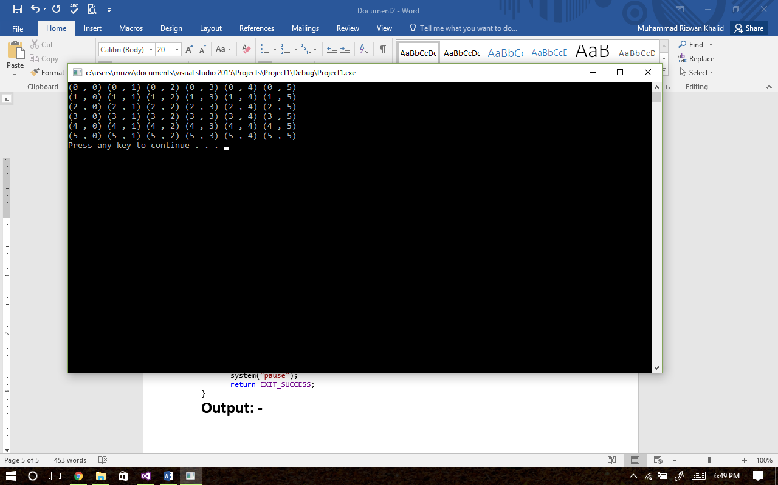

**Task: 5: Multiplication Table: -**

#define _CRT_SECURE_NO_WARNINGS

#include <stdio.h>

#include <stdlib.h>

int main()

{

printf(" x | 1 2 3 4 5 6 7 8 9\n");

for (int a = 1; a <= 12; a++)

{

printf(" %d | ", a);

for (int b = 1; b <= 9; b++)

{

printf(" %d", a*b);

}

printf("\n");

}

system("pause");

return EXIT_SUCCESS;

}

**Output: -**

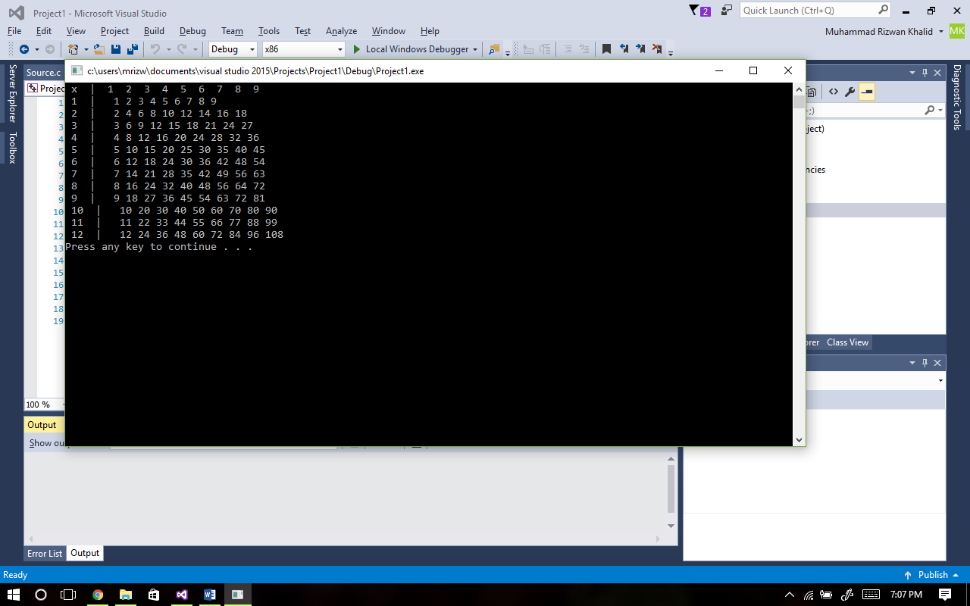

**Task: 06: Number Puzzles i: -**

#define _CRT_SECURE_NO_WARNINGS

#include <stdio.h>

#include <stdlib.h>

int main()

{

for (int a = 10; a < 99; a++)

{

for (int b = 0; b < 99; b++)

{

if ((a + b == 60) && ((a - b == 14) || (b - a == 14)))

printf("(%d , %d) ", a, b);

}

}

system("pause");

return EXIT_SUCCESS;

}

**Output: -**

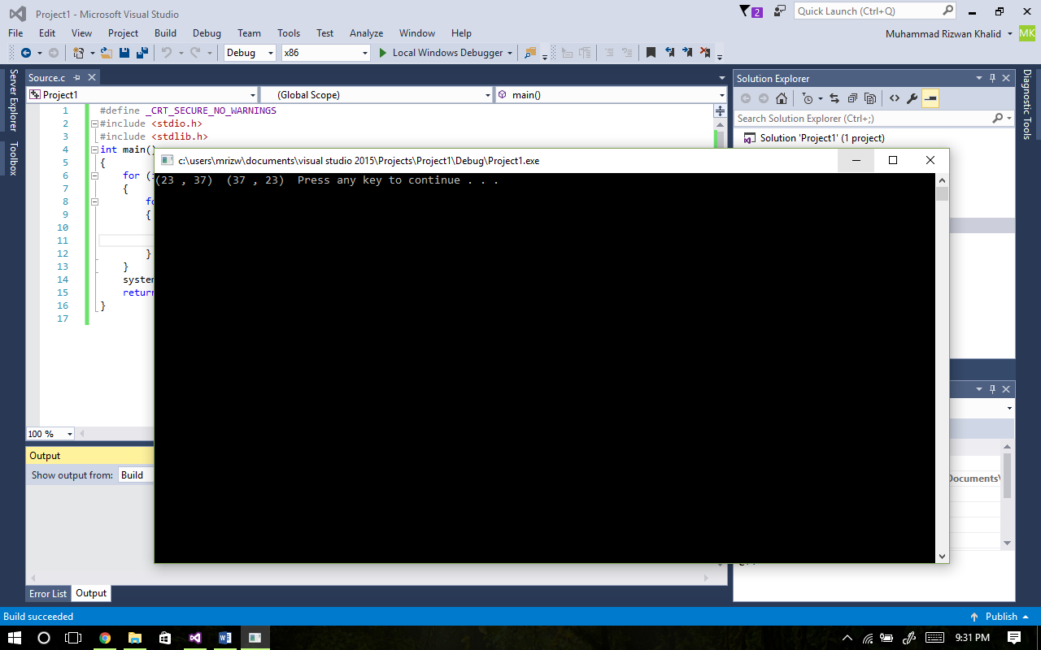

**Task: 07: Getting individual digits: -**

#define _CRT_SECURE_NO_WARNINGS

#include <stdio.h>

#include <stdlib.h>

int main()

{

for (int b = 10; b <= 99; b++)

{

printf("%d, %d+%d = %d\n", b, b / 10, b % 10, (b / 10) + (b % 10));

}

system("pause");

return EXIT_SUCCESS;

}

**Output: -**

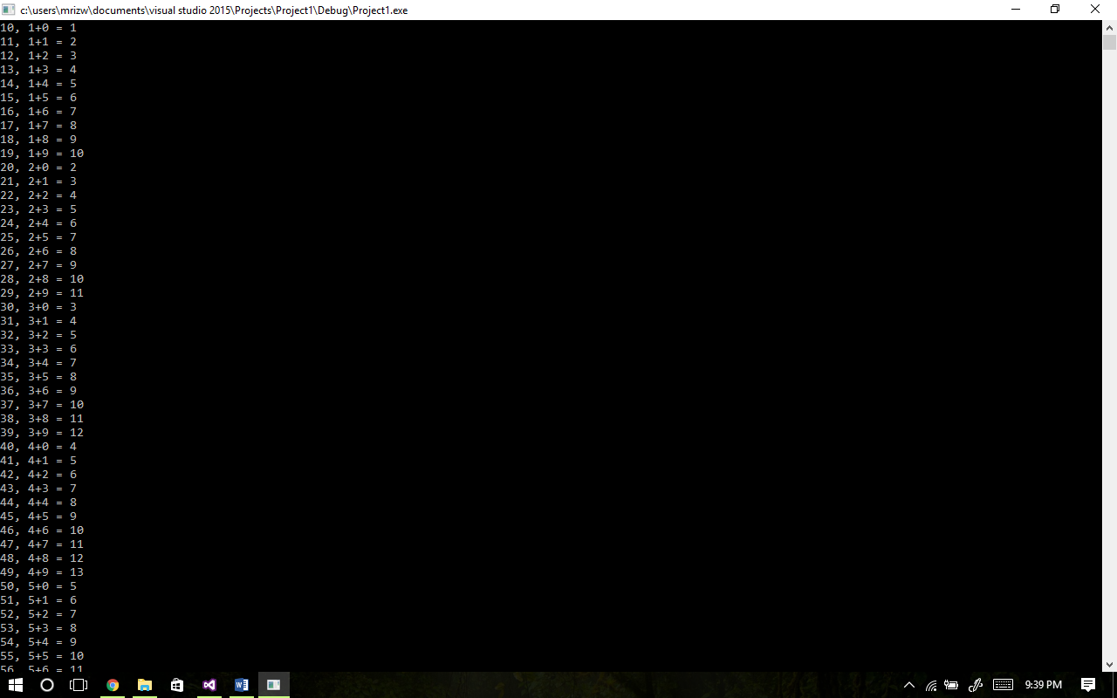

**Task: 09: Armstrong Numbers: -**

#define _CRT_SECURE_NO_WARNINGS

#include <stdio.h>

#include <stdlib.h>

int main()

{

for (int num = 100 ; num <= 999 ; num++)

{

int a = num / 100;

int b = (num / 10) % 10;

int c = num % 10;

if (a*a*a + b*b*b + c*c*c == num)

{

printf("(%d)^3 + (%d)^3 + (%d)^3 = %d\n", a, b, c, num);

}

}

system("pause");

return EXIT_SUCCESS;

}

**Output: -**

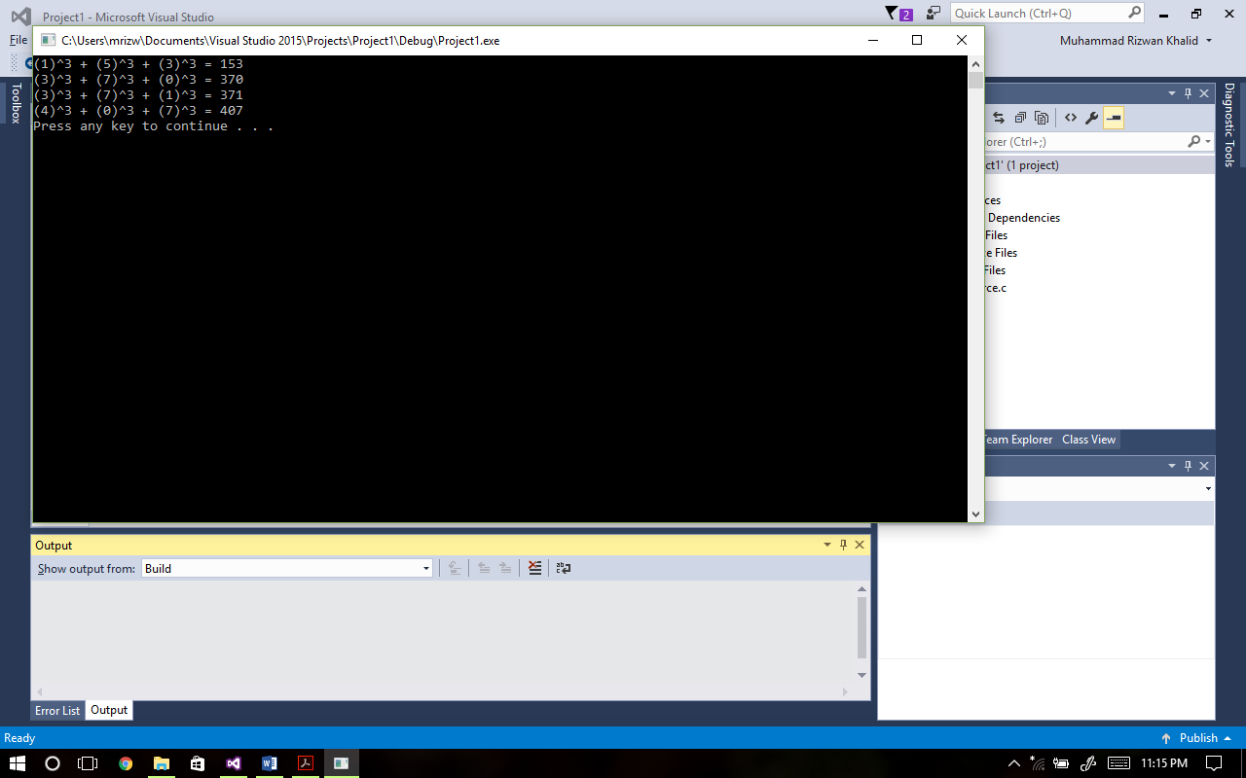

**Task: 08: More Number Puzzles: -**

#define _CRT_SECURE_NO_WARNINGS

#include <stdio.h>

#include <stdlib.h>

int main()

{

int num, num1, num2;

printf("1) Find two digits numbers <= 56 with sums of digit > 10\n");

printf("2) Find two digit number minus number reversed which equal sum of digits\n");

printf("3) Quit\n\n");

scanf("%d", &num);

switch (num)

{

case 1:

{

for (num1 = 10; num1 <= 99; num1++)

{

if ((num1 <= 56) && (((num1 / 10) + (num1 % 10)) > 10))

printf("\n%d\n", num1);

}

break;

}

case 2:

{

for (num2 = 10; num2 <= 99; num2++)

{

if ((num2 - (((num2 % 10) * 10) + (num2 / 10))) == ((num2 / 10) + (num2 % 10)))

printf("\n%d\n", num2);

}

break;

}

default:

{

break;

}

}

system("pause");

return EXIT_SUCCESS;

}

**Output: -**

