**Name:** Muhammad Rizwan Khalid

**Reg.No:** 180459

**Class:** BSCS-6A

**Task: 01: - Bubble Sort**

#include <stdio.h>

void main()

{

int data[100], i, n, j, temp;

printf("Enter the number of elements to be sorted: ");

scanf_s("%d", &n);

for (i = 0; i<n; i++){

printf("Enter %dth number: ", i + 1);

scanf_s("%d", &data[i]);

}

for (j = 0; j < (n - 1); j++)

for (i = 0; i < (n - j - 1); ++i){

if (data[i] < data[i + 1]){

temp = data[i];

data[i] = data[i + 1];

data[i + 1] = temp;

}

}

printf("In Descending order: ");

for (i = 0; i < n; i++) {

printf("%d ", data[i]);

}

printf("\n");

system("pause");

}

**Output: -**

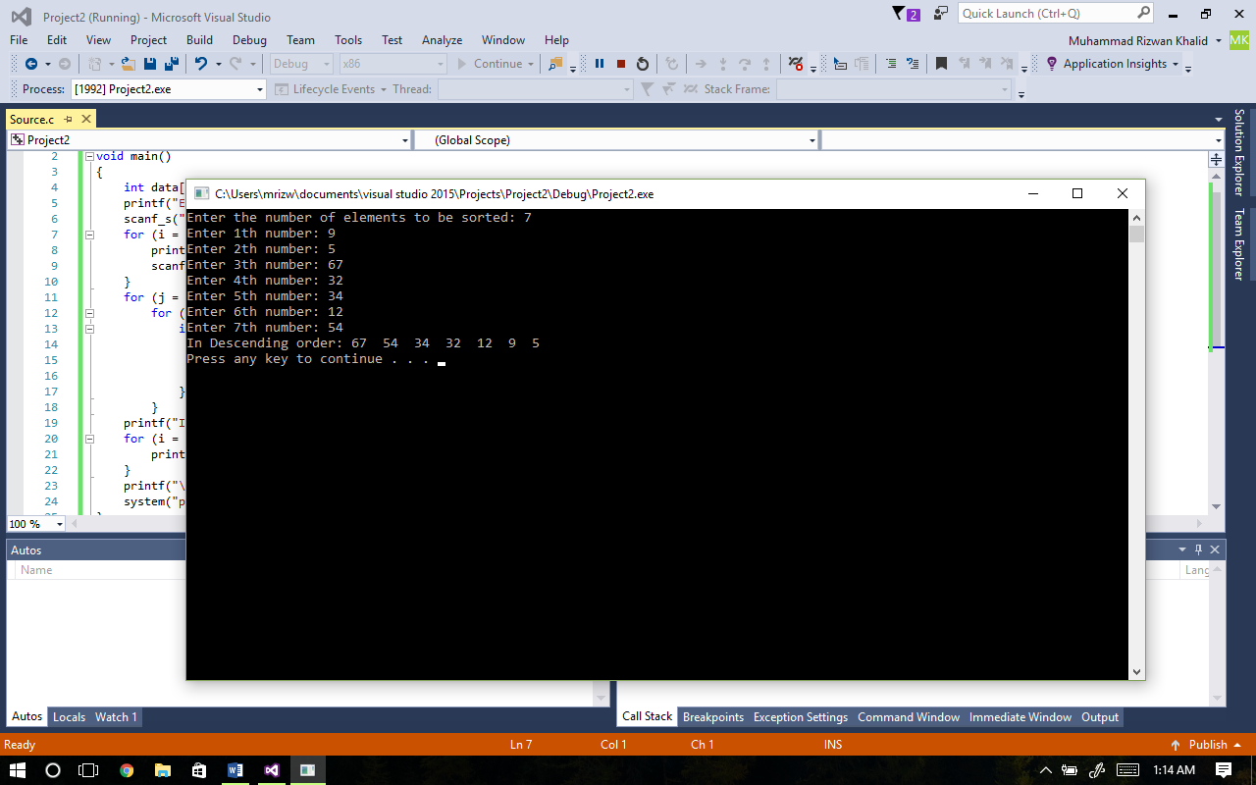

**Task: 02: - Fibbonaci Series**

#include <stdio.h>

void main()

{

int i, n, a[100];

printf("How many terms to be display : ");

scanf_s("%d", &n);

a[0] = 0; a[1] = 1;

for (i = 2; i<n; i++)

a[i] = a[i - 1] + a[i - 2];

printf("First %d Terms of fibonacci series \n", n);

for (i = 0; i<n; i++)

printf("%d ", a[i]);

printf("\n");

system("pause");

}

**Output: -**

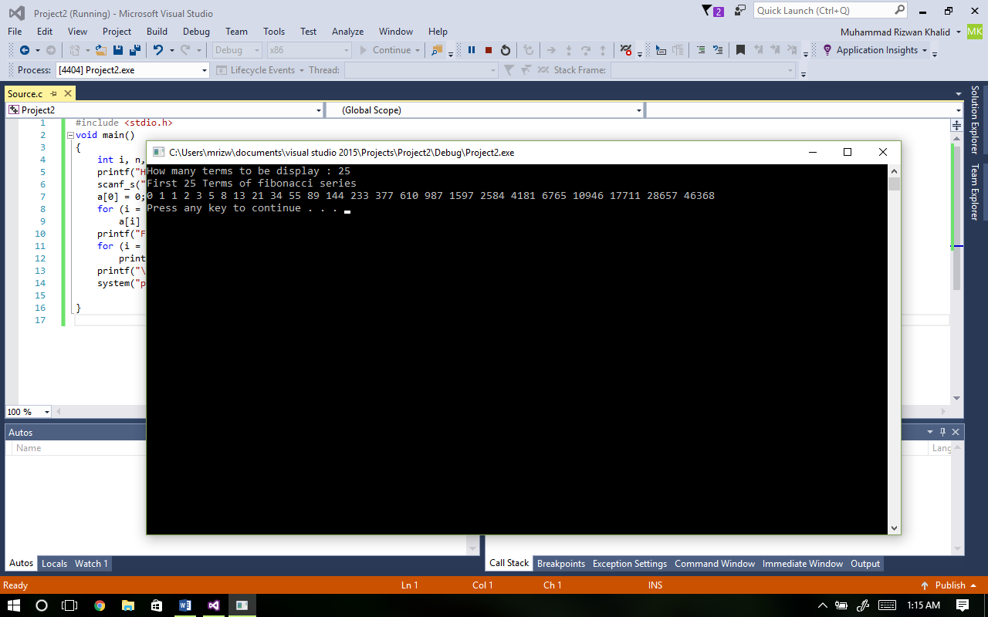

**Task: 03: - Average, greatest, even terms**

#include <stdio.h>

#include <stdlib.h>

#include <math.h>

float avg(int, int num[]);

int evenEnt(int, int num[]);

int greatestNum(int, int nums[]);

void main(){

int n;

printf("Enter the number of terms: ");

scanf_s("%d", &n);

int num[1000]; float average;

int i, count, max;

for (i = 0; i < n; i++){

printf("Enter the %dth number: ", i + 1);

scanf_s("%d", &num[i]);

}

average = avg(n , num);

count = evenEnt(n, num);

max = greatestNum(n, num);

printf("The average is %.2f\n", average);

printf("The number of even terms are %d\n", count);

printf("The greatest number is %d\n", max);

system("pause");

}

float avg(int n , int num[]){

float sum = 0; float avg;

for (int a = 0; a < n; a++){

sum = sum + num[a];

}

avg = sum / n;

return avg;

}

int evenEnt(int n ,int num[]){

int count = 0;

for (int i = 0; i < n; i++){

if (num[i] % 2 == 0){

count++;

}

}

return count;

}

int greatestNum(int n, int num[]){

int max = 0;

for (int i = 0; i < n; i++ ){

if (num[i] > max){

max = num[i];

}

}

return max;

}

**Output: -**

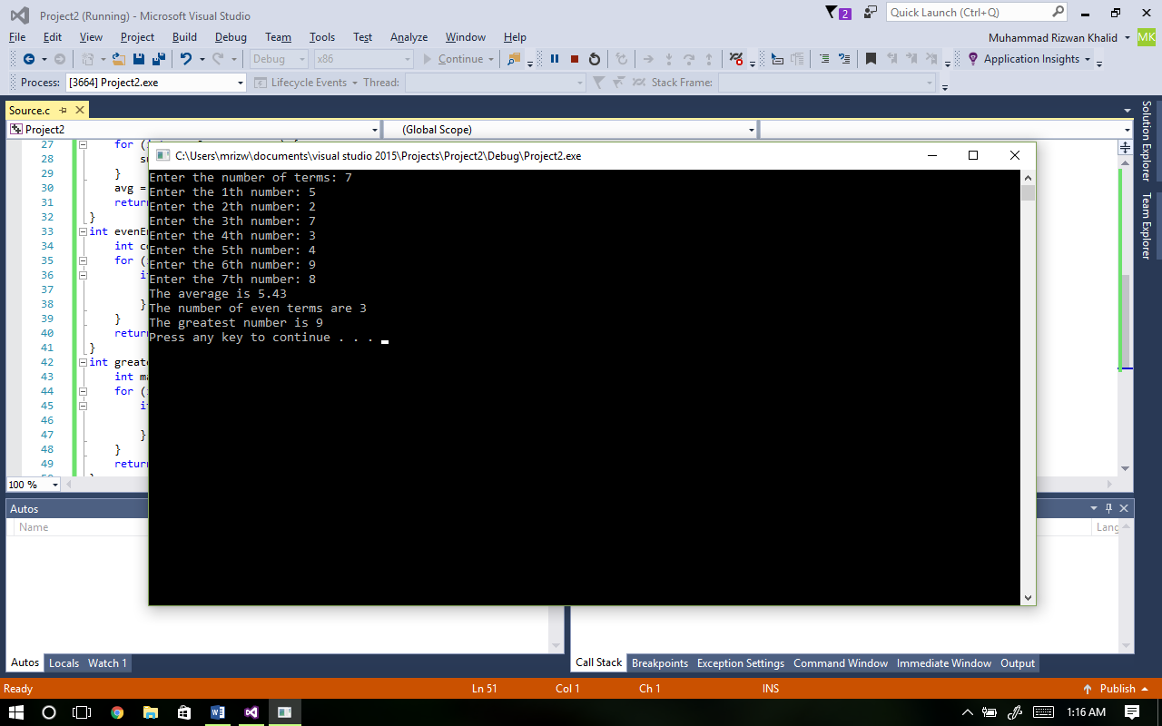

**Task: 04: -Average, variance, standard Daviation:**

#include <stdio.h>

#include <stdlib.h>

#include <math.h>

float avg(float, float num[]);

float stdDeviation(float, float num[], float);

void main(){

float n = 5;

float num[1000], average, std, variance;

int i;

for (i = 0; i < 5; i++){

printf("Enter the %dth number: ", i + 1);

scanf_s("%f", &num[i]);

}

average = avg(5 , num);

std = stdDeviation(5, num, average);

variance = std * std;

printf("The average is %.2f\n", average);

printf("The variance of numbers is %.2f\n", variance);

printf("The standard deviation is %.2f\n", std);

system("pause");

}

float avg(float n , float num[]){

float sum = 0; float avg;

for (int a = 0; a < n; a++){

sum = sum + num[a];

}

avg = sum / n;

return avg;

}

float stdDeviation(float n, float num[], float average){

float diff; float sum = 0; float std;

for (int i = 0; i < n; i++){

diff = (num[i] - average) * (num[i] - average);

sum = sum + diff;

}

std = sqrt(sum / n);

return std;

}

**Output: -**

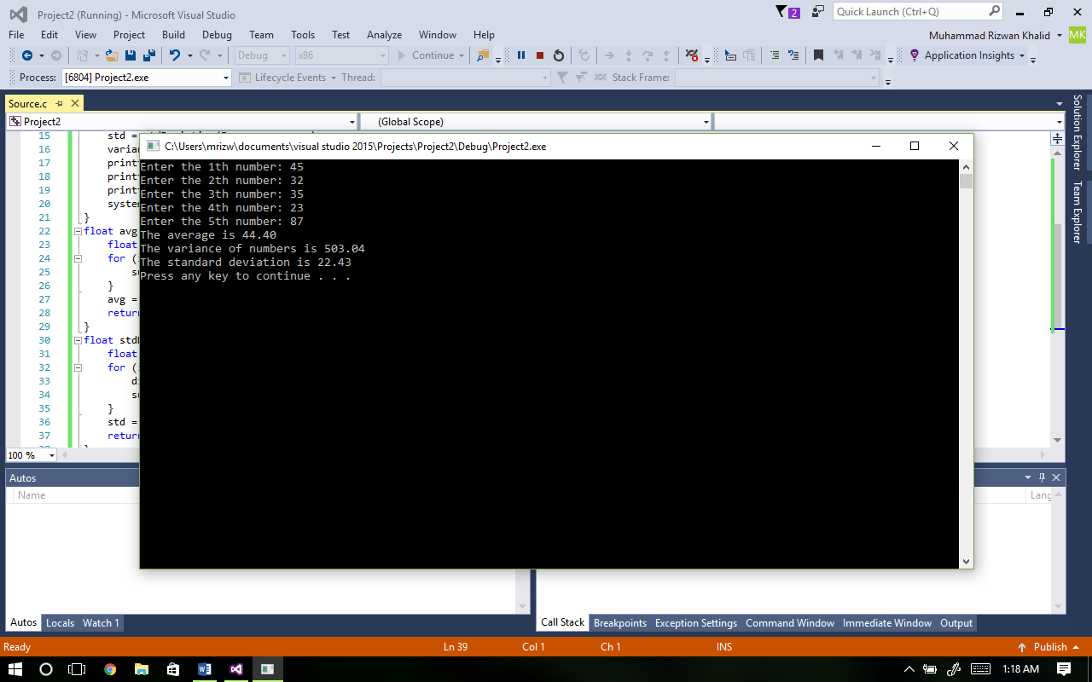

**Task: 05: - Greatest number and location:**

#include <stdio.h>

#include <stdlib.h>

void main(){

int num[10];

int i, location, max = 0;

for (i = 0; i < 10; i++){

printf("Enter the %dth number: ", i+1);

scanf_s("%d", &num[i]);

}

for (i = 0; i < 10; i++){

if (num[i] > max){

max = num[i];

}

}

for (i = 0; i < 10; i++){

if (max == num[i]){

location = i;

}

}

printf("The largest number is %d\n", max);

printf("The location of the largest number in array is %d\n", location);

system("pause");

}

**Output: -**

