**Task: 01: Cyclically Permutation of Elements: -**

#define _CRT_SECURE_NO_WARNINGS

#include <stdio.h>

#include <stdlib.h>

int main()

{

int num[1000], n, i, j, k, temp;

printf("Enter the value of n: ");

scanf("%d", &n);

for (i = 1; i <= n; i++){

printf("Enter %dth number: ", i);

scanf("%d", &num[i-1]);

}

for (j = 0; j < n; j++){

if (j < n - 1){

temp = num[j];

num[j] = num[j + 1];

num[j + 1] = temp;

}

}

for (k = 0; k < n; k++){

printf("%d\n", num[k]);

}

system("pause");

}

**Output: -**

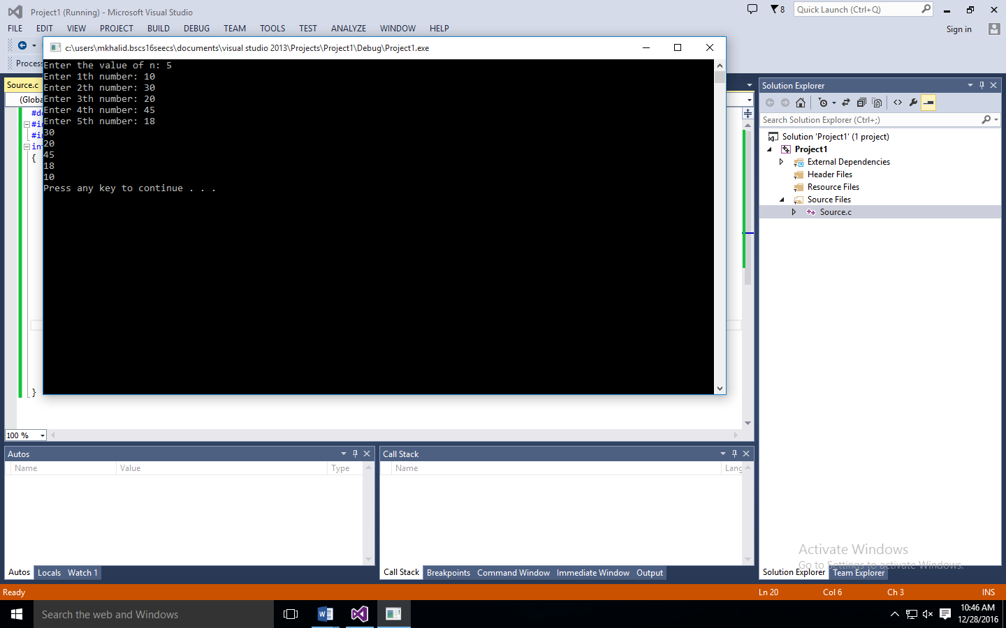

**Task: 02: Strings:-**

#define _CRT_SECURE_NO_WARNINGS

#include <stdio.h>

#include <stdlib.h>

#include <string.h>

int main(){

char firstName[1000], lastName[1000], fullName[1000];

int index;

printf("What is Your First Name: ");

gets(firstName);

printf("What is your Last Name: ");

gets(lastName);

strcpy(fullName, firstName);

strcat(fullName, " ");

strcat(fullName, lastName);

printf("%s\n", fullName);

for (index = 0; fullName[index] != 0; index++){

if (fullName[index] == 'a' || fullName[index] == 'e' || fullName[index] == 'i' || fullName[index] == 'o' || fullName[index] == 'u'){

fullName[index] = '$';

}

}

printf("%s\n", fullName);

system("pause");

}

**Output: -**

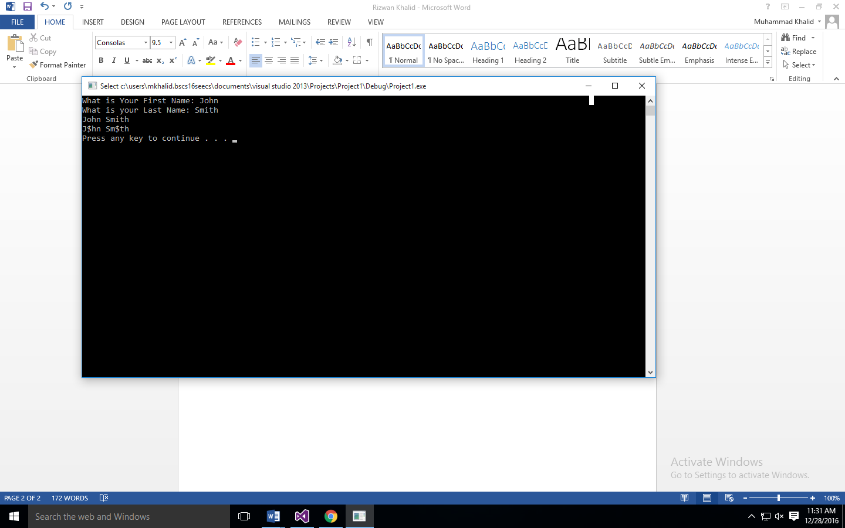

**Task: 03: Pointers: -**

#define _CRT_SECURE_NO_WARNINGS

#include <stdio.h>

#include <stdlib.h>

int main(){

int a;

int *aPtr;

a = 7;

aPtr = &a;

printf("The address of %p\nThe value of aPtr is %p", &a,aPtr);

printf("\n\nThe value of a %d\n the value of *aPtr is %d", a, *aPtr);

printf("\n\nShowing that * and & are complements of each other\n&*aPtr = %p\n*&aPtr = %p\n", &*aPtr, *&aPtr);

system("pause");

}

**Output: -**

