**Muhammad Rizwan Khalid**

**180459**

**BSCS-6A**

**Activity 1:**

1. If we change the name of class, then we will get the error “error: class Ac is public, should be declared in a file named Ac”.
2. If we remove one of the opening braces the we get the error “error: ';' expected” while if we remove one of the closing braces then we will get the error of “error: reached end of file while parsing”
3. If we change the case of ‘s’ in System.out.println then we will get the error “error: package system does not exist”
4. If we delete the semicolon at the end of statement then we will get the error “error: ';' expected”

**Screen Shot:**

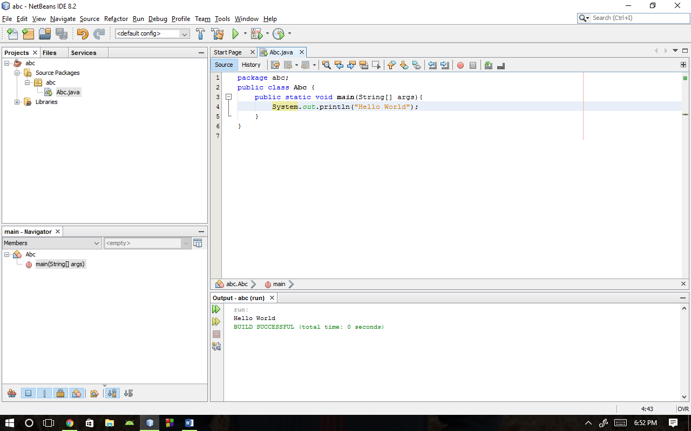

**Activity 2:**

package abc;

public class Abc {

public static void main(String[] args){

System.out.println("Hello, World!\nI am taking CS 212\nI hope it is a lot of fun!");

System.out.println("\nMy teacher's name is Hamayun/Anis\n");

System.out.println("I hope he gives me a grade of 4.0");

}

}

**Screen Shot:**

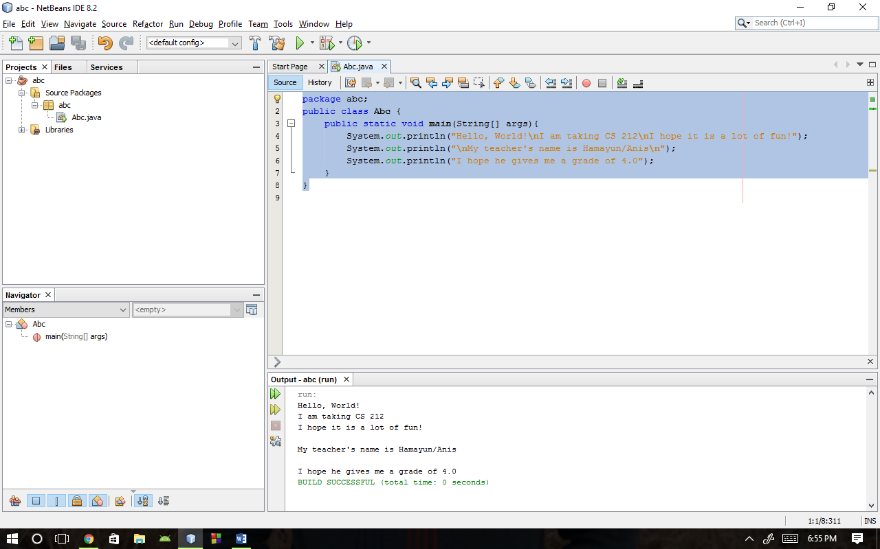

**Activity 3:**

package abc;

public class Abc {

public static void main(String[] args){

System.out.println("Properly indented programs");

System.out.println("look ever so much better!");

System.out.println("please fix me");

System.out.println("and make me beautiful again");

}

}

**Screen Shot:**

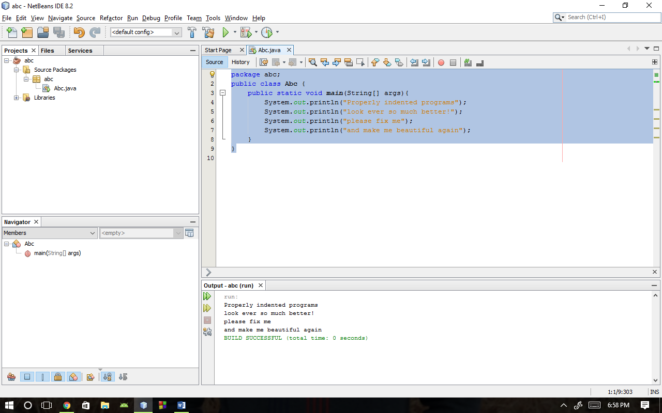

**Activity 4:**

package abc;

public class Abc {

public static void main(String[] args){

System.out.println("Testing, testing,");

System.out.println("one two three.");

System.out.println();

System.out.println("How much output");

System.out.println();

System.out.println("will there be?");

}

}

**Answer:** The will be six lines of output.

**Screen Shot:**

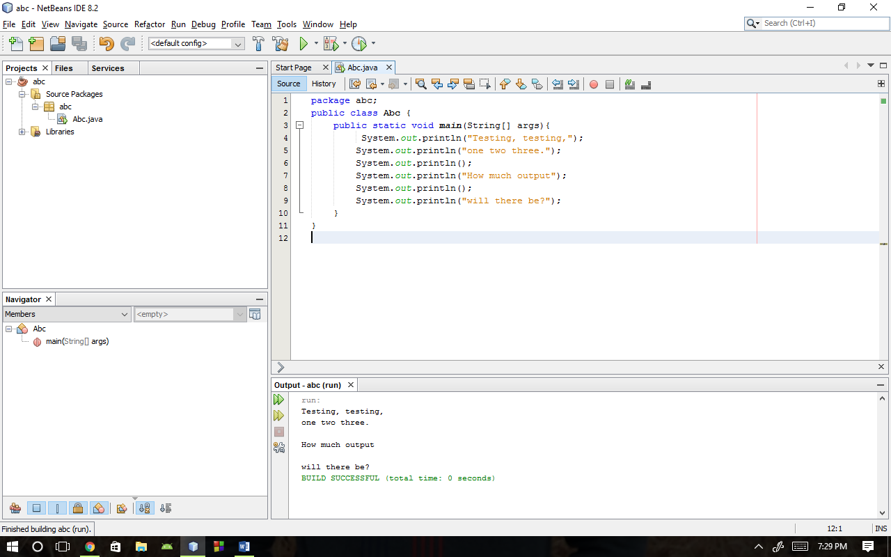

**Activity 5:**

package abc;

public class Abc {

public static void main(String[] args){

System.out.println("Hello world");

System.out.println("Do you like this program?");

System.out.println();

System.out.println("I wrote it myself.");

}

}

**Errors:**

1. The opening brace of the class was missing
2. Key word ‘void’ was missing.
3. Arguments of main were incorrect.
4. Double quotes in first print statement was missing.
5. ‘s’ was not capital in second print statement.
6. ‘p’ was capital in the second print statement. Spelling of print was incorrect.
7. The question mark was outside the quotation marks in second print statement.
8. Semicolon is missing at the end of third print statement.
9. ‘out’ keyword is missing in the last print statement.
10. Closing parenthesis of the last print statement is missing.
11. The wrong brace was there after the last print statement

**Screen Shot:**

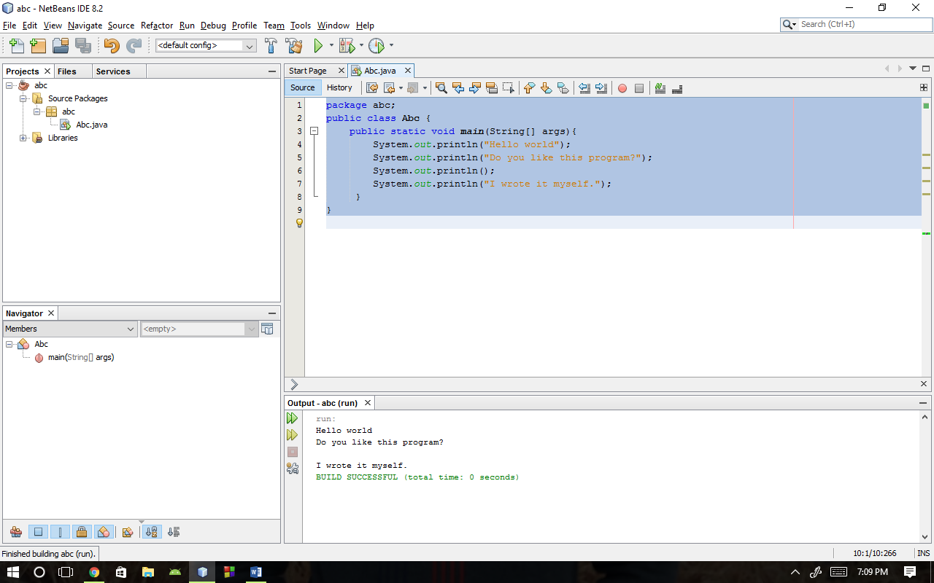

**Activity 6:**

1. If we change the file name then compiler the gives the error that class has not found.
2. If we skip the key term like void then compiler give the error “error: invalid method declaration; return type required”
3. If we forget to add quotation mark then compiler gives the error “error: unclosed string literal.”
4. If we forget to add parenthesis at the end of print statement then compiler gives the following error “error: ')' expected”
5. If we remove the period in print statement then compiler gives the error “error: cannot find symbol.”
6. If we forget to remove closing braces then compiler gives the error “error: reached end of file while parsing”

**Activity 7:**

package abc;

public class Abc {

public static void main(String[] args){

System.out.println("A \"quoted\" String is\n'much' better if you learn");

System.out.println("the rules of \"escape sequences.\"\n");

System.out.println("Also, \"\" represents an empty String");

System.out.println("Don,t forget: use \\\" istead of \"!");

System.out.println("' is not same as \"");

}

}

**Screen Shot:**

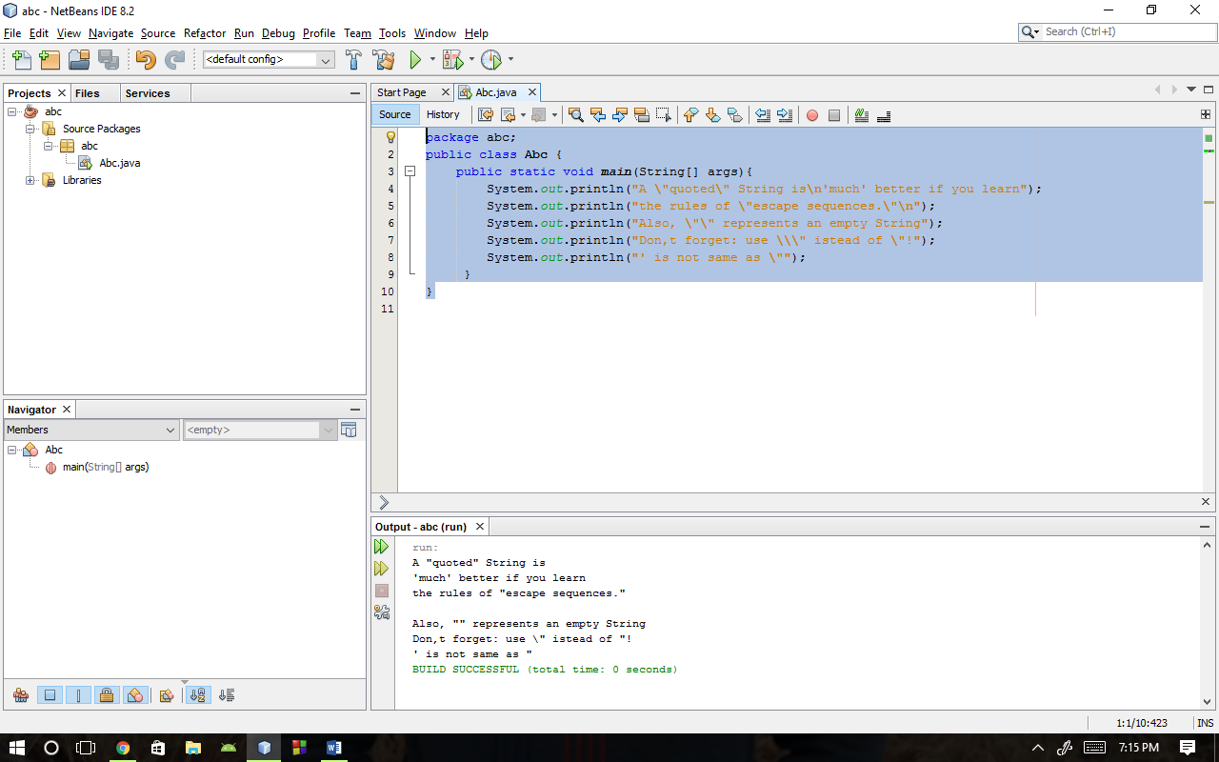

**Activity 8:**

package abc;

public class Abc {

public static void main(String[] args){

System.out.println(" \\/\n \\\\//\n\\\\\\///\n///\\\\\\\n //\\\\\n /\\");

}

}

**Screen Shot:**

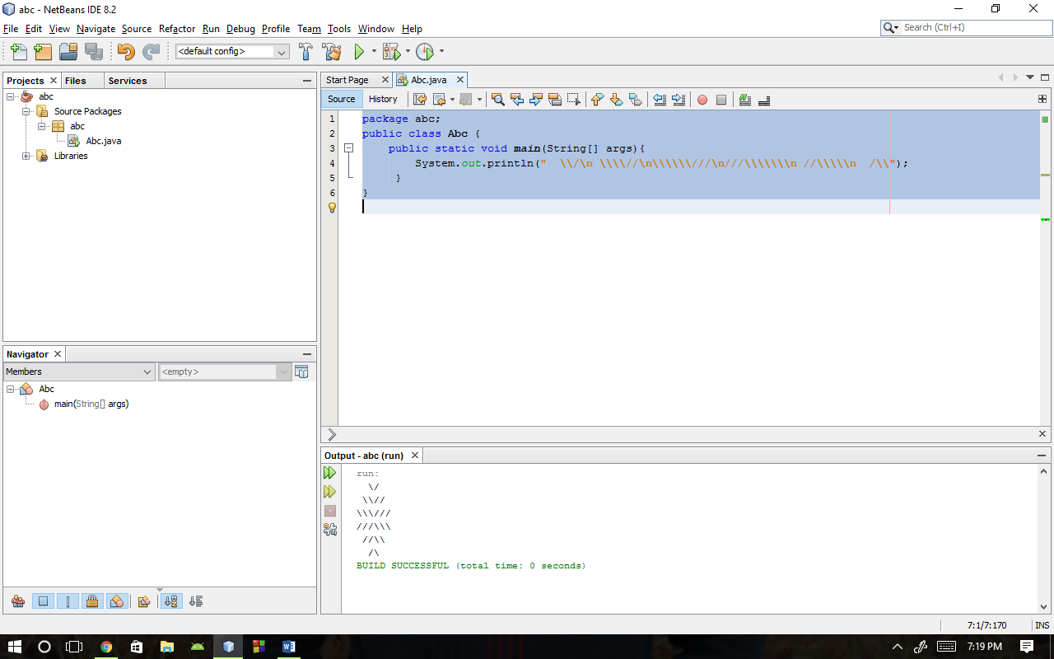

**Activity 9:**

package abc;

public class Abc {

public static void main(String[] args){

int result = 1 + 2; // result is now 3

System.out.println(result);

result -= 1; // result is now 2

System.out.println(result);

result *= 2; // result is now 4

System.out.println(result);

result /= 2; // result is now 2

System.out.println(result);

result += 8; // result is now 10

result %= 7; // result is now 3

System.out.println(result);

}

}

**Screen Shot:**

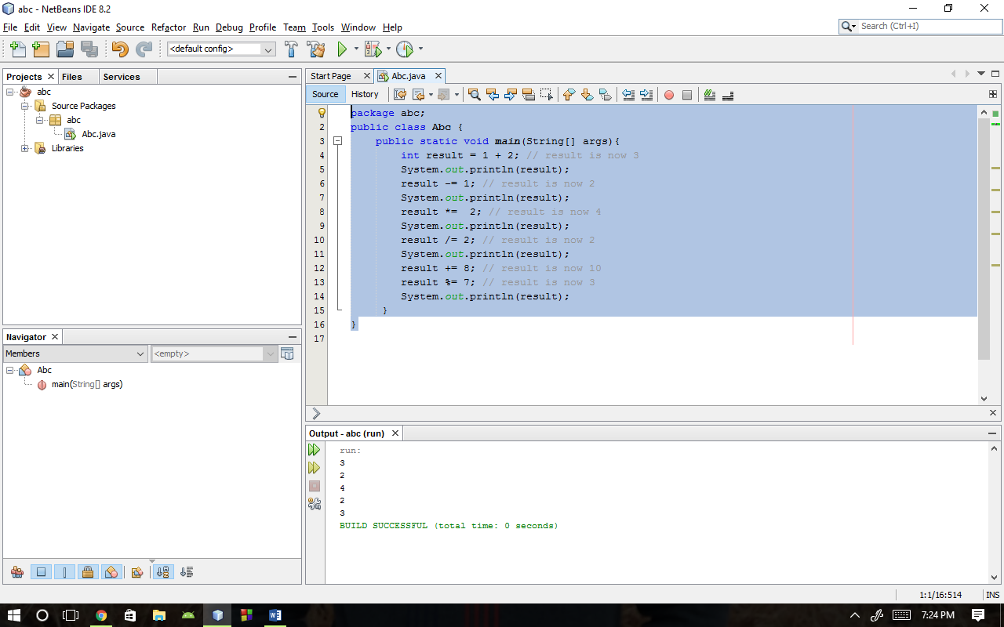

**Task 1:**

package abc;

import java.util.Scanner;

public class Abc {

public static void main(String[] args){

Scanner tuna = new Scanner(System.in);

String years; int course; double gpa;

System.out.println("Ënter the year: ");

years = tuna.nextLine();

System.out.println("Enter number of courses you have taken: ");

course = tuna.nextInt();

System.out.println("Enter your GPA: ");

gpa = tuna.nextDouble();

System.out.println("A studen in "+years+" year have taken "+course+" course and his previous gpa was "+gpa);

}

}

**Screen Shot:**

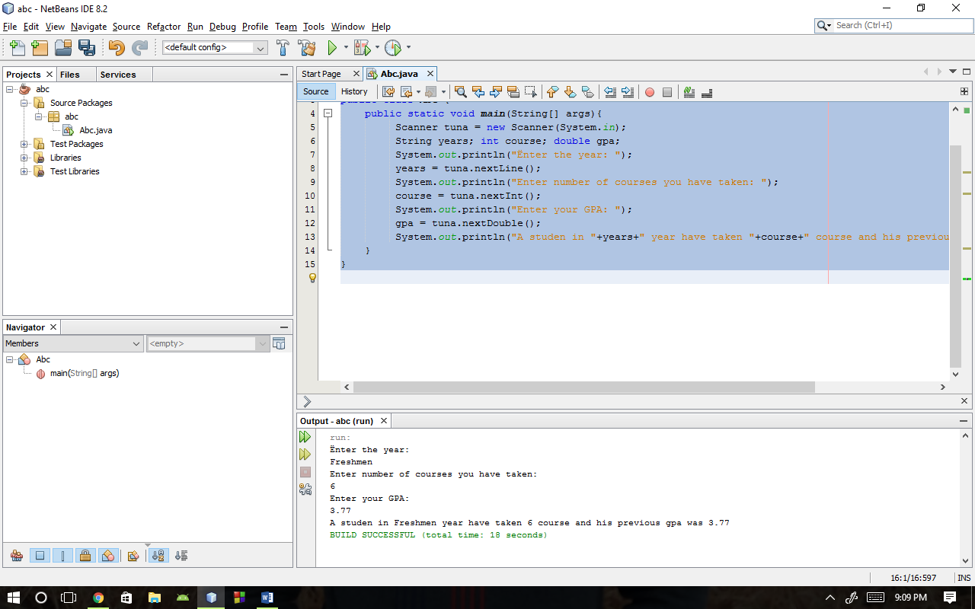

**Task 2:**

package abc;

import java.util.Scanner;

public class Abc {

public static void main(String[] args){

Scanner tuna = new Scanner(System.in);

int number;

System.out.println("Enter the five digit number: ");

number = tuna.nextInt();

System.out.print(number/10000);

System.out.print(" "+(number/1000)%10);

System.out.print(" "+(number/100)%10);

System.out.print(" "+(number/10)%10);

System.out.print(" "+(number%10)+"\n");

}

}

**Screen Shot:**

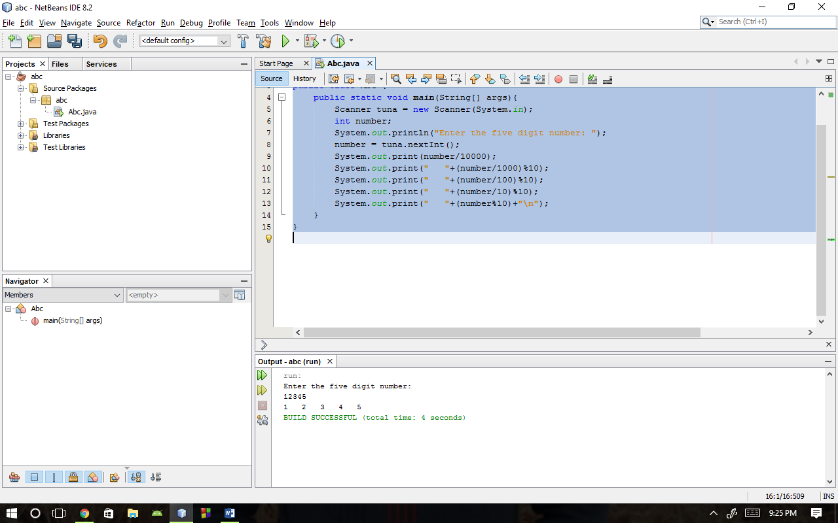

**Task 3:**

package abc;

import java.util.Scanner;

import java.lang.*;

public class Abc {

public static void main(String[] args){

Scanner tuna = new Scanner(System.in);

double x,y;

System.out.println("Enter the number: ");

x = tuna.nextDouble();

y = 12.3 * Math.pow(x, 4) - 9.1 * Math.pow(x, 3) + 19.3 * Math.pow(x, 2) - 4.6 * x + 34.2;

System.out.println("The value of expression for x is " + y);

}

}

**Screen shot:**

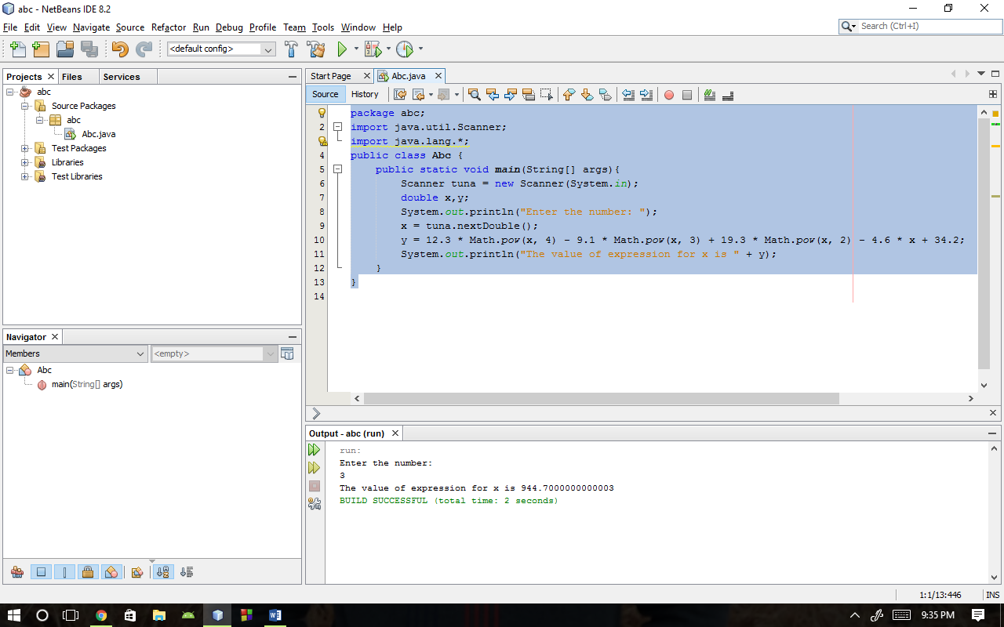

**Task 4:**

package abc;

import java.util.Scanner;

public class Abc {

public static void main(String[] args){

Scanner tuna = new Scanner(System.in);

float s, v, a, t, x;

System.out.println("Enter the initial Position: ");

s = tuna.nextFloat();

System.out.println("Enter the initial velocity: ");

v = tuna.nextFloat();

System.out.println("Enter time in seconds: ");

t = tuna.nextFloat();

System.out.println("Enter the accelration: ");

a = tuna.nextFloat();

x = (float) (s + (v * t) + ((1.0 / 2.0) * a * t * t));

System.out.println("The position of body is at "+x);

}

}

**Screen Shot:**

