**Muhammad Rizwan Khalid**

**180459**

**BSCS 6-A**

**Lab no: 02**

**Activity One:**

package activities;

import java.util.Scanner;

public class Activities {

public static void main(String[] args) {

Scanner input = new Scanner( System.in );

int number1; // first number to compare

int number2; // second number to compare

System.out.print( "Enter first integer: " ); // prompt

number1 = input.nextInt(); // read first number from user

System.out.print( "Enter second integer: " ); // prompt

number2 = input.nextInt(); // read second number from user

if ( number1 == number2 )

System.out.printf( "%d == %d\n", number1, number2 );

if ( number1 != number2 )

System.out.printf( "%d != %d\n", number1, number2 );

if ( number1 < number2 )

System.out.printf( "%d < %d\n", number1, number2 );

if ( number1 > number2 )

System.out.printf( "%d > %d\n", number1, number2 );

if ( number1 <= number2 )

System.out.printf( "%d <= %d\n", number1, number2 );

if ( number1 >= number2 )

System.out.printf( "%d >= %d\n", number1, number2 );

}

}

**Output:**

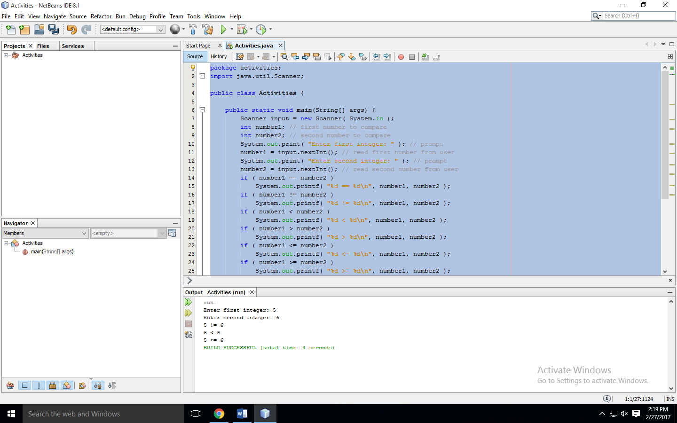

**Activity two:**

package activities;

import java.util.Scanner;

public class Activities {

public static void main(String[] args) {

int sum;

int x;

x = 1;

sum = 0;

System.out.printf( "Going to calculate the sum" );

while ( x <= 10 ){

sum += x;

x++;

}

System.out.printf( "The sum is: %d\n", sum );

}

}

**Answer to question**: There was the logical error in the while loop. As there was no increment in the value of x so the program was running infinitely.

**Output:**

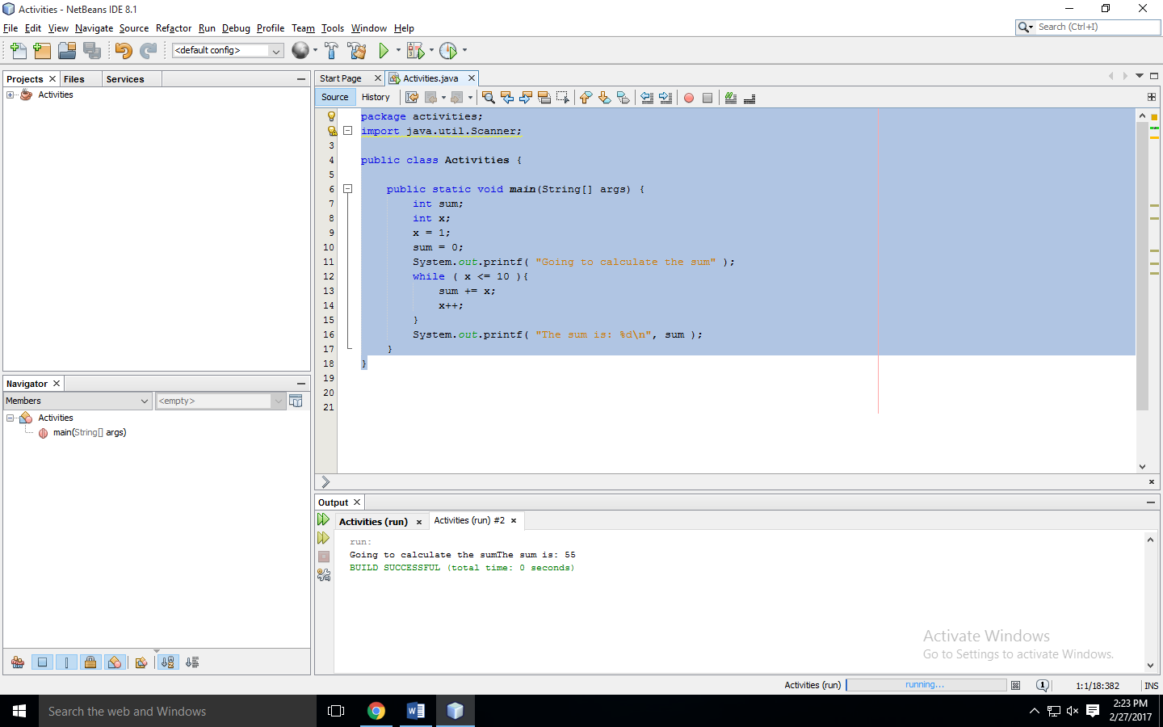

**Activity Three:**

package activities;

import java.util.Scanner;

public class Activities {

public static void main(String[] args) {

int y;

int x = 1;

int total = 0;

while ( x <= 10 ){

y = x * x;

System.out.println( y );

total += y;

++x;

}

System.out.printf( "Total is %d\n", total );

}

}

**Output:**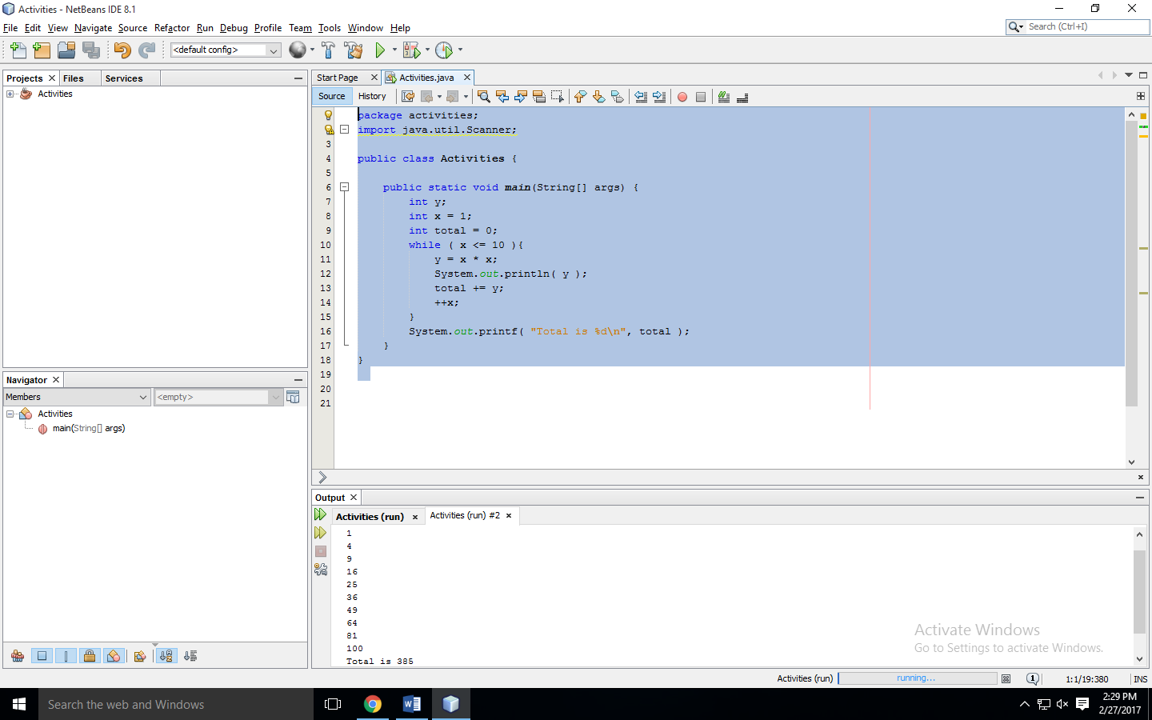

**Activity Four:**

package activities;

import java.util.Scanner;

public class Activities {

public static void main(String[] args) {

String [] suit = { "Clubs", "Diamonds", "Hearts", "Spades"};

String [] rank =

{

"2", "3", "4", "5", "6", "7", "8", "9", "10", "Jack", "Queen", "King", "Ace"

};

String [] deck = new String [suit.length * rank.length];

for (int i = 0; i < suit.length; i++)

for (int j = 0; j < rank.length; j++)

deck [rank.length * i + j] = rank [j] + " of " + suit[i];

for (int k = 0; k < (suit.length * rank.length); k++)

System.out.println(deck[k]);

**modify_deck(deck);**

for (int l = 0; l < (suit.length * rank.length); l++)

System.out.println(deck[l]);

}

private static void modify_deck(String [] deck){

int N = deck.length;

for (int i = 0; i < N; i++){

int r = i + (int) (Math.random() * (N - i));

String t = deck[i];

deck[i] = deck[r];

deck[r] = t;

}

}

}

**Output:**

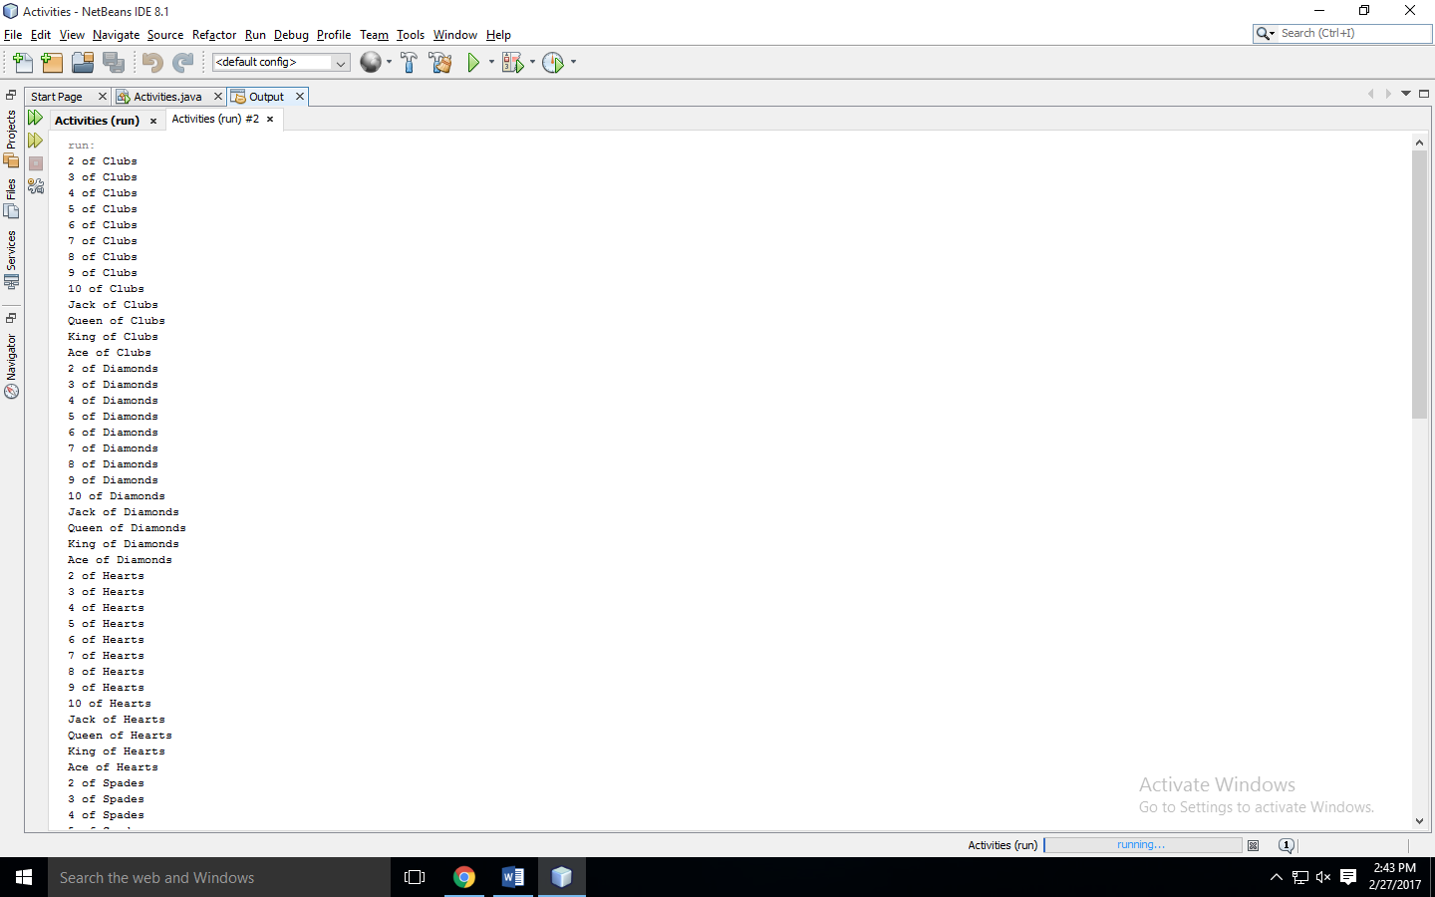

**Task one:**

package activities;

import java.util.Scanner;

public class Activities {

public static void main(String[] args) {

Scanner tuna = new Scanner(System.in);

float weight, height, bmi;

System.out.println("Enter your weight in kgs: ");

weight = tuna.nextFloat();

System.out.println("Enter your Height in meters: ");

height = tuna.nextFloat();

bmi = weight / (height * height);

System.out.println("BMI = " + bmi);

if ( bmi < 18.5)

System.out.println("Underweight");

else if ( bmi >= 18.5 && bmi <= 24.9)

System.out.println("Normal");

else if ( bmi >= 25.0 && bmi <= 29.9)

System.out.println("Overweight");

if ( bmi >= 30.0)

System.out.println("Obese");

}

}

**Output:**

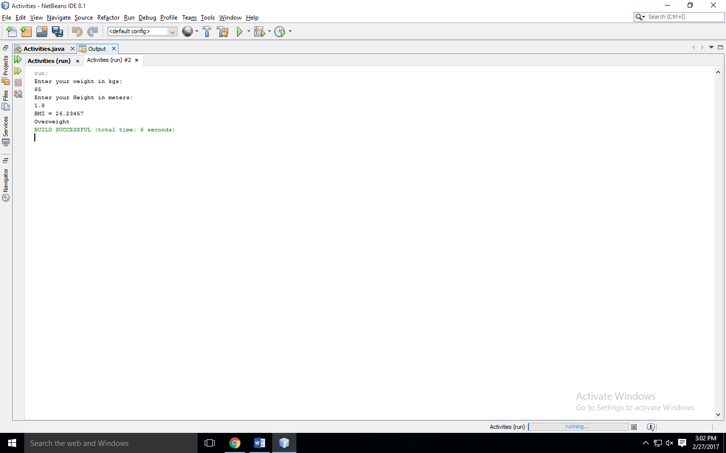

**Task two:**

package activity;

import java.util.Scanner;

public class Activity {

public static void main(String[] args) {

Scanner tuna = new Scanner(System.in);

int km, lt, trip = 0;

float average, mileage, sum = 0;

System.out.println("Enter the number of kms driven or -1 to end: ");

km = tuna.nextInt();

while(km != -1){

System.out.println("Enter the number of liters used: ");

lt = tuna.nextInt();

mileage = (float)(km / lt);

trip++;

System.out.println("Mileag for trip "+trip+ “ is ” +mileage);

sum = sum + mileage;

System.out.println("Enter the number of kms driven or -1 to end: ");

km = tuna.nextInt();

}

System.out.println("Number of trips: " + trip);

average = sum / trip;

System.out.println("The average mileage of the car is "+average+" km/lt");

}

}

**Output:**

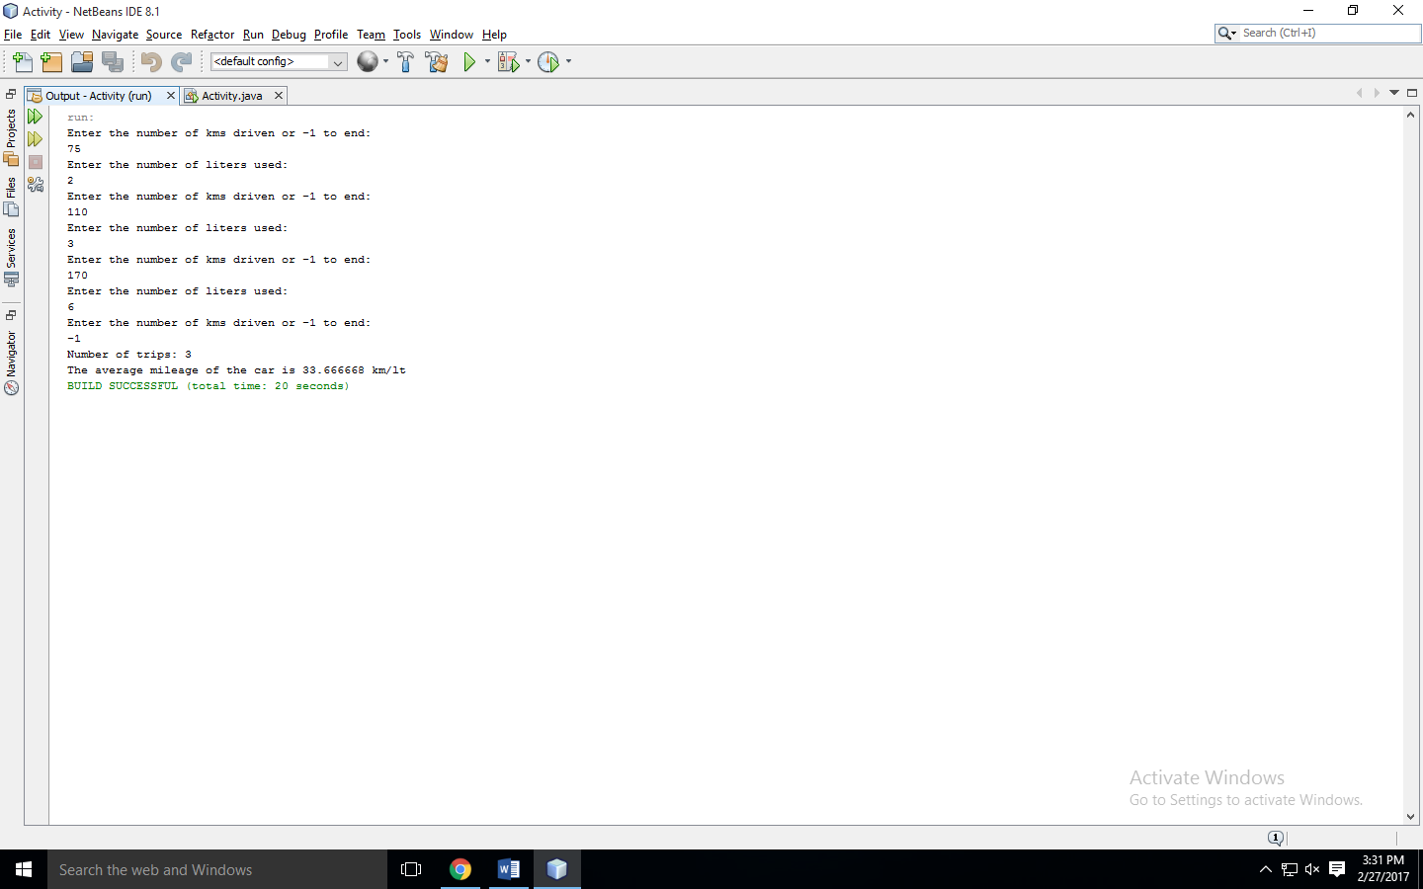

**Task three:**

package activity;

import java.util.Scanner;

public class Activity {

public static void main(String[] args) {

String [] suit = { "Clubs", "Diamonds", "Hearts", "Spades"};

String [] rank ={"2", "3", "4", "5", "6", "7", "8", "9", "10", "Jack", "Queen", "King", "Ace"};

String [] deck = new String [suit.length * rank.length];

for (int i = 0; i < suit.length; i++)

for (int j = 0; j < rank.length; j++)

deck [rank.length * i + j] = rank [j] + " of " + suit[i];

Deal(deck);

}

private static void modify_deck(String [] deck){

int N = deck.length;

for (int i = 0; i < N; i++){

int r = i + (int) (Math.random() * (N - i));

String t = deck[i];

deck[i] = deck[r];

deck[r] = t;

}

}

private static void Deal(String [] deck){

Scanner tuna = new Scanner(System.in);

int N;

int n = 0;

modify_deck(deck);

System.out.println("Enter the numer of poker hands <= 10: ");

N = tuna.nextInt();

for(int i = 0; i < N; i++){

for (int j = 0 + n; j < 5 + n; j++){

System.out.print(deck[j]+", ");

}

n += 5;

System.out.println();

}

}

}

**Output:**

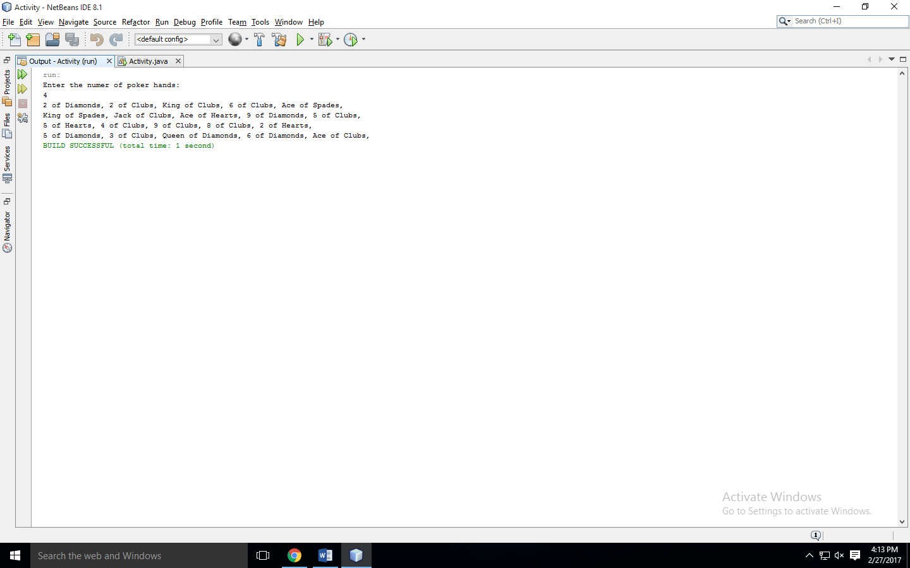

**Task four:**

package activity;

import java.util.Scanner;

import java.util.Random;

public class Activity {

public static void main(String[] args) {

Scanner tuna = new Scanner(System.in);

int m,n, num;

float p;

System.out.println("Enter the no of rows: ");

m = tuna.nextInt();

System.out.println("Enter the no of columns: ");

n = tuna.nextInt();

System.out.println("Enter the probability of mines: ");

p = tuna.nextFloat();

num = (int)( p * ( m * n ));

boolean [][] mine = new boolean[m][n];

int [][] sweep = new int[m][n];

Random rnd = new Random();

for(int i =0 ; i < num; i++){

mine[rnd.nextInt(m)][rnd.nextInt(n)] = true;

}

System.out.println("");

for(int j = 0; j < m; j++){

for(int l = 0; l < n; l++){

if (mine[j][l] == true)

System.out.print(" * ");

else

System.out.print(" . ");

}

System.out.println("");

}

for(int j=0;j<m;j++){

for(int l=0;l<n;l++){

if(mine[j][l] != true){

if((j-1 > 0) && (mine[j-1][l] == true))

sweep[j][l]++;

if((j-1 > 0 && l-1 > 0) && (mine[j-1][l-1] == true))

sweep[j][l]++;

if((j-1 > 0 && l+1 < n) && (mine[j-1][l+1] == true))

sweep[j][l]++;

if((l-1 > 0) && (mine[j][l-1] == true))

sweep[j][l]++;

if((l+1 < n) && (mine[j][l+1] == true))

sweep[j][l]++;

if(( l-1 > 0 && j+1 < m) && (mine[j+1][l-1] == true))

sweep[j][l]++;

if((j+1 < m) && (mine[j+1][l] == true))

sweep[j][l]++;

if((j+1 < m && l+1 < n) && (mine[j+1][l+1] == true))

sweep[j][l]++;

}

}

}

System.out.println("");

for(int j = 0; j < m; j++){

for(int l = 0; l < n; l++){

if (mine[j][l] == true)

System.out.print(" * ");

else

System.out.printf(" %d ",sweep[j][l]);

}

System.out.println("");

}

}

**Output:**

