**Muhammad Rizwan Khalid**

**180459**

**BSCS 6-A**

**Lab no: 02**

**Activity One:**

**Answer(1):** In the first program, we called the same class but this is not an error. The error arise when we pas argument 5 to the object. There is difference between the parameter lists. The default constructor has no parameter list while we are passing an integer argument to the object. The following error arises.

Test1 t1 = new Test1(5);

required: no arguments

found: int

reason: actual and formal argument lists differ in length

**Answer(2):** In the test 2 program we have called an invalid method. Test2 is class and does not contain any method named x(); so we cannot access this operation in the main. The following error arises.

error: cannot find symbol

t1.x();

symbol: method x()

location: variable t1 of type Test1

**Answer(03):** There are two errors in the test3 program firstly the class circle is not defined anywhere in the program. Secondly we are creating an object of undefined class. Furthermore, we are calling the method of getradius(); which is also not defined.

**Answer(4):** There is a difference of parameters in actual and formal argument list. We are passing the double type value 5.0 to the object which is the error because the default constructor has no parameter list.

**Answer(5):** In the test5 we are trying to print the default radius of the object. While the radius has private access to class circle. So there is an error.

**Activity two:**

package test1;

public class Test1 {

public static void main(String[] args){

method1();

}

public static void method1(){

method2();

}

public static void method2(){

Circle c = new Circle();

System.out.println("What is radius " + c.getRadius());

}

}

class Circle{

double radius = 1.0;

public double getRadius(){

return radius;

}

}

**Output:**

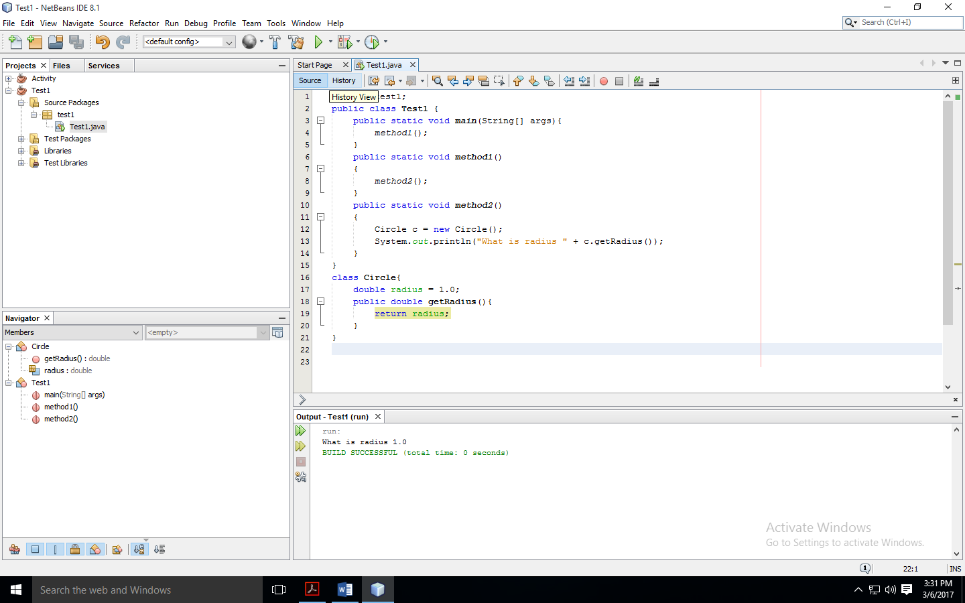

**Activity Three:**

package test1;

public class Test1 {

public static void main(String[] args){

Count myCount = new Count();

int times = 0;

for (int i = 0; i < 100; i++)

increment(myCount, times);

System.out.println("count is " + myCount.count);

System.out.println("times is " + times);

}

public static void increment(Count c, int times)

{

c.count++;

times++;

}

}

class Count{

public int count;

public Count(int c){

count = c;

}

public Count(){

count = 1;

}

}

**Answer to Question:** In primitive data types the copy of the variable is passed and the value of the variable remains unchanged like in this case we are passing times variable to the method increment. While in reference type, we pass the address of the instance and the value of the variable changes.

**Output:**

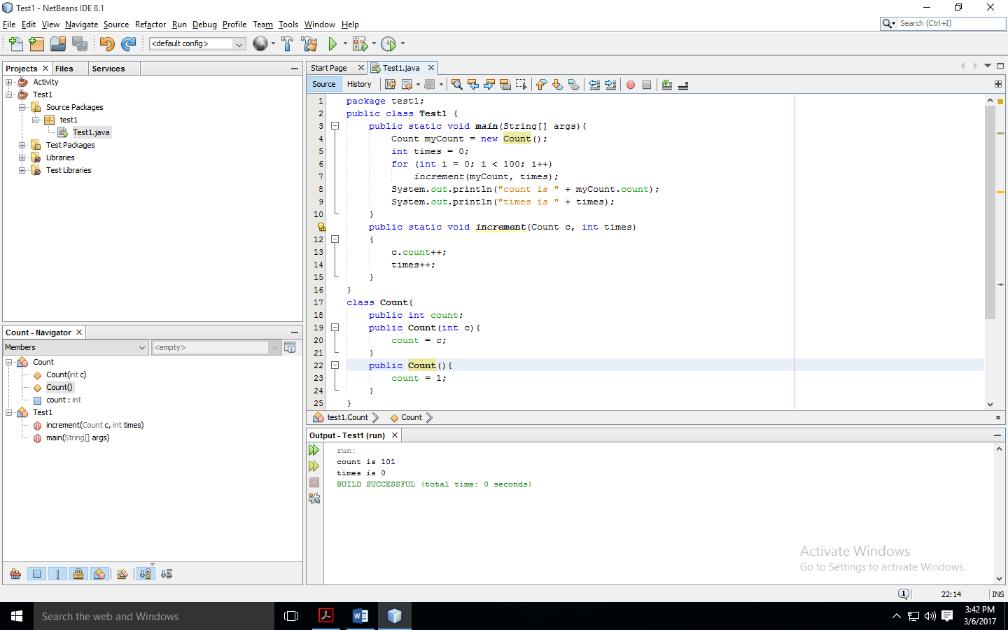

**Activity Four:**

package test1;

public class Test1 {

public static void main(String[] args){

Circle circle1 = new Circle(1);

Circle circle2 = new Circle(2);

swap1(circle1, circle2);

System.out.println("After swap1: circle1 = " +

circle1.radius + " circle2 = " + circle2.radius);

swap2(circle1, circle2);

System.out.println("After swap2: circle1 = " +

circle1.radius + " circle2 = " + circle2.radius);

}

public static void swap1(Circle x, Circle y){

Circle temp = x;

x = y;

y = temp;

}

public static void swap2(Circle x, Circle y){

double temp = x.radius;

x.radius = y.radius;

y.radius = temp;

}

}

class Circle{

double radius;

Circle(double newRadius){

radius = newRadius;

}

}

**Output:**

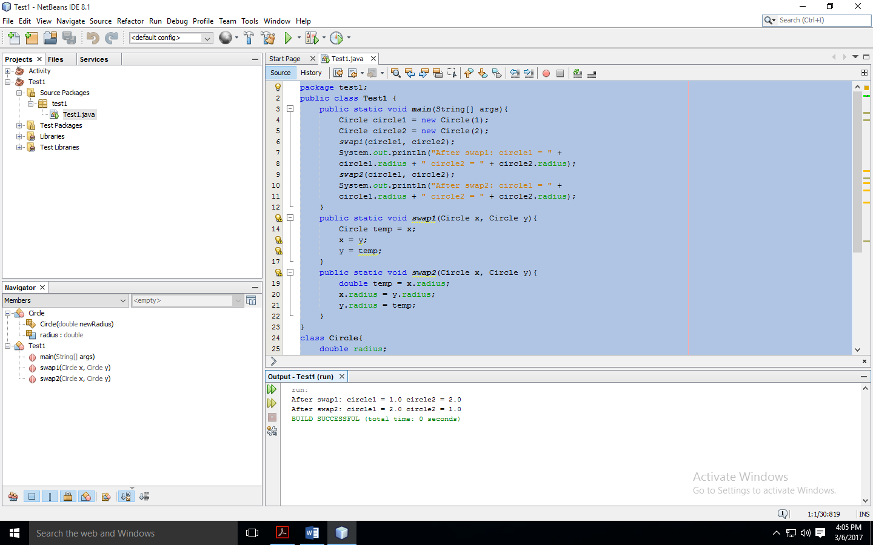

**Task one:**

package test1;

public class Test1 {

public static void main(String[] args){

Rectangle r1 = new Rectangle(4,40);

Rectangle r2 = new Rectangle(3.5,35.9);

System.out.println("Rectangle 1: ");

System.out.println("Width of r1: "+r1.width+" Height of r1: "+r1.height

+"\nArea: "+r1.getArea()+" Perimeter: "+r1.getPerimeter());

System.out.println("Rectangle 2: ");

System.out.println("Width of r2: "+r2.width+" Height of r1: "+r2.height

+"\nArea: "+r2.getArea()+" Perimeter: "+r2.getPerimeter());

}

}

class Rectangle{

double width;

double height;

Rectangle(){

width = 1.0;

height = 1.0;

}

Rectangle(double w, double h){

width = w;

height= h;

}

public double getArea(){

return width * height;

}

public double getPerimeter(){

return 2 * (width + height);

}

}

**Output:**

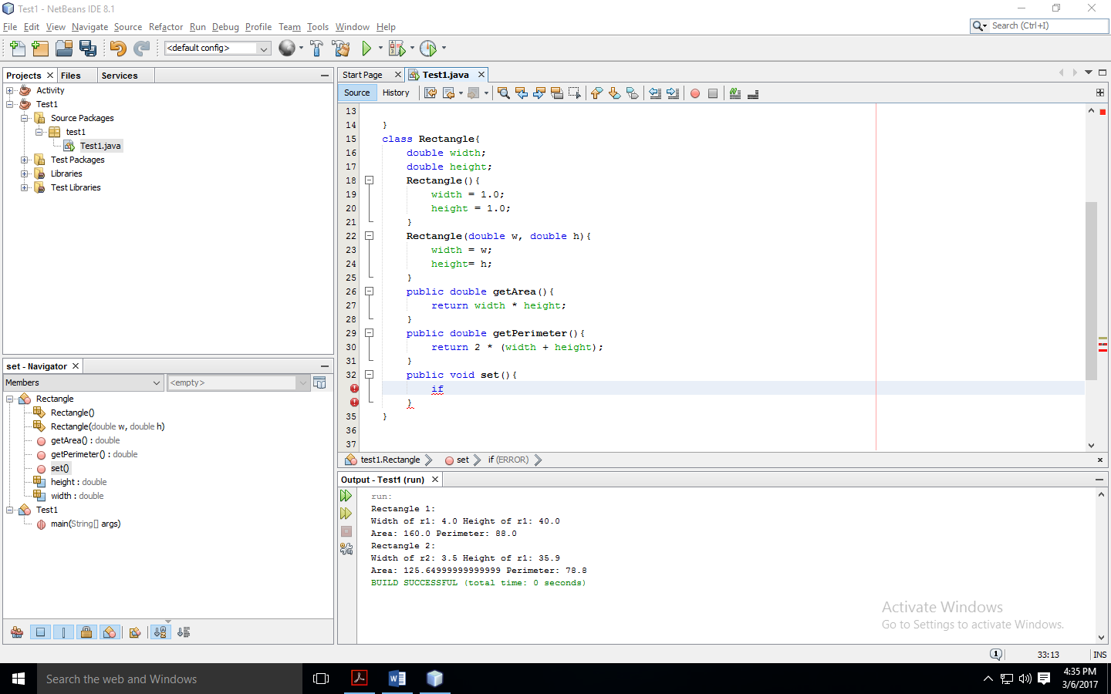

**UML Diagram for Class:**

|  |
| --- |
| Rectangle |
| width: Double  height: Double |
| Rectangle()  Rectangle(w: Double , h: Double) |
| getArea(): Double  getPerimeter(): Double |

|  |
| --- |
| r1: Rectangle |
| width = 4  height = 40 |

|  |
| --- |
| r2: Rectangle |
| width = 3.5  height = 35.9 |

**Task two:**

package test1;

public class Test1 {

public static void main(String[] args) {

Employee e1 = new Employee("Rizwan","Khalid",5000);

Employee e2 = new Employee("Jawad", "Mirza",4500);

System.out.println("Employee 1: "+e1.firstName+" "+e1.lastName);

System.out.println("Employee 2: "+e2.firstName+" "+e2.lastName);

System.out.println("The yearly salary of employee 1: "+e1.salary);

System.out.println("The yearly salary of employee 2: "+e2.salary);

System.out.println("\nAfter the 10% raise:");

e1.setSalary(1.10*e1.salary);

e2.setSalary(1.10*e2.salary);

System.out.println("The yearly salary of employee 1: "+e1.salary);

System.out.println("The yearly salary of employee 2: "+e2.salary);

}

}

class Employee{

String firstName;

String lastName;

double salary;

Employee(String f,String l, double s){

firstName = f;

lastName = l;

salary =s;

}

void setFirstName(String f){

firstName = f;

}

void setLastName(String l){

lastName = l;

}

void setSalary(double s){

salary = s;

}

String getFirstName(){

return firstName;

}

String getLastName(){

return lastName;

}

double getSalary(){

return salary;

}

}

**Output:**

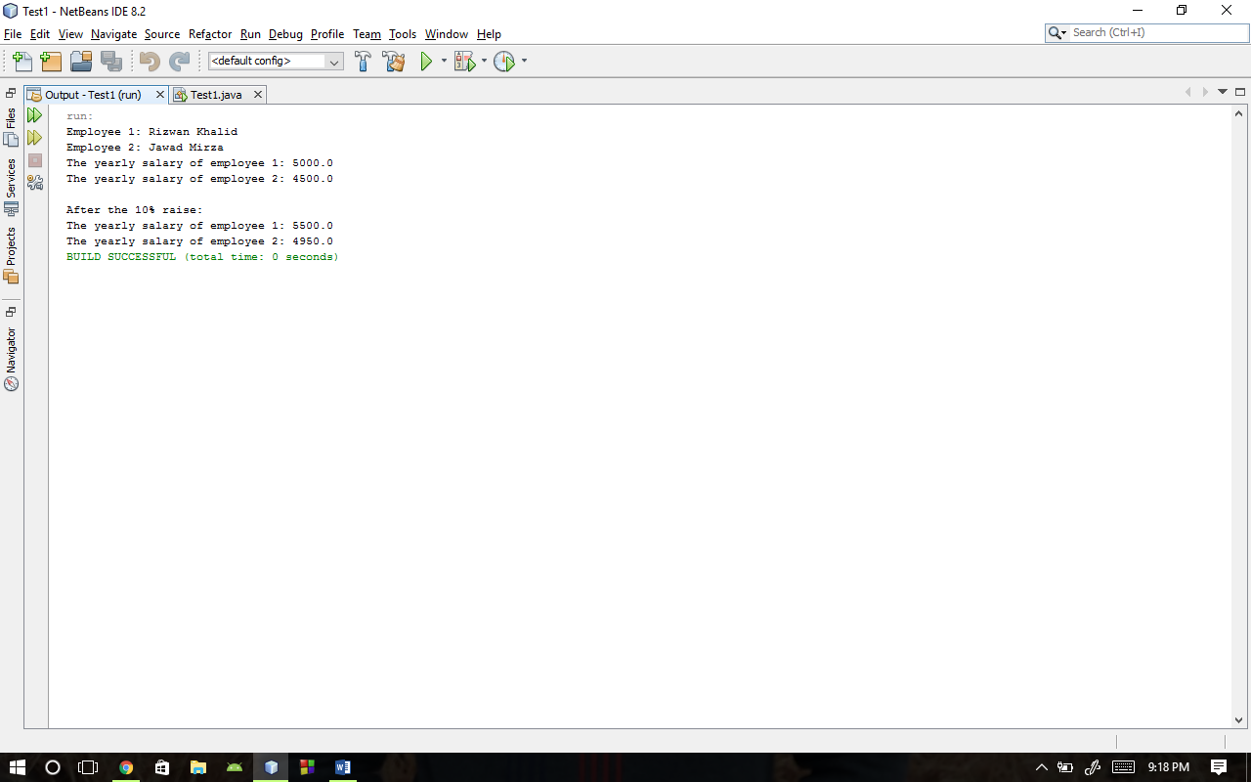

**Task three:**

package test1;

public class Test1 {

public static void main(String[] args) {

Date d1 = new Date(7,9,1997);

d1.setDay(28);

d1.setYear(1998);

d1.displayDate();

System.out.println("Day: "+d1.getDay()+"\nMonth: "+d1.getMonth()+"\nYear: "+d1.getYear());

}

}

class Date{

int day;

int month;

int year;

Date(int d, int m, int y){

day = d;

month = m;

year = y;

}

void setDay(int d){

day = d;

}

void setMonth(int m){

month = m;

}

void setYear(int y){

year = y;

}

int getDay(){

return day;

}

int getMonth(){

return month;

}

int getYear(){

return year;

}

void displayDate(){

System.out.printf("%d / %d / %d\n", day,month,year);

}

}

**Output:**

