**Muhammad Rizwan Khalid**

**BSCS – 6A**

**180459**

**Task: 01 (a): -**

package lab11;

import java.util.Scanner;

public class Lab11 {

public static void main(String[] args) {

Stack s = new Stack();

s.push(100);

s.push(200);

s.push(300);

System.out.println(s.peek());

s.pop();

s.pop();

System.out.println(s.peek());

}

}

class Stack{

int array[] = new int[1]; int count=0;

void push(int num){

if(array.length == 1 && count==0){

array[0] = num;

count=1;

}

else {

array = incrementSize();

array[0] = num;

}

}

void pop(){

array = decrementSize();

}

int peek(){

return array[0];

}

int [] incrementSize(){

int newArray[] = new int[array.length + 1];

for(int i = 1; i <= array.length; i++){

newArray[i] = array[i-1];

}

return newArray;

}

int [] decrementSize(){

int newArray[] = new int[array.length - 1];

for(int i = 0; i < array.length-1; i++){

newArray[i] = array[i+1];

}

return newArray;

}

}

**Output: -**

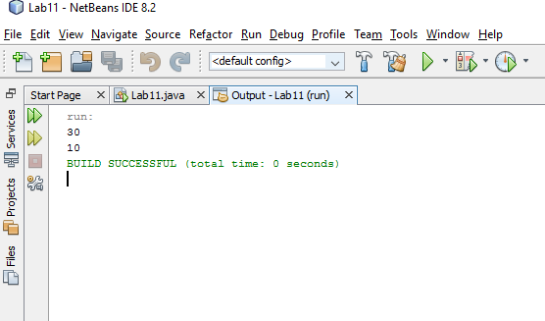

**Task: 01 (b): -**

package lab11;

import java.util.Scanner;

public class Lab11 {

public static void main(String[] args) {

Scanner input = new Scanner(System.in);

Stack s = new Stack();

System.out.print("Enter String of braces: ");

String string = input.next();

for(int i = 0; i < string.length(); i++){

if(string.charAt(i) == '('){

s.push(1);

}

else if(string.charAt(i) == ')'){

s.pop();

}

}

if(s.array.length == 0){

System.out.println("Tokens are balanced");

}

else

System.out.println("Tokens are un-balanced");

}

}

class Stack{

int array[] = new int[1]; int count=0;

void push(int num){

if(array.length == 1 && count==0){

array[0] = num;

count=1;

}

else {

array = incrementSize();

array[0] = num;

}

}

void pop(){

array = decrementSize();

}

int peek(){

return array[0];

}

int [] incrementSize(){

int newArray[] = new int[array.length + 1];

for(int i = 1; i <= array.length; i++){

newArray[i] = array[i-1];

}

return newArray;

}

int [] decrementSize(){

int newArray[] = new int[array.length - 1];

for(int i = 0; i < array.length-1; i++){

newArray[i] = array[i+1];

}

return newArray;

}

}**Output:**

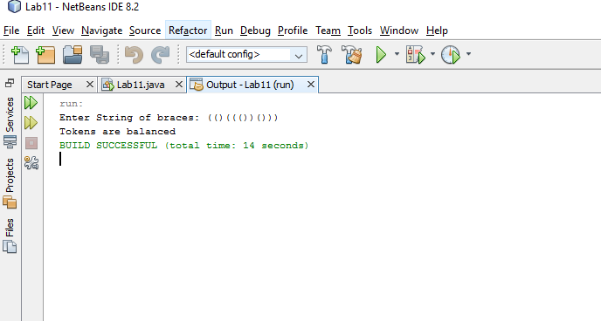

**Task: 02 (a) : -**

package lab11;

import java.util.Scanner;

public class Lab11 {

public static void main(String[] args) {

Scanner input = new Scanner(System.in);

Stack s = new Stack();

Queue q = new Queue();

q.Enqueue(100);

q.Enqueue(200);

q.Enqueue(300);

q.Dequeue();

System.out.println(q.Front());

System.out.println(q.Back());

}

}

class Queue{

int array[] = new int[1];

int count = 0;

void Enqueue(int num){

if(array.length == 1 && count == 0){

array[0] = num;

count = 1;

}

else{

array = incrementSize();

array[array.length-1] = num;

}

}

void Dequeue(){

array = decrementSize();

}

int Front(){

return array[0];

}

int Back(){

return array[array.length-1];

}

int[] incrementSize(){

int newArray[] = new int[array.length+1];

for(int i = 0; i < array.length; i++){

newArray[i] = array[i];

}

return newArray;

}

int[] decrementSize(){

int newArray[] = new int[array.length-1];

for(int i = 0; i < array.length-1;i++){

newArray[i] = array[i+1];

}

return newArray;

}

}

**Output:**

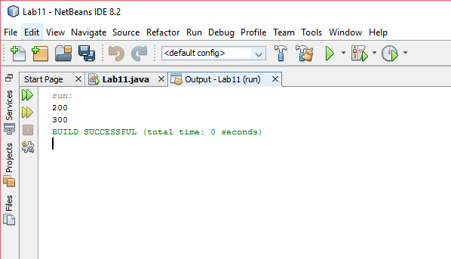

**Task: 02 (b): -**

package lab11;

import java.util.Scanner;

public class Lab11 {

public static void main(String[] args) {

Scanner input = new Scanner(System.in);

Stack s = new Stack();

Queue q = new Queue();

String string;

System.out.println("Enter Sentence: ");

string = input.nextLine();

string = string.toLowerCase();

char temp[] = new char[string.length()];int var=0;

for(int i=0; i< string.length() ; i++){

if((string.charAt(i) >= 'a' && string.charAt(i) <= 'z')){

s.push(string.charAt(i));

q.enqueue(string.charAt(i));

}

}

int z= s.array.length;

for(int i = 0; i < z; i++){

if(s.peek() != q.front()){

break;

}

s.pop();

q.dequeue();

}

if(s.array.length == 0){

System.out.println("This is a Palindrome!!");

}

else

System.out.println("This is not a Palindrome!!");

}

}

class Queue{

char array[] = new char[1];

int count = 0;

void enqueue(char num){

if(array.length == 1 && count == 0){

array[0] = num;

count = 1;

}

else{

array = incrementSize();

array[array.length-1] = num;

}

}

void dequeue(){

array = decrementSize();

}

int front(){

return array[0];

}

int back(){

return array[array.length-1];

}

char[] incrementSize(){

char newArray[] = new char[array.length+1];

for(int i = 0; i < array.length; i++){

newArray[i] = array[i];

}

return newArray;

}

char[] decrementSize(){

char newArray[] = new char[array.length-1];

for(int i = 0; i < array.length-1;i++){

newArray[i] = array[i+1];

}

return newArray;

}

}

class Stack{

char array[] = new char[1]; int count=0;

void push(char num){

if(array.length == 1 && count==0){

array[0] = num;

count=1;

}

else {

array = incrementSize();

array[0] = num;

}

}

void pop(){

array = decrementSize();

}

int peek(){

return array[0];

}

char [] incrementSize(){

char newArray[] = new char[array.length + 1];

for(int i = 1; i <= array.length; i++){

newArray[i] = array[i-1];

}

return newArray;

}

char [] decrementSize(){

char newArray[] = new char[array.length - 1];

for(int i = 0; i < array.length-1; i++){

newArray[i] = array[i+1];

}

return newArray;

}

}

**Output:**

