**First Window:**

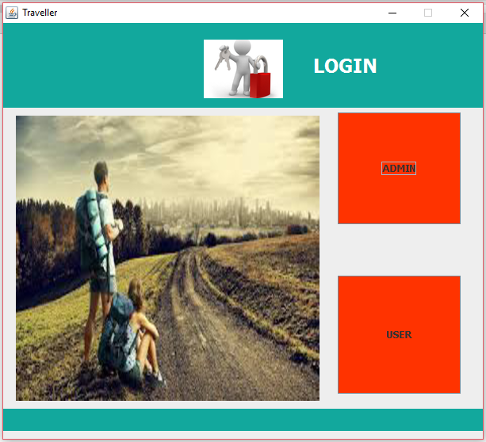

**Now Admin Login:**

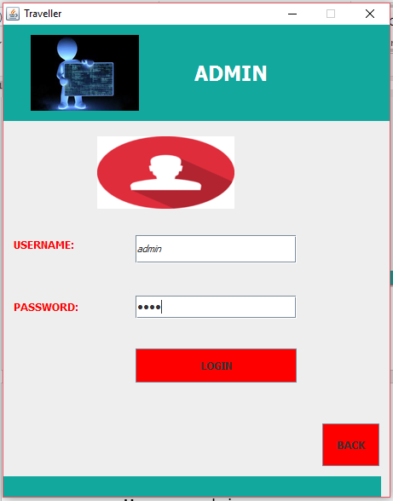

**Credentials Are:**

**Username:** admin

**Password:** 1234

**After Giving Credentials:**

We have added new Event into the existing file of Events in Islamabad directory.

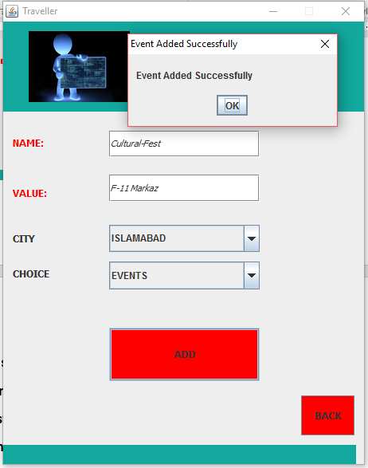

**Now Back to the first frame:** 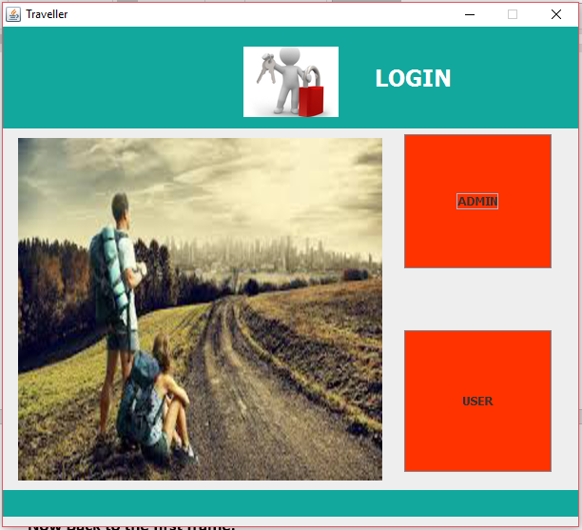

**Now entering the User Panel:**

Entering name and id of user as formality. User selected Islamabad City.

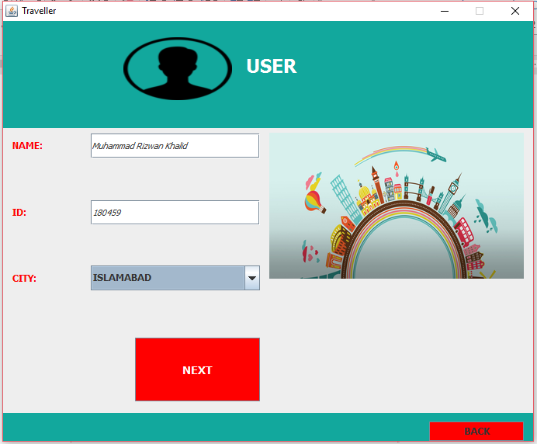

**Next is the combo boxes of events etc.**

By default event is in choice tab and other box is empty. For the first time we have to select different choice to get something appeared in the below box.

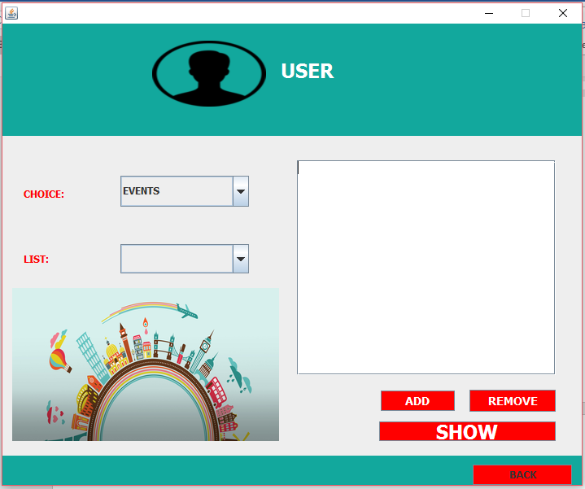

**Here comes the choices:**

We have selected places first then we go to events again to see if our new event is added or not

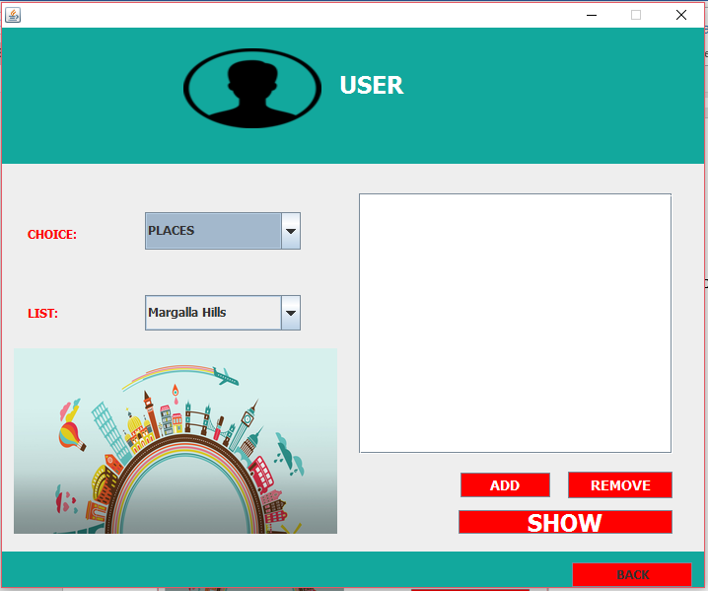

**Here Comes the added event:**

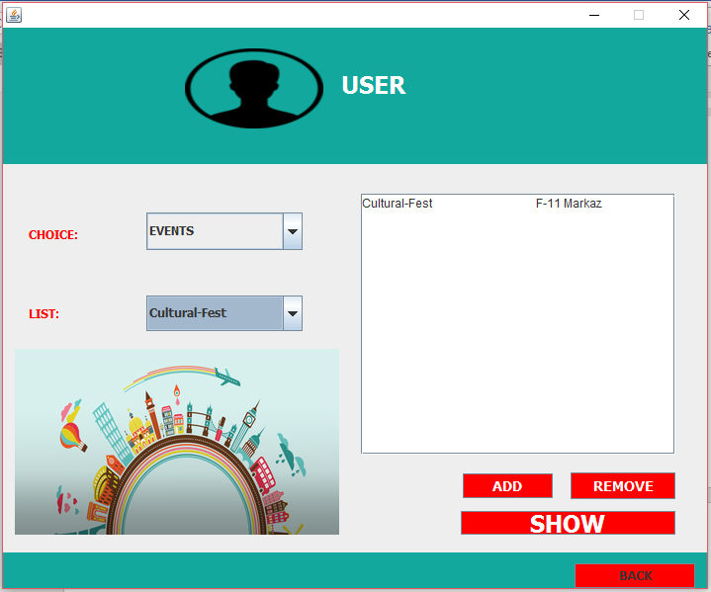

**We will click on add to add it to file of user:**

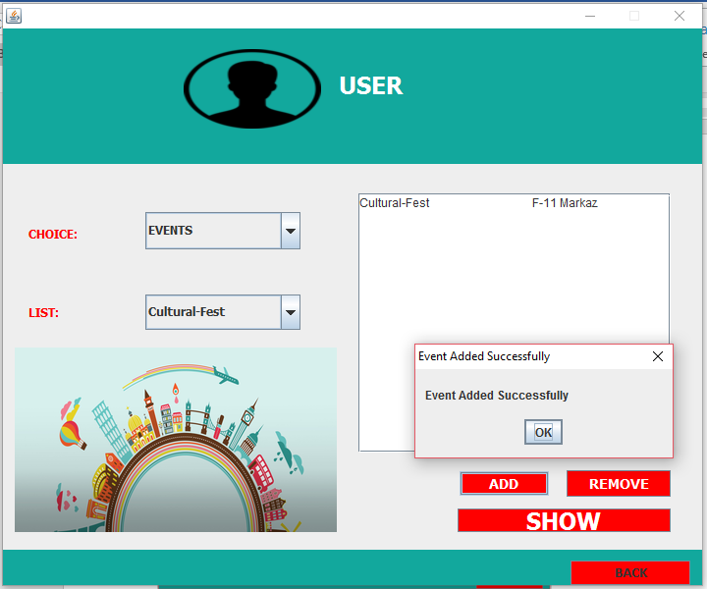

**After randomly adding and removing events, hotels, food and places:**

