2/7/2019
Abbas Naqvi && Rizwan Khalid
177410 && 180459
Artificial Intelligence
Lab 3

Department of Computing

CS370: Artificial Intelligence

Class: BSCS-6AB

Lab 3: Solving Problem by Searching

Date: 07-02-2019

Time: 10am-1pm & 2pm-5pm

Instructor: Dr. Imran Malik

Lab 3: Solving Problems by Searching

Introduction
This lab describes one kind of goal-based agent called a problem-solving agent. Problem-solving agents start by describing the goal, formulating the problem and then using searching techniques to find sequence of actions.

Objectives
In this lab you will implement problem-solving agent. Specifically you will formulate the specifics of your search problem and implement it. You will then use uninformed search strategies to solve your search problem and evaluate different strategies by measuring the cost of your solution and the time it takes to find the solution.

Pre-requisites:
Basic know how of OOP Concepts in Python
Basic know how of Python

Tools/Software Requirement
Python 2.7.9
Simpleai (http://simpleai.readthedocs.org/en/latest/)

Description

- First you have to install python 2.7.9 download it from following link.
https://www.python.org/downloads/release/python-279/

- Open your command prompt and go in to following path.
C:\Python27\Scripts

- Simpleai is a Python implementation of many of the artificial intelligence algorithms described in your text book: Artificial Intelligence: A modern Approach.
Install simpleai using the following command:

pip install simpleai
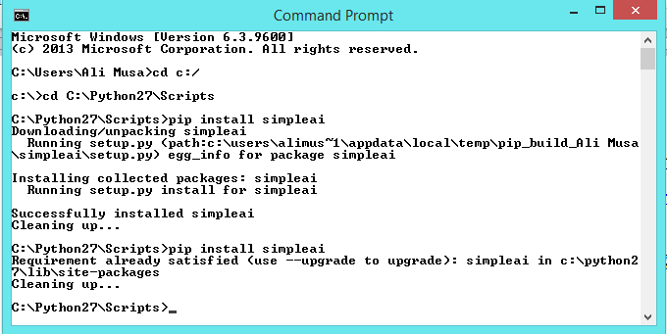

import sys
sys.path.append(“\path_where_simpleai_installed”)
from simpleai.search import SearchProblem, breadth_first, depth_first, limited_depth_first, iterative_limited_depth_first, uniform_cost

To solve problem using searching you will need to define the specifics of your particular search problem, which includes defining the following:
1.Formulate Goal:
2.Formulate Problem:
- Initial state
- Actions
- Transition model
- Goal test
- cost
3.Use searching algorithm to find solution:

See lab03.py to see how these things are defined for the case of 8-puzzle problem. Also see the documentation http://simpleai.readthedocs.org/en/latest/search_problems.html

Lab3.py
'''
8 puzzle problem, a smaller version of the fifteen puzzle:
http://en.wikipedia.org/wiki/Fifteen_puzzle
States are defined as string representations of the pieces on the puzzle.
Actions denote what piece will be moved to the empty space.
States must allways be inmutable. We will use strings, but internally most of
the time we will convert those strings to lists, which are easier to handle.
For example, the state (string):
'1-2-3
4-5-6
7-8-e'
will become (in lists):
[['1', '2', '3'],
['4', '5', '6'],
['7', '8', 'e']]
'''
from timeit import default_timer as timer
from simpleai.search import *
'''
SearchProblem, breadth_first, depth_first, limited_depth_first, iterative_limited_depth_first, uniform_cost'''

GOAL = '''1-2-3
4-5-6
7-8-e'''

INITIAL = '''4-1-2
7-e-3
8-5-6'''

def list_to_string(list_):
return '\n'.join(['-'.join(row) for row in list_])

def string_to_list(string_):
return [row.split('-') for row in string_.split('\n')]

def find_location(rows, element_to_find):
'''Find the location of a piece in the puzzle.
Returns a tuple: row, column'''
for ir, row in enumerate(rows):
for ic, element in enumerate(row):
if element == element_to_find:
return ir, ic

# we create a cache for the goal position of each piece, so we don't have to
# recalculate them every time
goal_positions = {}
rows_goal = string_to_list(GOAL)
for number in '12345678e':
goal_positions[number] = find_location(rows_goal, number)

class EigthPuzzleProblem(SearchProblem):
def actions(self, state):
'''Returns a list of the pieces we can move to the empty space.'''
rows = string_to_list(state)
row_e, col_e = find_location(rows, 'e')

actions = []
if row_e > 0:
actions.append(rows[row_e - 1][col_e])
if row_e < 2:
actions.append(rows[row_e + 1][col_e])
if col_e > 0:
actions.append(rows[row_e][col_e - 1])
if col_e < 2:
actions.append(rows[row_e][col_e + 1])

return actions

def result(self, state, action):
'''Return the resulting state after moving a piece to the empty space.
(the "action" parameter contains the piece to move)
'''
rows = string_to_list(state)
row_e, col_e = find_location(rows, 'e')
row_n, col_n = find_location(rows, action)

rows[row_e][col_e], rows[row_n][col_n] = rows[row_n][col_n], rows[row_e][col_e]

return list_to_string(rows)

def is_goal(self, state):
'''Returns true if a state is the goal state.'''
return state == GOAL

def cost(self, state1, action, state2):
'''Uniform cost
'''
return 1

start = timer()
result = breadth_first(EigthPuzzleProblem(INITIAL), graph_search=True)
end = timer()

# Time
print "Time: " + str(end - start)

# cost of solution
print result.cost

# Solution
for action, state in result.path():
print 'Move number', action
print state

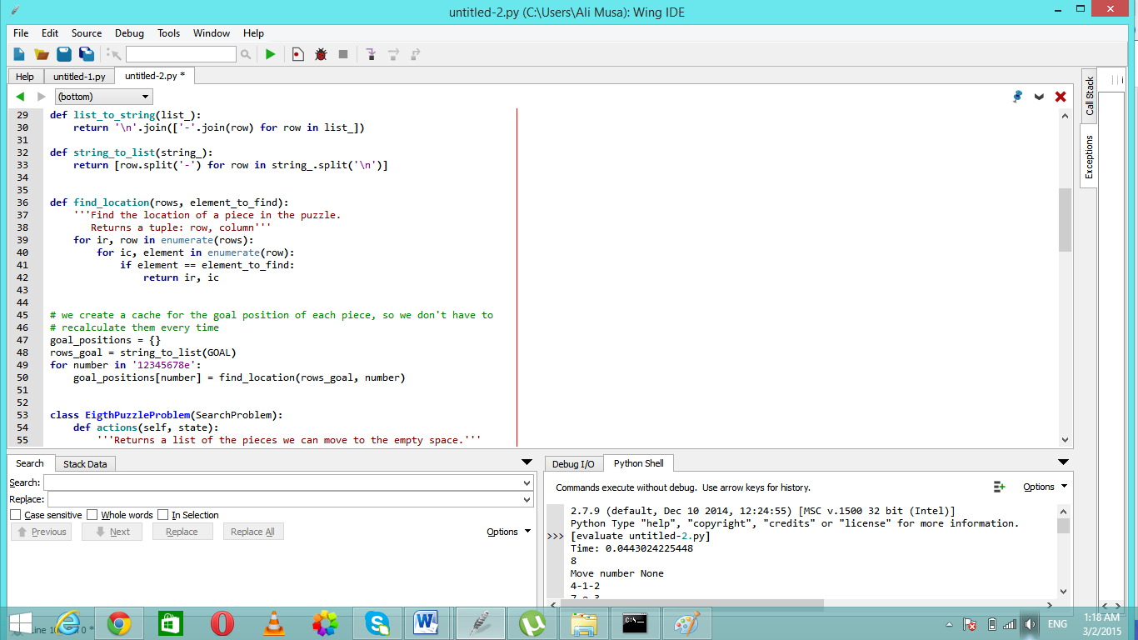

Lab Task 1
Solve the 8-puzzle problem using Breadth first, uniform cost, limited depth first, iterative limited depth first (These algorithms are implemented in the simpleai library). Evaluate these algorithms by filling out the following table.

Algorithms / Performance | Cost | Time
Breadth First | 8 | 0.164756141889
Uniform Cost | 8 | 0.0430846249527
Limited Depth First (L=30) | 28 | 0.806264788964
Limited Depth First (L=50) | 38 | 0.614589895513
Limited Depth First (L=100) | 100 | 4.46847022874
Iterative Limited Depth First | 8 | 0.02240308791

Lab Task 2
Formulate the problem of reaching Bucharest from Arad by sub classing SearchProblem as in the case of 8-puzzle problem. Then implement member functions actions, result, is_goal, cost according to the following map of Romania.

Solve the problem using Breadth first, uniform cost, depth first, limited depth first, iterative limited depth first. Evaluate these algorithms by filling out the following table.

Algorithms / Performance | Cost | Time
Breadth First | 450 | 0.000492089028861
Uniform Cost | 418 | 0.000859591355617
Depth First | 418 | 0.00029809786257
Limited Depth First (L=5) | 418 | 0.000331093427511
Limited Depth First (L=10) | 418 | 0.000331093427511
Iterative Limited Depth First | 450 | 0.000569457939757

+
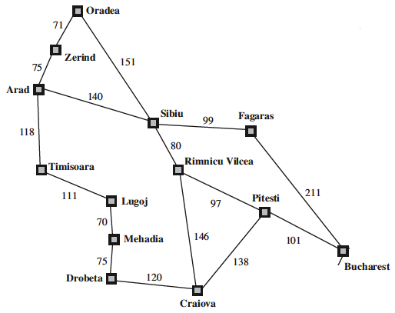

Deliverables: Upload a single Word file with the code in text boxes. The code should be properly documented.

Time to complete lab task: 3rd March 2015, 2355hrs

