**Smart Trash Bin Project**

Smart trash bin helps to solve the problems related to the garbage management. This project aims at developing the affordable smart trash bin using Arduino Nano, Servomotor, Ultrasonic sensor HC-SR04. The concept is very simple and easy to use.

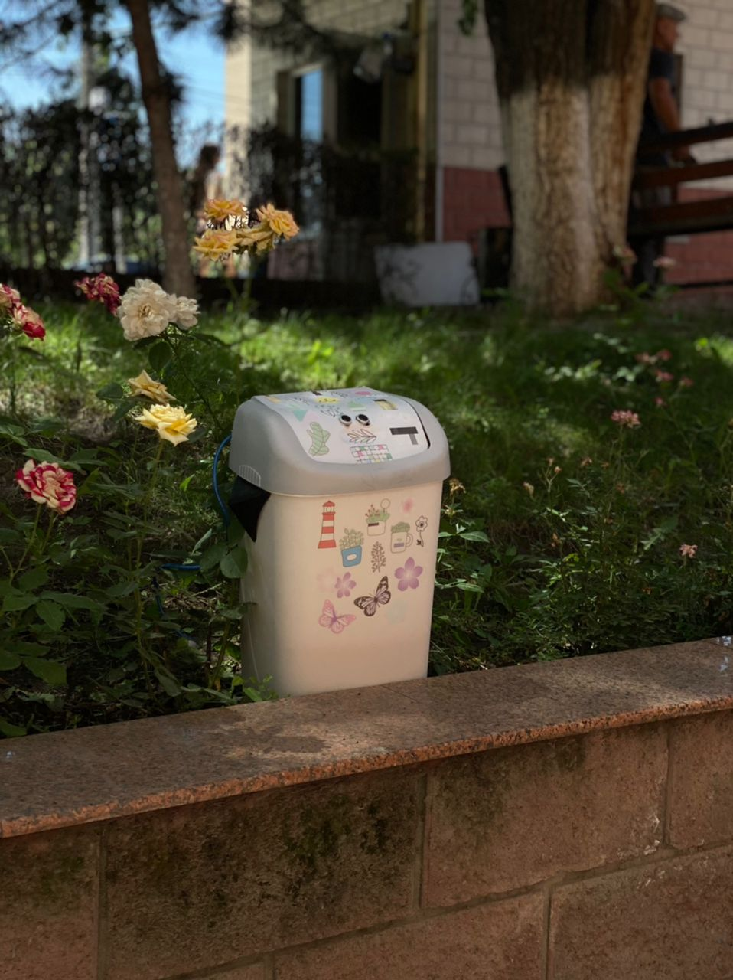

**Schematic**

[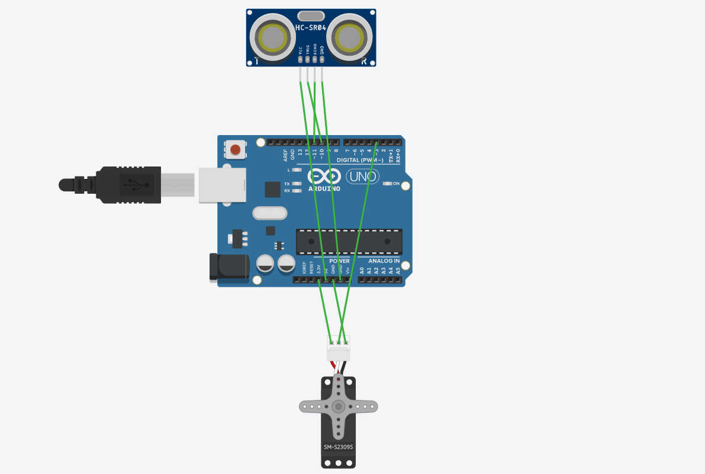](https://github.com/GalliFrey7/smart_trash_bin/blob/main/arduino_schematic.png)

int trig = 10;

int echo = 11;

int servoPin = 3;

**Photos & Videos**

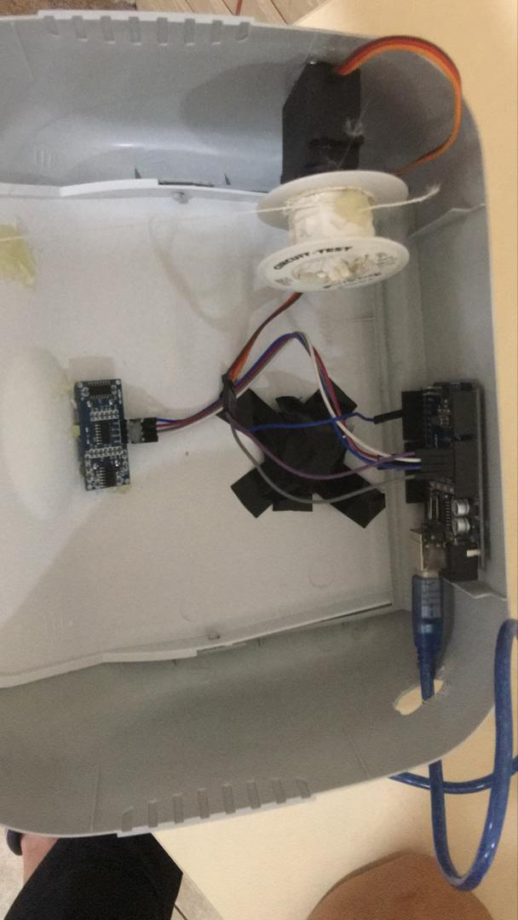

[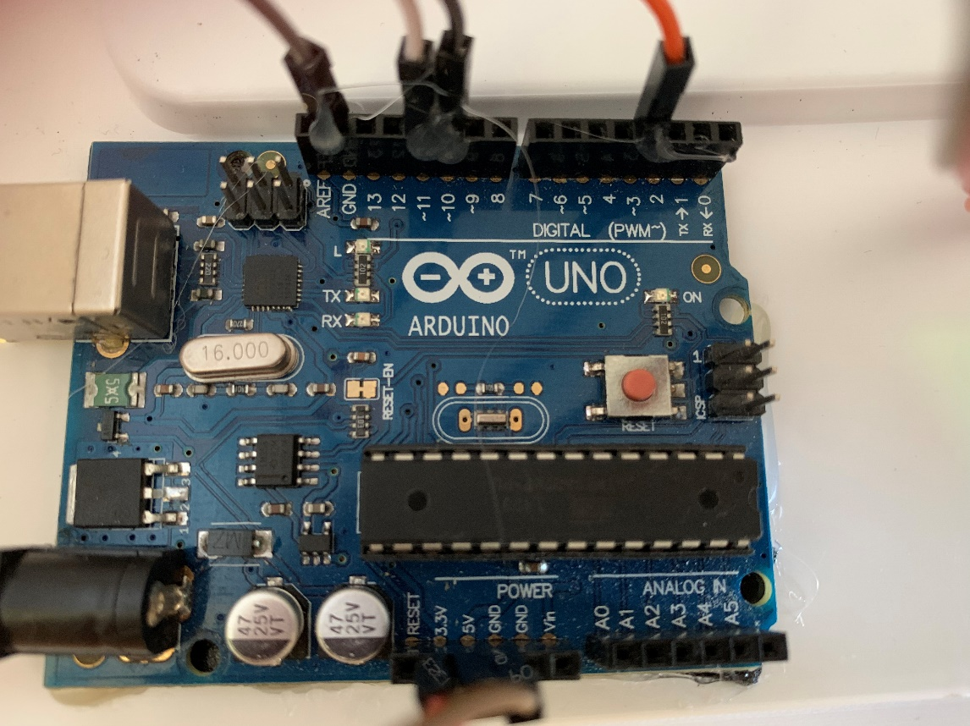](https://github.com/GalliFrey7/smart_trash_bin/blob/main/2CC6D479-273E-4821-914C-BC262BAE91A4.jpeg)

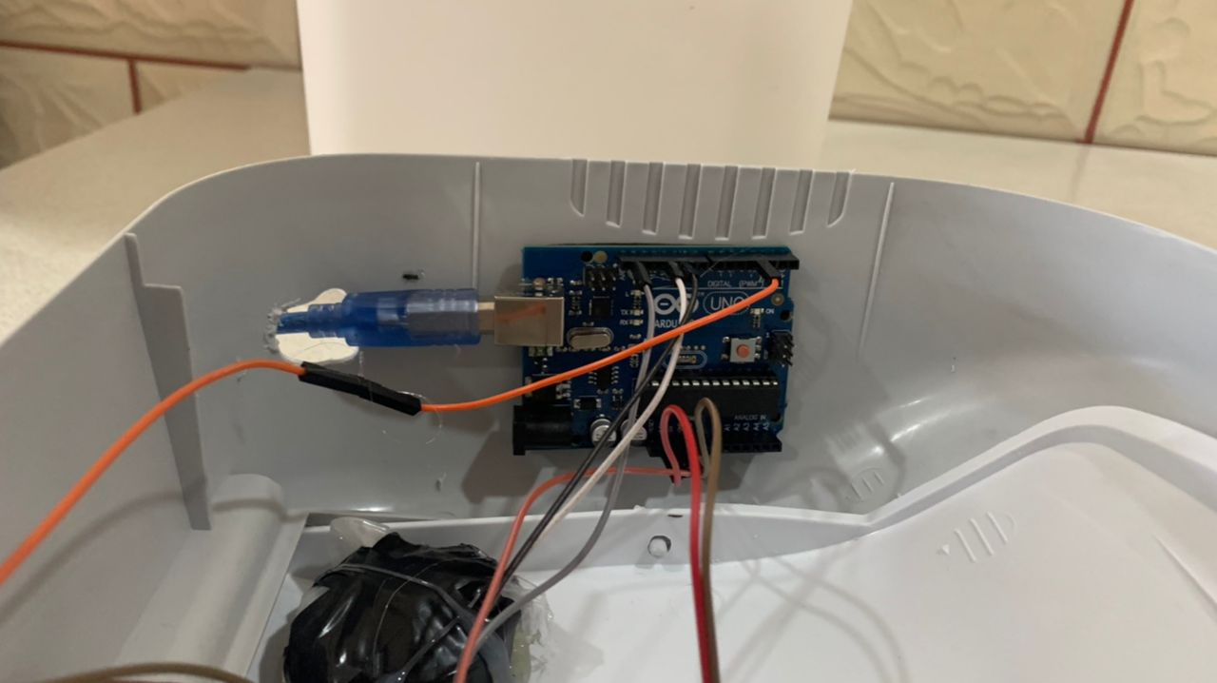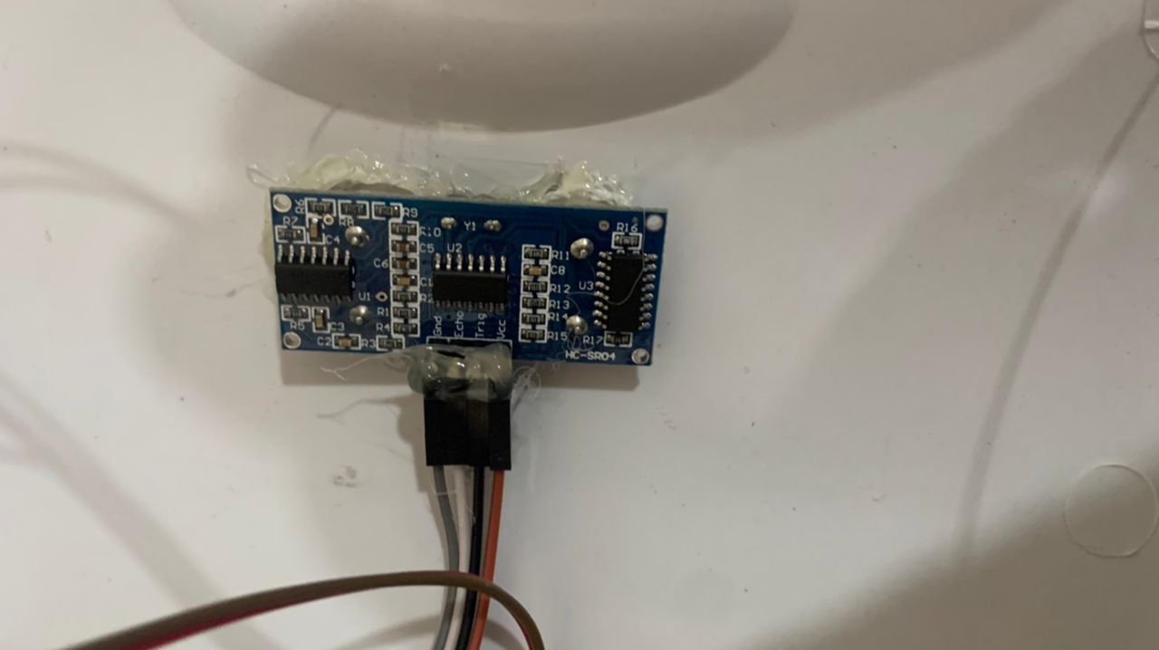

**Built With**

* [Arduino IDE](https://www.arduino.cc/en/software)
* [Arduino Uno](https://en.wikipedia.org/wiki/Arduino_Uno)
* [Servomotor](https://en.wikipedia.org/wiki/Servomotor)
* [Ultrasonic Sensor HC-SR04](https://lastminuteengineers.com/arduino-sr04-ultrasonic-sensor-tutorial/)