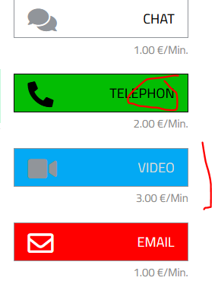

It must be written „Telefon“

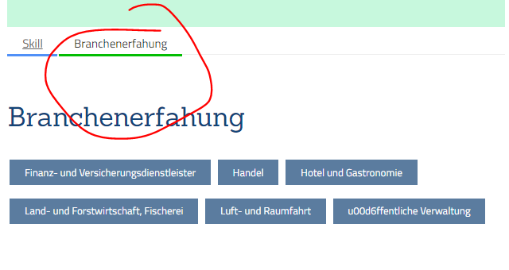

There is an „r“ missing it must be „Branchenerfahrung“

Proper Input Validation

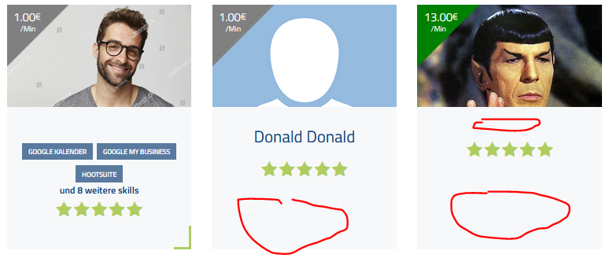

There Skills are not listed and even the name is missing.  
  
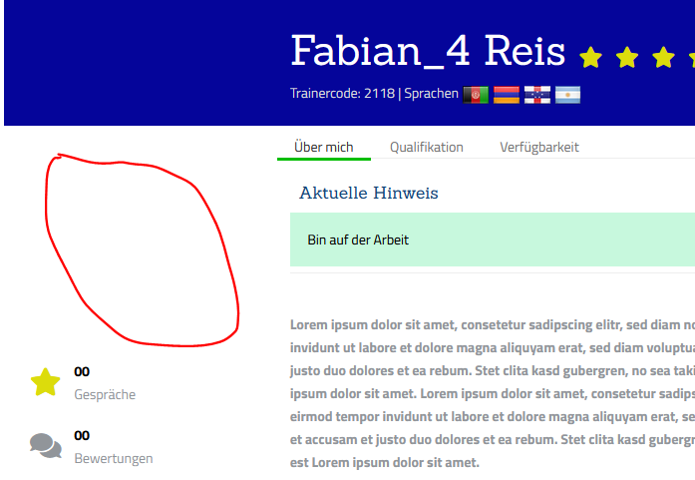

Profile picture is not displayed

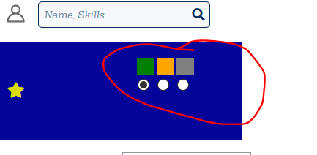

Im not logged in and it gives me the possibility to change my status.  
its does not let me change the status, but ist not good.  
every user should only edit his/her own account.

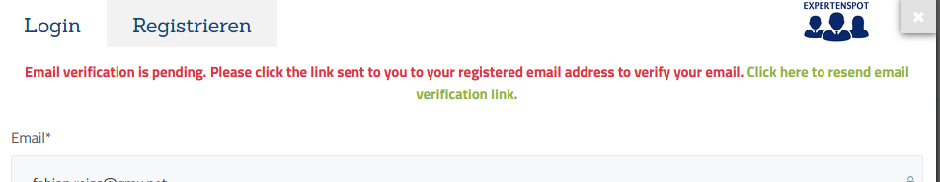

This must be in german, please exchange it with following sentence:  
  
[The following sentence in red]  
„Bitte klicken Sie auf den Bestätigungslink den wir ihnen an ihre Email Adresse geschickt haben.“  
[The following sentence in green, and this must be the hyperlink for sending th email again]  
„Klicken Sie hier um den Bestätigungslink erneut zu senden.“

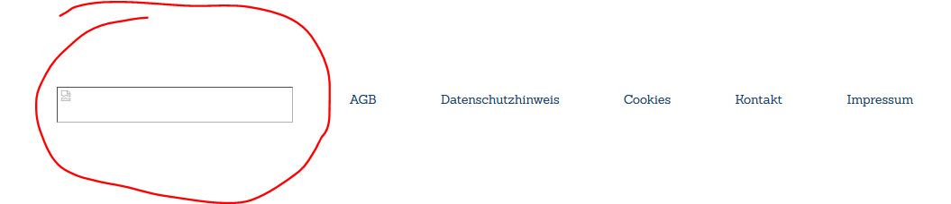

The Logo is missing in the footer

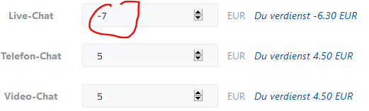

Negative values must not be allowed !!!

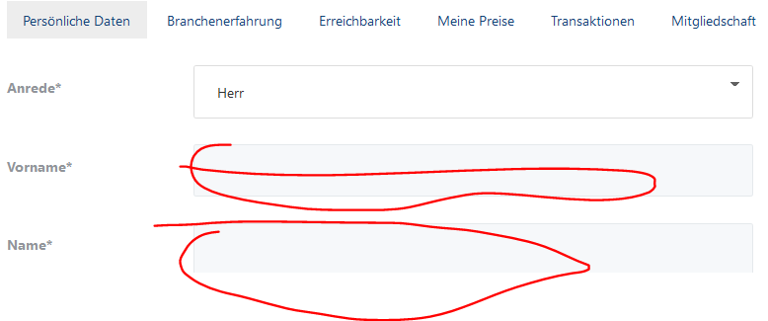

The name is not saved again… i tried twice..still no name

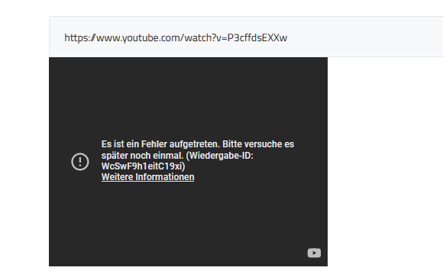

Youtube support is not working.



When i click on saving, it should be saying „ wird gespeichert“

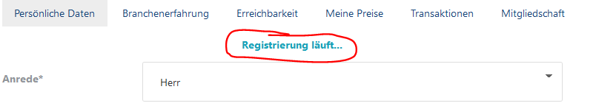

And this pops up…