 | Toll Bill Generation  Technical Design Document  Version 1.0
 | Prepared By / Last Updated By | Reviewed By | Approved By
Name
Role
Signature
Date

Table of Contents

1.0 Introduction 3
1.1 Purpose of this document 3
1.2 Project overview 3
2.0 Solution Summary 3
2.1 Scope 3
2.2 Assumptions 3
2.3 Dependencies 4
2.4 Risks 4
3.0 Schematic Diagram 4
4.0 System Design 4
4.1 Proposed design 4
4.2 Component inventory 4
5.0 Database Design 5
5.1 Data Model 5
5.2 Tables Structure 6
6.0 Appendices 8
6.1 Glossary 8
6.2 Other 8
7.0 Terms & Conditions 8
8.0 Change Log 9

Introduction

Purpose of this document
Tolling as a method of financing the transportation system is becoming more common in the India. Neither the traveling public nor State Departments of Transportation want vehicles to stop or slow down to pay to use a toll facility. To this end, several technologies, collectively called Electronic Toll Collection (ETC), have been developed in the last 15 years, allowing drivers to move in and out of toll systems without delay. Open Road Tolling (ORT), with all-electronic toll collection, is now the preferred practice, being more efficient, environmentally friendly, and safer than manual toll collection.

Project overview
This project captures the various concepts and techniques, which helps to put the requirements of the customer about toll bill generating technique using Java with JDBC. Admittedly, this would be at a scaled-down level since the purpose is to let the vehicles experience no delay in the toll lanes to pay charges.

Solution Summary

Scope
The scope of the system is explained through its following modules
1. Finance/Revenue Generation
2. Demand Management
3. Congestion Management

Assumptions
Considering cities, which are having the toll charges according to vehicle entry to city and exit to city. The different types of vehicle levels and the kind of travel type, the charges of toll are based-on.

Dependencies
- MySQL Workbench
- Eclipse IDE
- GitLab
- Maven

Risks
- Schedule / Time-Related / Delivery Related Planning Risks
- Sudden growth in requirements
- Operational / Procedural Risks
- Technical / Functional / Performance Risk

Schematic Diagram
A schematic, or schematic diagram, is a representation of the elements of a system using abstract, graphic symbols rather than realistic pictures. It gives an overview of overall system

System Design

Proposed design
<This sub-section shall elaborate the high-level design for this project>

Component inventory
<This sub-section shall list the components for this project>

Database Design

Data Model
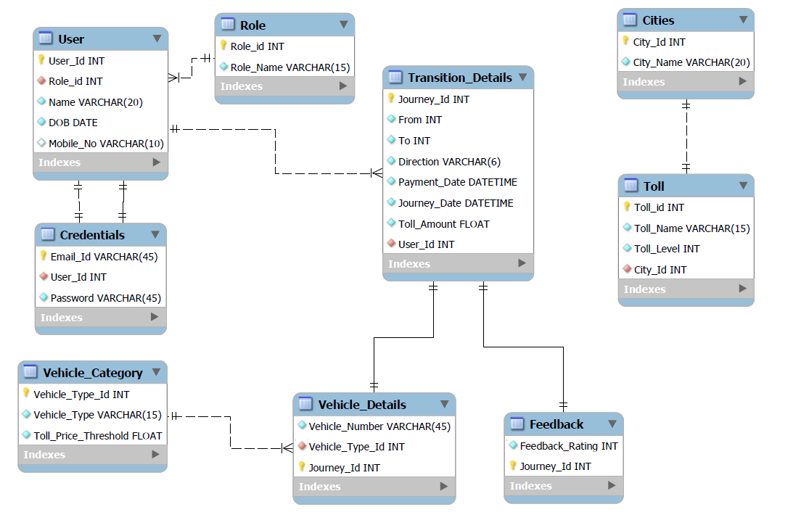

Tables Structure

User
Column Name | Data Type | Length | Nulls
User_Id | Integer | 6 | Not Allowed
Role_Id | Integer | 2 | Not Allowed
Name | String | 20 | Not Allowed
DOB | Date | - | Not Allowed
Mobile_No | String | 10 | Allowed

Role
Column Name | Data Type | Length | Nulls
Role_Id | Integer | 2 | Not Allowed
Role_Name | String | 15 | Not Allowed

Credentials
Column Name | Data Type | Length | Nulls
User_Id | Integer | 6 | Not Allowed
Email_Id | String | 40 | Not Allowed
Password | String | 25 | Not Allowed

Cities
Column Name | Data Type | Length | Nulls
City_Id | Integer | 5 | Not Allowed
City_Name | String | 20 | Not Allowed

Toll
Column Name | Data Type | Length | Nulls
Toll_Id | Integer | 5 | Not Allowed
Toll_Name | String | 15 | Not Allowed
City_Id | Integer | 5 | Not Allowed
Toll_Level | Integer | 1 | Not Allowed

Vehicle_Category
Column Name | Data Type | Length | Nulls
Vehicle_Type_Id | Integer | 2 | Not Allowed
Vehicle_Type | String | 15 | Not Allowed
Toll_Price_Threshold | Float | 3,2 | Not Allowed

Vehicle_Details
Column Name | Data Type | Length | Nulls
Journey_Id | Integer | 6 | Not Allowed
Vehicle_Type_Id | Integer | 2 | Not Allowed
Vehicle_Number | String | 12 | Not Allowed

Feedback
Column Name | Data Type | Length | Nulls
Journey_Id | Integer | 6 | Not Allowed
Feedback_Rating | Integer | 1 | Not Allowed

Transition_Details
Column Name | Data Type | Length | Nulls
Journey_Id | Integer | 6 | Not Allowed
User_Id | Integer | 6 | Not Allowed
From | Integer | 5 | Not Allowed
To | Integer | 5 | Not Allowed
Direction | String | 6 | Not Allowed
Payment_Date | DateTime | - | Not Allowed
Journey_Date | DateTime | - | Not Allowed
Toll_Amount | Float | 5,2 | Not Allowed

Appendices

Glossary
Acronyms | Definitions

Other

Terms & Conditions
Disclaimer: Please do not circulate or distribute this document outside of Cognizant Network, We have a Zero Tolerance Policy. Kindly adhere to 100% Compliance at all times.

Change Log
Version Number | Changes made
V<n.n> | <If the change details are not explicitly documented in the table below, reference should be provided here>
V<n.n> | Page no | Changed by | Effective date | Changes effected

