**What is Microsoft Power BI?**

Microsoft Power BI is a business intelligence (BI) platform that provides nontechnical business users with tools for aggregating, analyzing, visualizing and sharing data. Power BI's user interface is fairly intuitive for users familiar with Excel, and its deep integration with other Microsoft products makes it a versatile self-service tool that requires little upfront training.

Power BI is a business analytics service provided by Microsoft that lets you visualize your data and share insights. It converts data from different sources to build interactive dashboards and Business Intelligence reports.

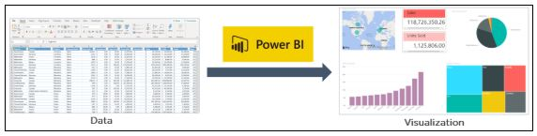

**Key features of Power BI**

*Microsoft has added a number of data analytics features to Power BI since its inception, and continues to do so. Some of the most important features are the following:*

* **Artificial intelligence:** Users can access image recognition and text analytics in Power BI, create machine learning models using automated ML capabilities and integrate with Azure Machine Learning.
* **Hybrid deployment support:** This feature provides built-in connectors that allow Power BI tools to connect with a number of different data sources from Microsoft, Salesforce and other vendors.
* **Quick Insights:** This feature allows users to create subsets of data and automatically apply analytics to that information.
* **Common data model support:** Power BI's support for the common data model allows the use of a standardized and extensible collection of data schemas (entities, attributes and relationships).
* **Cortana integration:** This feature, which is especially popular on mobile devices, allows users to verbally query data using natural language and access results using Cortana, Microsoft's digital assistant.
* **Customization:** This feature allows developers to change the appearance of default visualization and reporting tools and import new tools into the platform.
* **APIs for integration:** This feature provides developers with sample code and application program interfaces (APIs) for embedding the Power BI dashboard in other software products.
* **Self-service data prep:** Using Power Query, business analysts can ingest, transform, integrate and enrich big data into the Power BI web service. Ingested data can be shared across multiple Power BI models, reports and dashboards.
* **Modeling view:** This allows users to divide complex data models by subject area into separate diagrams, multiselect objects and set common properties, view and modify properties in the properties pane, and set display folders for simpler consumption of complex data models.

**Common uses of Power BI**

Microsoft Power BI is used to find insights within an organization's data. Power BI can help connect disparate data sets, transform and clean the data into a data model and create charts or graphs to provide visuals of the data. All of this can be shared with other Power BI users within the organization.

The data models created from Power BI can be used in several ways for organizations, including the following:

* telling stories through charts and data visualizations;
* examining "what if" scenarios within the data; and
* creating reports that can answer questions in real time and help with forecasting to make sure departments meet business metrics.

Power BI can also provide executive dashboards for administrators or managers, giving management more insight into how departments are doing.

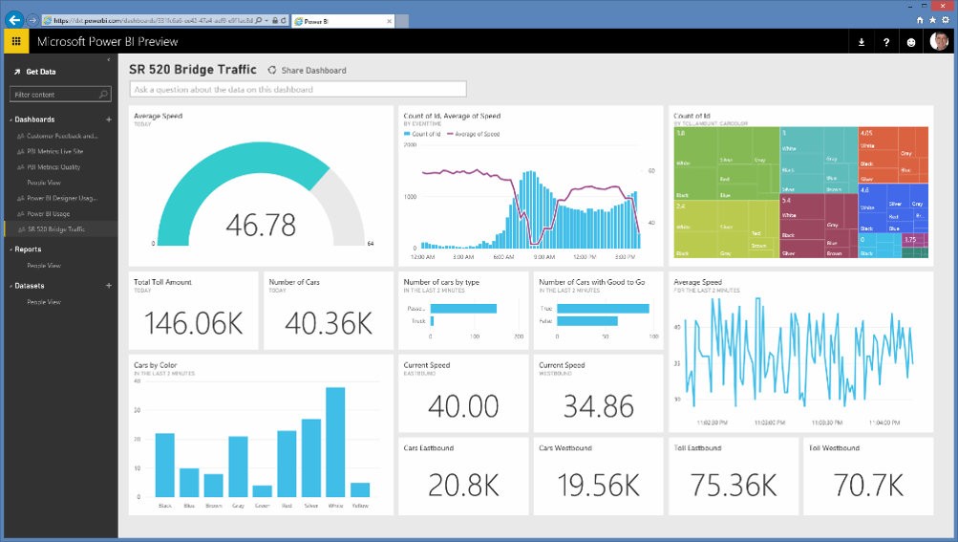

Fig: This Power BI preview shows the reporting and dashboard capabilities that Power BI offers.

**Who uses Power BI?**

Though Power BI is a self-service BI tool that brings data analytics to employees, it's mostly used by data analysts and BI professionals who create the data models before disseminating reports throughout the organization. However, those without an analytical background can still navigate Power BI and create reports.

Microsoft Power BI is used by both department reps and management, with reports and forecasts created to aid sales and marketing reps, while also providing data for management on how the department or individual employees are progressing toward their goals.

In addition, Power BI offers an admin portal for administrators to help configure the implementation of Power BI, as well as usage monitoring and licenses.

**Key features of Power BI**

Microsoft has added a number of data analytics features to Power BI since its inception, and continues to do so. Some of the most important features are the following:

* **Artificial intelligence.** Users can access image recognition and text analytics in Power BI, create machine learning models using automated ML capabilities and integrate with Azure Machine Learning.
* **Hybrid deployment support.** This feature provides built-in connectors that allow Power BI tools to connect with a number of different data sources from Microsoft, Salesforce and other vendors.
* **Quick Insights**. This feature allows users to create subsets of data and automatically apply analytics to that information.
* **Common data model support.** Power BI's support for the common data model allows the use of a standardized and extensible collection of data schemas (entities, attributes and relationships).
* **Cortana integration.** This feature, which is especially popular on mobile devices, allows users to verbally query data using natural language and access results using Cortana, Microsoft's digital assistant.
* **Customization.** This feature allows developers to change the appearance of default visualization and reporting tools and import new tools into the platform.
* **APIs for integration.** This feature provides developers with sample code and application program interfaces (APIs) for embedding the Power BI dashboard in other software products.
* **Self-service data prep.** Using Power Query, business analysts can ingest, transform, integrate and enrich big data into the Power BI web service. Ingested data can be shared across multiple Power BI models, reports and dashboards.
* **Modeling view**. This allows users to divide complex data models by subject area into separate diagrams, multiselect objects and set common properties, view and modify properties in the properties pane, and set display folders for simpler consumption of complex data models.

**Components of Power BI**

Microsoft Power BI works by connecting data sources and providing a dashboard of BI to the users. It can connect with just an Excel spreadsheet or bring together cloud-based and on-premises data warehouses. Data pulled from cloud-based sources, such as Salesforce CRM, is automatically refreshed.

With applications such as an Excel workbook or Power BI Desktop file connected to online or on-premises data sources, Power BI users must manually refresh or setup a refresh schedule to ensure the data in Power BI reports and dashboards use the most current data available.

Power BI consists of a collection of apps and can be used either on desktop, as a SaaS product or on a mobile device. Power BI Desktop is the on-premises version, Power BI Service is the cloud-based offering and mobile Power BI runs on mobile devices.

The different components of Power BI are meant to let users create and share business insights in a way that fits with their role.

1. **Power Query**

Power Query is the data transformation and mash up the engine. It enables you to discover, connect, combine, and refine data sources to meet your analysis need. It can be downloaded as an add-in for Excel or can be used as part of the Power BI Desktop.

1. **Power Pivot**

Power Pivot is a data modeling technique that lets you create data models, establish relationships, and create calculations. It uses Data Analysis Expression (DAX) language to model simple and complex data.

1. **Power View**

Power View is a technology that is available in Excel, Sharepoint, SQL Server, and Power BI. It lets you create interactive charts, graphs, maps, and other visuals that bring your data to life. It can connect to data sources and filter data for each data visualization element or the entire report.

1. **Power Map**

Microsoft's Power Map for Excel and Power BI is a 3-D data visualization tool that lets you map your data and plot more than a million rows of data visually on Bing maps in 3-D format from an Excel table or Data Model in Excel. Power Map works with Bing maps to get the best visualization based on latitude, longitude, or country, state, city, and street address information.

1. **Power BI Desktop**

Power BI Desktop is a development tool for Power Query, Power Pivot, and Power View. With Power BI Desktop, you have everything under the same solution, and it is easier to develop BI and data analysis experience.

1. **Power Q&A**

The Q&A feature in Power BI lets you explore your data in your own words. It is the fastest way to get an answer from your data using natural language. An example could be what was the total sales last year? Once you've built your data model and deployed that into the Power BI website, then you can ask questions and get answers quickly.

Included within Power BI are several components that help users create and share data reports. Those are the following:

* **Power Query:** a data mashup and transformation tool
* **Power Pivot:** a memory tabular data modeling tool
* **Power View:** a data visualization tool
* **Power Map:** a 3D geospatial data visualization tool
* **Power Q&A:** a natural language question and answering engine

Additionally, there are dozens of data sources that connect into Power BI, ranging from files (Excel, PDF, SharePoint, XML), databases (SQL Server Database, Oracle Database, IBM databases, Amazon Redshift, Google BigQuery), other Power BI data sets, Azure data connections and many online services (Dynamics 365, Salesforce Reports, Google Analytics, Adobe Analytics, Facebook and others).

**Power BI architecture**

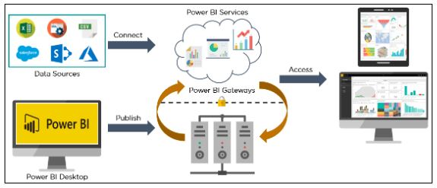

Power BI architecture is a service built on top of Azure. There are multiple data sources that Power BI can connect to. Power BI Desktop allows you to create reports and data visualizations on the dataset. Power BI gateway is connected to on-premise data sources to get continuous data for reporting and analytics. Power BI services refer to the cloud services that are used to publish Power BI reports and data visualizations. Using Power BI mobile apps, you can stay connected to their data from anywhere. Power BI apps are available for Windows, iOS, and Android platforms.

**What is Power BI?**

[Power BI](https://www.simplilearn.com/learn-power-bi-article) is a business analytics service by Microsoft. It provides interactive visualizations and business intelligence capabilities with an interface simple enough for end-users to create reports and dashboards. It allows users to connect to multiple data sources, clean and transform data, create custom calculations, and visualize data through charts, graphs, and tables.

Power BI can be accessed through a web browser, mobile device, or desktop application and integrated with other Microsoft tools like Excel and SharePoint. With its powerful [data modeling](https://www.simplilearn.com/what-is-data-modeling-article) and analysis capabilities, Power BI enables organizations to make data-driven decisions and gain insights into their business performance.

**What is Tableau?**

[Tableau](https://www.simplilearn.com/tutorials/tableau-tutorial) is a [data visualization](https://www.simplilearn.com/data-visualization-article) and business intelligence tool that enables users to connect, visualize and share data in a highly interactive and intuitive way. It allows users to quickly analyze and explore large and complex datasets using a drag-and-drop interface without requiring coding or programming skills. Tableau provides a wide range of chart types and visualization options, such as line charts, bar charts, maps, scatter plots, and many more.

Tableau can connect to various data sources, including databases, spreadsheets, big data platforms, and cloud services. It also allows users to perform data cleaning and transformation tasks, create custom calculations, and generate insights using advanced analytics features.

Tableau provides a suite of products, including Tableau Desktop for creating and publishing visualizations, Tableau Server for sharing and collaborating on data and visualizations across an organization, and Tableau Prep for preparing and cleaning data before analysis. With its user-friendly interface and powerful visualization capabilities, Tableau has become popular for businesses and organizations looking to make data-driven decisions.

**Features of Power BI**

Power BI is a comprehensive business analytics tool that offers a wide range of features to help users analyze, visualize, and share data. Some of the critical elements of Power BI include:

* **Data Visualization:** Power BI offers a variety of visualizations, including bar charts, line charts, pie charts, maps, and many more, which help users to gain insights from data.
* **Data Exploration:** Power BI allows users to explore deeply by drilling into data points, filtering data, and creating hierarchies.
* **Data Modeling**: Power BI enables users to create and manage relationships between different data sources, define calculations, and develop measures and KPIs.
* **Data Transformation:** Power BI includes tools that allow users to reshape and clean data for analysis.
* **Collaboration:** Power BI allows users to share and collaborate on reports and dashboards with colleagues and integrate with other Microsoft tools like Excel, SharePoint, and Teams.
* **Mobile Access:** Power BI provides a mobile app that allows users to access reports and dashboards from their mobile devices.
* **Natural Language Processing:** Power BI includes natural language processing capabilities that allow users to ask questions in natural language and receive answers through visualizations.
* **Real-time data:** Power BI can connect to real-time data sources like Azure Stream Analytics and Power BI streaming datasets and display real-time data in visualizations.

**Features of Tableau**

Tableau is a powerful data visualization and business intelligence tool that offers a wide range of features to help users analyze, visualize, and share data. Some of the critical features of Tableau include the following:

* **Data Visualization:** Tableau offers a variety of chart types, including bar charts, line charts, scatter plots, maps, and many more. It also provides interactive dashboards and visualizations that allow users to explore data and gain insights quickly.
* **Data Exploration:** Tableau allows users to explore data in depth by drilling into data points, filtering data, and creating hierarchies.
* **Data Modeling:** Tableau enables users to create and manage relationships between different data sources, define calculations, and create measures and KPIs.
* **Data Preparation:** Tableau includes a suite of data preparation tools that allow users to reshape and clean data for analysis.
* **Collaboration:** Tableau allows users to share and collaborate on reports and dashboards with colleagues and integrate with other tools like Slack, Salesforce, and Google Drive.
* **Mobile Access:** Tableau provides a mobile app that allows users to access reports and dashboards from their mobile devices.
* **Natural Language Processing:** Tableau includes natural language processing capabilities that allow users to ask questions in natural language and receive answers in the form of visualizations.
* **Real-time data:** Tableau can connect to real-time data sources like Amazon Kinesis, Apache Kafka, and Tableau Server extracts and display real-time data in visualizations.

**Advantages and Disadvantages of Power BI**

**Advantages of Power BI:**

* **Integration with Microsoft products:** Power BI is developed by Microsoft, which integrates well with other Microsoft products like Excel, SharePoint, and SQL Server.
* **Ease of use:** Power BI has a user-friendly interface and intuitive drag-and-drop features, which make it easy to create reports and dashboards without needing extensive technical knowledge.
* **Fast data processing:** Power BI can handle large amounts of data and provides fast data processing, so users can quickly get insights from their data.
* **Affordable:** Power BI offers affordable pricing options, including a free version and a low-cost subscription plan for small businesses.

**Disadvantages of Power BI:**

* **Limited customization options:** While Power BI offers a range of customization options, it may provide a different level of flexibility and customization than Tableau.
* **Limited data connectivity:** Power BI may only connect to a few data sources as Tableau, which can be a disadvantage if you need to work with data from multiple sources.
* **Limited features in the free version:** The free version of Power BI has limitations, such as a smaller data capacity and fewer features than the paid version.
* **Dependence on Microsoft products:** Since Microsoft develops Power BI, it may require using other Microsoft products to utilize all its features fully.

**Advantages and Disadvantages of Tableau**

**Advantages of Tableau:**

* **Data visualization capabilities:** Tableau is well-known for its advanced data visualization capabilities. It offers a wide range of charts, graphs, and other visualizations, making it easy to explore and communicate data.
* **Flexibility:** Tableau provides flexibility regarding data sources, allowing users to connect to a wide range of data sources, including cloud-based data platforms.
* **High level of customization:** Tableau offers a high level of customization, allowing users to customize the appearance and functionality of their reports and dashboards to fit their needs.
* **Strong community support:** Tableau has a large and active community of users who share tips, resources, and best practices, making it easy to get help and learn from others.

**Disadvantages of Tableau:**

* **High cost:** Tableau can be expensive, especially for larger organizations that need multiple licenses or access to more advanced features.
* **Steep learning curve:** Tableau can be more difficult to learn than Power BI, especially for beginners or those without a technical background.
* **Performance issues with large data sets:** Tableau may have performance issues with large data sets or complex calculations, which can slow the analysis process.
* **Limited support for real-time data:** Tableau may not be as effective in handling real-time data or streaming data sources as other tools designed specifically for real-time data processing

**Key Differences between Power BI and Tableau**

Power BI and Tableau differ primarily in their user interface and ease of use, data handling capabilities, and integration with other tools and platforms.

Power BI and Tableau are both powerful business intelligence tools that enable data visualization and analysis. While they have some similarities, there are key differences between the two:

1. **User Interface:** Tableau has a more user-friendly and intuitive interface, with drag-and-drop functionality and easier-to-use visuals. Power BI can take a bit more time to learn but provides more robust functionality for advanced users.
2. **Data Integration:** Power BI is more tightly integrated with Microsoft products, such as Excel and SQL Server, whereas Tableau can connect to a wider range of data sources, including cloud-based databases and web services.
3. **Pricing:** Power BI offers a more affordable pricing structure, with a free version and lower-cost paid options. Tableau, on the other hand, can be more expensive, especially for enterprise-level solutions.
4. **Customization:** Tableau provides more advanced customization options for dashboards and visualizations, whereas Power BI is more limited in this regard.
5. **Collaboration:** Power BI has more collaboration features built-in, such as co-authoring and commenting, whereas Tableau requires third-party tools to achieve similar functionality.
6. **Ownership and Pricing:** Power BI is a Microsoft product licensed on a per-user basis, while Tableau is owned by Salesforce and licensed on a per-user or per-server basis.
7. **Data Integration:** Power BI is tightly integrated with other Microsoft products like Excel, Azure, and Dynamics 365, while Tableau has more options for integrating with third-party applications and data sources.
8. **Visualization Capabilities:** Tableau is known for its exceptional visualization capabilities and has more advanced charting options. In contrast, Power BI has a more user-friendly interface for creating basic charts and visualizations.
9. **Data Modeling:** Power BI has more robust data modeling and ETL (Extract, Transform, Load) capabilities than Tableau, making it a better choice for data manipulation and analysis.
10. **Collaboration:** Tableau has more robust collaboration features, including creating and sharing interactive dashboards with other users, while Power BI is more focused on individual user analysis.
11. **Mobile App:** Power BI has a more robust mobile app for iOS and Android devices, while Tableau's mobile app is more limited in functionality.

Ultimately, the choice between Power BI and Tableau depends on the specific needs of the user and their organization. Power BI may be a better fit for Microsoft-centric environments, while Tableau may be a better fit for organizations with more complex data integration needs or advanced customization requirements. Let us dig deeper to understand more abour Power BI and tableau from scratch.

**Tableau Products**

Tableau offers several products that can be used for data analysis and visualization. Here are some of the main products:

* **Tableau Desktop:** This is the main product for creating data visualizations and dashboards. It is a desktop application that can connect to various data sources and allows users to create interactive visualizations using a drag-and-drop interface.
* **Tableau Prep:** This product is used for preparing and cleaning data before analysis. It allows users to combine and transform data from multiple sources to create a clean and consistent data set.
* **Tableau Server:** This product allows users to share their Tableau content securely within an organization. It provides a centralized location for storing and managing Tableau content and collaboration and governance features.
* **Tableau Online:** This is a cloud-based version of Tableau Server that allows users to share their Tableau content securely over the internet. It provides a scalable and flexible option for organizations that want to use Tableau without setting up their own infrastructure.
* **Tableau Mobile:** This product provides a mobile app for accessing and interacting with Tableau content on mobile devices. It allows users to view and interact with dashboards and visualizations on the go.
* **Tableau Public:** This is a free platform for creating and sharing public data visualizations. It allows users to publish their visualizations to the web and share them with a global audience.

**Power BI Products**

Power BI is a suite of business analytics tools developed by Microsoft. Here are some of the main products offered by Power BI:

* **Power BI Desktop:** The main product for creating data visualizations and reports. It is a Windows desktop application that can connect to a variety of data sources and allows users to create interactive visualizations using a drag-and-drop interface.
* **Power BI Service:** This cloud-based platform for sharing and collaborating on Power BI content. It provides a centralized location for storing and managing Power BI content, as well as collaboration and governance features.
* **Power BI Mobile:** This product provides mobile apps for accessing and interacting with Power BI content on mobile devices. It allows users to view and interact with dashboards and visualizations on the go.
* **Power BI Embedded:** This product allows developers to embed Power BI visualizations and reports into other applications, such as websites or business applications.
* **Power BI Report Server:** This is an on-premises version of the Power BI Service designed for organizations that need to keep their data behind a firewall. It allows users to create, publish, and manage Power BI reports on their own servers.
* **Power BI Premium:** This is a paid version of Power BI that offers additional features and capabilities, such as increased storage capacity, more frequent data refreshes, and higher performance.