**MySQL Programs (Stored Procedure)**

Create table EMP ( EMPNO numeric(4) not null, ENAME varchar(30) not null, JOB varchar(10), MGR numeric(4), HIREDATE date, SAL numeric(7,2), DEPTNO numeric(2) );

Insert into EMP (EMPNO ,ENAME, JOB, MGR, HIREDATE, SAL, DNO ) values(1000, 'Manish' , 'SALESMAN', 1003, '2020-02-18', 600, 30) ;

Insert into EMP (EMPNO ,ENAME, JOB, MGR, HIREDATE, SAL, DNO ) values(1001, 'Manoj' , 'SALESMAN', 1003, '2018-02-18', 600, 30) ;

Insert into EMP (EMPNO ,ENAME, JOB, MGR, HIREDATE, SAL, DNO ) values(1002 , 'Ashish', 'SALESMAN',1003 , '2013-02-18', 750, 30 );

Insert into EMP (EMPNO ,ENAME, JOB, MGR, HIREDATE, SAL, DNO ) values(1004, 'Rekha', 'ANALYST', 1006 , '2001-02-18', 3000, 10);

Insert into EMP (EMPNO ,ENAME, JOB, MGR, HIREDATE, SAL, DNO ) values(1005 , 'Sachin', 'ANALYST', 1006 , '2019-02-18', 3000, 10 );

Insert into EMP (EMPNO ,ENAME, JOB, MGR, HIREDATE, SAL, DNO ) values(1006, 'Pooja', 'MANAGER' , null , '2000-02-18' ,6000, 10 );

Create table dept (dno numeric(4) not null, dname varchar(10) not null,area varchar(30));

Insert into dept(dno,dname,area) values(10,'Store','Mumbai');

Insert into dept(dno,dname,area) values(20,'Purchase','Mumbai');

Insert into dept(dno,dname,area) values(30,'Store', 'Delhi');

Insert into dept(dno,dname,area) values(40,'Marketing','Pune');

Insert into dept(dno,dname,area) values(50,'Finance','Delhi');

Insert into dept(dno,dname,area) values(60,'Accounts','Mumbai');

1. **Write a Procedure that accepts values of two non-zero numbers using IN parameter and perform addition, subtraction, multiplication, division and print.**

CREATE DEFINER=`root`@`localhost` PROCEDURE `operations`(in val1 int,in val2 int)

begin

declare addition ,subtraction,multiplication int;

declare division float;

set addition =val1 + val2;

set subtraction =val1 - val2;

set multiplication =val1 * val2;

select addition ,subtraction,multiplication,division;

end

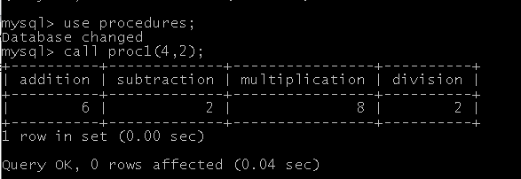

1. **Write a Procedure to print the string in REVERSE order. Take the input using IN parameter. (Ex .Database , o/p :esabatad)**

delimiter @@

create procedure proc2(in str varchar(20))

begin

select reverse(str);

end @@

call proc2("database");

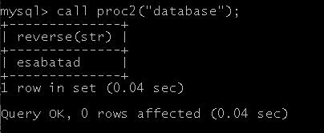

1. **Write a Procedure to display top 5 employee based on highest salary and display employee number, employee name and salary.**

delimiter %%

create procedure proc3(in len int)

begin

select empno,ename,sal from EMP order by sal desc limit len;

end %%

call proc3(6);

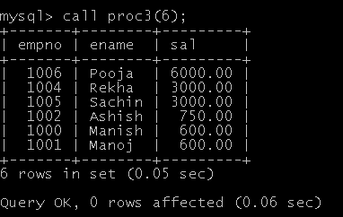

1. **Write a Procedure to create table emp_test with e_id integer, e_name varchar(10), e_joining_date date as columns**

delimiter ##

create procedure proc4()

begin

create table emp_test(e_id int,e_name varchar(10),e_joining date);

end ##

call proc4();

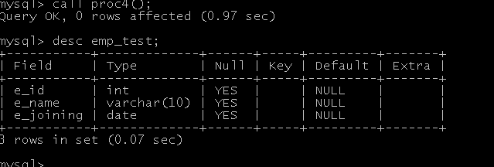

**5.Write a Procedure to add a department row in the DEPT table with the following values for columns deptno value 60,Dname value should be ‘Education’, area value should be Pune.**

delimiter &&

create procedure proc5()

begin

insert into dept(dno,dname,area) values(60,'Education','pune');

end &&

call proc5();

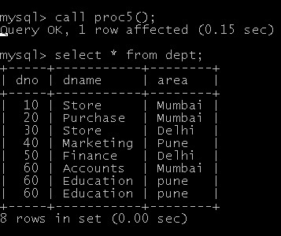

1. **Write a program that declares an integer variable called num, assigns a value to it and print, the value of the variable itself, its square, and its cube.**

delimiter $$

create procedure proc6(in val int )

begin

declare num,square,c int;

set num=val;

set square=val*val;

set c=val*val*val;

select num,square,c;

end $$

call proc6(6);

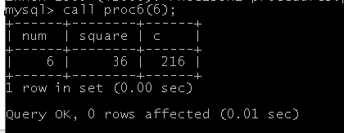

**7 .Write a program that declares an integer variable assign a value to it and display it using OUT parameter.**

delimiter **

create procedure proc7(out a int)

begin

declare val1 int default 10;

set a= val1;

end **

call proc7(@k1);

select @k1;

**8. Write a program that demonstrates the usage of IN and OUT parameters.**

delimiter &&

create procedure proc8(in e1 int,out len int)

begin

select length(ename) into len from emp where empno=e1;

end &&

call proc8(1000 , @k1)&&

select @k1;