**DBT Assignment**

**Following are the questions on Publishers, Authors, Titles and titleauthors tables:-**

*********************************************************

1. List pname, phone, email from Publishers.

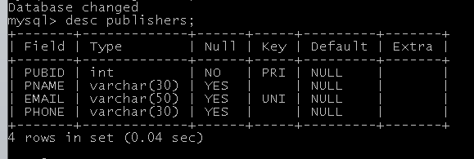

1. List aname, phone from Authors.
2. 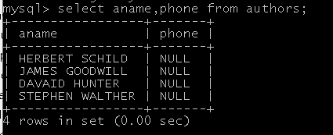
3. List titleid, title, pubdate from Titles.
4. 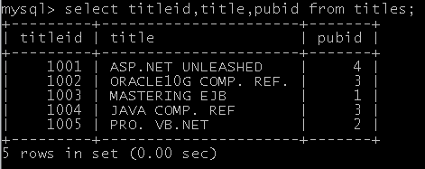

4. List auid, titleid, importance from titleauthors.

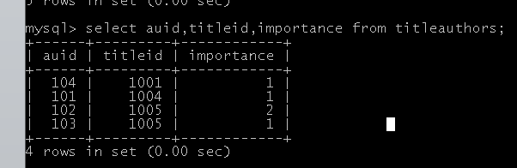

*************************(like)***************************

1. select subject name "oracle" from subjects table.
2. 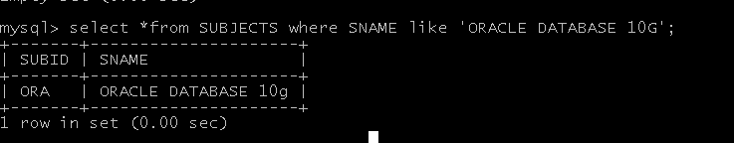
3. select subject name starts whith 'j'.

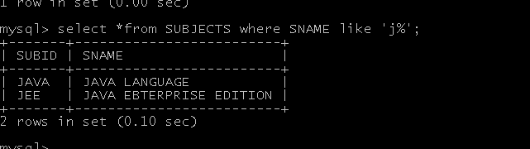

1. select subject name which contains ".net" .

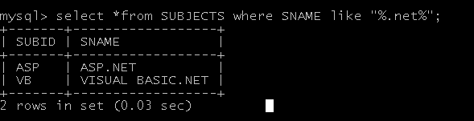

1. select author name ends whith 'er'.
2. 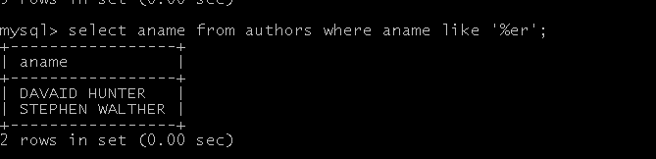
3. select publishers name which contains "hill".
4. 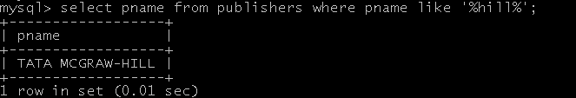

******************(relational operator)***********************

1. select title from title table having price less than 500.
2. 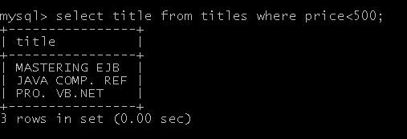
3. select title from title table published before '3 april'.

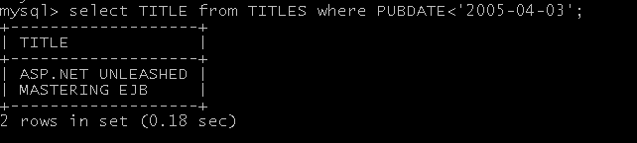

1. select subject name from subject having id as 'java' or 'jee'.
2. 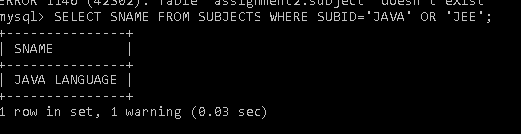

4. seelct author name from author table id greater than '103'.

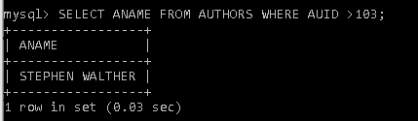

1. select all from title having titleid as 101 or price > 400.

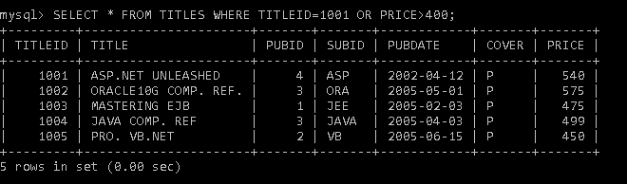

**********************(IN operator)*************************

6.select all from publishers table where publisher name is ('TECHMEDIA', 'WROX');

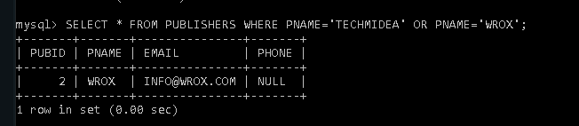

******************(aggregate function)**********************

1. select maximum price from titles table.

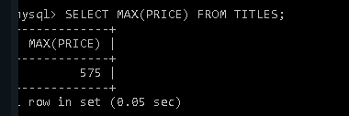

1. select average importance from titleauthors.

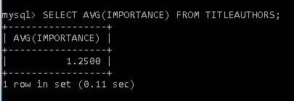

1. select number of records from author table

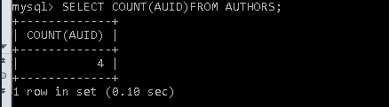.

4.select sum of prices of all books.

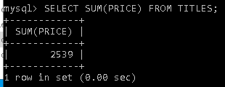

********************(date)********************************

1. select title from title table where month is 'Apr'.

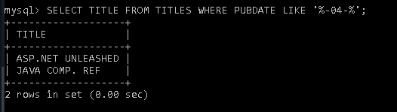

1. select year from system date.

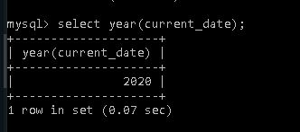

1. select month from system date.

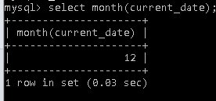

1. select last day of month when 'java' book published.

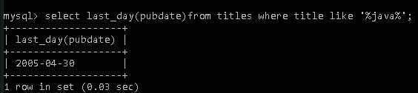

**********************(DML)*******************************

create table Employee with emp_id (number),emp_name(char(50)) and insert some value.

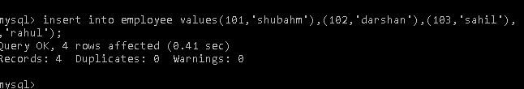

1. Add one column name 'dept_id ' in table name 'Employee';

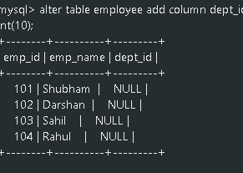

1. Change the datatype of column 'char' from tablename 'Employee' to 'varchar2'.

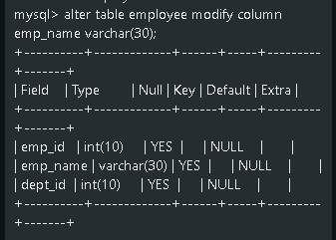

1. update name of employee to 'Scott'

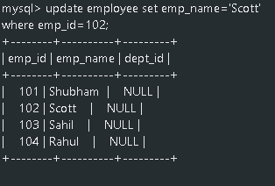

1. truncate the table.



**********************************************************

Table=> Emp

SAL(float(7,3))

------------------

1234.567

1530.019

1652.786

1775.156

**Perform :**

1. round

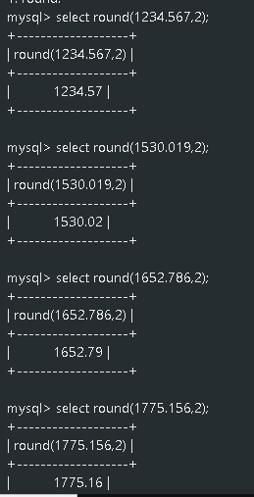

1. truncate

florr

1. ceil

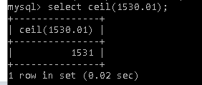

1. floor

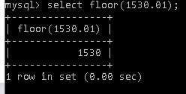

1. sign(-15)

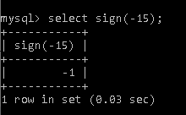

1. mod

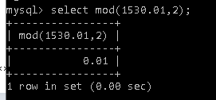

1. sqrt

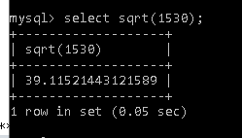

1. power

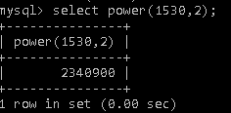

*****************************************************************

1. perform all string function on string "CDAC juhu".

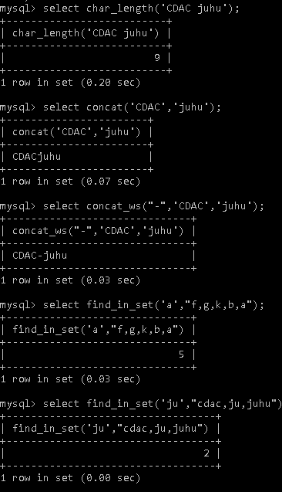

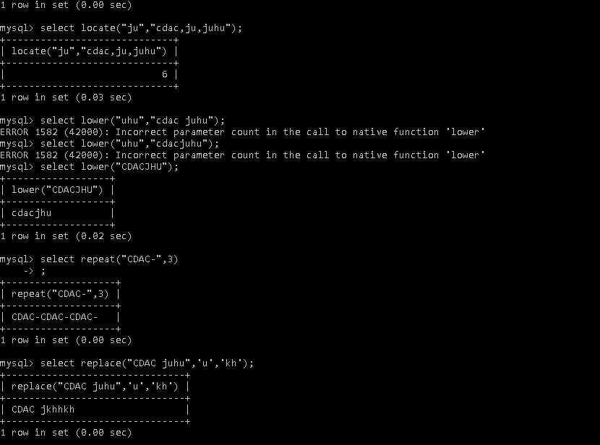

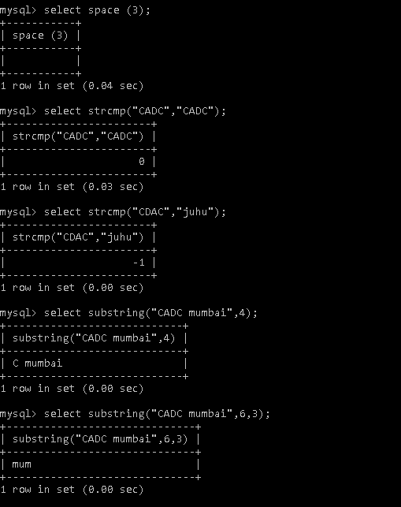

1. perform different date and time functions.

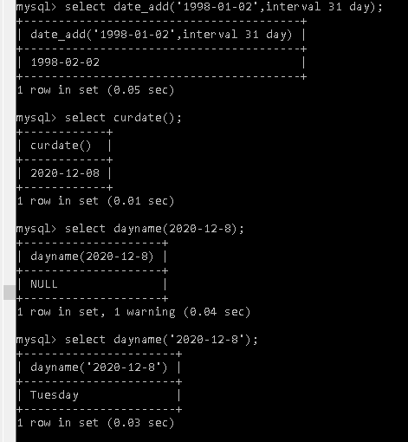

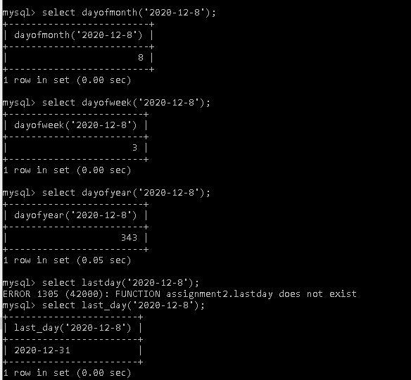

*****************************End**********************************