**Order by, group by,having**

1. create table Department with dept_id(integer),dept_name(varchar(50)).

dept_id will be foreign key in Employee table.

**Employee table**

---------------------------

empid emp_name dept_id salary manager

1 Arun 1 8000 4

2 kiran 1 7000 1

3 Scott 1 3000 1

4 Max 2 9000

5 Jack 2 8000 4

6 King 6000 1

**Department table**

-------------

dept_id dept_name

1 Finance

2 Training

3 Marketing

Apply not null,primary key and foreign key constraints.

***********order by

1. select all from authors sort ascending by author name.

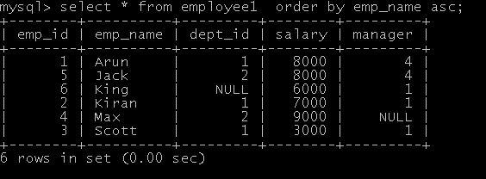

1. select all from department sort descending by department name.



***********group by

1. select all data and sum of salary from employee and group according to deptid.



1. select deptid and sum of salary where salary is greater than 17000 and group by deptid.



*********having

1. select deptid and sum of salary where sum of salary is greater than 18000 and grup by deptid.

2. select deptid and sum of salary where sum of salary is less than 20000 and grup by deptid.