Joins, Union, Subquery,Sequence

************joins*****************

1. select dept_name and emp_name where dept_id is same.

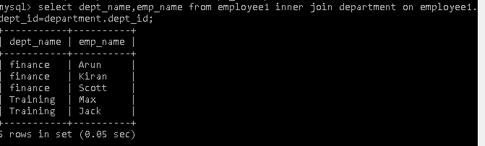

1. select all from both tables where dept_id is same.

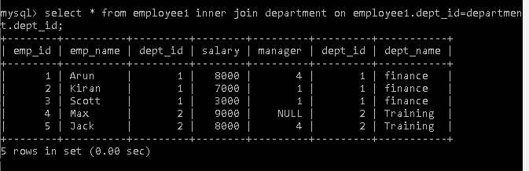

1. select dept_id and sum of salary group it by dept_id.

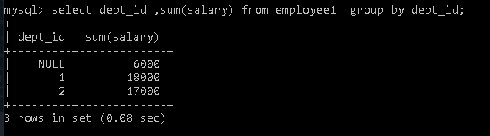

1. select dept_name and emp_name apply right outer join and left outer join.

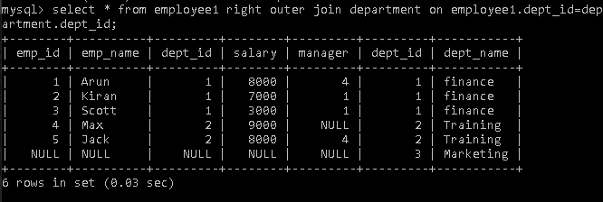

1. select emp_name with their respective manager names.

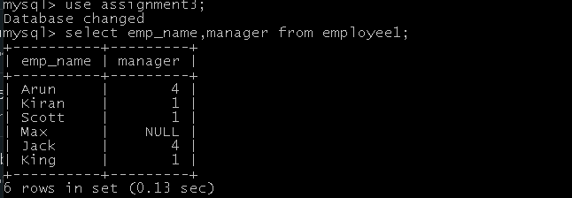

1. select epm_name with their respective department names

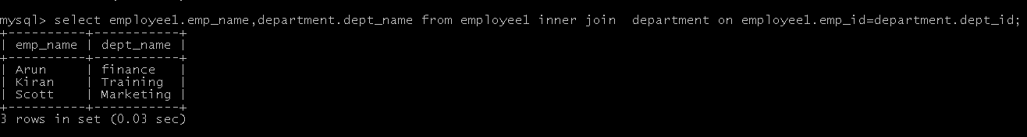.

*************union****************

Emp1 Emp2

--------------------- ------------------------

1 A 1 A

2 B 2 B

3 C 4 D

5 E

1. select same data from both table.
2. 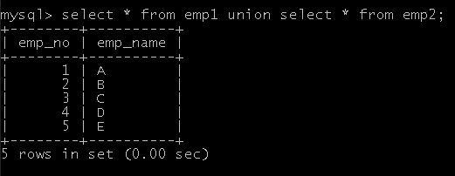

************subQuery*************

1. select employee having same salary as 'Arun'.

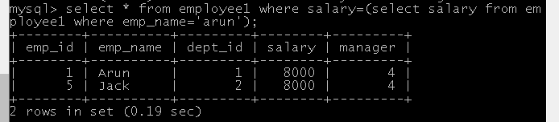

1. select employee belonging to same dept as 'jack'.
2. 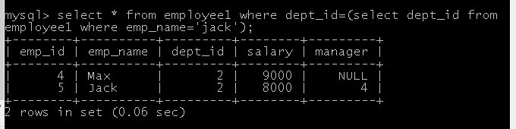
3. select name of employee havin lowest salary.

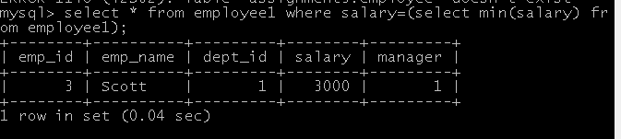

4. update salary =15000 of employees belonging to same dept as 'Max'.