

The Concept Paper for a Rainbow Scanner

by Iztok Fekonja, Head of Software, Nutek , Austria

https://www.nxp.com/products/processors-and-microcontrollers/arm-processors/i-mx-applications-processors/i-mx-8-applications-processors/i-mx-8m-family-armcortex-a53-cortex-m4-audio-voice-video:i.MX8M

Hallo Iztok, die Nummer von A1 ist 0800 664 800 von Oesterreich und entweder +43 50 664 8 oder+43 50 664 8 664 800 vom Ausland aus.

Software Concept

The main goal of the concept is to get as much high-tech (and look&feel) product at lowest runtime retail price.

I have done several startup projects, so I decided to follow known path:

- Standard Linux on board

- JavaScript user code implementation

- Node.js web engine with C++ AddOn extensions for video matrix processing

- JavaScript UI for dynamic modern user interface

There was also other solution proposal with Qt, but after analysing of actual requirements I decided to abandon it, because it was oversized and too much bound to their own vision.

It is a wish to get as less CPU/GPU load as possible in order to reduce the CPU model.

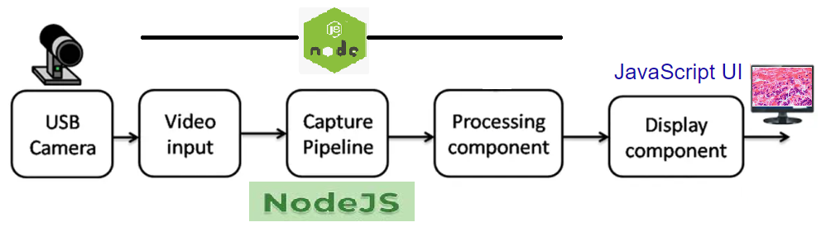

A strong CE capable of integrating an organization’s different functions, existing knowledge, and expertise will create a knowledge powerhouse that delivers outstanding products and results. Typically, the CE leads a small group of people to write the concept paper. This group should be able to link different activities within multiple functions and organizational hierarchies, and to break down cross-functional silos, with the knowledge and resources to manage horizontal value flows.

The CE in the LPPD environment oversees the whole product development process. This allows for the promotion of a better alignment of the entire organization; reducing typical handoffs, while minimizing common development wastes (i.e., useless information, knowledge loss, communication failures between functional silos, wishful thinking, etc.) that frequently lead to failed projects, excessive costs, delays, quality problems etc.

The development of a new product in the LPPD environment incorporates not only the physical products and services to be offered and delivered but also the new knowledge creation and usage. The concept paper is fundamental to supporting this project-management approach and this new leadership style and focus.


Chief Engineer

The Chief Engineer (CE) is a program or product engineer, with full responsibility for the development of a product family.

The CE has both a business and a technical responsibility, not just a focus on design elements.

The CE has to lead as having no authority as most people working in a project will have no hierarchical linkages with them.

Some companies have similar positions such as product manager or program manager, but often with a more limited range and scope.

The CE could also be called the Chief Entrepreneur. Allen Ward uses the term the Entrepreneur Systems Designer (ESD).

- The Concept Paper

Benefits of Having the CE Write the Concept Paper

In stark contrast to the current situation in most companies, using the LPPD approach and having a CE writing a concept paper creates the conditions for the emergence of the clear thinking required to make good products for customers and good processes for the company. An empowered CE will master knowledge about the market, the product, and the processes, and use this knowledge to develop both their personal and the organizational capability. Creating a concept paper goes hand-in-hand with empowering the CE to lead the development of a new product and ultimately a profitable value stream.

Writing a concept paper represents the social construction of commitment, engagement, agreement and alignment, providing the opportunity for contradictory voices and multiple arguments to be presented and considered during the initial stage of the project. This helps to define the decision-making process, establish the main stakeholders to be involved, and grasp the knowledge to be generated as well as the business results expected and the timing of the choices to be made in the upcoming development-process phases.

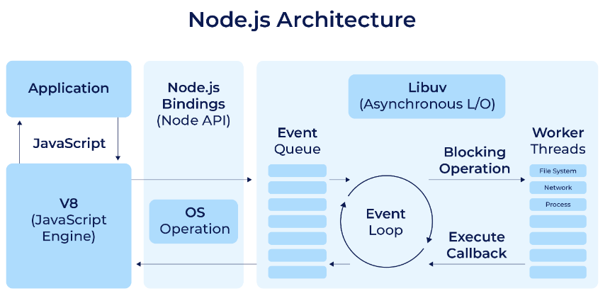

CP

The Study Phase: Deep Learning and Writing

The process of writing a concept paper is a unique and necessary development activity for the CE. No matter how knowledgeable they might be about the existing products and processes, they will always learn more by deeply studying the situation, “going to see” at the source, and asking the right questions to obtain vital data and facts. This will create a profound knowledge and understanding around the problem to be solved for the customer and the company.

The Concept Paper 3


Existing knowledge and previous experience by the

CE may be desirable, but it should be expected and

accepted that they will have some gaps to work on.

Writing a CP will develop and clarify their thinking

around the new value stream, which will enable

them to initiate and conduct a productive dialogue

during the various development stages. It will also

establish important definitions and understandings

of the new product to be tested and defended during

the course of the development journey.

The study phase can take up to several months, and will require a great deal of research, data collection, consultation, and reflection. It should allow for frank, objective, productive, and profound discussions with the key project stakeholders. This includes ongoing dialogue with senior management to align the new product development with the corporate strategy and business requirements. The concept paper is a summary of possibly a staggering amount of data and information that has been collected.

To be successful in the study phase requires certain personal characteristics, behaviors, and attitudes. The CE’s observation and listening skills have to be acute and perceptive enough to capture a multitude of inputs from customers and the environment into which the product will be introduced, as well as from other competing companies and major internal stakeholders, e.g., senior management, engineering, manufacturing, purchasing, suppliers etc.

This requires an open mind, scientific fact-driven thinking, an eagerness to learn, critical thinking skills, and a challenging attitude. The CE must also posses the necessary negotiation skills to reach agreements with the often highly opinionated individuals responsible for areas in which specific developments and experiments will need to be run.


The Study Phase

The CE, together with a very small team, visits the different gemba to observe—often with an ethnographic perspective—and listen, gather data, compare, discuss, debate customer needs, understand the competition, current product portfolio strengths and weaknesses, identify business needs, evaluate internal capabilities and knowledge base, identify gaps, assess disruptive factors etc.

- The Concept Paper

Why is this approach better? What is the benefit of having one person responsible for this critical and often complex activity? A typical organization gathers much of the information required for the new-product development process. Sometimes it is necessary to make budget definitions as part of the investment decision-making process.

Companies may use many different formats to present a business case for a new product to get the approval of top management. However, these cases are typically too generic, providing vague promises or wishes, with some cooked numbers that support an optimistic, with much wishful thinking, but ill-defined view. Even if they are well-documented—packed with lots of data and layers of slides—they are often the result of too many different functions and persons and not well-coordinated and aligned.

As important, this scattered approach dilutes responsibility and knowledge, and creates too many handoffs. With many people involved and no one clearly responsible, a PD project can quickly turn into an unmanageable and chaotic development processes. The people that will execute the resultant plan are not necessarily the people who defined it. The focus can become the optimization of functions, instead of the horizontal flow improvements and develop-ments. The results will likely be frustrating.

https://www.freepik.com/premium-vector/user-interface-elements-finance-mobile-app-financial-analytics-time-management-planning-gui-templates-unique-neumorphic-ui-ux-design-kit-manage-navigation-search-form-components_8906591.htm

https://www.freepik.com/free-photos-vectors/white-ui/2

Free
https://www.freepik.com/free-vector/web-element-layout-template-interface-illustration_3098857.htm#query=ui%20interface&position=37&from_view=keyword&track=robertav1_2_sidr

https://github.com/nodejs/node-core-utils

What is the Concept Paper?

The concept paper is typically a 10–30 page document that translates customer needs into clear, consistent requirements. It defines the parts and components of the product to be developed; provides guidance for the selection of concepts; defines key targets and tradeoffs; and formalizes the main project elements, such as specific objectives, timing, cost, budget, and knowledge reuse.

It should outline the product vision, the product scope and features, the main targets and ranges, the project timeline and its key milestones, and the project management roles and responsibilities. The specific definitions of these elements are as follows:

Product vision

The product vision is the core of the concept paper. It should present the overall concept, business reasons, and requirements for the product. It should answer the questions: Why we are developing this new product? What problem for our customers, company, and society are we trying to solve?

The Concept Paper 5

It could begin with the product background, such as a brief history of the product in the market, its relevance for the company, and the main reasons and business justification for this new product. It should contain all the necessary information, based on real facts and data, to get started with the new product. Understanding the customers’ needs is the crucial part of formulating the product vision.

Some specific questions to be asked are:

- How do customers currently use existing products?

- Who are the potential customers?

- What are their needs?

- What frustrates them?

- What problem are we trying to solve for them?

- Could we segment the market?

- What are the competing products and services?

- What are emerging and possible disruptive factors?

Product vision


Definition of value for customers, the company, and society, including the business and technical requirements.

Vision statement

Simple and crisp, clearly defining the product vision

Vision sketch

A simple drawing or image representing the new product

The best way to truly understand the customers’ requirements is through direct observation and engagement. Using an ethnographic approach that tries to understand customer needs from their point of view and perspective can be very useful. This involves the CE going to the existing customer base, where the potential customers are or could be. They should get as close as possible to actual customers, using products and concepts, in real conditions and situations, as much as possible. Qualitative direct observation will frame the definition of the real product value for the customers, which should derive the quantitative product requirements, functions, and features.

Additional requirements to enhance and improve customer experience could be explored as well. Traditional ways to assess the market, i.e., market research, analysis of data based on internal quality surveys, specific customer complains, data from external sources, etc., can be used to further understand the customer and existing products. But they should never be utilized as part of any blaming game for incorrect data and analysis as the CE is ultimately responsible.

- The Concept Paper

Product Sketch
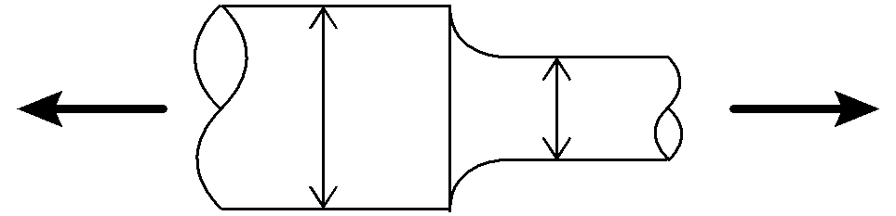

The product vision should also be informed by an understanding of different macroeconomic scenarios, a study of competitors’ products, competing products already offered by the company, and other possible disruptive alternatives and factors. These may be presented in this vision part of the paper, along with specific business objectives, e.g., increase market share, enter new market segments, protect an existing position, provide a better customer experience, increase margins, improve quality, diversify customers, etc.

A clear hoshin objective could inform the product vision. If a company does not have a clear definition of priorities, alignment, and communication around its True North, the process of writing the concept paper will expose this weakness, and therefore should stimulate an effort to clarify it. A clear and concise vision statement for the product should make the vision easily understood by all people involved. A simple and short phrase should capture the imagination of both the company and the team involved in the development effort.

A conceptual sketch or simple drawing here is often very helpful. Not of the final product, but as a visual representation of what the product might look like, to drive the team’s focus and attention and to engage others in the discussion. With these elements in place, the product-specific characteristics—its main features around the product scope—can now be thought out.

Product scope

The concept paper should define the potential product scope, including the main components and features, e.g., product content, the component’s architecture, the list of possible options, how much product variation and standardization there will be, whether it is part of a common platform with other products, etc. The new product could be an improvement of a current product, a major change in some key product elements, or a completely new, innovative, or even disruptive product. Or it could even have the pretension to create a new market or an entirely new business model.

The Concept Paper 7

The scope should include the must-have, nice-to-have, and must-not-touch features of the new product. “Must-haves” are the new essential requirements, elements and features for the new upcoming product. They could embody the new knowledge developed during the development stages. “Nice-to-haves” are new features that could be incorporated into the product depending on the various factors that interfere in the development, e.g., new knowledge generation, timing, and costs. Existing knowledge from previous projects could be very useful here. Finally, “must-not-touch” elements describe those features that will be maintained in the new product architecture.

Product Scope


Platform, modules

Models, versions, options

Components, subsystems

Reusable knowledge

Must haves

Nice-to-haves

Must-not-touch

Is/is not list

A clarification of what the new product “is” and what it “is not” and “doesn’t intend to be” could be helpful to avoid the constant loopbacks, rework, divergent and conflicting ideas, chaos, scattering, and dispersion that tend to occur during the development process. These definitions help to frame the cooperation and engagement with different functions where the deep pockets of knowledge are often available that would have to pulled during the development process. It is a way to guarantee the alignment and focus throughout the project. At the same time it clearly defines the requirements and the areas in which the CE will need assistance and support.

Product Targets

Once the customer needs and product vision

are translated into specific product features
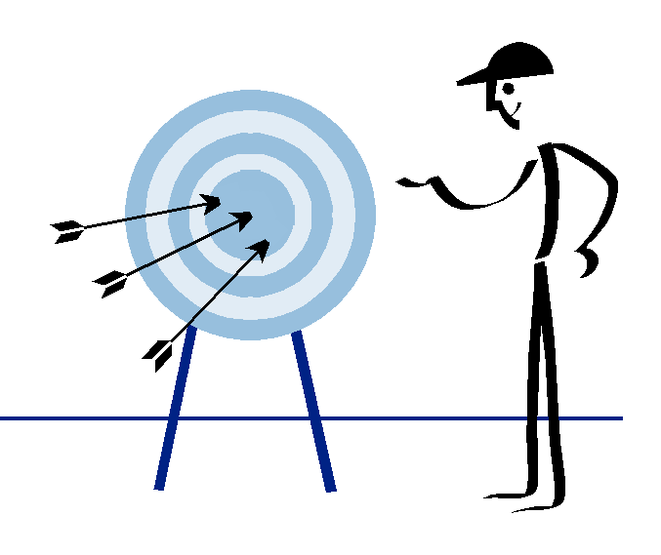

and scope, the next step should be the

definition of specific quantitative product

requirements around targets and ranges.

Specific targets for the economic side might

include such indicators as expected volumes,

costs, margins, sales forecasts, technical

performance features, lifecycle expectancy,

etc. A typical description of product targets

as compared with competitors’ existing

products could be laid out in a simple

matrix as follows (see right).

- The Concept Paper

Main New Product Targets (illustrative)
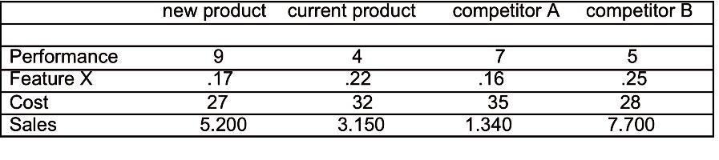

The definition of targets should frame the process in order to quickly search and explore different alternatives and ways to test them (as well as multiple solutions if possible). This will allow for progressively deselecting the weaker perspectives and continuously working on the better ones (set-based concurrent engineering).

Key trade-offs could then be defined to generate the necessary, validated learning and knowledge throughout the development process. This knowledge can be represented in simple trade-off curves that show the understanding of the behavior, how to solve specific problems, and whether the solutions envisioned are worth pursuing.

The definition of ranges instead of specific targets can be equally useful as the project should be focused on system optimization rather than searching for specific punctual improvements. The definition of those minimum- and maximum-accepted values establishes what is sufficient and helps to avoid excessive efforts in time and resources to reach targets that sometimes are hard to attain.

Trade-off Curves
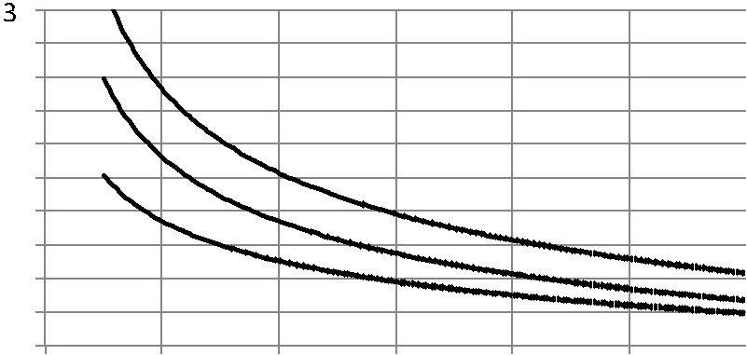

D/d 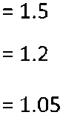

The Concept Paper 9

Project Timeline and Milestones

An excellent product idea will not succeed if it is poorly executed. It’s important for the CP to define the project cadence with key delivery dates of specific elements, plus methods and tools to evaluate progress. The project timeline should also be well defined. The fundamental PD decisions and definitions should be laid out, as well as when they should happen. The project success depends upon assessing deliveries expected for the time assessed. If they’re not achieved, some decisions will have to be made to allow the project to continue.

To guarantee the cadence and flow you need to define the main project milestones. A project milestone is a special event that represents a point in time that marks the expected conclusion of certain activities and tasks, and more importantly, the expected deliveries. They work like “pulling events” when many activities have to performed in order to make some critical decision to move the process forward. They can also be seen as decision points based on some specific learnings achieved.

Milestones are integrated events (3 to 10 in a typical project) that make the knowledge progress visible and represent the conclusion of a learning cycle. They pull the required development work and knowledge. The definition of objectives and dates of these integrative events will help to synchronize the work of different functions and areas. This creates clarity around the work to be done and delivered.

April |  | May |  | June |  | July |  | Aug. |  | Sept. |  | Oct. |  | Nov. |  | Dec.
1–15 | 15–30 | 1–15 | 15–30 | 1–15 | 15–30 | 1–15 | 15–30 | 1–15 | 15–30 | 1–15 | 15–30 | 1–15 | 15–30 | 1–15 | 15–30 | 1–15 | 15–30
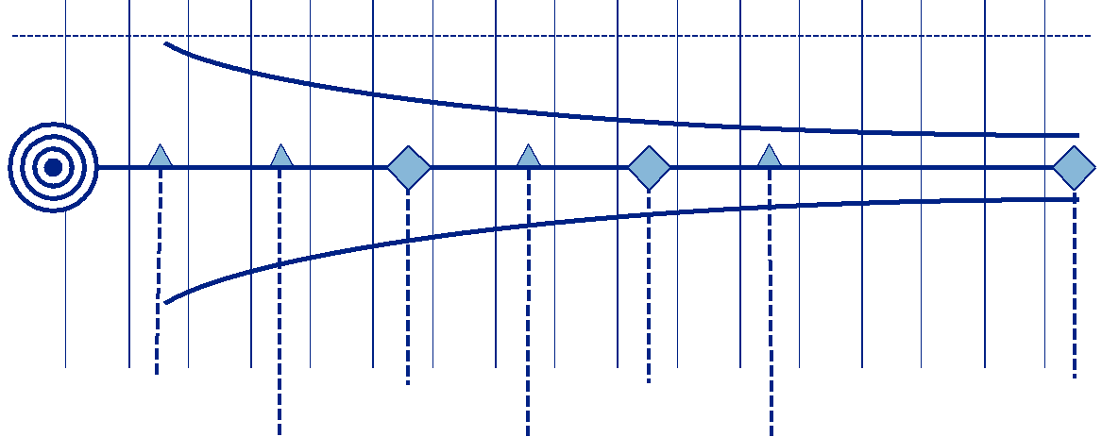

Target

Select 5 Build 3 Build beta Product
concepts prototypes prototype confirmed

Choose Deselect Learning
3 concepts 2 prototypes evaluated

Milestones are key integrating events when knowledge progress is made visible, and represent the conclusion of a learning cycle.

- The Concept Paper

Milestones should define the key project engineering, purchasing, and manufacturing decisions, all placed in a time frame. An emphasis on physical and tangible elements is often useful. Examples include:

- concepts definitions

- concept de-selection

- prototype definitions

- evaluation of tests/knowledge generated

- start of production

Another mechanism to evaluate progress and to advance the project are design reviews, which are used to evaluate the current stage of the design against the previously defined requirements. These design reviews should involve the project sponsors and, if possible, external experienced people.

And finally, a daily routine could be established to guarantee the discipline and the problem solving arena where emerging issues are dealt with as they appear to allow the necessary time to fix them to mitigate its consequences. The project critical path would also be defined in this part of the concept paper.

Project Management

Methods and Techniques, Roles and Responsibilities

It is important that the concept paper details how the project is going to be managed, including team composition and definitions, and the roles and responsibilities of each person. Content should include senior-management sponsors, key A3s for the project, visual management and daily management schemes, designated problem solving tools, the project support scheme, and the help chain. The contributions of the right people, at the right time, and the expected learning and how it will be validated should also be captured and displayed clearly.

This part of the concept paper should frame some resource allocation definitions, such as the size of the team, global or local team composition for complex projects in global companies, co-location strategies, how the dedicated functions will be allocated, the key project personnel around the CE, etc.

The Concept Paper 11

Many people might be involved in multiple projects, which will require synchronization across different functional groups. There should be a generic timeline for the whole project and more short-term timelines, e.g., “allow two weeks for a more detailed approach.” Design reviews in the scheduled time, such as who is going to be involved and how they will be engaged, should be included. The obeya room project-management architecture could be the place for making this work visible, allowing for exposed problems to be solved by an engaged and committed team.

The project obeya should make the real project conditions visible and expose problems and challenges. And it should be an exciting and dynamic work area that shows everyone where they are in terms of the development work, generate and expose new ideas, elicit learning and reflection, engage team members, and stimulate thinking. Some of the main targets and visual aids (e.g., pictures of existing products, concept sketches, early-phase product prototypes, A3s of key project elements, etc.) should be publicly displayed in this space. The main elements of the CP should be clearly displayed.

Companies in the transition process of using visual systems but in parallel having a traditional planning and control may have a difficult time managing two parallel and often antagonistic practices. A definition towards using the visual management entirely in at least one project could be an useful decision.

Additional key elements defined in the concept paper could include: major challenges and risks, connections with other company projects, specific assumptions and definitions about the business implications, critical factors and risks, support-function requirements etc.

Two Views of a Product Obeya
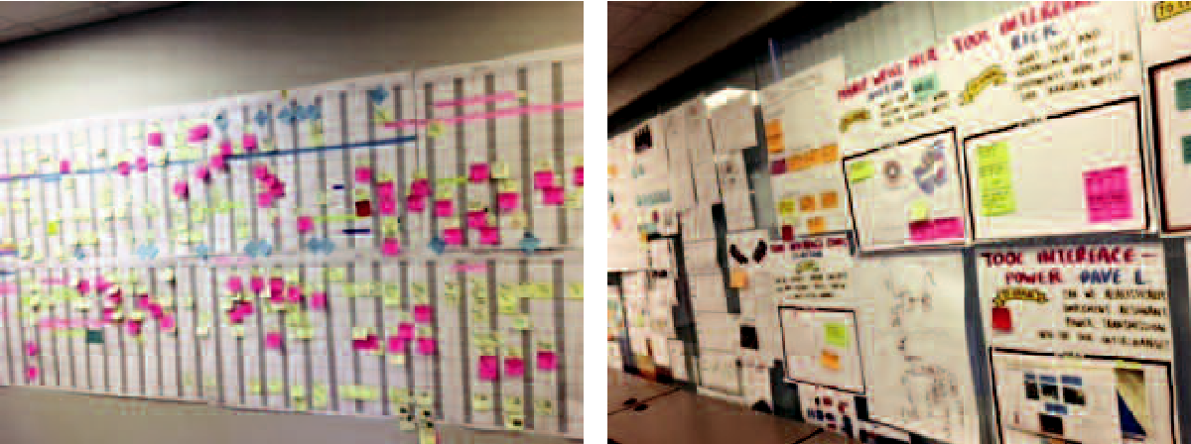

- The Concept Paper

The Concept Paper Enhances and Transforms Product Development

The effort of writing the concept paper often represents a major turning point for many companies in their LPPD journey. In addition to developing deep product knowledge, it creates alignment and commitment from the major organizational functions at the start of the project. This provides clarity and focus for the development and execution of the project.

More importantly, it helps the CE to build credibility and understanding around the crucial elements of the new product and forms the foundation for leading without authority, thanks to the knowledge and support gained, and the alignment achieved for the entire company.

Development processes tend be chaotic, with high levels of uncertainty. Many projects fail because they start too loosely with some vague ideas about the future products. What sounds like an initial good idea, often doesn’t survive a very simple check and critique. Conversely, you can start with an idea or concept that proves to be inadequate only in the advanced phases of the project, resulting in much rework and long lead times.

Writing a concept paper allows the CE to navigate flexibly but firmly in frequently turbulent waters. It may take a long time to research and write it, and can be very time-consuming. But it engages almost the whole organization and facilitates the teamwork required to develop a successful value stream for a new product. Drafting the concept paper is a key part of the nemawashi process (planting the seeds for the harvest) by getting organizational alignment and agreement prior to starting the project.

The concept paper should not be a frozen document. It will and should become a living document throughout the entire development process, changing and improving based on facts and learnings—not just new opinions—as new factors emerge. Reviewing its content around major significant milestones can be seen as reflection moments.

It is not necessary to define all elements of the new product before beginning to write a concept paper. But having a formalized document helps to prevent scope changes—even vision changes—from happening too quickly and erratically. Having the CE act as the sole guardian of the concept paper avoids the common situation where many people contribute interesting ideas despite none of them having a knowledgeable and systemic point of view.

Communication and Engagement

Communicating and engaging with everyone is fundamental in any successful project. To support this, an A3 based on the concept paper should be written to easily and visually communicate its main elements. As the development process unfolds, additional teams may

The Concept Paper 13

get involved and a quick engagement will be needed. An A3 can be a useful and efficient way to explain the main elements and the overall project story to them.

Once finalized, the concept paper can be signed by key people involved to formalize the agreement and presented to a company-wide audience at a product “kickoff” event. This will energize the company and engage the teams in the construction of a successful future for the organization.

A3

Vision Timeline

Scope

Targets Management

Analysis

It can also be used to “celebrate” the agreement achieved so far, and engage the team and the supporting functions to gain the commitment required to move the project forward. If written and presented properly, it should be able to engage people emotionally and drive passion around the new product.

Product “Kickoff” Event
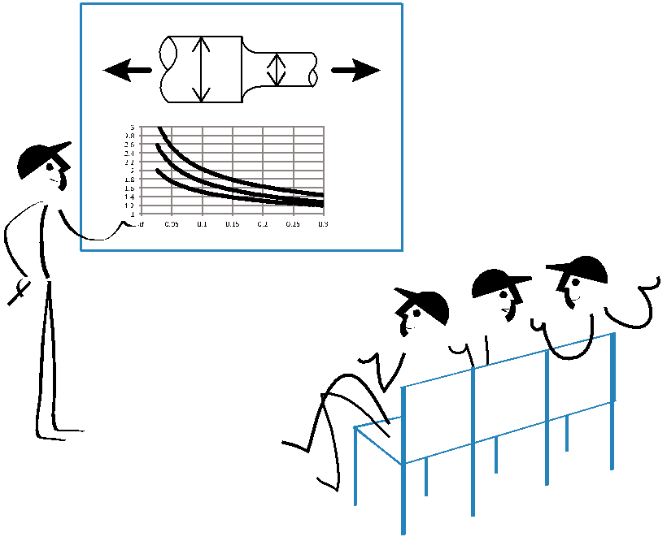

D/d

A public ceremony where the concept paper is presented and discussed to communicate and validate product ideas, create alignment around the product vision, and explain the benefits for the company.

- The Concept Paper

Conclusion

A good concept paper should be clear, compelling, concise, and time oriented. How detailed it should be and how deep it goes depends on the maturity of the company, the nature of the project, the current project development processes, and the knowledge and capability of the CE. The CE’s ability to tell a compelling story and present a winning argument about the new product is a key success factor for engaging and gaining support.

By defining the product’s vision, features, and targets, as well as the project’s timeline and the management processes, the concept paper establishes a common project language, a standard framework for thinking, and the flow needed to get a new project started. It engages the deep thinking of the CE and enhances their capabilities and skill. It creates commitment around the new product from the perspective of the customer, and transforms an organization’s ideas into concrete technical and business realities around new products that better satisfy their customers. It is a great way to kickstart a development project and create outstanding and successful product.

Notes

Thanks to John Shook, Jim Morgan, Eric Ethington, John Drogosz, and Katrina Appell for providing the LPPD learning environment. Eric and Katrina made very useful specific contri-butions to the content of this paper. Thanks to Thomas Skehan for editorial and art support and Cameron Ford for editorial assistance.

A first version of this article was presented at the LPPD Co-Learning Partners meeting at FMC Shilling Robotics in Davis, Ca in November 2016. And thanks to FMC Technologies Rio Tech Center for providing the testing ground for some of those ideas and concepts.

The LEI-LPPD web site (www.lppd.org) has multiple learning resources that further support this article. Some of the issues mentioned, such as set based concurrent engineering (SBCE) obeya, and visual management, milestones, etc., are discussed in greater detail on the site.

References

Liker, Jeff & James Morgan. The Toyota Product Development System: Integrating People, Process And Technology. Productivity Press, 2006.

Sobek, Durward and Allen Ward. Lean Product and Process Development. Lean Enterprise Institute, 2007.

Hino, Satoshi. Inside the Toyota Mind. Productivity Press. 2006.

The Concept Paper 15



215 First Street, Suite 300

Cambridge, MA 02142

617-871-2900 • lean.org


