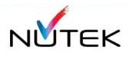

The Concept Paper for a Rainbow Scanner

by Iztok Fekonja, Head of Software, Nutek , Austria

https://www.nxp.com/products/processors-and-microcontrollers/arm-processors/i-mx-applications-processors/i-mx-8-applications-processors/i-mx-8m-family-armcortex-a53-cortex-m4-audio-voice-video:i.MX8M

https://www.compulab.com/products/computer-on-modules/mcm-imx8m-mini-nxp-i-mx-8m-mini-solder-down-som-system-on-module/

https://www.phytec.com/product/phycore-imx8m-mini/

https://www.cyberport.at/notebook-und-tablet/tablets.html?productsPerPage=15&sort=price_asc&q=&page=1
https://www.refurbed.at/p/samsung-galaxy-tab-4-7-0-t230-7/5931b/

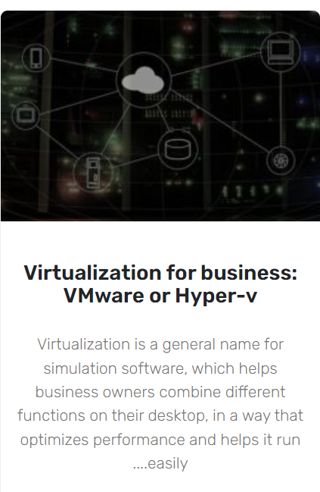
Software Concept

The main goal of the concept is to get as much high-tech (and look&feel) product at lowest runtime retail price.

The concept is proven “factory automation” way (Soft PLC), where the solution consists of two main components:
- Realtime Data acquisition and digital analysis
  - Linux on MX8M board
  - Realtime service process processing image data
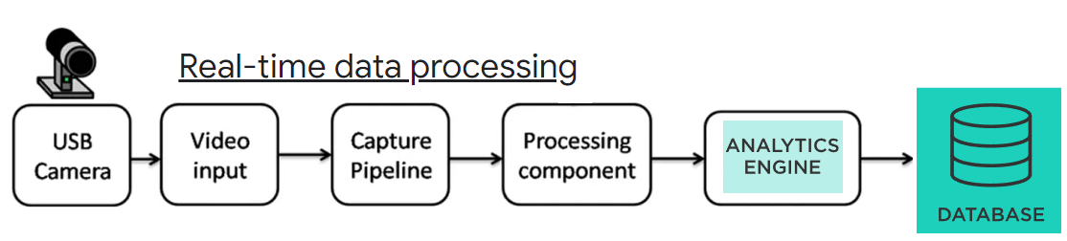
- Independent GUI Presentation on Touchpanel
  - Node.js web engine with C++ AddOn extensions
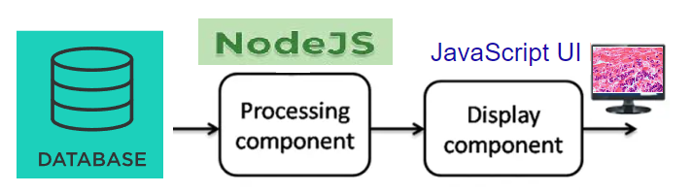
  - JavaScript UI for dynamic modern user interface



Benefits of Node.js Architecture

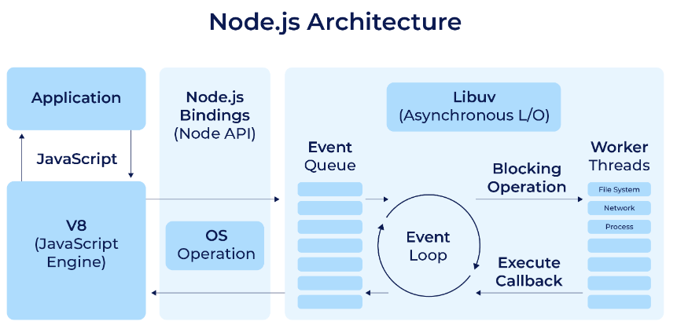

CP

The Study Phase:

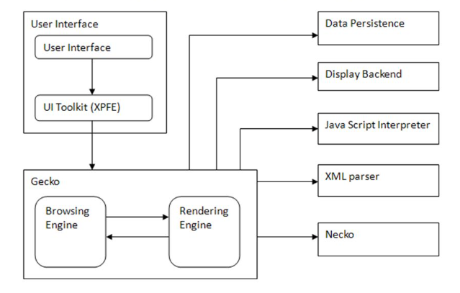

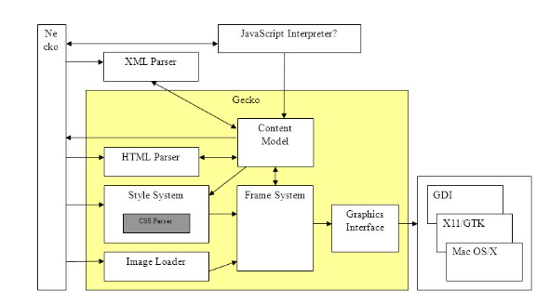
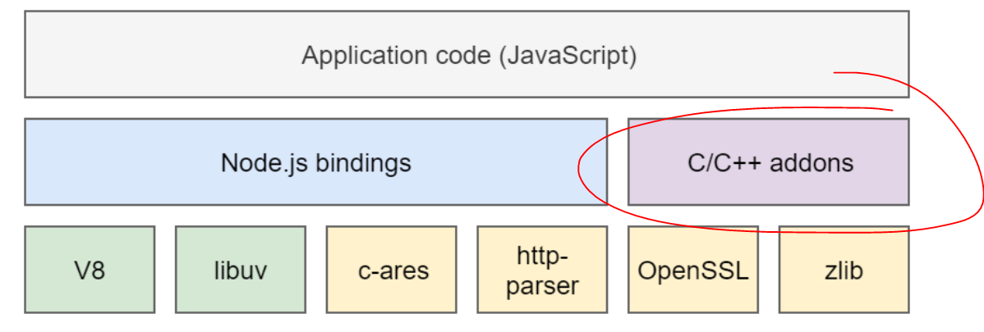

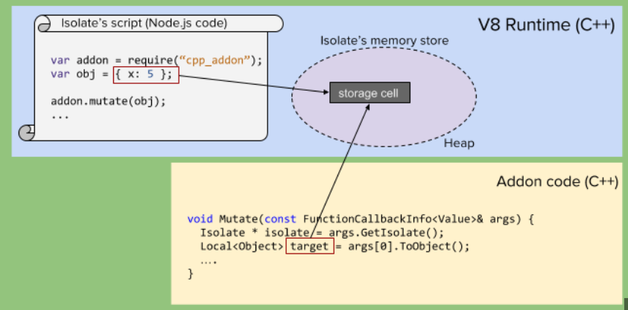

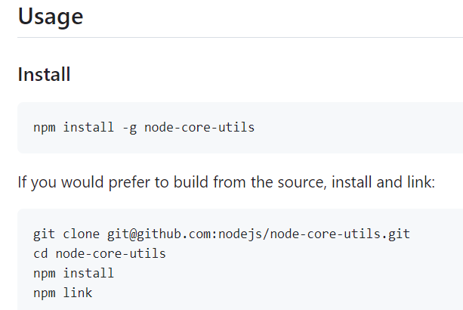

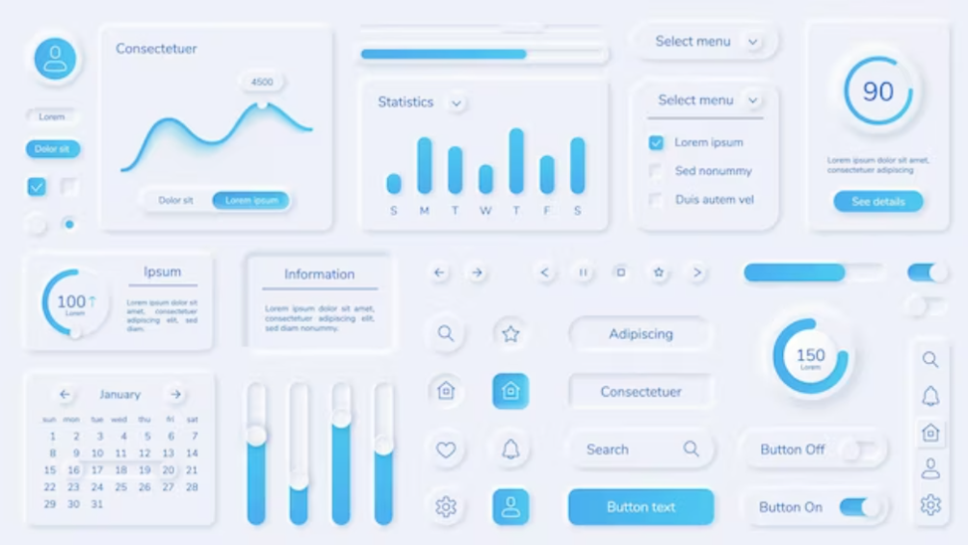
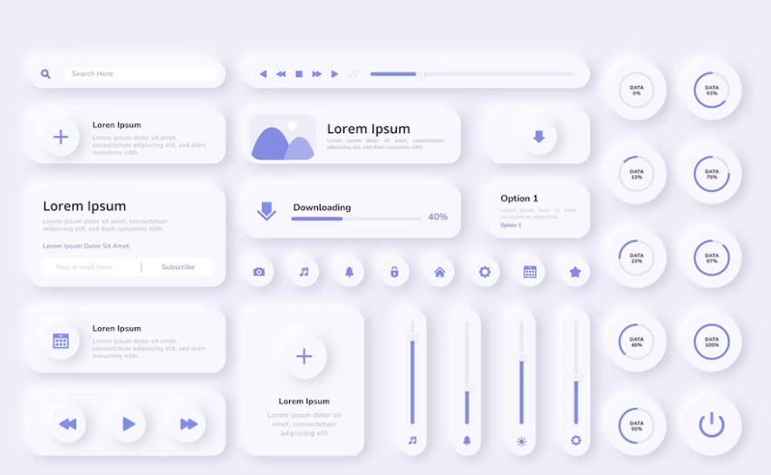

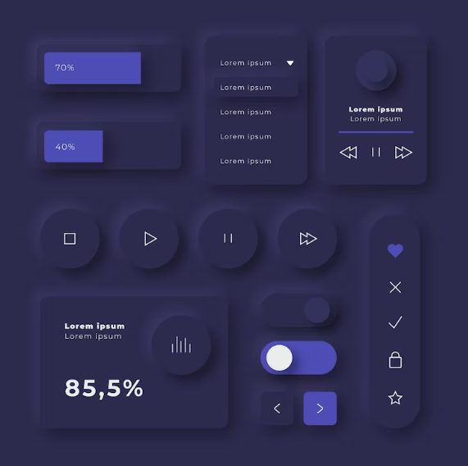

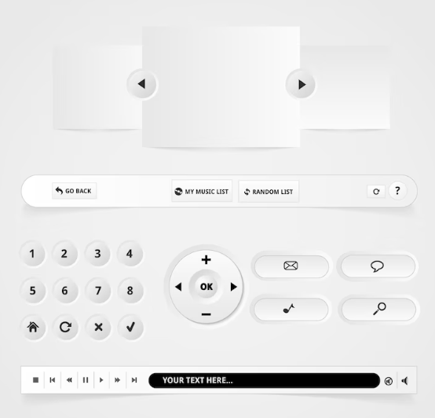

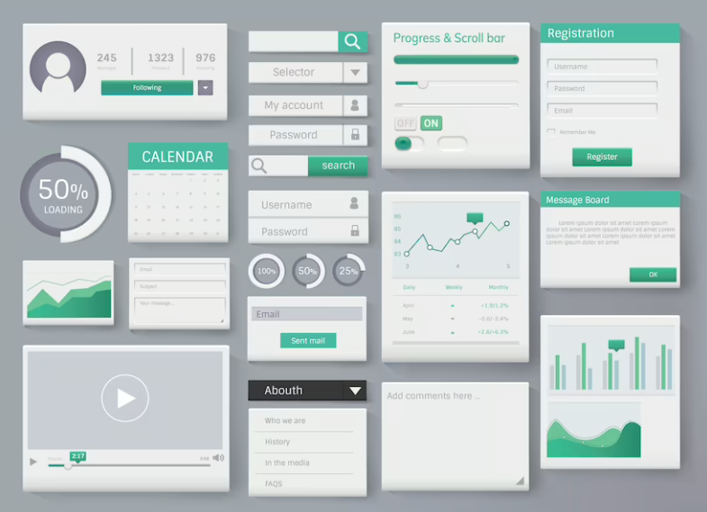

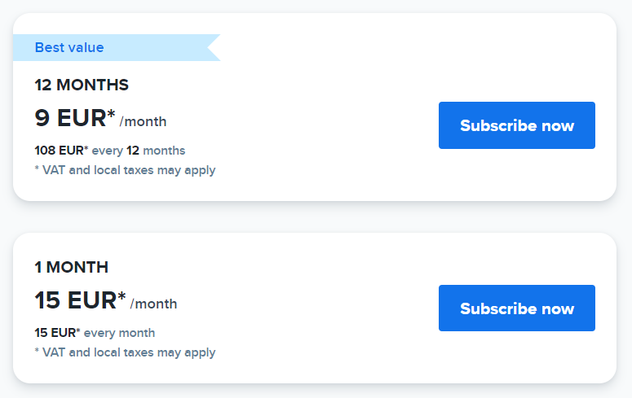

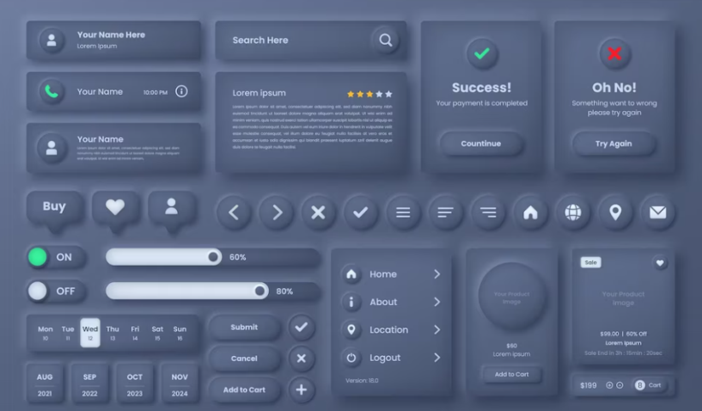

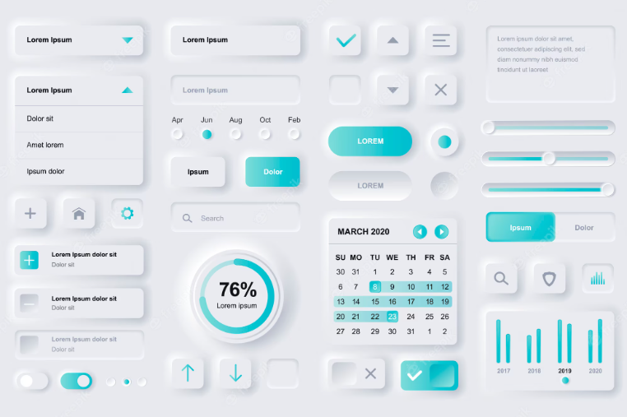

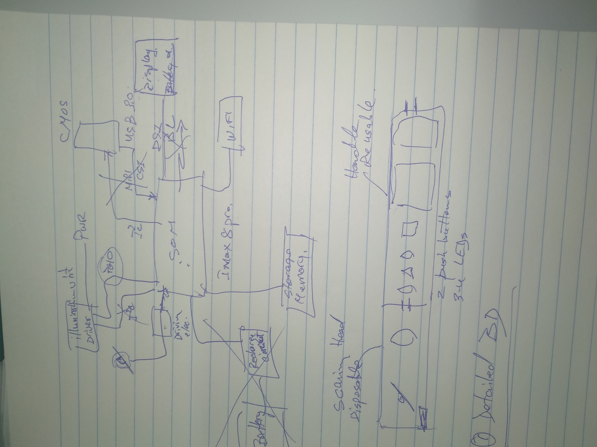

https://www.freepik.com/premium-vector/user-interface-elements-finance-mobile-app-financial-analytics-time-management-planning-gui-templates-unique-neumorphic-ui-ux-design-kit-manage-navigation-search-form-components_8906591.htm

https://www.freepik.com/free-photos-vectors/white-ui/2

Free
https://www.freepik.com/free-vector/web-element-layout-template-interface-illustration_3098857.htm#query=ui%20interface&position=37&from_view=keyword&track=robertav1_2_sidr

https://github.com/nodejs/node-core-utils

Concept Paper

Reference


