Table of Contents

Installation/Set Up of Jenkins 2

Installation 2

Setup 3

Installation/Set up JDK 6

Installation/Set Up of GIT 6

Installation 6

Setup 6

Installation/ Setup of Maven 7

Installation and Setup of Sonar 7

Installation 7

Setup 8

Installation/Set Up of ZAP 9

Installation/Set Up of WinSCP 12

Installation/Set Up of Azure CLI 2.0. 13

Installation/Set Up of Katalon Studio 13

Installation/ Set up SVN 14

Step 1) Navigate to the actual repository with App and Service code base. 14

Step 2) Navigate to Hooks - > Post-commit hook - > Edit 15

Step 3) Add the batch commands below - > apply -> Ok 15

Plugins to be Installed/ verified if installed. 16

## Installation/Set Up of Jenkins

### Installation

Download Jenkins war from the below link <https://updates.jenkins-ci.org/download/war/>

From the command prompt, browse to the directory where the jenkins.war file is present.

Run the below command, to start the Jenkins at localhost: 8080 (Can modify the port to be run)

Else, download the installer (Installs as service)

<https://jenkins.io/download/>

For the first time installation on a system generates administrator key. Which needs for the first time access.

Initializing the Jenkins with two options, select which is suitable based on the requirement.

1. Most used set of plugins with Jenkins.
2. Custom set of plugins with Jenkins.

After which the dashboard is ready with no jobs/tasks.

Use New Item to create a job/task based on requirement.

Dashboard with jobs

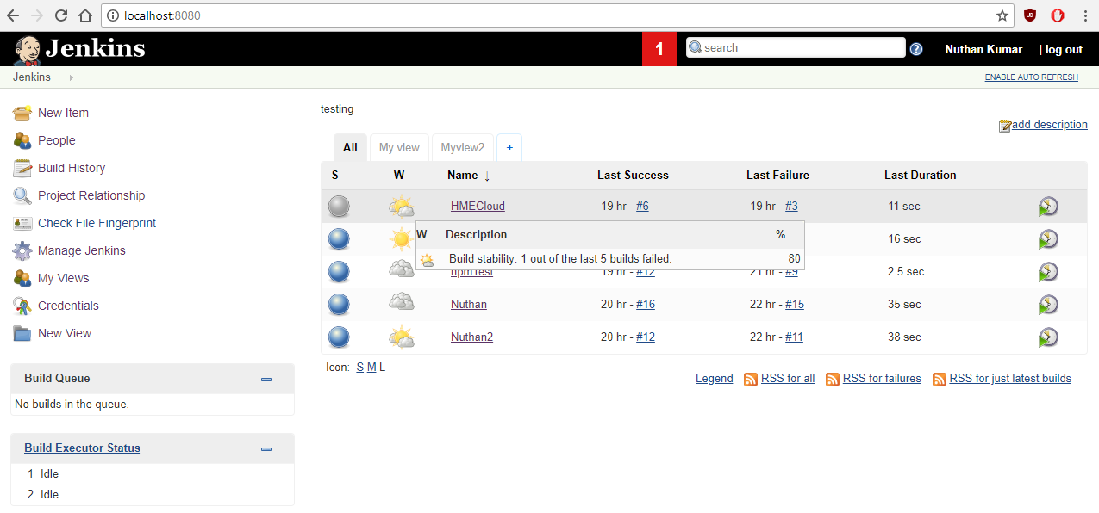

### Setup

Commonly Used for Configuration of Jenkins for any plugins

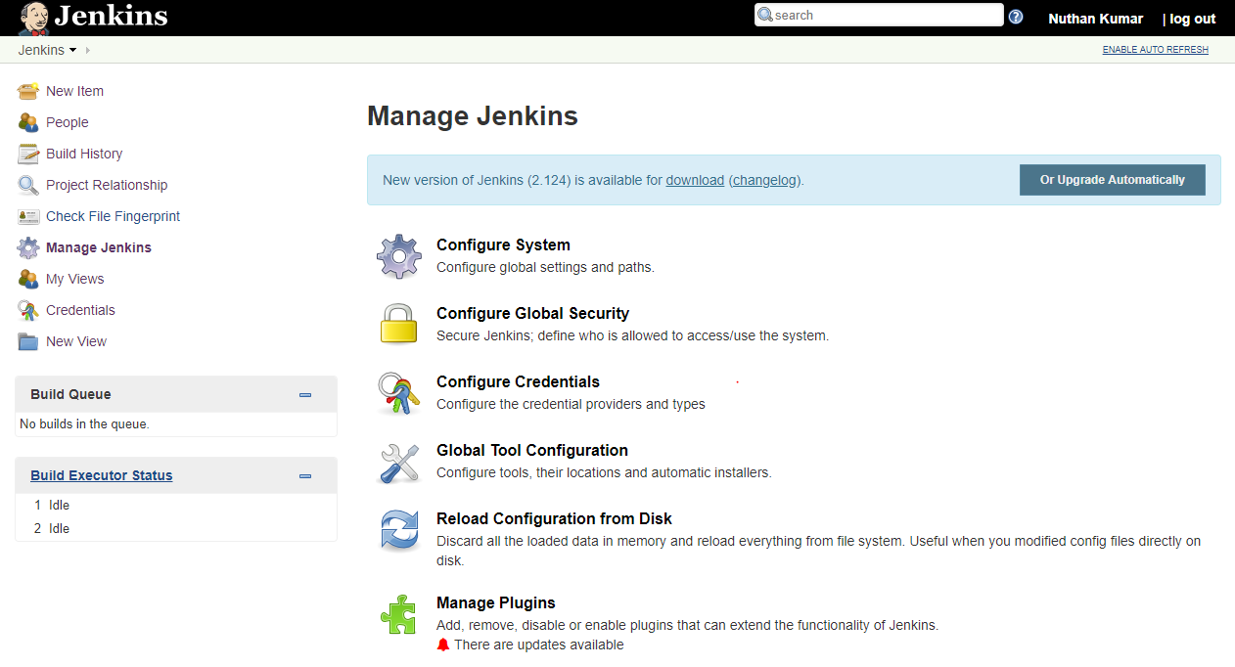

For plugins

Global variables definitions

System Configuration

#### Configure system

1. System Details.
2. Server configuration.
3. Repository Details

Example

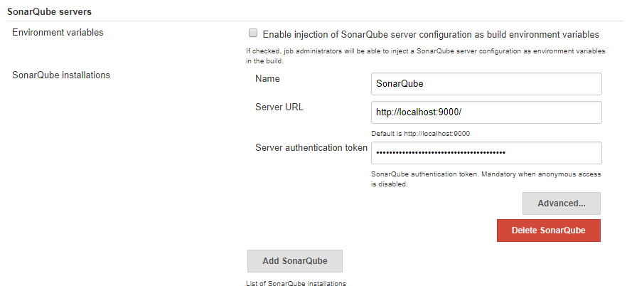

#### Global Tool configuration

1. All the environmental variables for Jenkins go here.
2. Any .exe file to be executed are configured here (ex. GIT and NodeJS)

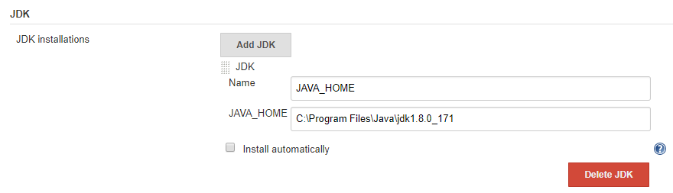

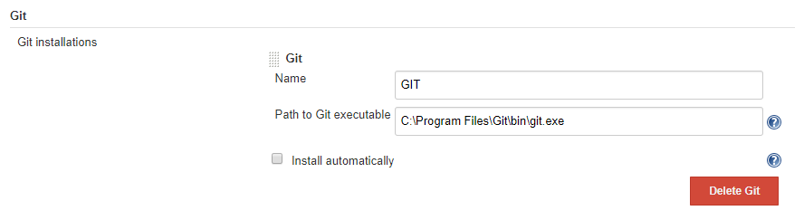

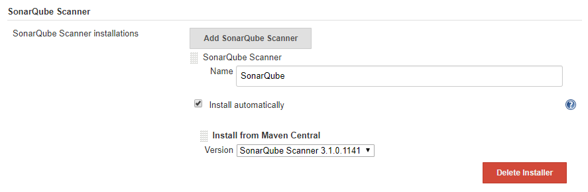

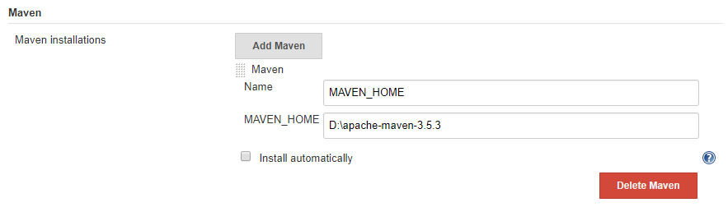

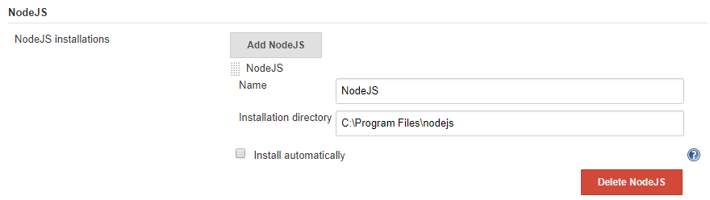

#### Manage Plugin

1. All the plugins installed/Available/updates.
2. Advanced provides you to manually install plugins using .hpi files.

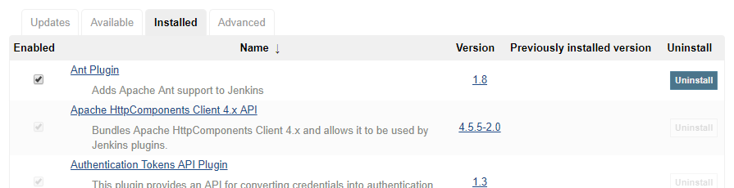

## Installation/Set up JDK

Download JDK at

<http://www.oracle.com/technetwork/java/javase/downloads/jdk8-downloads-2133151.html>

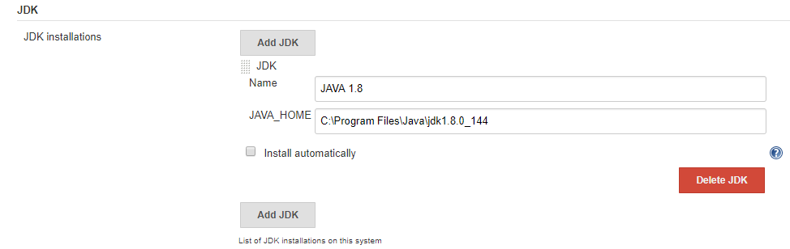

## Installation/Set Up of GIT

### Installation

Download GIT here <https://git-scm.com/download/win> and run the installer, which installs

1. GIT UI
2. GIT Bash

### Setup

1. Provide the path until git.exe to allow Jenkins to access/execute commands on the repository.



1. Create a repository using GIT UI/ GIT bash on local machine.
2. Create a repository in GIT repository to link with local repository.
3. If already having a repository, then use the existing repository URL with credentials for the JOB.

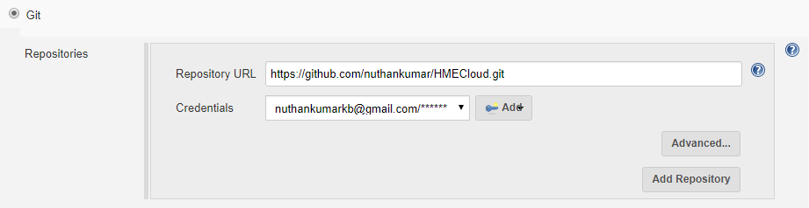

## Installation/ Setup of Maven



## Installation and Setup of Sonar

### Installation

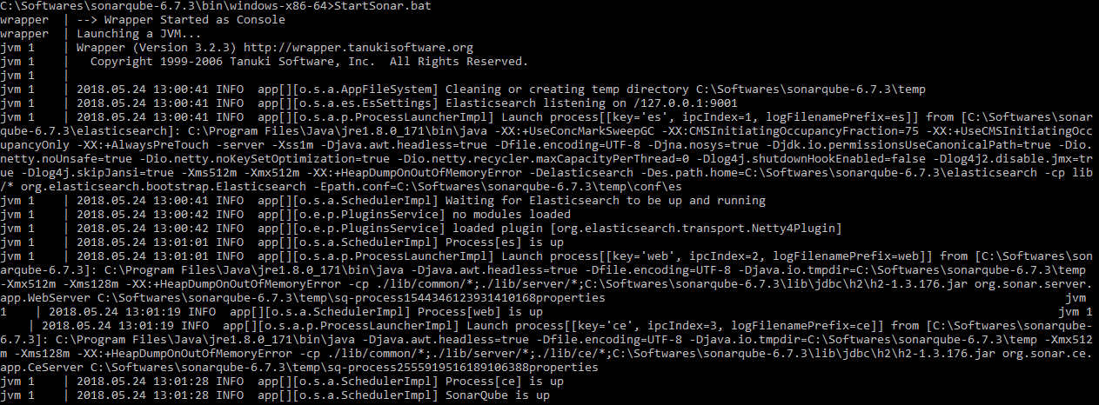

### Setup

Authentication token will be available while creating the user.



Add the project specifications on the JOB configuration

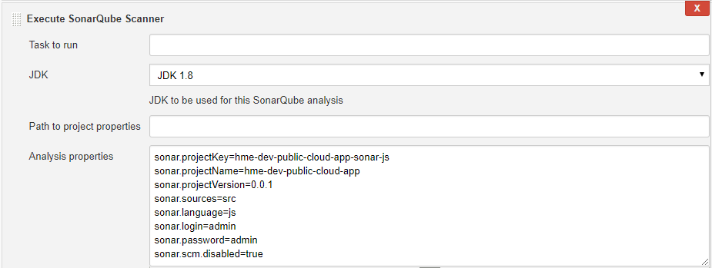

## Installation/Set Up of ZAP

Download ZAP at

<https://www.owasp.org/index.php/OWASP_Zed_Attack_Proxy_Project>

Keep the localhost and port as default values

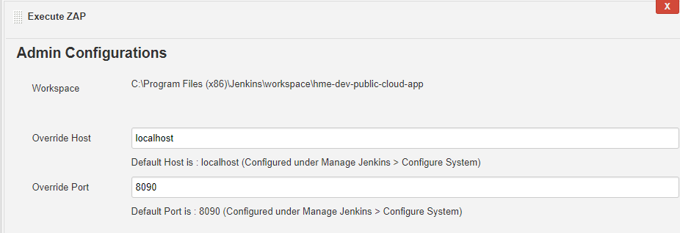

Provide the system JDK installed on Jenkins.

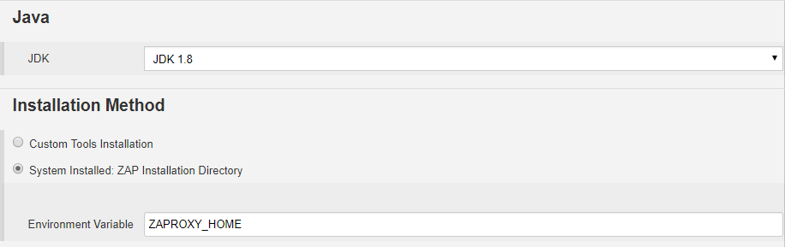

Provide the below ZAP home path and project name filepath

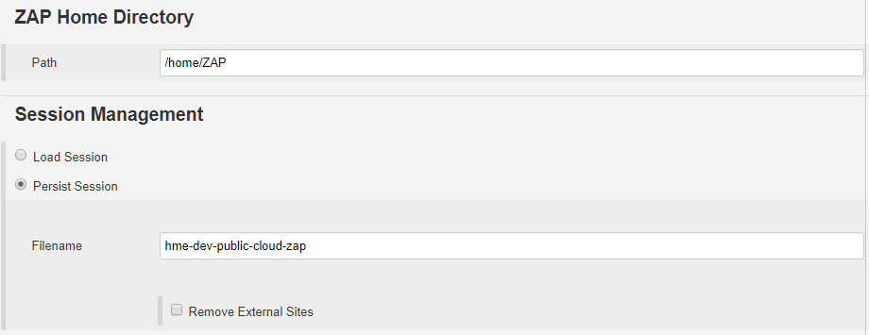

Context name could be anything related to the project

Include the project url in the context.

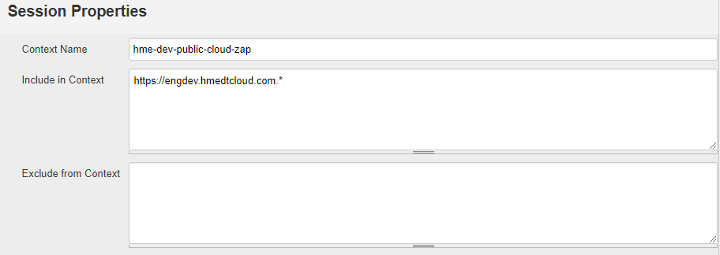

Provide the access details for the website and logged in Indicator values.

Target url is the main login URL for the website.

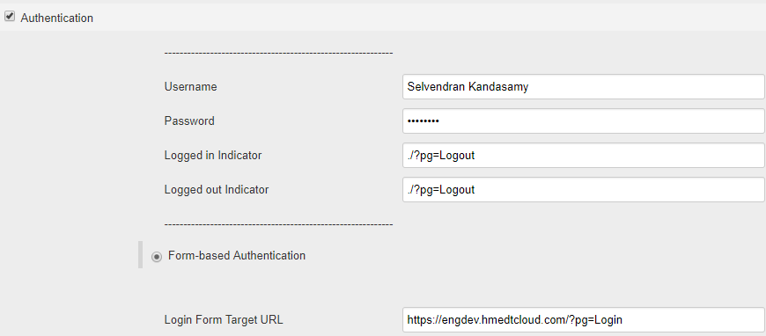

Add the attack mode. Provide starting point.

Select Spider Scan and recurse.

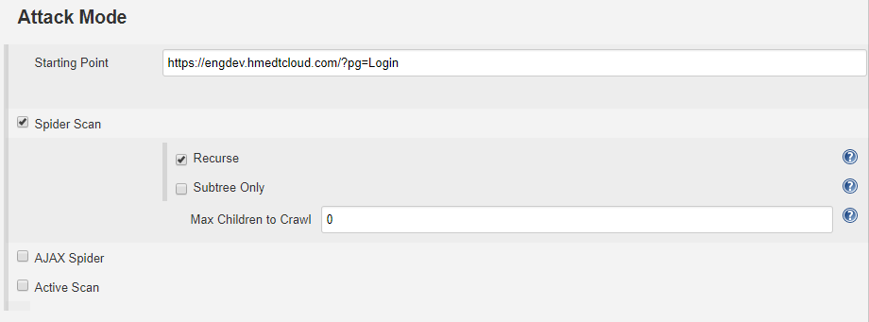

Generate Reports.

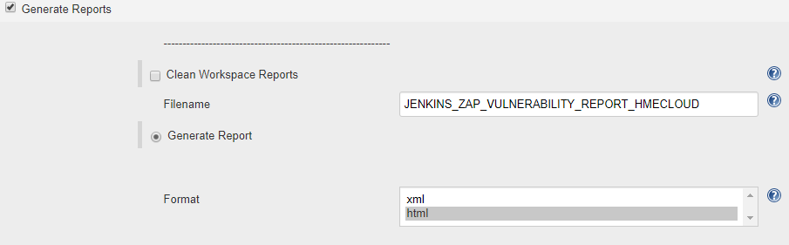

## Installation/Set Up of WinSCP

Download WinSCP at

<https://winscp.net/eng/download.php>

We can generate the command for the moving files using FTP Transfer.

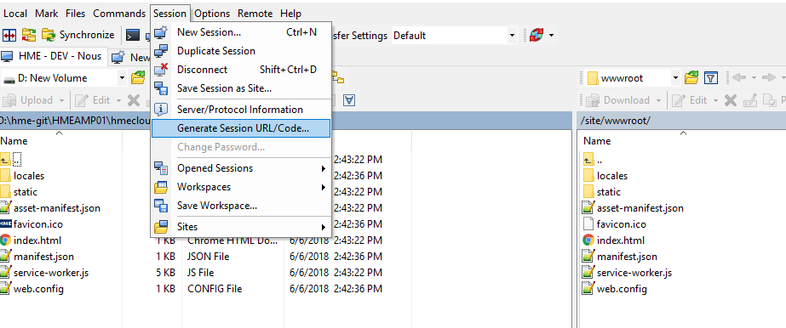

Use the batch commands and modify based on the requirement.

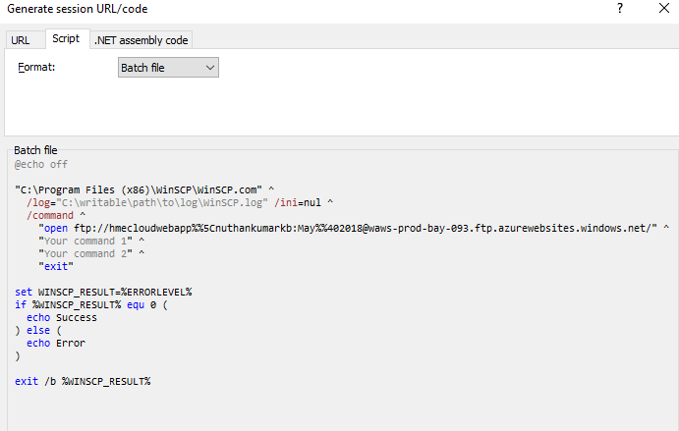

## Installation/Set Up of Azure CLI 2.0.

Download at <https://docs.microsoft.com/en-us/cli/azure/install-azure-cli-windows?view=azure-cli-latest>

We must be able to access the Azure CLI under this folder structure.

C:\Program Files (x86)\Microsoft SDKs\Azure\CLI2\wbin

Verify Azure using az login command.



## Installation/Set Up of Katalon Studio

Download at <https://www.katalon.com/>

Add all the testcases required for the test suite and commit the suit.

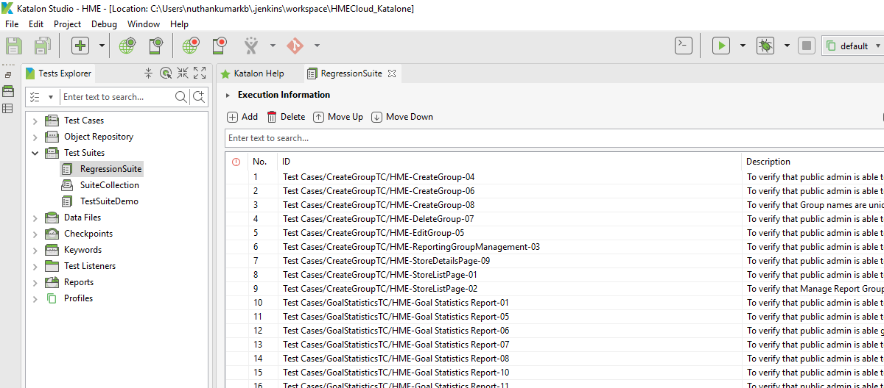

## Installation/ Set up SVN

### Step 1) Navigate to the actual repository with App and Service code base.

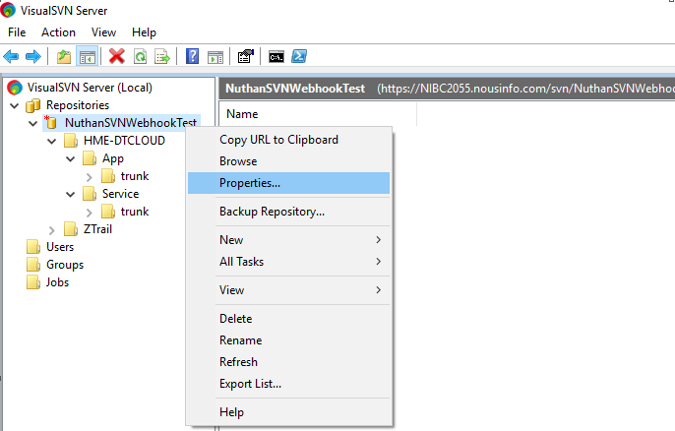

Here NuthanSVNWebhookTest is the repository where we have HME-DTCLOUD under which App and Service is available.

### Step 2) Navigate to Hooks - > Post-commit hook - > Edit

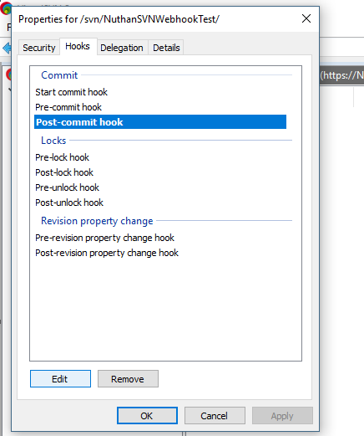

### Step 3) Add the batch commands below - > apply -> Ok

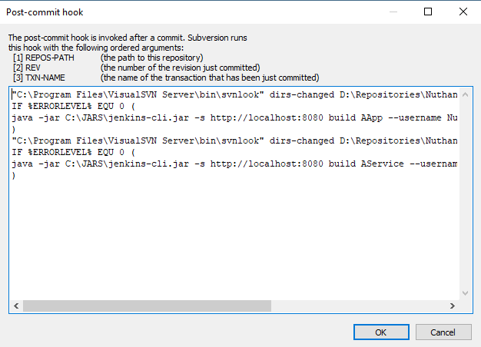

"{*path_to_visualSVN_bin*}\svnlook" dirs-changed {*absolute_path_to_repository*} | findstr /b /i "HME-DTCLOUD/App/trunk"

IF %ERRORLEVEL% EQU 0 (

{*path_to_java.exe*} -jar {*path_to_jenkins-cli.jar*} -s {*Jenkins_url*} build {*job_name_app*} --username {*Jenkins_username*} --password {*Jenkins_password*}

)

"{*path_to_visualSVN_bin*}\svnlook" dirs-changed {*absolute_path_to_repository*} | findstr /b /i "HME-DTCLOUD/Service/trunk"

IF %ERRORLEVEL% EQU 0 (

{*path_to_java.exe*} -jar {*path_to_jenkins-cli.jar*} -s {*Jenkins_url*} build {*job_name_service*} --username {*Jenkins_username*} --password {*Jenkins_password*}

)

For the example mentioned in the document, below is the batch commands

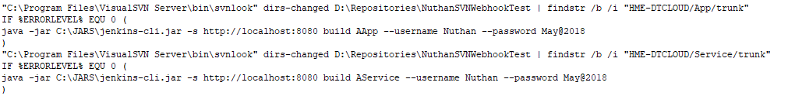

## Plugins to be Installed/ verified if installed.

* GitHub
* NodeJS Plugin
* OWASP ZAP Plugin
* SonarQube Scanner for Jenkins
* Subversion Plug-in