## Steps to configure pre commit hook on SVN repository for HMECloud

### Step 1) Navigate to the actual repository with App and Service code base.

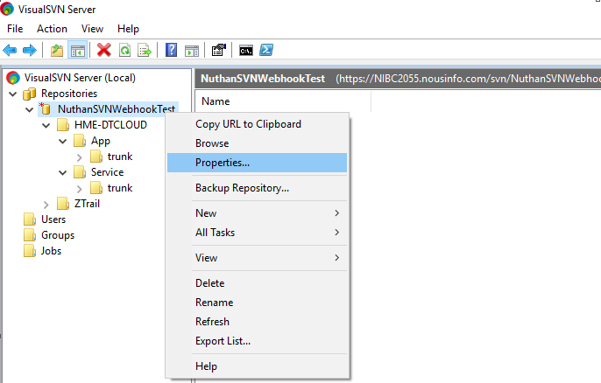

Here NuthanSVNWebhookTest is the repository where we have HME-DTCLOUD under which App and Service is available.

### Step 2) Navigate to Hooks - > Post-commit hook - > Edit

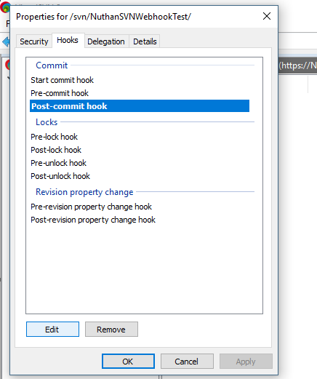

### Step 3) Add the batch commands below - > apply -> Ok

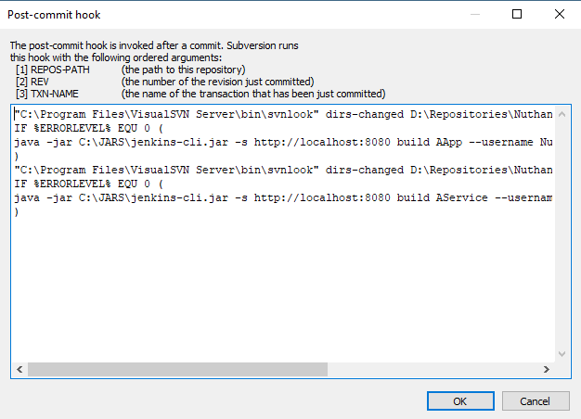

"{*path_to_visualSVN_bin*}\svnlook" dirs-changed {*absolute_path_to_repository*} | findstr /b /i "HME-DTCLOUD/App/trunk"

IF %ERRORLEVEL% EQU 0 (

{*path_to_java.exe*} -jar {*path_to_jenkins-cli.jar*} -s {*Jenkins_url*} build {*job_name_app*} --username {*Jenkins_username*} --password {*Jenkins_password*}

)

"{*path_to_visualSVN_bin*}\svnlook" dirs-changed {*absolute_path_to_repository*} | findstr /b /i "HME-DTCLOUD/Service/trunk"

IF %ERRORLEVEL% EQU 0 (

{*path_to_java.exe*} -jar {*path_to_jenkins-cli.jar*} -s {*Jenkins_url*} build {*job_name_service*} --username {*Jenkins_username*} --password {*Jenkins_password*}

)

For the example mentioned in the document, below is the batch commands

