## Steps to Create Service Principle for CI/CD for Function App

Step 1) Create a function app

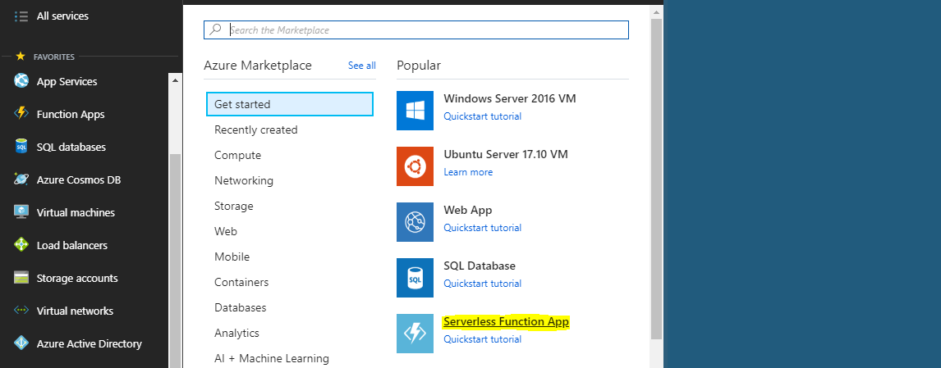

Step 2) Use the Subscription.

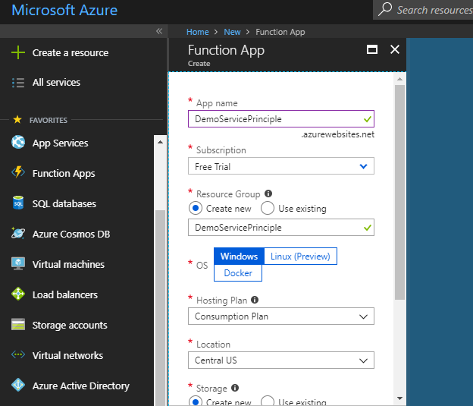

Step 3) Go to App registration

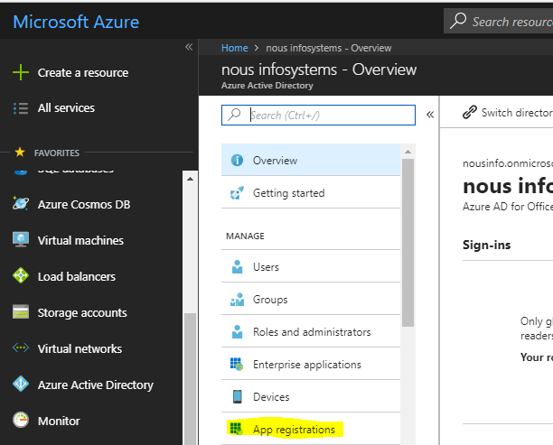

Step 4) use the Function application URL.

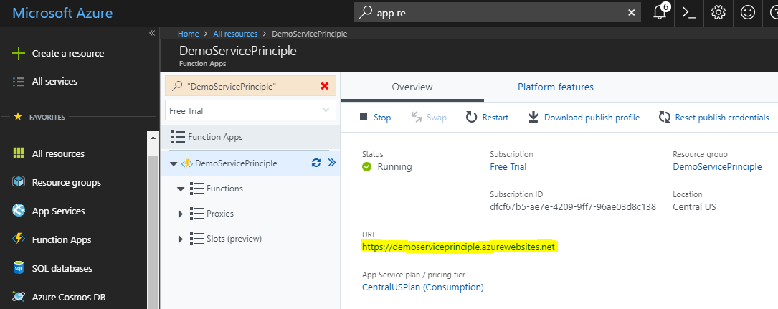

Step 5) App registration complete. Application ID = Client ID

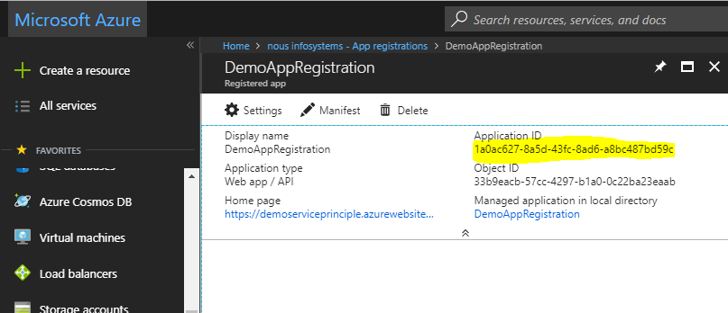

Step 6) Go to appRegistration - > Keys -> create a key. Key = Client Secret.

Note: Copy for the first time. You cannot see it the next time.

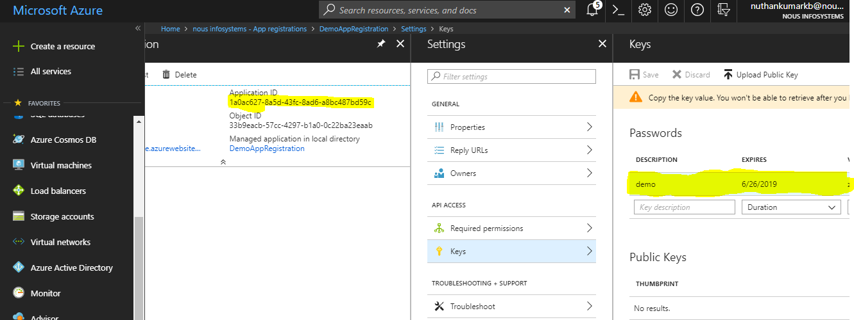

Step 7) Go to Azue Active Directory -> Properties -> Directory ID = Tenant ID.

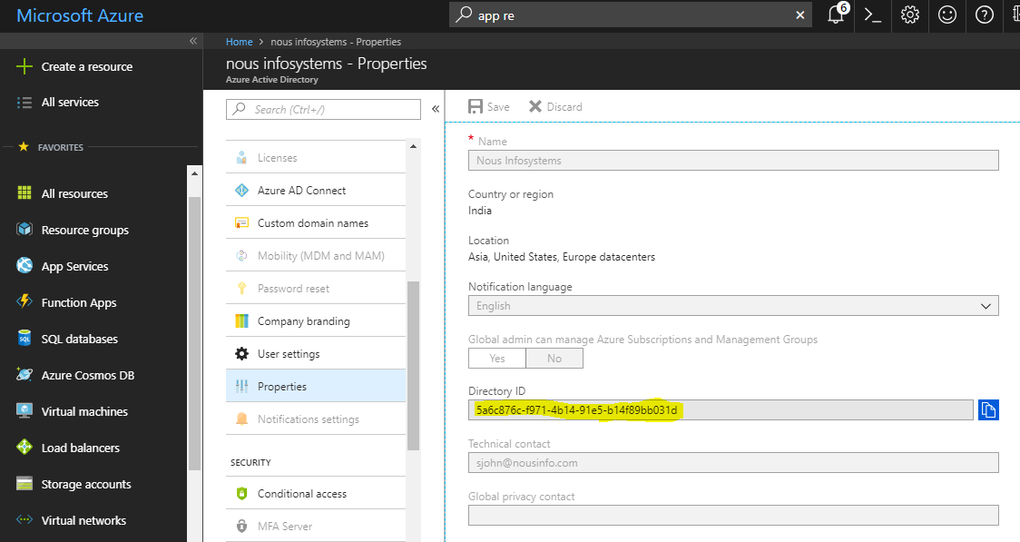

Step 8) Go to Subscriptions -> choose subscription -> Access Control (IAM)

Click on Add -> give the role Contributor -> Search the appRegistration for function App.

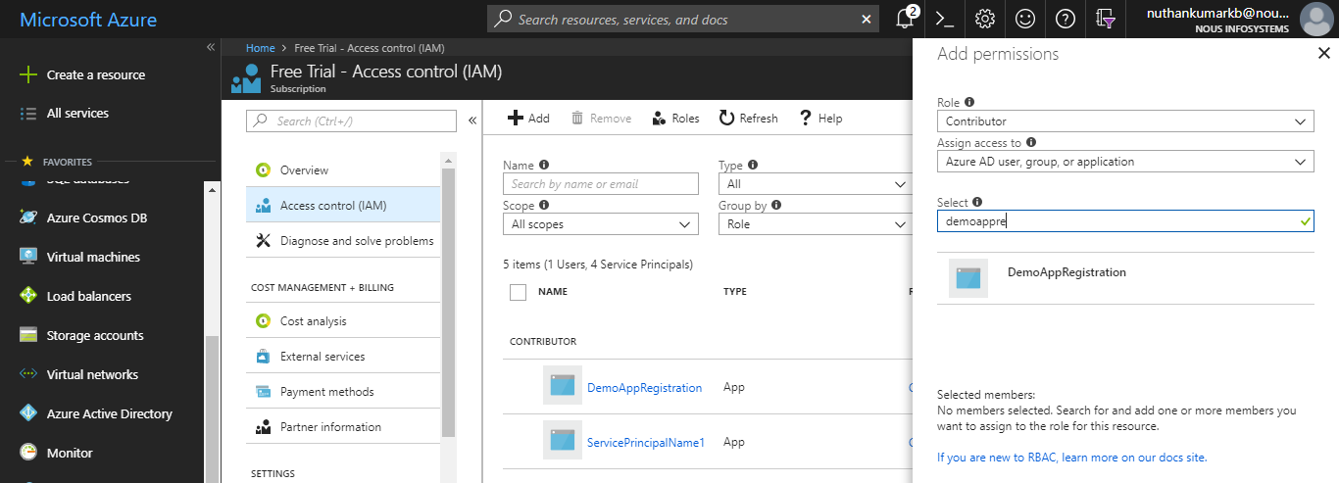

Step 9) we must be able to see a service place for the particular Function App.

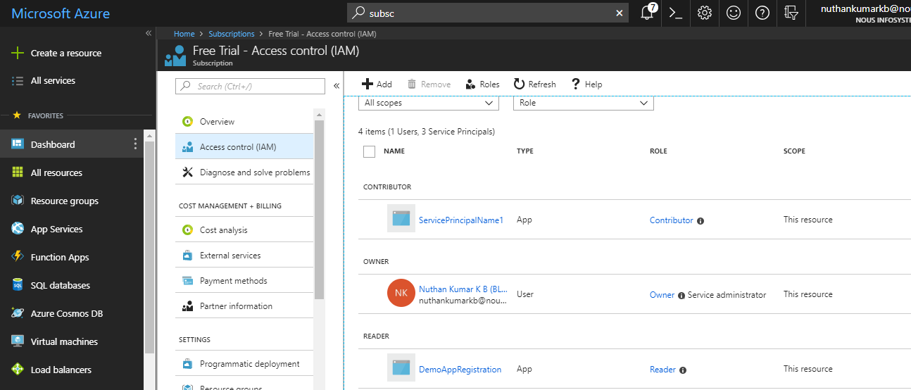

Step 10) Use credential for Jenkins choosing Microsoft Azure Service Principal

Subscription ID

Application ID = Client ID = username

Key = Client Secret = password

Directory ID = Tenant ID = tenant

Commands on Azure CLI 2.0

az login --service-principal --username 1a0ac627-8a5d-43fc-8ad6-a8bc487bd59c --password zXvSnlxGVlF+R6u7Alh9k4781KyW4/jC1auBisootu8= --tenant 5a6c876c-f971-4b14-91e5-b14f89bb031d

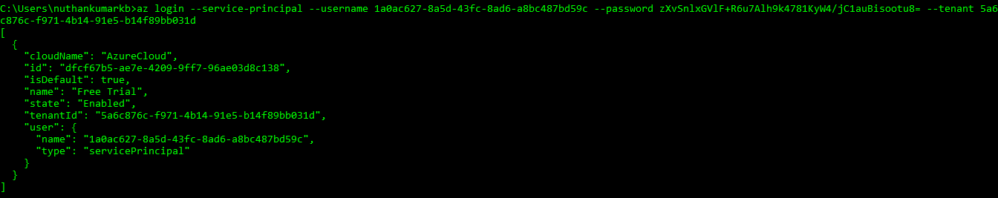

az functionapp deployment source config-zip -g DemoServicePrinciple -n DemoServicePrinciple --src "D:\sample-az-func\sample-az-func.zip"

