* Install JDK 1.8.*
* Install Maven 3.5.*
* Environmental Variables.
* Set Variable JAVA_HOME to C:\Program Files\Java\jdk1.8.0_171
* Path %JAVA_HOME%\bin
* Add this to path C:\Softwares\apache-maven-3.5.4\bin

Clone your repository:

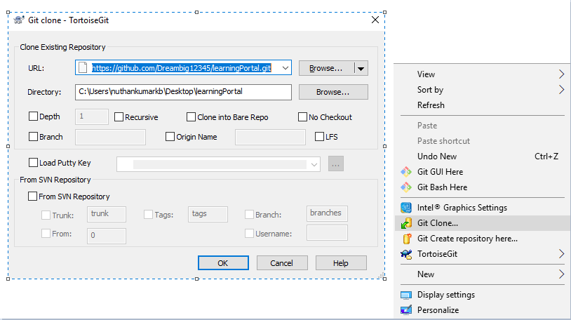

TESTING TEAM:

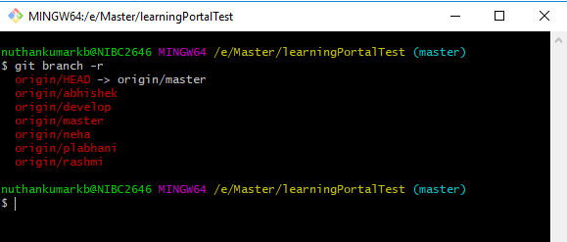

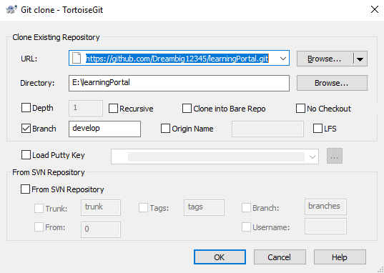

Use the above to check out the code for building the application and running the applications.

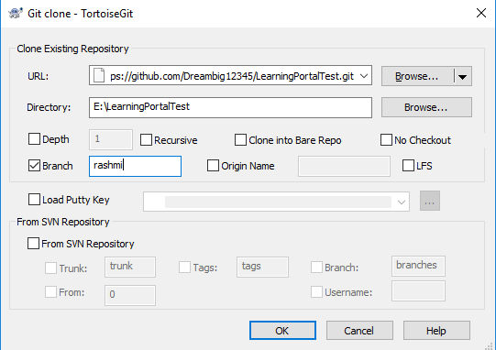

Use the above to check out the particular test branch per user and work on the test cases using katalon.

DEV TEAM:

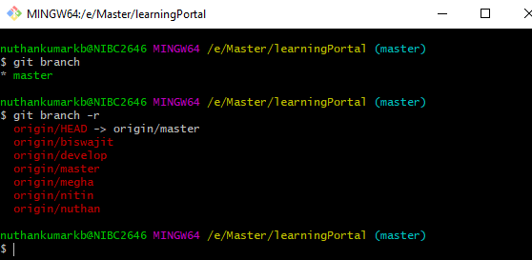

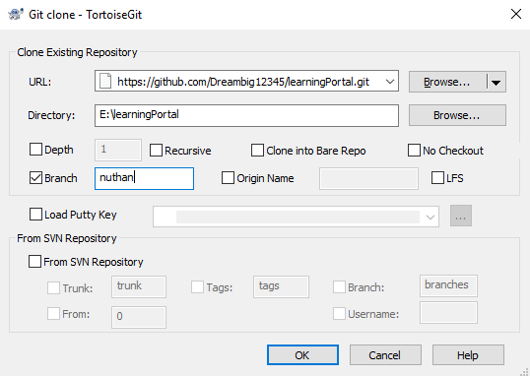

Use the above to check out and work on your respective branch.

Commit: Note : follow this step for every changes.

- git status

- git add .

- git status

- git commit –m “relevant message”

- git push origin *yourbranchname*

Download MySQL 5.7 server.

<https://dev.mysql.com/downloads/installer/>

Download MySQL workbench

<https://dev.mysql.com/downloads/workbench/?utm_source=tuicool>

Run mysqld

If you get an error create a folder ‘data’ inside bin

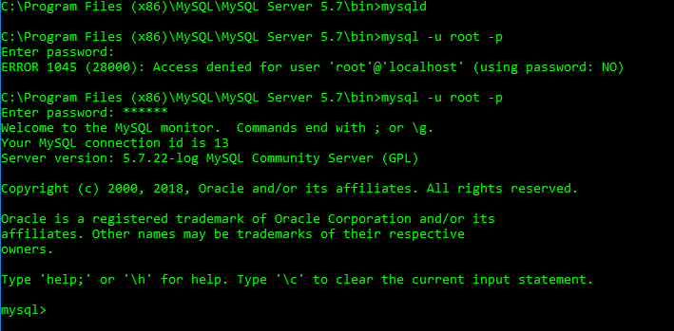

Open workbench and connect to localhost 3306 and open query browser and run the queries inside here.

C:\Users\nuthankumarkb\Desktop\learningPortal\src\main\resources\static\db

Goto project directory and give mvn clean



Mvn clean package



Mvn sprin-boot:run



Import in eclipse when needed for development or to see code

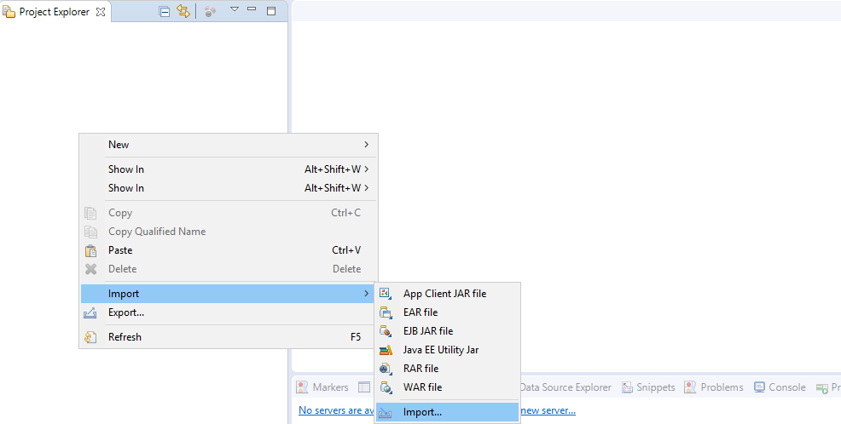

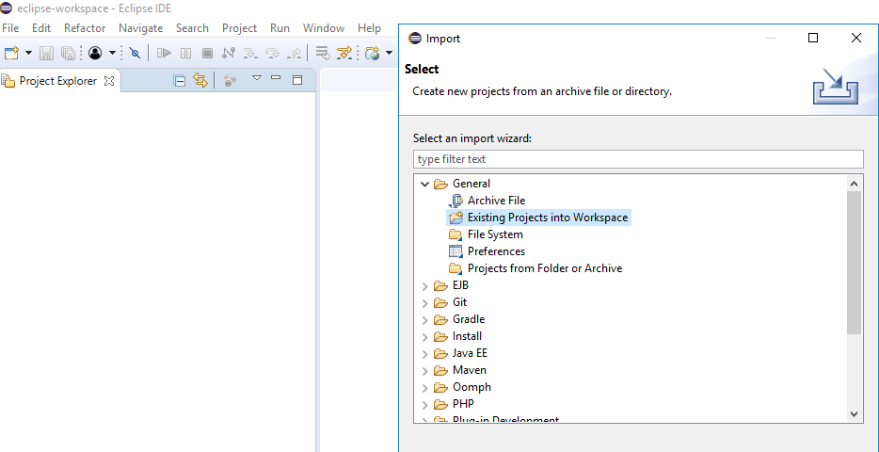

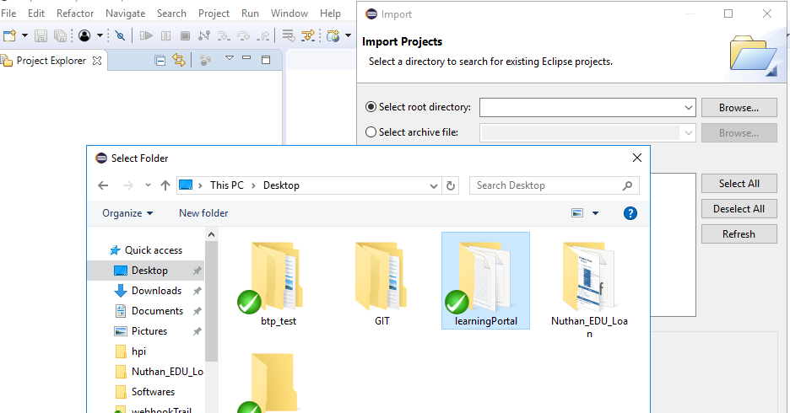

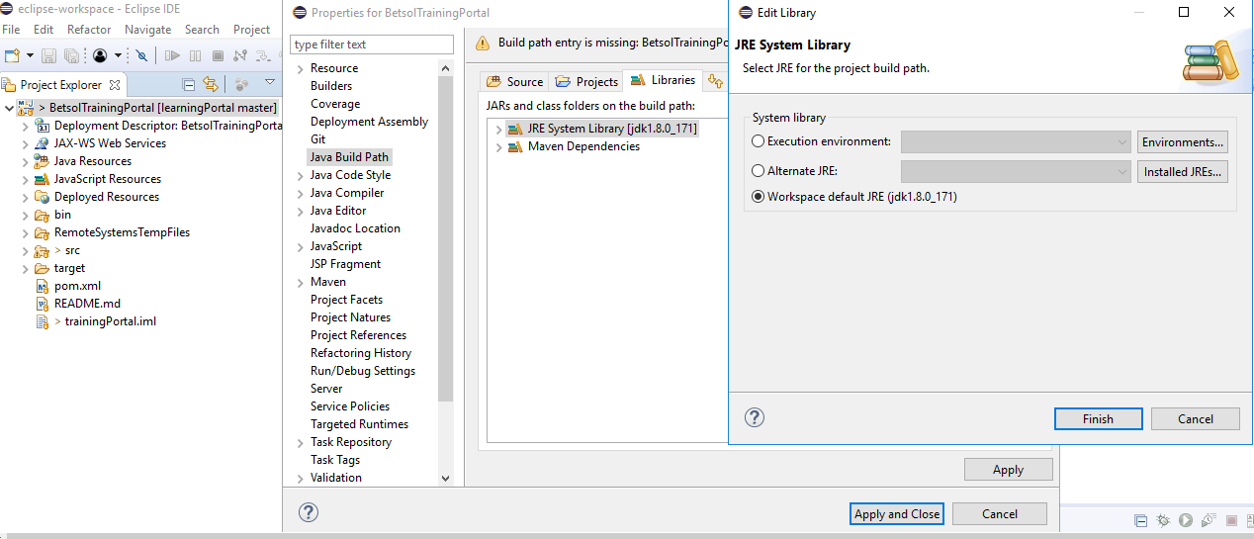

How to verify GIT commit or sync

Open git bash in the project folder

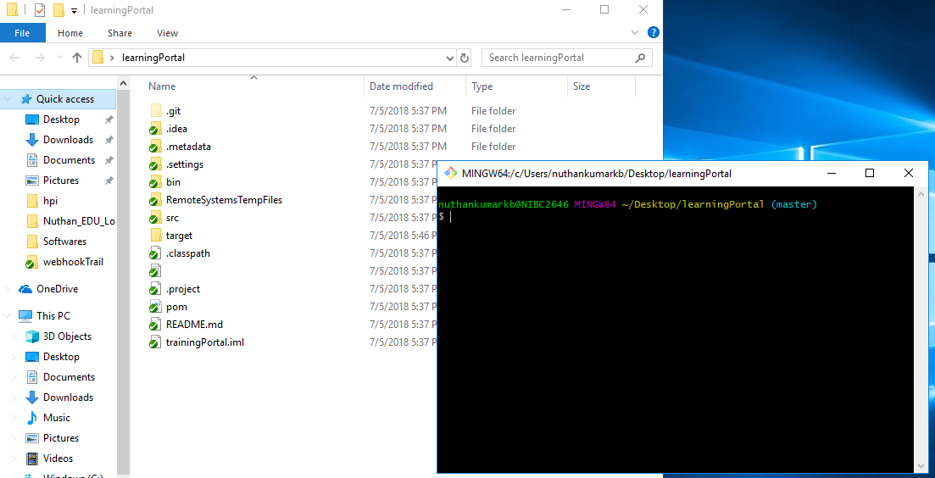

Add a file called testing

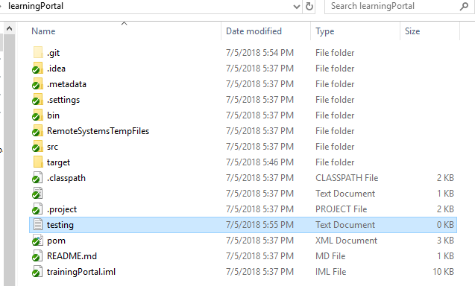

Run these commands to verfiy

nuthankumarkb@NIBC2646 MINGW64 ~/Desktop/learningPortal (master)

$ git config --global user.name "nuthankumarkb"

nuthankumarkb@NIBC2646 MINGW64 ~/Desktop/learningPortal (master)

$ git config --global user.email nuthankumarkb@gmail.com

nuthankumarkb@NIBC2646 MINGW64 ~/Desktop/learningPortal (master)

$ git status

On branch master

Your branch is up to date with 'origin/master'.

nothing to commit, working tree clean

nuthankumarkb@NIBC2646 MINGW64 ~/Desktop/learningPortal (master)

$ git status

On branch master

Your branch is up to date with 'origin/master'.

Untracked files:

(use "git add <file>..." to include in what will be committed)

testing.txt

nothing added to commit but untracked files present (use "git add" to track)

nuthankumarkb@NIBC2646 MINGW64 ~/Desktop/learningPortal (master)

$ git add .

nuthankumarkb@NIBC2646 MINGW64 ~/Desktop/learningPortal (master)

$ git status

On branch master

Your branch is up to date with 'origin/master'.

Changes to be committed:

(use "git reset HEAD <file>..." to unstage)

new file: testing.txt

nuthankumarkb@NIBC2646 MINGW64 ~/Desktop/learningPortal (master)

$ git commit -m "testing commit"

[master ad042d2] testing commit

1 file changed, 0 insertions(+), 0 deletions(-)

create mode 100644 testing.txt

nuthankumarkb@NIBC2646 MINGW64 ~/Desktop/learningPortal (master)

$ git push origin

Counting objects: 2, done.

Delta compression using up to 8 threads.

Compressing objects: 100% (2/2), done.

Writing objects: 100% (2/2), 257 bytes | 257.00 KiB/s, done.

Total 2 (delta 1), reused 0 (delta 0)

remote: Resolving deltas: 100% (1/1), completed with 1 local object.

To https://github.com/Dreambig12345/learningPortal.git

1481eb4..ad042d2 master -> master

nuthankumarkb@NIBC2646 MINGW64 ~/Desktop/learningPortal (master)

$ git status

On branch master

Your branch is up to date with 'origin/master'.

nothing to commit, working tree clean

nuthankumarkb@NIBC2646 MINGW64 ~/Desktop/learningPortal (master)

$

<http://localhost:8888/>

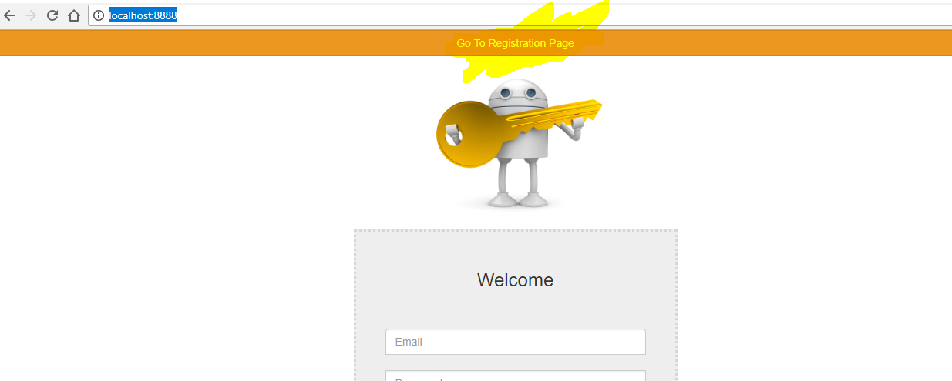

Register

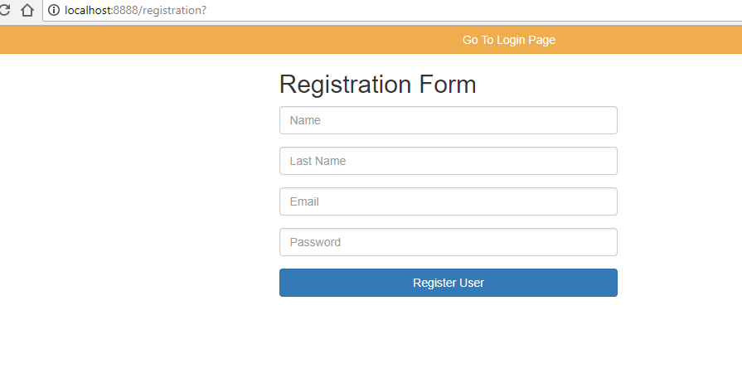

Clone the project <https://github.com/Dreambig12345/LearningPortalTest.git>

And open the project in katalon Studio and verify the two test cases.