## Azure Web App and Function App creation and deployment process

Login into Microsoft Azure portal.

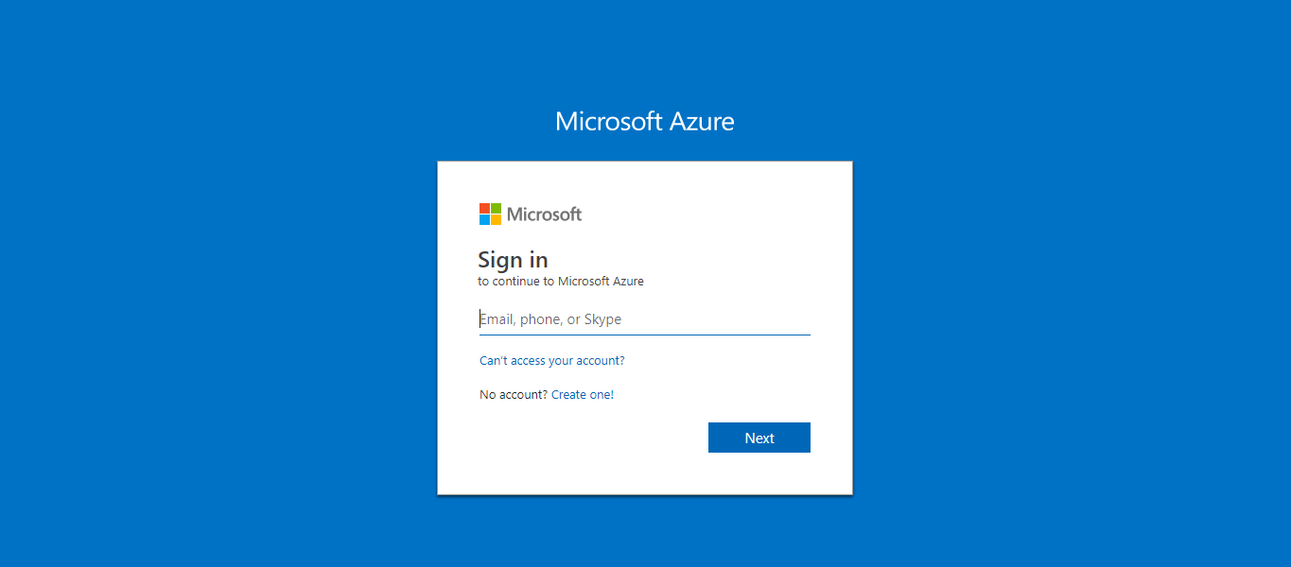

Create a Web app hme-demo-webapp

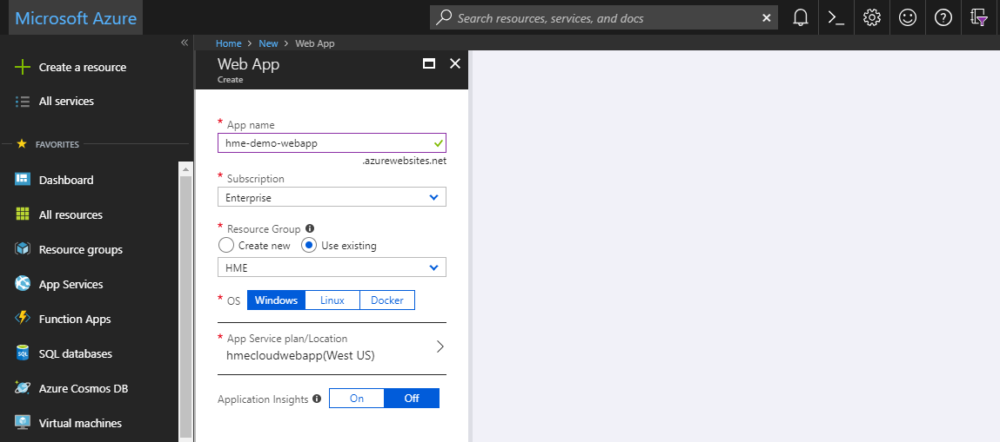

We can see the webapp dashboard.

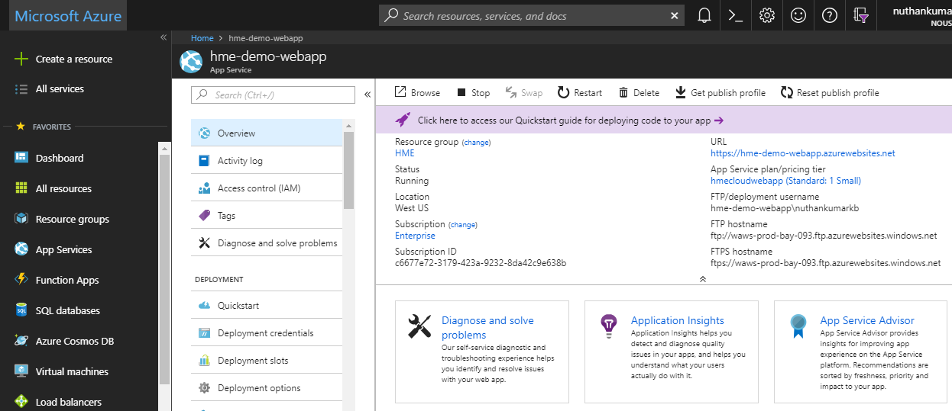

Create a deployment credentials for the Web app

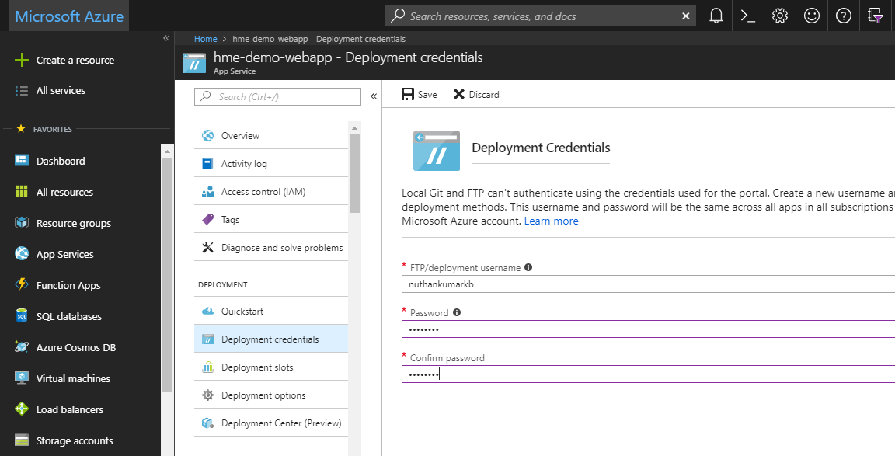

Check the properties to find deployment user, Host name for future use.

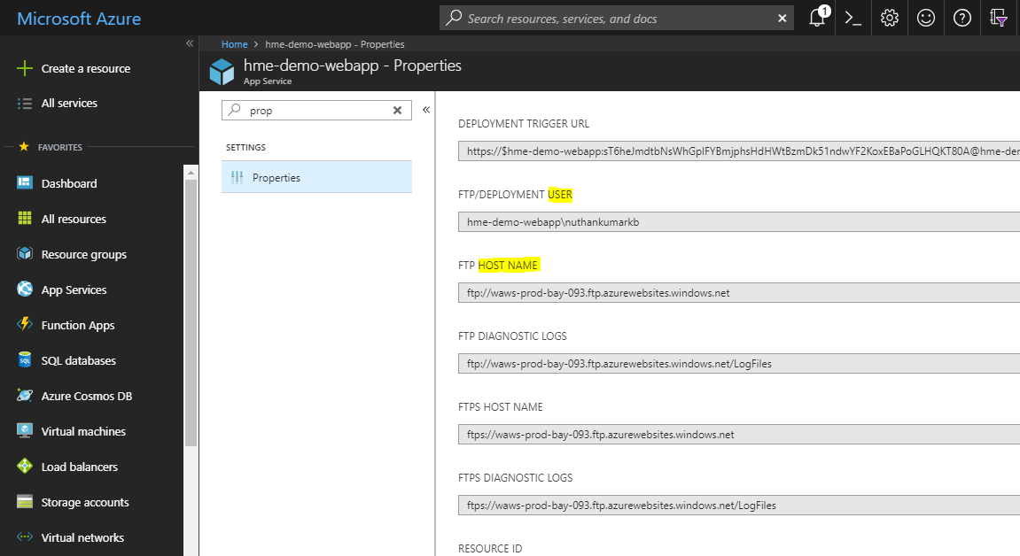

Use the associated deployment user, Host name and password provided during deployment credential step.

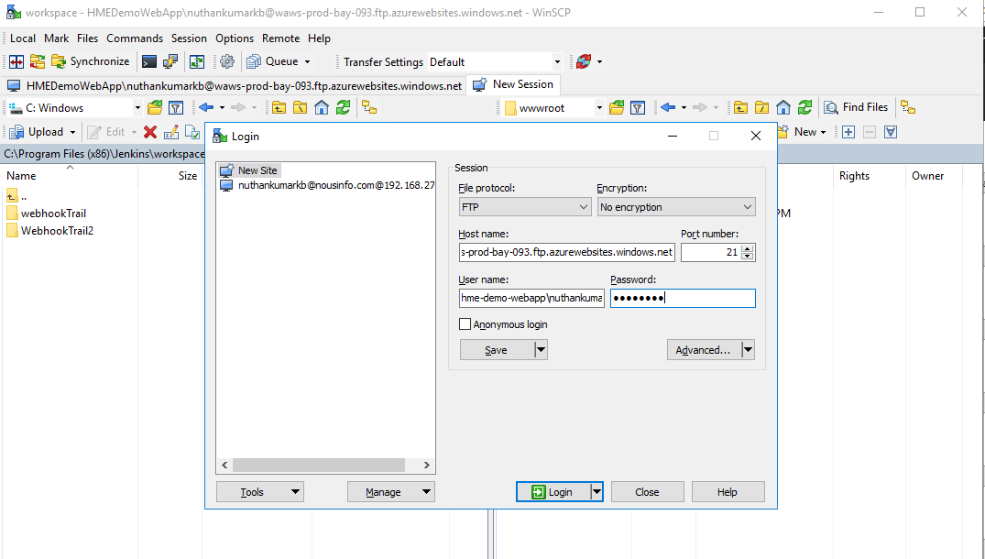

Copy and paste the contents needed (from the build folder of the application to /site/wwwroot/

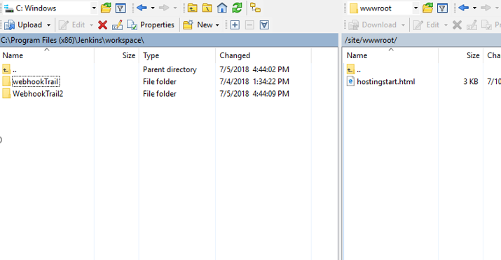

Can use the Generate script for script to open session.

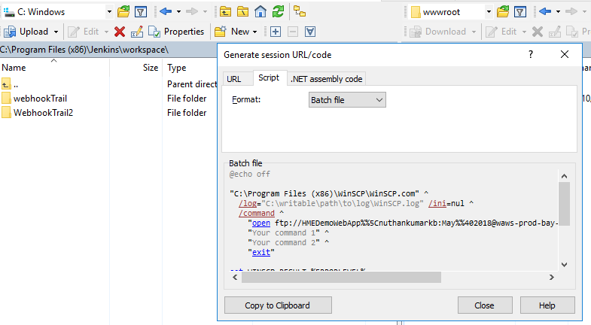

Application deployment files can be accessed here:

<https://hmedemowebapp.scm.azurewebsites.net/ZipDeploy>

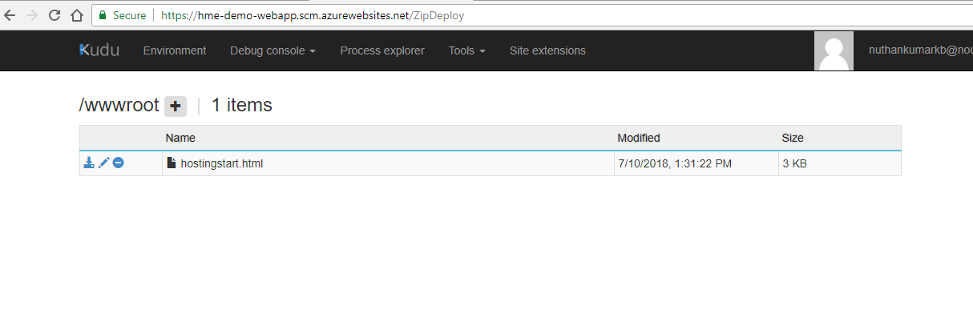

Create Function App hme-demo-functionapp

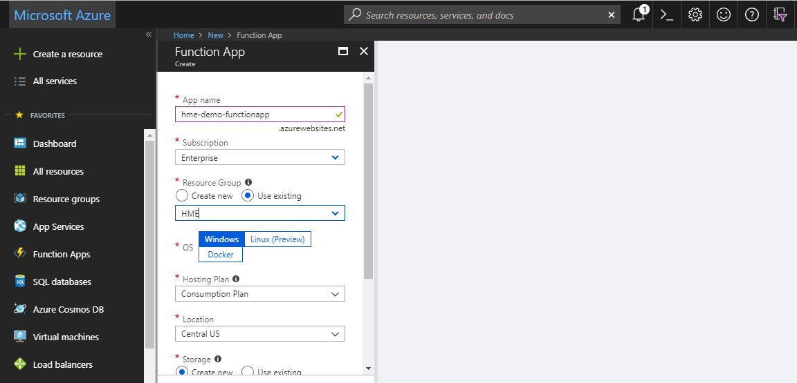

Function app dashboard

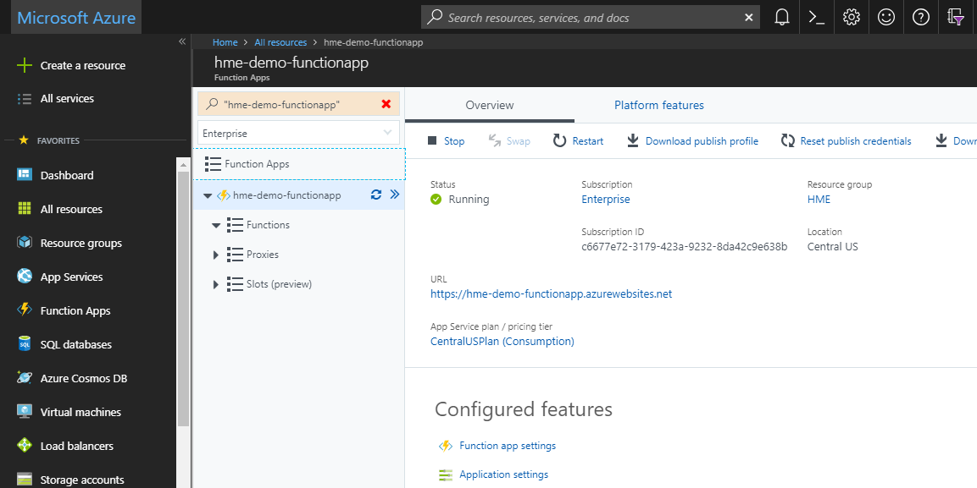

We will require a service principle to deploy the function app using CI/CD

## Steps to Create Service Principle for CI/CD for Function App

Step 1) Create a function app

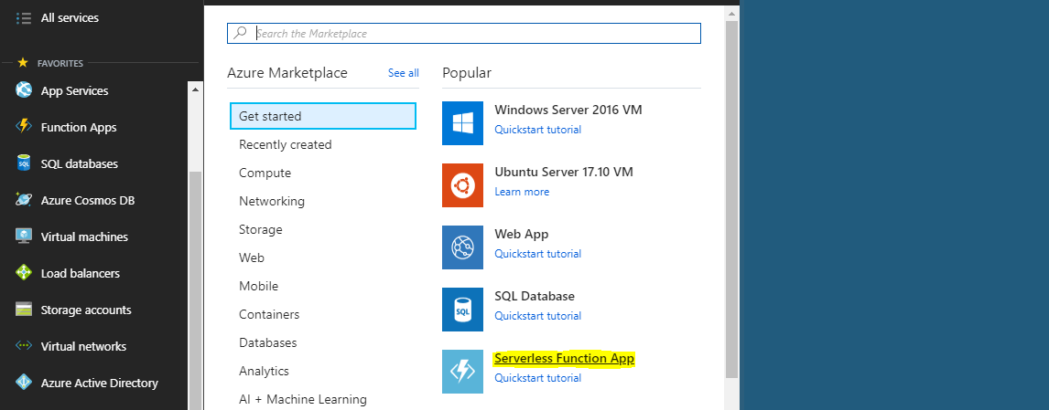

Step 2) Use the Subscription.

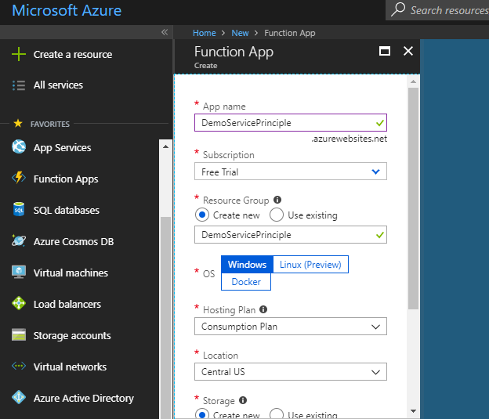

Step 3) Go to App registration

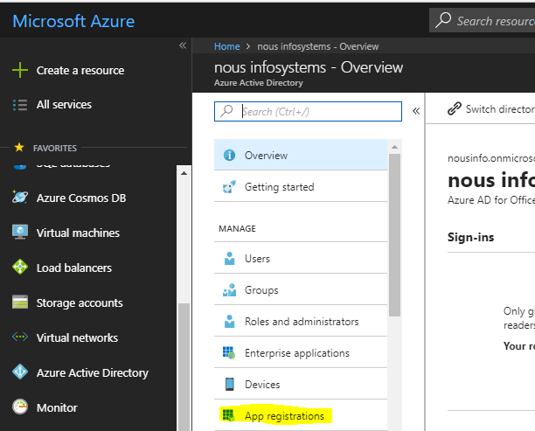

Step 4) use the Function application URL.

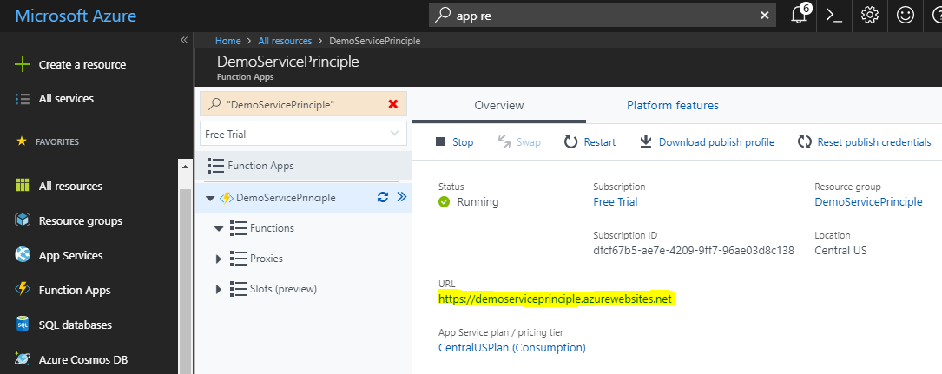

Step 5) App registration complete. Application ID = Client ID

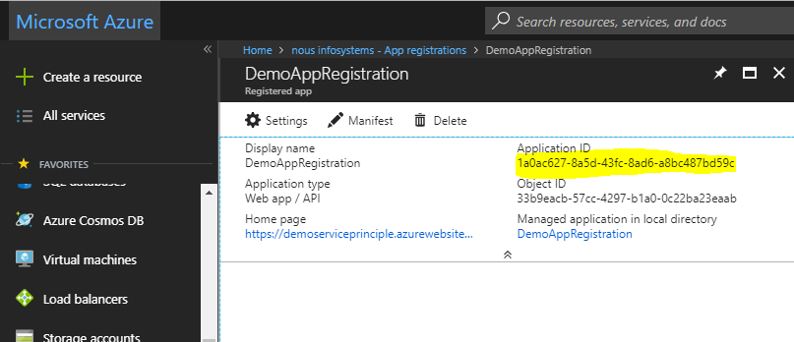

Step 6) Go to appRegistration - > Keys -> create a key. Key = Client Secret.

Note: Copy for the first time. You cannot see it the next time.

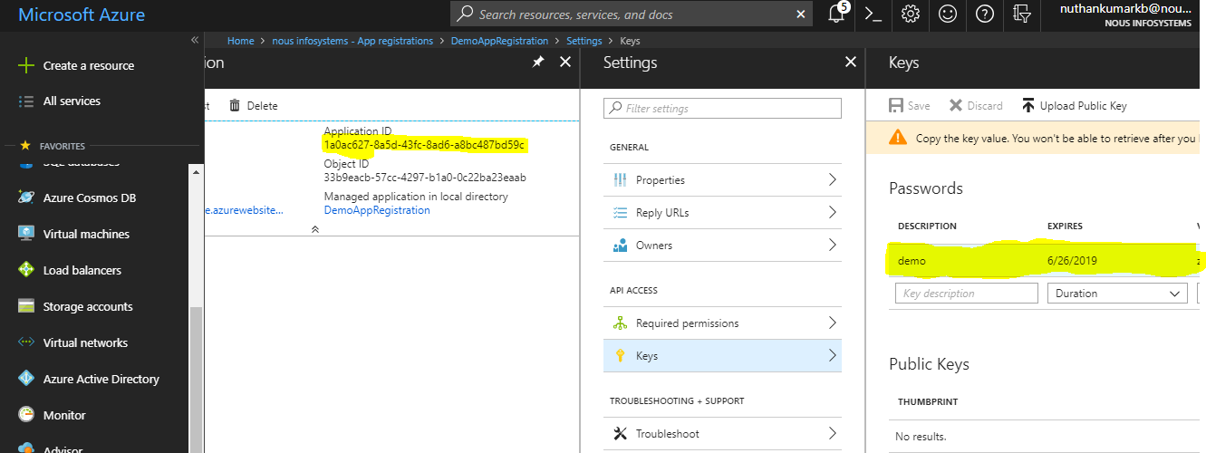

Step 7) Go to Azue Active Directory -> Properties -> Directory ID = Tenant ID.

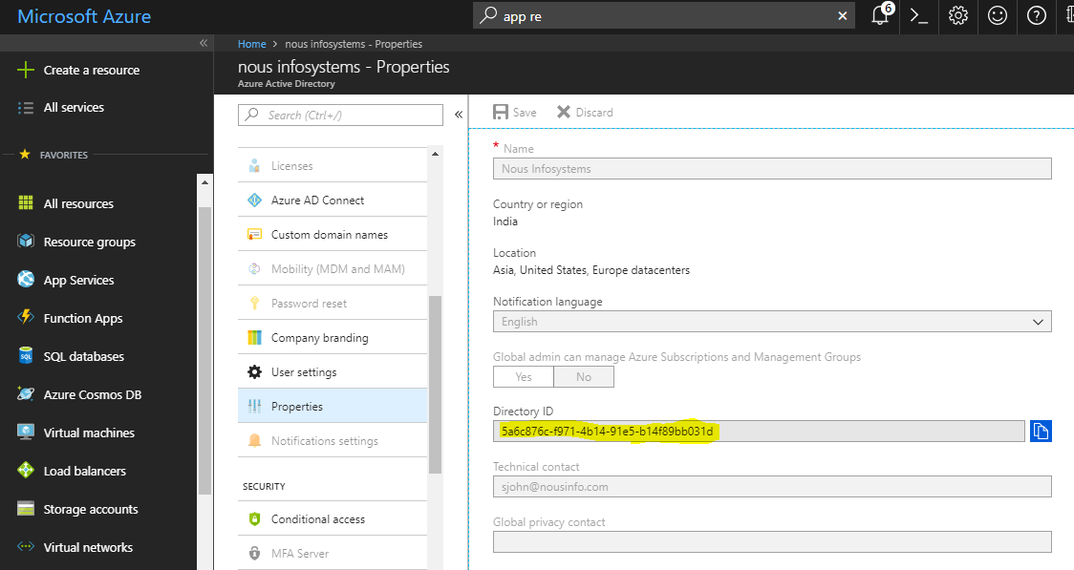

Step 8) Go to Subscriptions -> choose subscription -> Access Control (IAM)

Click on Add -> give the role Contributor -> Search the appRegistration for function App.

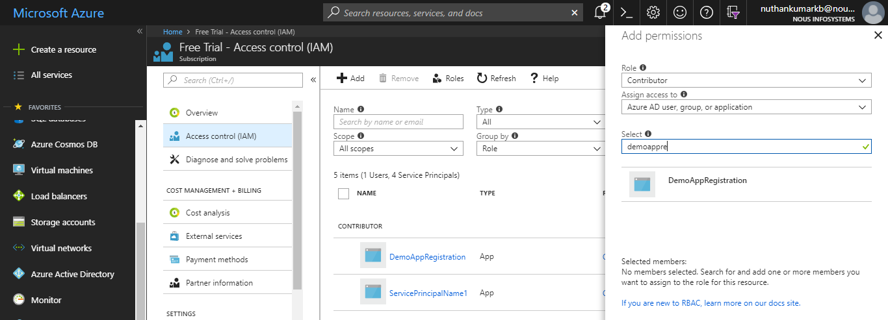

Step 9) we must be able to see a service place for the particular Function App.

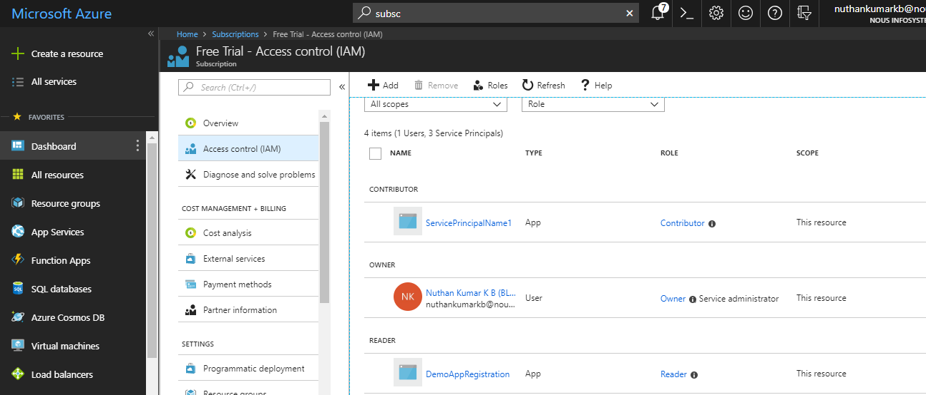

Step 10) Use credential for Jenkins choosing Microsoft Azure Service Principal

Subscription ID

Application ID = Client ID = username

Key = Client Secret = password

Directory ID = Tenant ID = tenant

Commands on Azure CLI 2.0

az login --service-principal --username 1a0ac627-8a5d-43fc-8ad6-a8bc487bd59c --password zXvSnlxGVlF+R6u7Alh9k4781KyW4/jC1auBisootu8= --tenant 5a6c876c-f971-4b14-91e5-b14f89bb031d

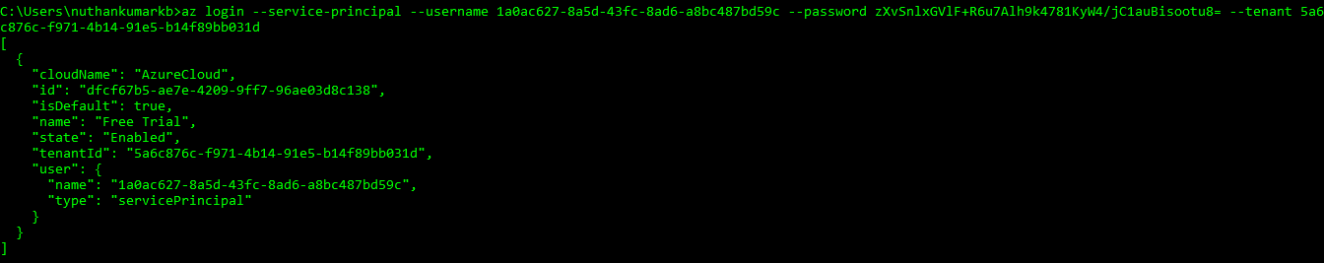

az functionapp deployment source config-zip -g DemoServicePrinciple -n DemoServicePrinciple --src "D:\sample-az-func\sample-az-func.zip"

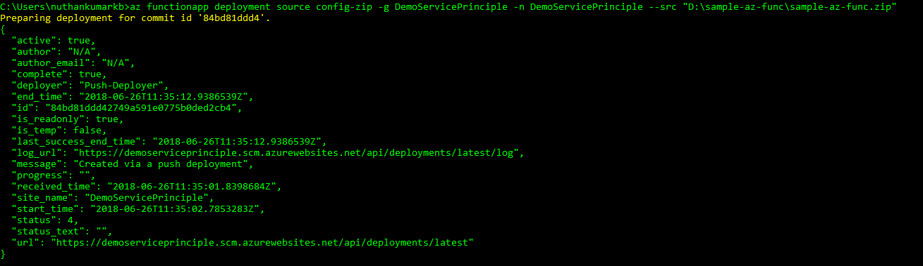

<https://hme-demo-functionapp.scm.azurewebsites.net/ZipDeploy>

