
User Manual
Open Source IRC Client

Author | Daniel Hetrick
License | GPL 3 (explained)
Source Code | https://github.com/nutjob-laboratories/merk
Last modified | Saturday, October 18, 2025

Table of Contents
Summary 4
Running MERK 5
PyInstaller Version 5
Python Version 5
Updating MERK 6
Zip File Version 6
Installer Version 6
Command-Line Arguments and Options 7
Using Command-Line Options 8
Resetting MERK to Default Settings 9
Directories and Configuration Files 10
New User Help 11
Connection Dialog 12
Server Windows 13
Channel Windows 14
Private Chat Windows 15
Style Editor 16
How Text Styles Are Applied 17
Script Editor 18
Log Manager 19
The Windowbar 21
Regular and Dark Mode 22
Commands and Scripting Guide 23
Command List 23
IRC Commands 23
All Other Commands 25
Script-Only Commands 29
Non-Script Commands 30
Context-less Commands 31
Subwindow Management Commands 32
Additional Command Help 33
Using the goto Command 35
Using the if Command 36
Using the /rem Command 38
Using the /print and /prints Commands 38
Using the restrict, only, and exclude Commands 39
Using the insert Command 40
Using /show, /hide, /close, and context Commands 41
Using the /resize, /move, and /window Commands 42
Using the /ignore Command 44
Using the /config and /user Commands 45
Using the /connect and the Other Connection Commands 47
Using the /quit and /quitall Commands 47
Using the /shell Command 48
Using the /reclaim Command 48
Using the /delay Command 48
Using the /macro Command 49
Scripting MERK 51
Connection Scripts 51
All Other Scripts 51
Errors 52
Context 53
Aliases 55
Built-In Aliases 56
Script Arguments 58
Writing Connection Scripts 60
Example Scripts 62
Wave 62
Greeting 63
Example Connection Script 64
Inserting Files 65
Showing the Local Temperature 66
Connecting to Servers 67
Dice Rolling Script 68
Custom Day-of-the-Week Away Message 69
"Trout" Command 70
Advanced Settings 71
Options 71

Summary
IRC (Internet Relay Chat) is a text-based chat system for instant messaging. IRC is designed for group communication in discussion forums, called channels, but also allows one-on-one communication via private messages… .
Internet Relay Chat is implemented as an application layer protocol to facilitate communication in the form of text. The chat process works on a client–server networking model. Users connect, using a client—which may be a web app, a standalone desktop program, or embedded into part of a larger program—to an IRC server, which may be part of a larger IRC network. Examples of ways used to connect include the programs Mibbit, KiwiIRC, mIRC and the paid service IRCCloud.
From the Wikipedia entry on IRC, at https://en.wikipedia.org/wiki/IRC

MERK is a free and open source Internet Relay Chat client for Windows and Linux. It uses a "multiple document interface", in which the application works as a parent window that contains other windows for servers, channels, and private chats. The popular Windows shareware client mIRC is an example of another IRC client that uses a multiple document interface.
MERK is written in the Python programming language, using the PyQt library for the graphical interface and the Twisted library for networking. MERK also comes bundled with three other open source libraries:
- qt5reactor, for getting PyQt and Twisted to work together
- pyspellchecker, which provides the spellchecking mechanism
- emoji, providing support for emoji shortcodes

MERK has a scripting engine allowing most functionality to be automated. The core concept of the scripting engine is the context: a context is a window, either a channel, private chat, or server window, that the commands executed are intended to interact with. Scripts can be executed on connection, or executed from text input. MERK comes with a script editor with features to make writing scripts easy and fun, with no prior programming experience required.
As IRC is a text-based protocol, MERK features a rich text display, which can be easily configured. MERK supports the display of mIRC colors, which can optionally be stripped from messages.

Running MERK
MERK comes in two different versions: the Python version, which uses the Python interpreter to run MERK, and a PyInstaller version of MERK, which runs on Windows, and doesn't require the Python interpreter. Both versions behave exactly the same way, and have only minor differences.

PyInstaller Version
Download the Windows version of MERK, and unzip the archive to anywhere you'd like. The archive contains a folder named lib, the merk.exe executable, and README.html. Just double click merk.exe, to run MERK. That's it!
There's also an installer for MERK. Download the Windows installer version and unzip the archive to wherever you'd like. Double click on setup.exe, which will guide you through installing MERK on your computer. MERK can be installed wherever you'd like, and can either be installed for a single user, or for all users on your computer.

Python Version
MERK requires several libraries to be installed in order to run: Python 3.9+, PyQt, Twisted, and if you'd like to connect to servers via SSL/TLS, PyOpenSSL and service_identity. If you're running MERK on Windows, you may also need pywin32. All of these libraries can be installed easily with PIP, the Python package installer. To install the base requirements, open a terminal, and enter:
pip install PyQt
pip install Twisted
pip install PyOpenSSL
pip install service_identity

If you're using MERK on Windows, also enter:
pip install pywin32

Once all the requirements are installed, unzip the downloaded archive of MERK, use the terminal to navigate to the directory you unzipped MERK to, and type:
python merk.py

Updating MERK
As MERK stores all its configuration files separate from the executable/installation, updating MERK to the latest version is easy.

Zip File Version
You can do this one of two ways: either delete merk.exe and the lib folder, wherever you extracted them do, and unzip the new version of MERK in the same folder; or unzip the new version of MERK in the same directory and overwrite all files.

Installer Version
This version of MERK is even easier to update. Just download the installer of the newer version of MERK, unzip setup.exe, and double click on it. You don't have to uninstall the older version, the new version will overwrite the old one.

Command-Line Arguments and Options
The command-line interface of MERK works identically on all platforms.
usage: python merk.py [--ssl] [-p PASSWORD] [-c CHANNEL[:KEY]] [-C SERVER:PORT[:PASSWORD]]
[-S SERVER:PORT[:PASSWORD]] [-n NICKNAME] [-u USERNAME] [-a NICKNAME]
[-r REALNAME] [-h] [-d] [-x] [-t] [-R] [-o] [-f] [-s FILE]
[--config-name NAME] [--config-directory DIRECTORY] [--config-local]
[--scripts-directory DIRECTORY] [--user-file FILE]
[--config-file FILE] [--reset] [--reset-user]
[--reset-all] [-Q NAME] [-D] [-L]
[SERVER] [PORT]

Connection:
SERVER Server to connect to
PORT Server port to connect to (6667)
--ssl, --tls Use SSL/TLS to connect to IRC
-p, --password PASSWORD
Use server password to connect
-c, --channel CHANNEL[:KEY]
Join channel on connection
-C, --connect SERVER:PORT[:PASSWORD]
Connect to server via TCP/IP
-S, --connectssl SERVER:PORT[:PASSWORD]
Connect to server via SSL/TLS

User Information:
-n, --nickname NICKNAME
Use this nickname to connect
-u, --username USERNAME
Use this username to connect
-a, --alternate NICKNAME
Use this alternate nickname to connect
-r, --realname REALNAME
Use this realname to connect

Options:
-h, --help Show help and usage information
-d, --donotsave Do not save new user settings
-x, --donotexecute Do not execute connection script
-t, --reconnect Reconnect to servers on disconnection
-R, --run Don't ask for connection information on start
-o, --on-top Application window always on top
-f, --full-screen Application window displays full screen
-s, --script FILE Use a file as a connection script

Files and Directories:
--config-name NAME Name of the configuration file directory (default: .merk)
--config-directory DIRECTORY
Location to store configuration files
--config-local Store configuration files in install directory
--scripts-directory DIRECTORY
Location to look for script files
--user-file FILE File to use for user data
--config-file FILE File to use for configuration data
--reset Reset configuration file to default values
--reset-user Reset user file to default values
--reset-all Reset all configuration files to default values

Appearance:
-Q, --qtstyle NAME Set Qt widget style (default: Windows)
-D, --dark Run in dark mode
-L, --light Run in light mode

Using Command-Line Options
MERK's command-line options allow users to do many things on startup. All of these uses are completely optional, and never have to be used. Most command-line options feature a long version (for example --donotexecute) and a shorter version (-x, which does the same thing).
If user settings are in place (that is, the default nickname, username, etc), command-line options can be used to connect to one or more IRC servers automatically on startup. For example, to automatically connect to the DALnet IRC network, you can use:
merk.exe us.dal.net 6687

This will automatically connect to DALnet, executing any connection script previously set up with MERK. To prevent the connection script from executing, try:

merk.exe --donotexecute us.dal.net 6667

Multiple servers can be connected to, as well, though the method is a little different. Use the -C option to connect to normal IRC servers, and the -S option to connect to IRC servers via SSL/TLS. In the next example, we're going to connect to the Libera network via SSL/TLS, and DALnet:

merk.exe -S irc.libera.chat:6697 -C us.dal.net:6667

If you want MERK to skip asking for a server to connect to on startup, use the --run option:

merk.exe --run

MERK can even be configured to run on a USB thumb drive! For this example, assume that MERK has been extracted into the root directory of a USB thumb drive. In the same directory as merk.exe, create a text file, and type this into it:

merk.exe --config-local

Save this file as merk.bat. Now, to run MERK off of the thumb drive, double click on merk.bat (which is a Windows batch file). This will run MERK normally, but store all of the configuration files in a folder named .merk in the drive where you're running MERK from. MERK is now completely portable!

Resetting MERK to Default Settings
If your installation of MERK becomes unusable or for any other reason, you can reset MERK back to default settings with the following command-line option:
python merk.py --reset

If you are running MERK with the PyInstaller executable, use:
merk.exe --reset

To reset all user settings, use the --reset-user command-line option. This will remove all user settings, including your nickname, alternate username, username, realname, connection history, and any connection scripts:
python merk.py --reset-user

To reset all settings, and return MERK configuration files to their default state with all default settings, use --reset-all. This will reset both your user file, user.json, and the settings file, settings.json, to all default values.
merk.exe --reset-all

Directories and Configuration Files
MERK stores all its settings in a directory it creates in the user's home directory, named .merk. Inside this directory, MERK creates:
- logs. This directory is where MERK stores channel and private chat logs.
- styles. This directory is where MERK stores text style files, and the palette used for dark mode.
- scripts. This directory is where MERK stores, and first looks for, scripts. This is the default directory chosen when running a script via the server window toolbar, input menu, or right click menus, or when saving a script in the editor.
- settings.json. This file is where MERK stores and loads application settings.
- user.json. This file is where MERK stores user information, such as the chosen nickname, username, and the like, as well as the application's connection history and any connection scripts.

When using the /script command, if a full filename is not provided, MERK will look for the script in several locations, in order:

- The scripts directory.
- The settings directory (by default, .merk in the user's home directory).
- The application's installation directory.

First, MERK will attempt to find the script using the provided filename, and if the script is still not found, it will append the default file extension (which is .merk) to the filename and search again. This same pattern is used with the /edit and /insert commands.

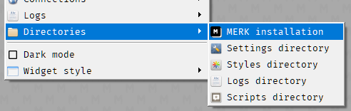
These folders can be opened in your default file manager from the client by clicking on the appropriate entry in the "Directories" sub-menu, near the bottom of the "Settings" menu.

New User Help
Most dialogs feature text explaining how the dialog or the settings in it work.

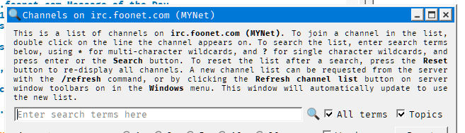The explanation text from the channel list dialog.

While new users of MERK may find these helpful, experienced users may not want to see them. To hide the help text on dialogs, turn on "Simplified dialogs" in the settings menu or the settings dialog:

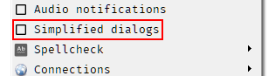The "Simplified dialogs" option in the "Settings" menu. Click this entry to simplified dialogs on and hide the help text.

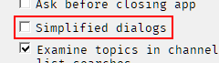The "Simplified dialogs" option on the first page of the "Settings" dialog.

"Simplified dialogs" is turned off by default, showing the help text on dialogs every time a dialog is opened.

Connection Dialog
When you first run MERK, a connection dialog is displayed, allowing you to connect to an IRC server. The dialog has three tabs: User Information, Internet Relay Chat Server, and Connection Script.
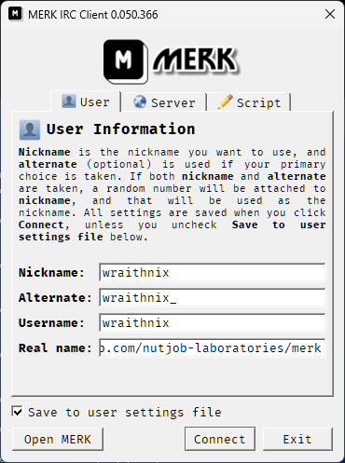 | 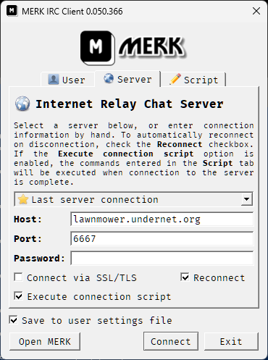 | 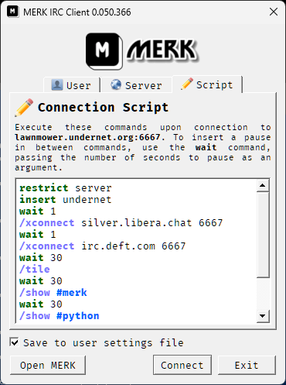

- User Information is where the user enters their various user information for connection. Nickname is the nickname you'd like to use, and Alternate (optional) will be used if that nickname is already taken; if both are taken, a random number is generated and added to Nickname.
- Internet Relay Chat Server is where the user enters the IRC server to connect to. By default, the last server MERK connected to is pre-entered. Host is the IP address or hostname of the desired IRC server, and Port is the server's port. Password is the server's password, if one is required; leave blank if one is not required. Click Connect via SSL/TLS to connect via SSL/TLS, and click Reconnect if MERK should automatically try to reconnect on disconnection. Click Execute connection script to execute the connection script on the next tab as soon as MERK connects to the server.
- Connection Script has a small script editor for editing the script MERK will execute upon connection to the server. The syntax highlighting settings can be edited with the "Settings" dialog. If Execute connection script is unchecked, this script will not be executed.
- Save to user settings files, if checked, will save any information entered into the dialog to user.json, and will be loaded automatically the next time MERK is started up.
Click Connect to connect to the IRC server using the entered information, or Exit to close MERK. To start MERK without connecting to a server, click Open MERK.

Server Windows
Server windows are the first windows you will see in MERK; they appear as soon as connection to an IRC server begins. Server windows behave differently from channels or private chat windows: closing a server window does not disconnect from the server, it only hides the window. To view a hidden server window, click on its entry in the "Windows" menu or the system tray menu. You cannot chat to other users from a server window without using commands like /msg or /notice.
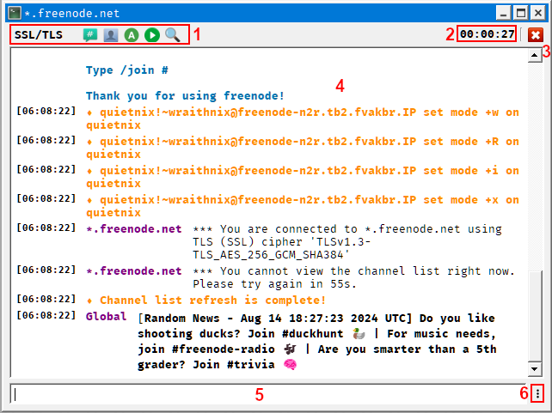
- Toolbar. Buttons that perform basic actions; some on the IRC server, such as joining a channel, changing your nickname, and setting your away status, and others on the client, like selecting a script to run, refreshing the channel list from the server, and opening the channel list dialog. Clicking the button labeled "TCP/IP" (for normal connections) or "SSL/TLS" (for encrypted connections) will show a menu with information about the server.
- Connection uptime. This displays how long MERK has been connected to the server.
- Disconnect. Pressing this button issues a QUIT command and quickly disconnects from the IRC server.
- Display. Displays any messages from the server, as well as notices, outgoing private messages, and the like.
- Text input widget. Type commands in here, and press "enter" to execute them.
- Input menu. Clicking on this brings up a menu that allows you to do various tasks, like changing the spellchecker's language. This button is present on channel or private message windows, too.

Channel Windows
Closing a channel window leaves the channel.
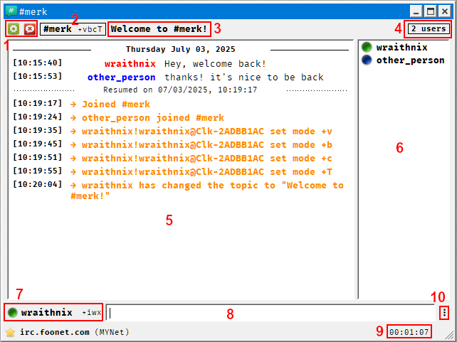

- Mode Editor and Banlist. The mode editor button displays a menu that allows the user to set or remove popular channel modes, if their status allows it; if they are not a privileged enough user, the button is hidden. The banlist displays a list of users that have been banned from the channel; if the banlist is empty, the button is hidden.
- Name and mode display. Here, the channel name and any channel modes are displayed.
- Topic. The channels topic is displayed here. Click on the topic to edit it, and press enter to send any changes to the server.
- User count. How many users are currently in the channel
- Chat display. Channel chat, as well as system messages, are displayed here.
- User list. A list of users in the channel is displayed here. Privileged users have special icons next to their name (green for channel operators, blue for voiced users, etc.), and normal users do not. Nicknames are displayed in bold if the users are present, and in normal weight if they are away. Double click a user's name to open a private chat window.
- Nickname. This displays the currently used nickname, and any user modes set.
- Text input widget. Type your chat or commands here, and press "enter" to send them to the server or client.
- Uptime. This displays how long the client has been connected to the channel.
- Input menu. Clicking on this brings up a menu that allows you to do various tasks, like changing the spellchecker's language.

Private Chat Windows
Closing a private chat window does not leave the chat, or block the sender; it only closes the window.
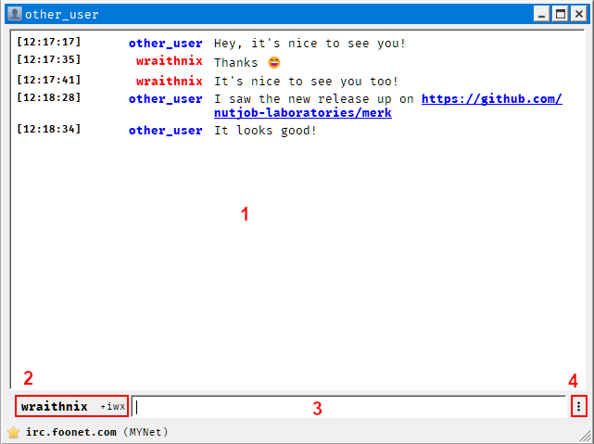
- Chat display. Private chat is displayed here, as well as system messages.
- Nickname. This displays the currently used nickname, and any user modes set.
- Text input widget. Type your chat or commands here, and press "enter" to send them to the server or the client.
- Input menu. Clicking on this brings up a menu that allows you to do various tasks, like changing the spellchecker's language.

Style Editor
MERK has a text style engine that colors and styles all chat text, and can be edited by users with the style editor.
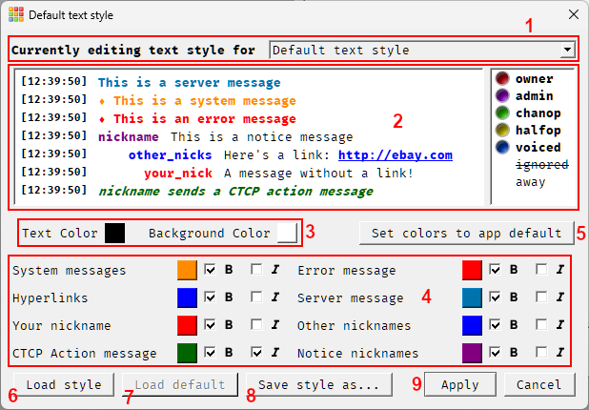
- Style selector. Select what text style to edit. When launched from the "Tools" menu, this will default to editing the default text style; when launched from context menus or the /style command, the text style of the window that launched the style editor will be selected. The text style of any window currently in use can be selected.
- Display. This is what the text style will look like in the client. Any changes in color or style will be displayed here instantly. If editing the default text style, or the text style of a channel, an example user list is shown as how it will appear in the client. The example user list is not shown when editing the text style of server windows or private chats.
- Background and foreground color. Set the color of the text and the background color here.
- Message styles. Change the color and style of individual message types here.
- Set colors to app default. Set all colors to the default style that ships with MERK. This is different from the "default" style that is applied to server windows and any windows that do not have a style.
- Load style. Here, you can open any existing MERK style file for editing. Colors and styles will be loaded and displayed.
- Load default. This will load in whatever style the user has set as the default text style. This button is disabled when editing the default text style.
- Save style as…. Save this style to a file. It will not be applied, only saved to a file.
- Apply and Cancel. Applying this style automatically saves it. Pressing the "cancel" button closes the dialog, and all changes are discarded.

How Text Styles Are Applied
All chat windows start by using the default style. All text styles currently in use can be edited with the "Style Editor", found in the "Tools" menu

All chat windows can have their own styles which can be edited by selecting the "Style Editor" option from the "Tools" menu, or "Edit [NAME]'s text style" in the input options menu, or the chat display right click menu. Styles for channel and private chat windows are saved with the IRC network of the channel or private chat in mind, so they will load no matter which server the client is connected to. For example, if the user has set a text style for the #merk channel on the EFnet network, it will load and be applied to the #merk channel window if the user is connected to irc.underworld.no on port 6667, irc.choopa.net on port 9999, or irc.prison.net on port 6667, as all of these servers are on the EFnet IRC network.
Server window text styles are specific to the server being connected to, regardless of what network the server is on. So, if the user has set a style for irc.prison.net on port 6667, the server window text style for that connection will be loaded. If the user connects to irc.choopa.net on port 9999, the default style will be loaded; even though both servers on the EFnet network, they are still different servers.

Script Editor
To launch the script editor, use the /edit command, or select Script Editor from the "Tools" menu

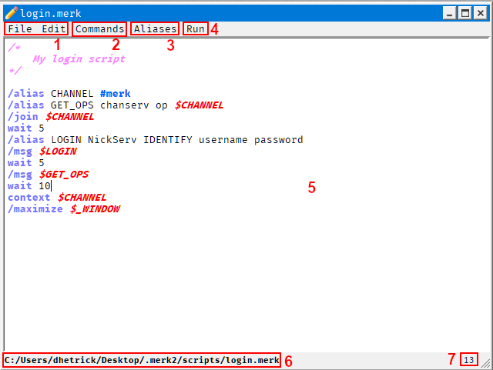
- File and Edit Menus. All the normal selections of a text editor, like opening and saving files, cut and paste, find and replace, etc. Connection scripts can also be opened for editing, as well as created.
- Commands. Each entry in this menu allows the user to insert a command into the open script. Click the desired command, fill out the entries in the dialog that pops up, if needed, and the command will be inserted into the script.
- Aliases. Insert built-in aliases into the script.
- Run. Run the currently open script in any context/window available. The user also can run the script in all contexts/windows simultaneously. Scripts are executed with no arguments and no filename.
- Script display. Features syntax highlighting. Colors used for the display can be set in the "Settings" dialog.
- Filename. The currently open script's filename is displayed here.
- Line number. The line number the cursor is currently on.

The colors and styles used for the syntax highlighting can be changed in the "Settings" dialog. Comments, commands, channels, aliases, and script-only commands can be styled individually. These colors and styles will also be used in the "Connection Script" tab of the connection dialog.

Log Manager
The log manager allows users to view, delete, and export MERK logs. It can be launched from the "Tools" menu | 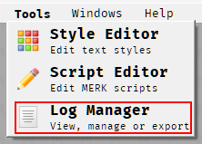

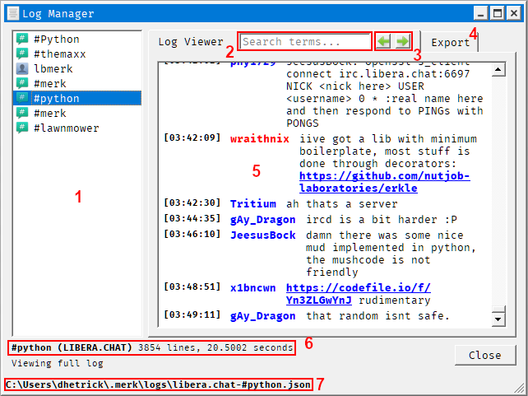
- Logs. A full list of all logs in MERK. Hover the mouse over the log name to see what IRC network the log is from. Click a log name to view information about the log, as well as use export options. Double click a log name to view the contents of a log.
- Search. Search the log for specific words. Typing in the terms and pressing enter will find the first instance of the term in the log; hitting enter again will find the next, and so on.
- Next Result and Previous Result. Move forward and backwards in the word search results.
- Log Viewer and Export Tabs. Click tabs to switch functions. The Export tab has settings and functionality to export MERK logs to JSON or a custom delimited format.
- Log display. Logs are loaded in full for viewing. For longer logs, this may take some time. Logs use the whatever default text style the user has set.
- Log information. Contains the log name, what IRC network the log is from, how many lines of chat the log contains, and how long it took to render the entire log, if the log is being viewed.
- Log filename. The full filename of the current log.

Additional log options can be seen by right-clicking on the log's name:
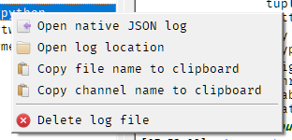
If the "Open native JSON log" option is selected, the JSON file that MERK uses will be opened in the default application that the user's operating system to open JSON files. There is additional information in the native log format that tells MERK how to render the log for viewing; to use MERK logs with other applications, the log should be exported to strip this information out.
Logs that are very large will not be fully loaded for the log display; only the last 5000 lines of chat are loaded, as it can take up to a minute to render a log this large, depending on the speed of the computer running MERK. This can be changed by using the /config command: the setting log_manager_maximum_load_size sets the maximum number of lines to load.

The Windowbar
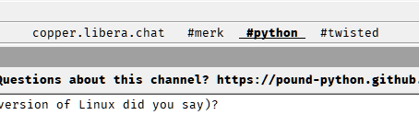
The "windowbar" is a widget that is located by default on the top of the main window that displays a list of open subwindows. Clicking on a window's name switches "focus" to that window, bringing it to the front; double click the window name to bring the window to the front and maximize it. By default, the windowbar only shows channel windows, private chat windows, and script editor windows, but you can use the "Settings" dialog (or the windowbar's right click menu) to show other window types. Think of the windowbar as a sort of task manager, only for windows in MERK.
Right click on an entry in the windowbar for more options. Each window type shows different options. Right click on the windowbar itself to change settings for the windowbar. Most things about the windowbar can be changed, including the order windows are shown, what windows are shown, whether icons are shown on entries, and more. | 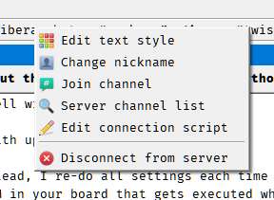The windowbar right click menu for a server window.

Although immobile by default, the right click menu and the "Settings" dialog can make the windowbar movable; the windowbar can float, or be "docked" at the bottom or the top of MERK's main window.

Regular and Dark Mode

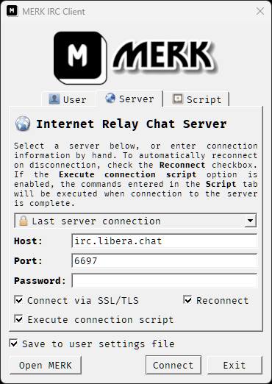Normal Mode | 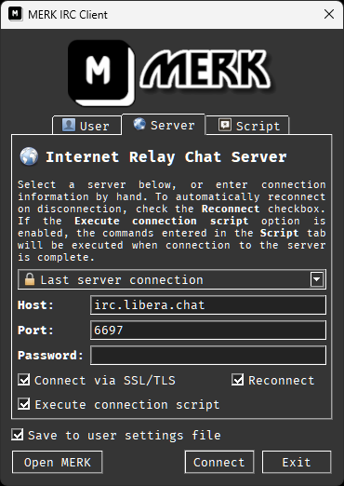Dark Mode

MERK can be operated in "normal" mode, seen above to the left, or in "dark" mode, on the right. To switch to "dark" mode, select it in the "Settings" menu or in the "Settings" dialog. MERK will have to be restarted for it to take effect, and you'll be prompted to restart MERK automatically.

For more advanced users, if you want to edit the palette that "dark" mode uses, all of the colors used by the application are stored in a file in the styles directory named dark.palette. The file format is specific to MERK, but you can edit it with a text editor. All colors are stored in the hexadecimal format used by HTML. To re-create the file and reset the "dark" mode values back to the default, delete dark.palette and restart MERK; the application will regenerate the file with default values.

Commands and Scripting Guide

Command List

IRC Commands
All of these commands are related to IRC, in some way, shape, or form. Most of them are present in most other modern IRC clients.
Command | Description
/away [MESSAGE] | Sets status as "away"
/back | Sets status as "back"
/ctcp REQUEST USER | Sends a CTCP request to a user. Valid requests are TIME, VERSION, USERINFO, SOURCE, or FINGER
/invite NICKNAME CHANNEL | Sends a channel invitation
/finger TEXT... | Sets the CTCP FINGER response. Pass * as the argument to clear the FINGER response text.
/join CHANNEL [KEY] | Joins a channel
/kick CHANNEL NICKNAME [MESSAGE] | Kicks a user from a channel
/knock CHANNEL [MESSAGE] | Requests an invitation to a channel
/list [TERMS] | Lists or searches channels on the server; use "*" for multi-character wildcard and "?" for single character
/me MESSAGE... | Sends a CTCP action message to the current chat
/mode TARGET MODE... | Sets a mode on a channel or user
/msg TARGET MESSAGE... | Sends a message
/nick NEW_NICKNAME | Changes your nickname
/notice TARGET MESSAGE... | Sends a notice
/oper USERNAME PASSWORD | Logs into an operator account
/part CHANNEL [MESSAGE] | Leaves a channel
/ping USER [TEXT] | Sends a CTCP ping to a user
/quit [MESSAGE] | Disconnects from the current IRC server
/quitall [MESSAGE] | Disconnects from all IRC servers
/raw TEXT... | Sends unprocessed data to the server
/reclaim NICKNAME | Repeatedly attempts to change nickname to NICKNAME until successful; by default, attempts are made every 30 seconds
/refresh | Requests a new list of channels from the server
/time | Requests server time
/topic CHANNEL NEW_TOPIC | Sets a channel topic
/userinfo TEXT... | Sets the CTCP USERINFO response. Pass * as the argument to clear the USERINFO response text.
/version [SERVER] | Requests server version
/who NICKNAME [o] | Requests user information from the server
/whois NICKNAME [SERVER] | Requests user information from the server
/whowas NICKNAME [COUNT] [SERVER] | Requests information about previously connected users

All Other Commands
These commands are specific to MERK, and are for using and manipulating the client. Commands with a gray background are for use in scripts only; they cannot be used in the text input widget, and will only produce an error. Some of these commands cannot be used in scripts.
Command | Description
/alias [TOKEN] [TEXT...] | Creates an alias that can be referenced by $TOKEN. Call with only TOKEN as the argument to see TOKEN's value. If TEXT is a mathematical statement, it will be evaluated, with the resulting value stored as the alias' value. Call without any arguments to see all aliases and their values.
/cascade | Cascades all subwindows
/clear [SERVER] [WINDOW] | Clears a window's chat display. SERVER is optional if WINDOW belongs to the same context.
/close [SERVER] [WINDOW] | Closes a subwindow. SERVER is optional if WINDOW belongs to the same context.
/config [SETTING] [VALUE...] | Changes a setting, or searches and displays one or all settings in the configuration file
/config export [FILENAME] | Exports the current configuration file
/config import [FILENAME] | Imports a configuration file into settings
/config restart | Restarts MERK using the same command-line arguments used to start MERK
/connect SERVER [PORT] [PASSWORD] | Connects to an IRC server
/connectssl SERVER [PORT] [PASSWORD] | Connects to an IRC server via SSL
context WINDOW_NAME | Moves execution of the script to WINDOW_NAME; can only be called from scripts
/delay SECONDS COMMAND... | Executes COMMAND after SECONDS seconds
/edit [FILENAME] | Opens a script in the editor; if called without an argument, opens an editor window
end | Immediately ends a script. Can only be called from scripts.
exclude WINDOW... | Prevents a script from executing in WINDOW's context. Multiple WINDOWs can be specified. Can only be called from scripts.
/exit [SECONDS] | Exits the client, with an optional pause of SECONDS before exit
/find [TERMS] | Finds filenames that can be found by other commands, like /script or /edit. If called without any arguments, /find will list all files visible to commands. Can use * for multi-character wildcards and ? for single character wildcards.
/focus [SERVER] [WINDOW] | Sets focus on a subwindow. SERVER is optional if WINDOW belongs to the same context.
/fullscreen | Toggles full screen mode
goto LINE_NUMBER | Moves execution of the script to LINE_NUMBER. The only script-only command that can be issued from an if command. Can only be called from scripts.
halt [MESSAGE...] | Halts a script's execution, and displays an error MESSAGE with line number and file name. Can only be called from scripts.
/help [COMMAND] | Displays command usage information
/hide [SERVER] [WINDOW] | Hides a subwindow. SERVER is optional if WINDOW belongs to the same context.
if VALUE1 OPERATOR VALUE2 COMMAND... | Executes COMMAND if VALUE1 and VALUE2 are true, depending on OPERATOR. Valid OPERATORs are (is) (result is true if VALUE1 and VALUE2 are equal), (not) (result is true if VALUE1 and VALUE2 are not equal), (in) (result is true if VALUE1 is contained in VALUE2), (gt) (result is true if VALUE1 is a greater number than VALUE2), (lt) (result is true if VALUE1 is a lesser number than VALUE2), (ne) (result is true if VALUE1 and VALUE2 are numbers and are not equal), and (eq) (result is true if VALUE1 and VALUE2 are numbers and are equal). Can only be called from scripts.
/ignore USER | Hides a USER's chat in all chat windows. This can be set to a nickname or hostmask. Capitalization is ignored. Use * as multiple character wildcards, and ? as single character wildcards.
insert FILE [FILE...] | Inserts the contents of FILE where it appears in the script. FILE should be a MERK script. If a filename contains spaces, put it in quotation marks. Multiple files can be passed as arguments. Can only be called from scripts.
/macro NAME SCRIPT [USAGE] [HELP] | Creates a macro, executable with /NAME, that executes SCRIPT. USAGE and HELP are used for the command list displayed with /help.
/maximize [SERVER] [WINDOW] | Maximizes a subwindow. SERVER is optional if WINDOW belongs to the same context.
/minimize [SERVER] [WINDOW] | Minimizes a subwindow. SERVER is optional if WINDOW belongs to the same context.
/move [SERVER] [WINDOW] X Y | Moves a subwindow to X (left and right) and Y (up and down) coordinates. SERVER is optional if WINDOW belongs to the same context.
/msgbox MESSAGE... | Displays a messagebox with a short message
/next | Shifts focus to the "next" subwindow
only WINDOW... | Restricts a script to only executing in WINDOW's context. Multiple WINDOWs can be specified. Can only be called from scripts.
/play FILENAME | Plays a WAV file
/previous | Shifts focus to the "previous" subwindow
/print [WINDOW] TEXT... | Prints text to a window
/prints [WINDOW] TEXT... | Prints a system message to a window
/private NICKNAME [MESSAGE] | Opens a private chat subwindow for NICKNAME
/random ALIAS LOW HIGH | Generates a random number between LOW and HIGH and stores it in ALIAS
/reconnect SERVER [PORT] [PASSWORD] | Connects to an IRC server, reconnecting on disconnection
/reconnectssl SERVER [PORT] [PASSWORD] | Connects to an IRC server via SSL, reconnecting on disconnection
/rem [TEXT...] | Does nothing. Can be used as a target for goto
/resize [SERVER] [WINDOW] WIDTH HEIGHT | Resizes a subwindow. SERVER is optional if WINDOW belongs to the same context.
restrict channel|server|private | Prevents a script from running if it is not being executed in a channel, server, or private chat window. Up to two window types can be set. Can only be called from scripts.
/restore [SERVER] [WINDOW] | Restores a subwindow. SERVER is optional if WINDOW belongs to the same context.
/s FILENAME [ARGUMENTS] | A shortcut for the /script command.
/script FILENAME [ARGUMENTS] | Executes a list of commands in a file. If the script has a file extension of .merk, it may be omitted from FILENAME.
/shell ALIAS COMMAND... | Executes an external program, and stores the output in an alias
/show [SERVER] [WINDOW] | Shows a subwindow, if hidden; otherwise, shifts focus to that subwindow. SERVER is optional if WINDOW belongs to the same context.
/style | Edits the current window's style. Cannot be called from a script
/tile | Tiles all subwindows
/unalias TOKEN | Deletes the alias referenced by $TOKEN
/unignore USER | Un-hides a USER's chat in all chat windows. This can be set to a nickname or hostmask. Capitalization is ignored. To un-hide all users, use * as the argument.
usage NUMBER [MESSAGE...] | Prevents a script from running unless NUMBER or more arguments are passed to it, and displays MESSAGE. Can only be called from scripts
/user [SETTING] [VALUE...] | Changes a user setting, or searches and displays one or all settings in the user file. Pass * as VALUE to set a setting as blank
wait SECONDS | Pauses script execution for SECONDS; can only be called from scripts
/window [COMMAND] [X] [Y] | Manipulates the main application window. Valid commands are move, size, maximize, minimize, restore, readme, settings, and logs. Call with no arguments to see window information and a list of subwindows.
/xconnect SERVER [PORT] [PASSWORD] | Connects to an IRC server & executes connection script
/xconnectssl SERVER [PORT] [PASSWORD] | Connects to an IRC server via SSL & executes connection script
/xreconnect SERVER [PORT] [PASSWORD] | Connects to an IRC server & executes connection script, reconnecting on disconnection
/xreconnectssl SERVER [PORT] [PASSWORD] | Connects to an IRC server via SSL & executes connection script, reconnecting on disconnection

Script-Only Commands
These commands can only be called from scripts. Attempts to use them in the text input widget will fail and show an error.
Command | Description
context WINDOW_NAME | Moves execution of the script to WINDOW_NAME; can only be called from scripts
end | Immediately ends a script. Can only be called from scripts.
exclude WINDOW... | Prevents a script from executing in WINDOW's context. Multiple WINDOWs can be specified. Can only be called from scripts.
if VALUE1 OPERATOR VALUE2 COMMAND... | Executes COMMAND if VALUE1 and VALUE2 are true, depending on OPERATOR. Valid OPERATORs are (is) (result is true if VALUE1 and VALUE2 are equal), (not) (result is true if VALUE1 and VALUE2 are not equal), (in) (result is true if VALUE1 is contained in VALUE2), (gt) (result is true if VALUE1 is a greater number than VALUE2), (lt) (result is true if VALUE1 is a lesser number than VALUE2), (ne) (result is true if VALUE1 and VALUE2 are numbers and are not equal), and (eq) (result is true if VALUE1 and VALUE2 are numbers and are equal). Can only be called from scripts.
goto LINE_NUMBER | Moves execution of the script to LINE_NUMBER. The only script-only command that can be issued from an if command. Can only be called from scripts.
halt [MESSAGE...] | Halts a script's execution, and displays an error MESSAGE with line number and file name. Can only be called from scripts.
insert FILE [FILE...] | Inserts the contents of FILE into the script. FILE should be a MERK script. If a filename contains spaces, put it in quotation marks. Multiple files can be passed as arguments. Can only be called from scripts.
only WINDOW... | Restricts a script to only executing in WINDOW's context. Multiple WINDOWs can be specified. Can only be called from scripts.
restrict channel|server|private | Prevents a script from running if it is not being executed in a channel, server, or private chat window. Up to two window types can be set. Can only be called from scripts.
usage NUMBER [MESSAGE...] | Prevents a script from running unless NUMBER or more arguments are passed to it, displaying MESSAGE. Can only be called from scripts.
wait SECONDS | Pauses script execution for SECONDS; can only be called from scripts

Non-Script Commands
These commands cannot be called from scripts. Scripts that use these commands will prevent the script from being executed, and show an error.
Command | Description
/edit [FILENAME] | Opens a script in the editor; if called without an argument, opens an editor window. Cannot be called from a script
/style | Edits the current window's style. Cannot be called from a script

Context-less Commands
These commands can be called without specifying the channel, chat, or window they are for. They will run in the current context. Commands with a gray background are IRC specific commands.
Command | Description
/clear | Clears the current window's chat display
/close | Closes the current subwindow
/focus | Sets focus on the current subwindow
/hide | Hides the current subwindow
/invite NICKNAME | Sends a channel invitation to the current channel
/kick NICKNAME [MESSAGE] | Kicks a user from the channel
/maximize | Maximizes the current subwindow
/me MESSAGE... | Sends a CTCP action message to the current chat
/minimize | Minimizes the current subwindow
/mode MODE... | Sets a mode on the current channel
/move X Y | Moves the current subwindow to X (left and right) and Y (up and down) coordinates.
/part [MESSAGE] | Leaves the channel
/print TEXT... | Prints text to the current window
/prints TEXT... | Prints a system message to the current window
/resize WIDTH HEIGHT | Resizes the current subwindow
/restore | Restores the current subwindow
/show | Shows the current subwindow, if hidden
/topic NEW_TOPIC | Sets the current channel's topic

Subwindow Management Commands
These commands can be called without specifying the channel, chat, or window they are for. They will run in the current context. Commands with a gray background are IRC specific commands.
Command | Description
/cascade | Cascades all subwindows
/close [SERVER] [WINDOW] | Closes a subwindow
/focus [SERVER] [WINDOW] | Sets focus on a subwindow
/hide [SERVER] [WINDOW] | Hides a subwindow
/maximize [SERVER] [WINDOW] | Maximizes a window
/minimize [SERVER] [WINDOW] | Minimizes a window
/move [SERVER] [WINDOW] X Y | Moves a subwindow to X (left and right) and Y (up and down) coordinates.
/next | Shifts focus to the "next" subwindow
/previous | Shifts focus to the "previous" subwindow
/resize [SERVER] [WINDOW] WIDTH HEIGHT | Resizes a subwindow
/restore [SERVER] [WINDOW] | Restores a window
/show [SERVER] [WINDOW] | Shows a subwindow, if hidden
/tile | Tiles all subwindows
/window | Generates and displays a list of all connected windows

Additional Command Help
- wait – Can only be called from scripts
- context – Can only be called from scripts
- end – Can only be called from scripts
- usage – Can only be called from scripts
- restrict – Can only be called from scripts
- insert – Can only be called from scripts
- only – Can only be called from scripts
- exclude – Can only be called from scripts
- if – Can only be called from scripts
- goto – Can only be called from scripts
- halt – Can only be called from scripts
- /style – Cannot be called from scripts
- /edit – Cannot be called from scripts

Most commands can be issued in both the text input widget and scripts. There are eleven commands, however, that can only be issued in scripts: wait, context, usage, restrict, insert, only, exclude, if, goto, halt, and end. These ten commands cannot be used in the text input widget. There are two commands that cannot be called by a script, and can only be used in the text input widget: /edit and /style will display an error and prevent execution if called by a script.
Most commands require a context to be executed in (see Context). Commands that can be issued without explicitly specifying a context are /clear, /invite, /kick, /me, /mode, /part, /topic, /maximize, /minimize, /hide, /show, /close, /print, /prints, /resize, /move, /focus, and /restore; they will be executed in whatever the current context is, and may not function correctly if the current context does not support that command (for example, calling /invite from a server window). The only exception is /me: if called from the text input widget of a channel or private chat window, it will send a CTCP action to the current window, using all arguments as the text to send in the message. If /me is called from a server window, the first argument specifies the channel or private chat to send the CTCP message to. For example, to send a CTCP message containing "is using MERK" to the #merk channel, you could call /me #merk is using MERK from a server window. When calling /me from a script, the command will always send to the current chat if running in a channel or private chat window, and must specify the context if running in a server window. If a context is specified as the first argument to /me, and the command is executed in a channel or private chat window, the specified context will be sent as part of the CTCP action message.

The goto command cannot be used to "jump" to a line that contains any script-only command other than end. If the "jumped to" line contains any script-only command besides end, the script will display an error and end execution. Use the /rem command for a target line that "does nothing".
Most commands that require a numerical argument require an integer; that is, a whole or natural number. Several commands can take floating-point numbers as arguments, allowing for fractional numbers: if, wait, /delay, and /exit. As most of these commands' numerical arguments relate to the amount of time to "pause" a command or script's execution, floating-point numbers allow these commands to "pause" for time periods of less than a second. For example, to "pause" a script for 500 milliseconds, or one half of a second:
wait 0.5

To convert milliseconds into seconds, divide the number of milliseconds by 1000 to determine the number of seconds. 1 millisecond is 0.001 seconds, 2ms is 0.002 seconds, and so on.

Using the goto Command
The goto command is extremely powerful, and allows a script to "jump" from one line to another line; that is, it can change the sequence of execution of a script. It is not recommended to use goto in scripts that contain comments, as comments are stripped out of a script before execution, and may change the line count of a script. Using the insert command can also alter the line count of a script, so goto should not be used in scripts that use insert. Instead, if your script has insert or comments, execute scripts with goto using the /script command.
goto cannot be used to "jump" to a line that contains a script-only command other than end. If goto is used in this way, an error will be raised, and script execution will halt. The /rem command can be used as a target, as the command is not a script-only command, and does nothing.
Using goto is easy: pass the line number you wish to "jump" to as the only argument. Execution of the script will immediately move to the desired line. For example:
1 | /print This is the beginning of the script!
2 | goto 4
3 | /print This line will never be executed.
4 | /print This line will ALWAYS be executed!
5 | end
This script:
- Prints "This is the beginning of the script!" to the current window
- "Jumps" immediately to line 4
- Prints "This line will ALWAYS be executed!" to the current window, which is the result of the command on line 4.
- End the script.
With the goto command in place, line 3 will never be executed, as the goto command skips right over it.
goto is the only script-only command that can be called from an if command; all other script-only commands are forbidden, and will display an error.
WARNING! There are no protections in place preventing a script from entering an infinite loop. goto can lock up or crash MERK.
Please use goto carefully and sparingly.

Using the if Command
The if command allows MERK scripts to have a small amount of flow control. It compares two values, and if the values' comparison is true, executes a command. The entity that sets how the comparison works is called the operator. MERK has seven operators:
Operator | Description
(is) | True if the first value is equal to the second value. Values are treated as strings, and are case in-sensitive.
(not) | True if the first value is not equal to the second value. Values are treated as strings, and are case in-sensitive.
(in) | True if the first value is contained in the second value; for example, o (in) pop evaluates to true because "pop" has "o" in it. Values are treated as strings, and are case in-sensitive.
(lt) | True if the both values are numbers, and the first value is less than the second value. If either value is not a number, an error is displayed and script execution stops.
(gt) | True if both values are numbers, and the first value if greater than the second value. If either value is not a number, an error is displayed and script execution stops.
(eq) | True if both values are numbers, and the first value is equal to the second value. If either value is not a number, an error is displayed and script execution stops.
(ne) | True if both values are numbers, and the first value is not equal to the second value. If either value is not a number, an error is displayed and script execution stops.
The first value is passed as the first argument, followed by the OPERATOR, followed by the second value. All other arguments should contain the command to execute if the comparison is true. if can execute almost any command available, with one major exception: if cannot execute any script-only command other than goto. Any attempt to use if to execute a script-only command besides goto will result in a "Line contains no command" error, and script execution will be halted. Remember, goto cannot be used to "jump" to a line with any script-only command other than end.
As an example, here's a script that tests if the user has a specific nickname (merk), and uses the /reclaim command if someone use is using the nickname.
1 | if merk (is) $_NICKNAME goto 4
2 | /print "merk" nickname in use, trying to reclaim it…
3 | /reclaim merk
4 | end
This script:
- Tests if the user's current nickname is merk, and if it is, calls goto to move execution to line 4, which ends the script
- Prints a message to the user telling them that the script is going to use the /reclaim command
- Issues the /reclaim command to reclaim the merk nickname
- Ends the script
Values are tokenized like script arguments; values can have whitespace in them as long as they are contained in quotes. Values can also be mathematical statements, which are evaluated before comparing with the if statement's operator. For example, let's assume that you have a number stored in an alias named mynum, and you want to determine if that number is even or odd:
1 | if "$mynum % 2" (eq) 0 goto 4
2 | /print $mynum is odd
3 | end
4 | /print $mynum is even
5 | end

Using the /rem Command
The /rem command does nothing. It can be used to add "comments" to a script, or as a target for the goto command. Since the goto command cannot be used to "jump" to a line that contains a script-only command, place a /rem command in the line before the desired script-only command, and "jump" to the line with the /rem command.
For example, the following code will display an error on line 3 and exit:
1 | goto 3
2 | /print This will never display
3 | goto 4
4 | /print This will display

As line 3, the target the goto command "jumps" to in line 1, contains a script-only command (another goto), an error will be displayed and the script will exit. To make this script work in exactly the same way (other than updating the target of the second goto command), we can use the /rem command:
1 | goto 3
2 | /print This will never display
3 | /rem This line does nothing
4 | goto 5
5 | /print This will display

Using the /print and /prints Commands
The /print command can be used to print text to the current or another window; use the name of the window context as the first argument to print to another window. If this window cannot be found, the text will print to whatever the current window context is. The window specified by the first command must be "connected" to the current context (that is, they share an IRC server connection).
The /prints command works exactly the same way, only it prints a "system" message, like the messages emitted by most commands.

Both /print and /prints can print HTML, and are not written to the log.

/* This will print to the current window */
/print Hello world!

/* This will print to the #merk channel window.
If the client is not in #merk, it will print to the current window. */
/print #merk Hello world!

/* This will print some HTML as a system message */
/prints <i>This is in italics!<i><br><u>And this is underlined on a new line!</u>

Using the restrict, only, and exclude Commands
The restrict script-only command restricts a script's execution to a specific context. The first argument sets what type of context the script will function in: server restricts the script's context to server windows or connection scripts, channel restricts the script's context to channel windows, and private restricts the script's context to private chat windows. A restricted script will not execute in another context, and will show an error. Up to two context types can be passed, so restrict private channel would prevent a script from being executed in server windows. So, to restrict a script's execution to chat windows only, you could use:
restrict private channel
/print This will only print to chat windows

The similar only script-only command can be used to restrict a script's execution to specific contexts; for example, specific channels, server windows, or private chats. Pass the name of the window as an argument to the command; an unlimited number of arguments can be passed to the command. For example, to restrict a script's execution to channels named #merk or #merkirc, you could use:
only #merk #merkirc
/print This will only print to windows named #merk or #merkirc

The exclude script-only command works just like the only command, only it prevents a script from executing in specific contexts. Pass the name of the window as an argument to the command; an unlimited number of arguments can be passed to the command. To prevent a script's execution in any channel named #merk or #merkirc, you could use:
exclude #merk #merkirc
/print This will not print to windows named #merk or #merkirc

Using the insert Command
The insert script-only command reads in the contents of any file passed as an argument to it, and "inserts" it into the script where it is called. Any built-in aliases (see Built-In Aliases) in the inserted script will reference the script being executed, not the script being inserted, including any arguments passed to the calling script. For example, assume you have a script named stuff.merk, and it contains:
/print Hello from $_SCRIPT!

In another script, we use the insert command to insert this file into the script test.merk:
/print This is my main script!
insert stuff.merk
/print And now my script is complete!

Once processed, the script that will be executed will look like:

/print This is my main script!
/print Hello from test.merk!
/print And now my script is complete!

The insert command can be used to insert multiple files into a script; pass each file's name as a separate argument to insert, or issue insert multiple times. Arguments passed to the insert command are tokenized like script arguments, so filenames with spaces in them can be passed to insert, as long as they are contained in quotation marks.
inserted files may contain insert as well, up to a maximum "depth" of 10. That is, a file can insert a file that calls insert, which can insert call a file that calls insert, which can insert a file that calls insert, which can insert a file that calls insert, and so on, up to a maximum of 10 "layers" of files that call insert. Changing this behavior is only possible by using the /config command on the maximum_insert_file_depth setting, or by editing settings.json directly with a text editor.
Using the insert command can alter the line count of a script, and thus the goto command should not be used in an inserted script, or in a script that uses insert.

Using /show, /hide, /close, and context Commands
/show and context switch contexts programmatically, but in slightly different ways. /show will show a window hidden with the /hide command, and also move focus to that window; that means that any commands issued without context will now be issued in that window's context. /hide simply "hides" a window without closing that window. A hidden window is no longer visible, but will still appear in the windowbar; it is not closed, and if the window's context is a channel, the client will still be present in that channel. /show will not move "focus" to a subwindow, and cannot be used to switch context; to switch to a windows context, use the /focus command. /show and /hide can be issued from the text input widget.
context can only be issued in scripts, and completely moves the script's context to the new window.
Both /hide and /show can take up to two arguments. Pass the name of the window to hide or show as the first argument if the window shares a context (that is, the same server connection) as the window issuing the command. If the window to be shown or hidden is in another context (a different server connection), pass the name of the server window as the first argument, followed by the name of the window to be shown or hidden as the second argument. The IRC server's hostname is normally used for the name of the server window, but you can use the address used to connect to the server, or address:port to switch to the server window's context. To "select" the server window with one of these commands, use * as the name of the window along with the name of the server.
For the following example, assume that we have two active connections: we are in the channels #merk and #python on silver.libera.chat, and the channels #qt and #merk on lawnmower.undernet.org. Our test script is executed in #python's context, on silver.libera.chat:
/* Here, we hide #merk's window in the current context */
/hide #merk

/* Now, we switch context to lawnmower.undernet.org's window */
context lawnmower.undernet.org

/* This shows to #merk, only it's on the UnderNet server,
not the Libera server */
/show #merk

/* In order to show #merk's window on Libera, we use the server
argument of /show */
/show silver.libera.chat #merk

/close works exactly the same as /show and /hide, only instead of showing or hiding a window, it closes a window. If the window is for a channel, the channel will be left.
You can use the /windows command to see a list of currently available subwindows.

Using the /resize, /move, and /window Commands
The /resize and /move commands can be used to resize and move MERK subwindows, respectively.
Much like /hide and /show, /resize's and /move's first two arguments set what window the command is going to work on. Pass the name of the window as the first argument if the window shares the same context as the window the command is being executed in. If the window belongs to the context of another server, pass the name of the server followed by the window name as the first two arguments.
/resize takes two additional arguments: the new width of the subwindow, and the new height of the subwindow. So, to set a subwindow's size to a width of 800 pixels, and a height of 600 pixels, you can use:
/resize #merk 800 600

/move works similarly, and also takes two additional arguments: the new X and Y values of the subwindow. The X value sets where the top left corner of the subwindow will be located from left to right, and the Y value sets where the top left corner of the subwindow will be located from top to bottom. An error will be shown if invalid values are used (like negative numbers, or if it would move the window to where it would no longer be visible).
This example uses the /move command to move the subwindow for #merk on tungsten.libera.chat to a new location 950 pixels to the right, and 500 pixels from the top:
/move tungsten.libera.chat #merk 950 500

To find out exactly how big the area that contains the subwindows is, as well as what subwindows are available, call the /window command with no arguments.
The /window command is used to manipulate the main application window. To move the main application window, pass move as the first argument to /window, followed by the X and Y values. To resize the window, pass size as the first argument to /window, followed by the width and height:
/* Moves the main application window to the coordinates 200,200 */
/window move 200 200

/* Resizes the main window to 1024x768 */
/window size 1024 768

To maximize, minimize, or restore the main application window, pass maximize, minimize, or restore to /window as the only argument, respectively.
/window can also be used to open dialogs and other types of subwindows. To open up the README, pass readme as the only argument to /window. To open up the settings dialog, pass settings as the only argument to /window. To open the log manager, pass logs as the only argument to /window.

Using the /ignore Command
The /ignore command hides chat from a given nickname or user. However, messages from an /ignored user are still received and logged, they are just not displayed. That user's chat is hidden from all chat displays, no matter what server they are on. You can pass a nickname (which will hide all chat from any user with that nickname) or a hostmask (which will hide chat from only users with that hostmask) to the /ignore command. The /ignore list is saved to the configuration file, and will be applied universally until the user is /unignored. The /ignore list cannot be edited by the /config command; the only way to unignore a user is either through the right click userlist menu, the settings menu, or with the /unignore command.
The /ignore command can also be used with wildcards. Use * to substitute for any number of characters, and ? to substitute for a single character. For example, to ignore any user that has "annoying.com" anywhere in their hostmask or nickname, you could use:
/ignore *annoying.com*

Users /ignored in this way must be /unignored with the /unignore command. Right clicking on an ignored user in the userlist will not give an option to unignore the user. To show the users messages again, either call /unignore with the specific entry used to ignore them as an argument (so, /unignore *annoying.com* in the example above), or clear the ignore list by clicking on "Clear ignore list" in the settings menu, or calling /unignore * to clear the ignore list.
Call /ignore with no arguments to see the ignored user list in full. Attempting to add an entry to the ignore list that already exists will result in an error.

Using the /config and /user Commands
The /config command allows users to edit the main MERK configuration file, settings.json, from within the client. Warning! It is possible to break or otherwise "mess up" MERK's configuration with this command. If this occurs, see Resetting MERK to Default Settings to undo the damage.

If called with no arguments, /config will list all the settings that can be edited with the command. To search settings, pass search terms to the command as an argument. For example, to search all settings that have the word "windowbar" in them, you could execute /config windowbar; this will print a list of all the settings that match the search term:

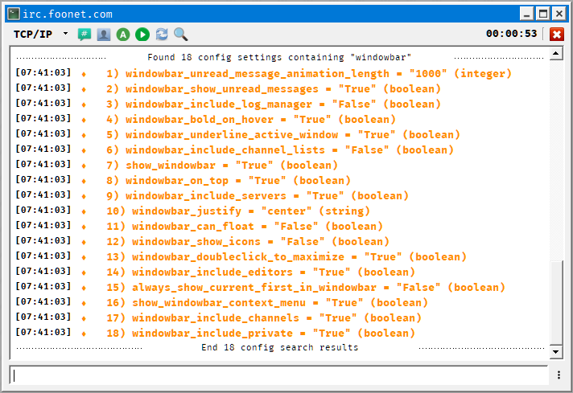A search with /config for settings containing "windowbar"

Each listing contains the name of the setting, what the setting's value currently is, and what type of variable the setting is. To change a setting, pass the name of the setting as the first argument to /config, followed by the new setting value. The new value will be checked to make sure it's valid, and if so, stored as the new setting's value. For example, to change the show_windowbar setting to "False", you could execute:

/config show_windowbar false

If a setting's value is a string, all arguments after the setting will be assumed to be part of the new value. For example, if using /config to change the default "away" message to "I'm busy right now!", you could execute:

/config default_away_message I'm busy right now!

MERK should be restarted after changing settings with /config. Although many settings are applied instantly, some settings will only be applied after restarting.
/user works exactly the same way as /config, only it edits the user configuration file. For most settings, this just changes default values. However, for finger and userinfo, this setting changes the values sent when MERK receives a CTCP FINGER or USERINFO request, respectively.

To set a value to a blank string, pass * as the value to set.

Here's some example uses of /user:

/* This sets the default nickname */
/user nickname new_nickname

/* This sets the default username */
/user username new_nickname

/* This sets the CTCP FINGER response */
/user finger Hey! Stop pointing at me!

/* This clears the CTCP USERINFO response */
/user userinfo *

/config can also be used to import and export configuration files. To export the current configuration file, pass export as the first argument to /config, followed by the filename to export the configuration to; if no filename is passed, the user will be prompted for a filename. To import a configuration file, pass import as the first argument to /config, followed by the filename of the configuration file to import; if no filename is passed, the user will be prompted for a file to import. After importing a configuration file, MERK should be restarted as soon as possible.

/config can also be used to restart MERK. Use restart as the only argument to /config to restart MERK, using the same command-line initially used to start MERK.

Using the /connect and the Other Connection Commands
These commands are used to connect MERK to IRC servers:
- /connect connects to an IRC server, and does not execute any existing connection scripts
- /connectssl connects to an IRC server via SSL/TLS, and does not execute any existing connection scripts
- /xconnect connects to an IRC server, and executes any existing connection scripts
- /xconnectssl connects to an IRC server via SSL/TLS, and executes any existing connection scripts

Pass the hostname or IP address of the server as the first argument to these commands, and the port number to connect to as the second argument. These commands can be issued from the text input widget or from scripts. Please see Connecting to Servers for an example connection script that uses these commands.
These commands will not automatically reconnect on disconnection. To ensure that MERK reconnects to the server on disconnection, add re before connect in all of these commands:
- /reconnect connects to an IRC server, and does not execute any existing connection scripts, automatically reconnecting on disconnection
- /reconnectssl connects to an IRC server via SSL/TLS, and does not execute any existing connection scripts, automatically reconnecting on disconnection
- /xreconnect connects to an IRC server, and executes any existing connection scripts, automatically reconnecting on disconnection
- /xreconnectssl connects to an IRC server via SSL/TLS, and executes any existing connection scripts, automatically reconnecting on disconnection

Using the /quit and /quitall Commands
These commands are used to disconnect MERK from an IRC server. The /quit command disconnects from the IRC server associated with the context the command was issued in. It can be issued without an argument, or with a "quit" message as all arguments to the command; this will be used instead of the default "quit" message.
The /quitall works exactly the same way as /quit, only it will disconnect from all servers that MERK is currently connected to.
/* This will disconnect from the IRC server associated
with the context the command is issued in. It will
use "See you later!" as the "quit" message. */
/quit See you later!

/* This will disconnect from *all* connected servers with
the same message used in the last example. */
/quitall See you later!

Using the /shell Command
The /shell command allows a script, or command, to execute an external process and store any output in an alias. The first argument to the command is the alias to store the output in, and all other arguments are executed as an external process.

For example, let's use /shell to write a script that calls the fortune Linux/UNIX program to display a fortune-cookie-like "fortune". We're going to call fortune with the -s command-line flag to generate a short fortune, store it in an alias named FORTUNE, and then send it as a message to the current chat:

restrict channel private
/shell FORTUNE fortune -s
/msg $_WINDOW Here's a fortune: $FORTUNE

This script:

- Restricts the script's execution to channel and private chat windows, as it sends a message to the current window, which won't work in server window contexts.
- Executes /shell, which calls fortune -s and stores the output in FORTUNE.
- Sends a message to the current chat window containing the fortune.

Using the /reclaim Command
The /reclaim command can be used to "reclaim" a nickname currently in use by another user. When used, MERK will periodically try to change the nickname to the desired nickname until the desired nickname is "claimed" by the client. By default, MERK will attempt to change the nickname every 30 seconds; this can be changed by using /config to change the reclaim_nickname_frequency setting to the desired number of seconds.

Using the /delay Command
The /delay command is used to delay a command's execution for a set amount of time. Pass the number of seconds to delay the execution of the command as the first argument, and all other arguments will be used as the command to execute. For example, to wait 5 minutes (which is 300 seconds) before changing your nick to merk_user, you could use:
/delay 300 /nick merk_user

The command to be executed with /delay cannot contain any script-only commands, even in scripts. The command will fail with a "no command found" error.

Using the /macro Command
The /macro command allows users to create their own "commands"; it creates a named command, just like MERK's other commands, that executes a script, passing any arguments to the script. Arguments to the /macro command are tokenized like arguments passed to scripts, so if you have an argument that contains whitespace in it, contain it in quotes.
Macro names, much like aliases, cannot contain punctuation (with the exception of the underscore, _). They also cannot have the same name as existing commands.
As an example, we're going to create a macro named /hello. First, we'll write the script the macro will execute. Our macro will take one argument, a name, and send a message containing a greeting to that name to the current context. Any and all script commands can be used, including script-only commands:
restrict channel private
usage 1 /hello NAME
/msg $_WINDOW Hello, $_1!
Save this script to a file named hello.merk in MERK's "scripts" folder. Now that our script exists, we can create the macro for our command:
/macro hello hello.merk
Now, we can use our macro! To send a greeting to a user named "bob", just enter:
/hello bob
Thanks to the usage script-only command, if we call our macro with less arguments than we need, the scripts usage text will be displayed. And thanks to the restrict script-only command, if this macro is called from a server window, the macro will not execute and an error will be displayed.
Arguments to macros are tokenized (and treated) just like arguments to scripts. In the example above, the command /hello bob is treated exactly like the command /script hello.merk bob was called. If you wanted to send a greeting to a user that contains spaces in the "name" argument, use quotes to contain the argument; for example, to send a greeting to "Bob the Builder", you could use the /hello macro like:
/hello "Bob the Builder"
Macros are not saved by MERK, so they must be recreated every time MERK is started. An easy way to make sure that the macros you use are always available is to create them in your connection scripts.
The /macro command can take two optional arguments; these arguments set the text that is displayed in the command list displayed by the /help command. The first optional argument sets the usage text (displayed in the left hand column of the /help display), and the second optional argument sets the command description (displayed in the right hand column of the /help display). To modify the previous example to use the usage and help arguments, we could create the macro with:
/macro hello hello.merk "/hello NAME" "Says hello to another user"
This adds our usage and help information to the /help display:
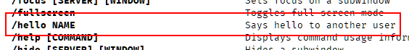
It is not possible to pass the help text to the /macro command without passing the usage text first; while both arguments are optional, and usage text may be passed without help text, if help text is desired, usage text must be passed as an argument first. If both usage and help text arguments are omitted, the macro is still added to the /help display; usage is set to the name of the macro, and the help text is set to "Executes script ", with the name of the script the macro executes.
Macros cannot have the same name as existing commands. Macro names must also start with a letter, and not a number or other symbol. Multiple macros cannot have the same name; a new macro with the same name as an existing macro will "overwrite" the older macro.
Macros are treated like commands in a lot of respects. If autocomplete for commands is turned on, autocomplete will work for macros. Macros are added to the list of commands that displays when the /help is used, and macros will be highlighted just like commands in the text input widget. If scripting is turned off in settings, the /macro command will be disabled.

Scripting MERK
There are two types of scripts in MERK: connection scripts, and all other scripts.

Connection Scripts
Connection scripts are the scripts entered into the connection dialog, and are intended to be executed as soon as the client connects to the server. Unlike other scripts, they are stored in the user configuration file, and, outside of connection, can only be executed with the script editor. Connection scripts have the context of the associated server window created when connection begins (see Context and Writing Connection Scripts).

All Other Scripts
All other scripts are, well, scripts: a list of commands, one per line, issued in order. Scripts have a context, which is the window that they are called from or executed in. They can be executed in several ways:

- From the "Run" button on a server window's toolbar. The script will be executed in the server window's context.
- From the "Run" entry in a window's input menu. The text in the text input widget will be replaced with a call to the /script command to execute the selected file.
- From the "Run" entry in a window's chat display right-click menu. The text in the text input widget will be replaced with a call to the /script command to execute the selected file.
- By issuing the /script command. The script will be executed in the window that the command was called from's context.
- From the "Run" menu in a script editor window. The user can select which context to run the script in, or optionally select to run the script on all windows simultaneously (with each window running that script in the window's context).

When using the /script command, scripts are searched for as outlined in Directories and Configuration Files; if the script can be found in this directory search, the path to that script can be omitted. For example, if a script named example.merk is in the /scripts directory, calling /script example.merk will execute that script. If the file extension to the script is .merk, than the file extension can be omitted; /script example will also execute the script in the previous example.

Scripts can have comments. Comments must begin with /* and end with */, and can span multiple lines. Commands issued within comment blocks will be ignored, as will any text inside the comment block:

/*
/msg $_WINDOW This command WILL NOT be executed
*/

/msg $_WINDOW This command WILL be executed

Errors
For the most part, MERK handles script errors in two ways. Errors in script-only commands will prevent execution, while errors in other commands will halt the script execution when the error is encountered. If any of the following script-only command errors or conditions are detected, the script will not execute:
- Calling wait with a non-number argument
- Calling usage with the wrong number of arguments
- Calling usage with a non-number as the first argument
- Calling restrict with the wrong number of arguments
- Calling restrict with an argument that is not server, channel, or private
- Calling only with no arguments
- Calling end with any arguments
- Calling insert no arguments
- Calling insert with a file that cannot be found, doesn't exist, or can't be read. Errors of this type will not display the filename the faulty insert call was in.
- Calling context with a context that doesn't exist
- Executing a script in a context that is not allowed by restrict
- Executing a script in a context that is not allowed by only
- Executing a script in a context that is not allowed by exclude
- Calling a command that cannot be called in scripts

Every other command error will display an error message (if script error messages are turned on in settings), and halt execution of the script. Error messages will be displayed for:
- Lines that do not contain a command
- Lines that start with / and are not followed by a valid command
- Calls to commands with an incorrect number of arguments
- Calls to commands with invalid arguments
- Scripts being executed in the "wrong" context
- Errors in command execution
- Using goto to "jump" to a line that contains a script-only command
If an error is encountered, an error message with be displayed. The error message will contain:
- The line number the error occurred on. On files that contain the insert command, the line number may not be accurate, as the script will include the inserted file. Comments are stripped from scripts before execution, which may also result in inaccurate line numbers in error reports.
- The name of the file the error is located in. If the error is in a connection script, the filename displayed will be SERVER:PORT for the server's connection script. If the filename is not known or does not exist, the filename will be set to script. Errors in calling the insert command will not contain the filename the error occurred in, only what the erroneous call was.
- A description of the error.

Context
A script or command's context is a reference to the window the script or command is being executed in. Context is, for the most part, only necessary for scripts; the context for any commands issued by a window's text input widget is the window the command is being issued in.
Some commands can ignore an argument if they are for the current context; for example, when issuing the /part command, you can ignore the CHANNEL argument if the command is intended to be executed in the current window's context:
/* This leaves the current channel */
/part

/* This invites a user to the current channel */
/invite my_friend

/* This kicks a user from the current channel */
/kick my_enemy

/* This gives a user operator status in the current channel */
/mode +o my_friend

/* This sets the topic in the current channel */
/topic Welcome to my channel!

Context-less commands should not be issued by scripts, as it can get confusing if you run the script in the wrong context. However, if the script is being ran in any window's context, context-less commands are available to the script.
When running a script from a window, either through the server window's toolbar, or the input menu, the script is always ran in that window's context. The script editor "Run" menu allows you to choose which context to run the script in. If MERK is connected to more than one server, and in more than one channel or private chat on each server, the "Run" menu will give options to run the script in all of each context; for example, you can run a script in all connected channels.
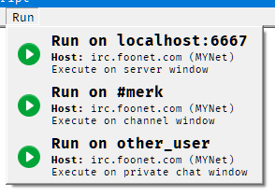 | An example "Run" menu from the script editor. The client is connected to a server on localhost:6667, and is in the channel #merk while having a private chat with other_user. Each selection will run the script in the specified context.

A window's context is "connected" to any other window contexts that share the same network stream. Commands issued from the text input widget in server or chat windows can only effect other windows that share the same server connection. This is called a "shared context".
For example, let's assume that MERK is connected to two servers, irc.example.com and irc.other.net. On irc.example.com, MERK is connected to two channels, #merk and #python. On irc.other.net, MERK is connected to the channel #qt. In this example, #merk and #python have a shared context, while #qt doesn't have a shared context with the other two window. Commands issued in #qt will not be able to have an effect on #merk or #python, and vice versa.
Scripts can use the context command to "move" the script to another context. The context command will search for all windows, no matter what context. The order context looks for windows is:
- Windows that have a shared context with the context the script was executed in.
- Windows from all contexts.
- Server windows.

context will move to the first window it finds with the name passed to it. If you are in multiple channels with the same name, this may be problematic.
If a script is intended to only be ran in a specific type of context, the restrict command can be used, in one of three ways:
- restrict server – The script will only run in server windows or connection scripts
- restrict channel – The script will only run in channel windows
- restrict private – The script will only run in private chat windows

A script that has been "restricted" will only run in the context specified, and will not execute and show an error if it is ran in another context. Up to two contexts can be passed to restrict. For example, to make sure that a script is ran only in chat windows, use restrict channel private.
Outside of scripts, it is possible to "move" to another window's context via commands. The /show command can move to the context of any other window.

Aliases
Aliases are tokens that can be created to insert specific strings into your input in the client (if the "Interpolate aliases into input" setting is turned on, which is the default) or into your scripts. They function kind of like variables do in programming languages. As an example, let's create an alias named 'GREETING', and set it to the value 'Hello world!':

/alias GREETING Hello world!

Now, if you want to insert the string "Hello world!" into a command or any output, you can use the alias interpolation symbol, which is $ by default, followed by the alias's name, to insert your alias into the command or output:

/msg #mychannel $GREETING

This sends a message to #mychannel that says "Hello world!" to everyone in the channel!

Alias names must start with a letter, and not a number or other symbol. This is to prevent overwriting built-in aliases created for each window's context (see Built-In Aliases). Alias names also cannot contain punctuation, except for underscores.

To create an alias, use the /alias command. To see a list of all aliases set for the current window, issue the /alias command with no arguments. To delete an alias, issue the /unalias command.

Aliases can also be used as macros, and can contain an entire command. For example, let's say that you like to issue a greeting to everyone that enters a channel, but typing /msg #mychannel Hello, and welcome! is a pain to type every time someone joins, you could create this alias:

/alias GREETING /msg $_WINDOW Hello, and welcome!

Now, whenever someone joins your channel, just type $GREETING into the text input widget to send your message! The above example uses a built-in alias, which is explained in Built-In Aliases.

All aliases are global in scope; that is, they are available to all and every script executed on the client after they are created. They can also be changed by any script or command. Aliases created by connection scripts will be available and visible to any scripts executed after the connection script (including other connection scripts). Any script can also delete an alias with the /unalias command.

Built-in aliases cannot be deleted with the /unalias command. The client will display an error that says the alias doesn't exist if attempted.

Built-In Aliases
Each window has a number of aliases for use that are built-in to the window's context, and do not require the user to create them. Built-in alias names start with an underscore (_) and are all uppercase. Some built-in aliases (see Script Arguments) are only created in certain circumstances; these have a gray background.

Alias | Value
_0, _1,... | Any arguments that have been passed to the currently running script; the first argument will be set to $_1, the second argument will be set to $_2, and so on. $_0 will contain all arguments, separated by spaces; if no arguments have been passed, $_0 will be set to none.
_ARGS | The number of arguments passed to a script. If no arguments have been passed to the script, this will be set to 0.
_CLIENT | The name of the IRC client, MERK.
_CONNECTION | If the connection type of the server the window is connected to; if connected via SSL/TLS, this will be set to SSL/TLS, otherwise it will be set to TCP/IP.
_COUNT | The number of users in the current channel. For server and private chat windows, this will be set to 0.
_CUPTIME | The number of seconds that MERK has been running.
_HOST | The reported hostname of the server the window is connected to; if that is not known, then this will be set to the server's address, a colon, and the server's port.
_DATE | The current date, in "MM/DD/YYYY" format.
_DAY | The current day of the week.
_EDATE | The current date, in "DD/MM/YYYY" format.
_EPOCH | The current time in UNIX epoch format.
_FILE | The full filename of the currently running script. If called from an /inserted file, this will contain the name of the script being executed, not the /inserted file. If the current script does not have a filename, this will be set to script.
_HCHANNELS | The number of hidden channels on the server the window is connected to. If this is not known, this will be set to 0.
_MODE | Any modes set on the user associated with the window. If no modes are set, this will be set to none.
_MONTH | The name of the current month.
_NETWORK | The network the server the window is connected to is on; if this is not known, this will be set to unknown.
_NICKNAME | The user's current nickname.
_ORDINAL | The current day of the month.
_PORT | The port on the server the window is connected to.
_PRESENT | If the window the alias is being used in is a channel window, this will contain a list of users in that channel, separated by commas. If there are no users in the channel, or if this is used in a non-channel context, this will be set to none.
_REALNAME | The user's realname, as set in user settings.
_RELEASE | The URL for the current latest release of MERK, as known at the release of the running version.
_RVERSION | The current release version of MERK, as known at the release of the running version.
_SCHANNELS | The number of visible channels on the server the window is connected to. If this is not known, this will be set to 0.
_SCOUNT | The number of visible users on the server the window is connected to. If this is not known, this will be set to 0.
_SCRIPT | The name of the file, without the full path, of the currently running script. Only present in scripts that have been executed with the /script command. If called from an /inserted file, this will contain the name of the script being executed, not the /inserted file. If the current script does not have a filename, this will be set to script.
_SERVER | The server the window is connected to; this will be the address used to connect to the server, not the server's reported hostname.
_SOFTWARE | The server software the server the window is connected to is using. If this is not known, this will be set to unknown.
_SOURCE | The URL to MERK's source code.
_STAMP | The current time, following the format setting for timestamps.
_STATUS | If the window is associated with a channel, this will contain the window's channel status (operator, voiced, etc.); otherwise, this will be set to normal.
_SUPTIME | How long, in seconds, the client has been connected to the server associated with the current window.
_TIME | The current time, in 24-hour format.
_TOPIC | If the window the alias is being used in is a channel window, this will contain the channel's topic, if there is one. If the channel does not have a topic, or if the window is not a channel, this will be set to No topic.
_UPTIME | How long the window the script is being ran in has been connected or has been in use, in seconds.
_VERSION | The current version of MERK in use.
_USERNAME | The user's username, as set in user settings.
_WINDOW | The name of the window the script is being used in.
_WTYPE | The type of window the alias is being used in; either server for server windows, channel for channel windows, or private for private chat windows.
_YEAR | The current year.

Built-in aliases can be very useful in scripts, where the script may not "know" what context it is running in:

/* This sends a message to the current channel */
/msg $_WINDOW Hello, everybody! My name is $_NICKNAME

/* This sets the current channel's topic */
/topic $_WINDOW We've been around for $_UPTIME seconds!

They can also be used to display information about the client:

/* This sets the default away message */
/config default_away_message $_CLIENT $_VERSION – I'm away right now

Script Arguments
Arguments can be passed to a script with the /script command; just pass them as arguments to the command following the script file name. The /script command is the only way to pass arguments to a script.
Script arguments are tokenized differently than arguments for commands. In arguments for most commands, arguments are considered to consist of either a single word, with no spaces, or a number of words separated by spaces. A channel name, for example, or a nickname may be an argument; the /msg command looks for a channel or nickname as the first argument, with all other arguments being the message to be sent. Arguments to scripts can contain spaces, and the number of arguments is important. To use an argument with spaces in it, contain the argument with quotation marks.
/* This calls a script with a single argument */
/script myscript.merk "Hello, world!"

/* Here are multiple arguments, with spaces in each */
/script test.merk "First argument!" "Second argument!" "And third!"

To access these arguments, a built-in alias is created for each one, and another is created for all arguments. Each built-in alias is named with the number of the argument: $_1 for the first argument, $_2 for the second, $_3 for the third, and so on. The built-in alias $_0 contains all arguments passed to the script, joined by single spaces; if no arguments have been passed to the script, $_0 will contain the string none.

To make sure your script is called with the right number or arguments, use the usage command. As the first argument to usage, pass the number of arguments your script requires. All arguments after this first will be displayed as the error message if your script it called with an improper number of arguments.

As an example, let's write a script that sends a greeting to someone in the current chat. Our script will require a single argument, a name. When executed with the right number of arguments, it will send the greeting to chat, and if executed with too few arguments, will tell the user how to use the script. Open the script editor, and paste the following code into it, saving the file as greet.merk.

/*
This script requires a single argument.
If none or more than one argument is passed,
display script usage information.
*/
usage 1 Usage: /script $_SCRIPT NAME

/msg $_WINDOW Hello there, $_1! Nice to see you!

Let's execute our script! In the text input widget, type the following and hit enter:

/script greet other_user

Our greeting is sent to the current chat:

If we executed our script with no arguments, an error message is displayed:
Connection scripts are never called with any arguments. Scripts executed by any way other than the /script command are never called with any arguments.
Several built-in aliases are created for scripts. $_FILE contains the full filename of the script (including path) being called, $_SCRIPT contains the filename of the script without the path, and $_ARGS contains the number of arguments the script was called with. The example above has a use of the $_SCRIPT built-in alias. If a script is executed from the editor (and thus doesn't have a filename), both $_FILE and $_SCRIPT will be set to script.
Scripts executed with the "Run" menu in the editor are never called with any arguments, and will only have the $_SCRIPT or $_FILE built-in aliases if the script has been saved to or loaded from a filename. Scripts executed with the "Run script" button on server window toolbars will have the $_SCRIPT and $_FILE built-in aliases, but as they are never called with arguments, will have the $_ARGS built-in alias set to none.
Argument built-in aliases can be used with inserted scripts, but they will always reference the script that is being executed, not the inserted script. For example, if an inserted script includes the built-in alias $_1, that alias will interpolate to the first argument that was passed to the script that is being executed, not the inserted file.

Writing Connection Scripts
Connection scripts are the scripts that can be entered in the connection dialog, and are executed as soon as the client completes connecting to a server. A connection script's context is the server window created when connecting. In fact, calling restrict server to restrict the connection script's execution to a server window will pass successfully, while using restrict with any other context type will cause the connection script to not execute.

To issue commands that will have an effect on another window, use the context command to move the script to that window's context.
Before contexting to another context, be aware that that window (and the context) may "not exist" yet. The channel window may not be rendered yet, the private chat that you intended to start has not started yet, etc. The wait command will help you in these situations, so you can make sure that all the contexts for your script have been created before you issue commands.
For example, let's say that when you connect to your favorite server, automatically join your favorite channel, #merk, say hello, and maximize the channel window. Your connection script might look like:
/alias FAVORITE #merk
/join $FAVORITE
/msg $FAVORITE Hello, everybody!
wait 10
context $FAVORITE
/print $_WINDOW Maximizing $FAVORITE!
/maximize $_WINDOW
How long to wait after connection will take some trial and error, due to many factors: the speed of your Internet connection, the speed of your computer, how busy the server is, how big of a log the client is loading for display, among other things. When in doubt, a longer wait is preferable to a shorter one, to make sure that your script executes properly. When first writing a connection script, try wait 30 to pause the script for 30 seconds, and tweak from there.

Example Scripts

Wave
This is a simple script that sends an emoji to the current chat, and adds a shortcut to executing the script. When executed in a channel or private chat window, it will send the "wave" emoji to the current chat. It also creates an alias, allowing the user to type $wave to send the wave emoji.
/*
Wave Script
By Dan Hetrick
*/

restrict channel private
/msg $_WINDOW :wave:
/alias wave /script $_FILE

What this script does specifically:
- Restrict the scripts execution to channel and private chat windows.
- Sends the "wave" emoji to the current chat
- Creates an alias named "wave" that will re-execute the script

Greeting
This script sends a greeting to the as a private message to a user. It takes a single argument, the username of the person the greeting is being sent to.

/*
Greeting Script
By Dan Hetrick
*/

usage 1 Usage: /script $_SCRIPT nickname
/msg $_1 Hello! Nice to see you!

What this script does specifically:

- Makes sure the script is called with a single argument
- Sends a greeting as a private message to the user set in the single argument

Example Connection Script
This script should be set as a connection script. Upon connection to the server, it will log the user into NICKSERV, join a channel the user owns, tell CHANSERV to give them operator status in the channel, set the channel topic, maximize the channel's window, and send a greeting to the channel

/*
Example Server Connection Script
*/

restrict server
/alias USERNAME my_username
/alias PASSWORD my_password
/alias CHANNEL #my_channel
/alias TOPIC Welcome to my channel!
/alias GREETING $_NICKNAME is here, everybody!

/msg nickserv IDENTIFY $USERNAME $PASSWORD
wait 5
/join $CHANNEL
/msg chanserv OP $CHANNEL
wait 10
context $CHANNEL
/topic $TOPIC
/maximize
wait 1
/msg $_WINDOW $GREETING

What this script does specifically:

- Restrict the script's execution to server windows
- Sets an alias for the user's NICKSERV username
- Sets an alias for the user's NICKSERV password
- Sets an alias for the user's channel
- Sets an alias for the channel's topic
- Sets an alias for the greeting to send once everything else is done
- Logs into NICKSERV with the set username and password
- Waits 5 seconds
- Join the set channel
- Tells CHANSERV to give the user operator status in the set channel
- Waits 10 seconds
- Switches contexts to the channel window
- Sets the current channel's topic
- Maximizes the current channel window
- Waits 1 second
- Sends the greeting to the current channel

Inserting Files
If there's data or aliases that you want to use in more than one script, the /insert command makes that easy. In the last example, a script was used to login to NICKSERV. In this example, we're going to store our login information in one script, and use it in another.
login.merk
/*
NICKSERV Login
*/

/alias USERNAME my_username
/alias PASSWORD my_password
/alias LOGIN_TO_NICKSERV /msg NICKSERV IDENTIFY $USERNAME $PASSWORD

Now, to login to NICKSERV from another script, use the /insert command to insert this file into the script, and issue the full command:

insert login.merk
$LOGIN_TO_NICKSERV

Once all aliases have been interpolated into the script, this will end up being the script that is executed:

/msg NICKSERV IDENTIFY my_username my_password

Showing the Local Temperature
This script will use the /shell command to fetch the currently temperature in a specific location. You may have to edit the call to get the temperature in your location. I live in Detroit, Michigan, in the United States of America, so that's the location I'm going to use. We're going to use the curl executable to get the temperature from https://wttr.in/.

restrict channel private
/shell TEMP curl.exe -s "https://wttr.in/Detroit?format=%t"
/msg $_WINDOW It's currently $TEMP here in Detroit

This script:
- Restrict the script's execution to channel or private chat windows only, as it sends a message to the current window.
- Use the /shell command to call curl.exe to fetch the current temperature, and store it in the TEMP alias.
- Send a message to the current window containing the TEMP alias.

Connecting to Servers
Scripts can call other scripts, allowing scripts to be "chained"; that is, to execute one after the other. This script is an example of a connection script that connects to multiple servers, and executes multiple scripts.

First, let's create our initial connection script. We're going to use it upon connection to UnderNet. It will login to our X account before connecting to two other servers.

restrict server
/msg X@channels.undernet.org login username password
/join #merk
/xconnect palladium.libera.chat 6667
/xconnectssl irc.underworld.no 6697

This script:
- Restricts the script's execution to server window contexts.
- Sends a private message to UnderNet's user service bot, logging into an account.
- Joins the #merk channel.
- Connects to palladium.libera.chat on port 6667, executing any existing connection script when it connects.
- Connects to irc.underworld.no via SSL/TLS, on port 6697, executing any existing connection script when it connects.

Scripts can also execute other scripts with the /script command.

Dice Rolling Script
This script uses the /random command to simulate a dice roll and send the result to the current channel. Pass the number of sides of the dice to roll as the first argument to the script; so, to roll a 20 sided die, pass 20 as the argument to the script:

restrict channel private
usage 1 Usage: /script $_SCRIPT NUMBER_OF_SIDES
/random roll 1 $_1
/msg $_WINDOW Rolling a $_1 sided die: $roll

This script:
- Restricts the script's execution to chat window contexts.
- Sets the usage text for the script, and makes sure that the script is called with one argument.
- Generates a random number from 1 to the number passed as an argument to the script. If the argument is not a number, the script will stop executing and display an error. The generated random number is stored in the alias $roll.
- Sends a message to the current chat showing the random number that was generated.

In the game Dungeons & Dragons, rolling a 20 on a 20-sided die is a "critical", which usually means the roll succeeds or deals extra damage. Here's a version of the script rolls a 20-sided die, and notifies if a critical is rolled:

1 | restrict channel private
2 | /print Rolling...
3 | /random roll 1 20
4 | if $roll (is) 20 goto 7
5 | /msg $_WINDOW Rolled a $roll
6 | end
7 | /msg $_WINDOW Critical! Rolled a $roll
8 | end

This script:
- Restricts the script's execution to chat window contexts.
- Generates a random number from 1 to the number passed as an argument to the script. If the argument is not a number, the script will stop executing and display an error. The generated random number is stored in the alias $roll.
- Displays a message to the user
- Checks to see if the roll was a 20, and if it was, "jumps" to line 7
- Displays the roll to the current chat
- Ends the script
- This is the line our if "jumps" to; it displays to the current chat that the roll was a critical
- Ends the script

Custom Day-of-the-Week Away Message
This script sets MERK's default away message to a custom message depending on what day of the week it is.
1 | if $_DAY (is) Monday goto 9
2 | if $_DAY (is) Tuesday goto 11
3 | if $_DAY (is) Wednesday goto 13
4 | if $_DAY (is) Thursday goto 15
5 | if $_DAY (is) Friday goto 17
6 | if $_DAY (is) Saturday goto 18
7 | if $_DAY (is) Sunday goto 21
8 | halt $_DAY is not a recognized day!
9 | /config default_away_message I hate Mondays
10 | end
11 | /config default_away_message At least it's not Monday
12 | end
13 | /config default_away_message It's Wednesday, my dudes
14 | end
15 | /config default_away_message It's almost Friday...
16 | end
17 | /config default_away_message It's Friday!
18 | end
19 | /config default_away_message I love Saturday!
20 | end
21 | /config default_away_message It's almost Monday...
22 | end

This script uses if and the built-in alias $_DAY to check what day of the week it is, and sets the default away message, using goto and /config, with a special message for each individual day. If, for some reason, the name of the day of the week stored in $_DAY is not recognized, the script uses the halt command to show an error message to the user.

"Trout" Command
Many IRC clients have had the ability to create a "trout" command or macro: a command that takes a single nickname as an argument, and sends a CTCP action message to the current chat that says "slaps NICKNAME with a trout". Here's how you can do that in MERK!

First, we're going to write a script that takes a single argument and uses it to send a CTCP action message to the current chat. We'll save this script to a file named trout.merk in your scripts directory:

restrict channel private
usage 1 Usage: /trout NICKNAME
/me slaps $_1 with a trout
Now that we have our script, we'll use it to create a macro. We can put this command into the text input widget, a connection script, or another script:

/macro trout trout.merk "/trout NICKNAME" "Slaps someone with a trout"

Our "trout" command is complete!

Advanced Settings
The last section in the "Settings" dialog shows a number of settings that can be used to fundamentally change how MERK works. WARNING: Changing these settings may break your installation of MERK, break any existing scripts, or fill up your hard drive. If this occurs, please see Resetting MERK to Default Settings.
Changing these settings is not recommended, but may be desired.

Options
To change any of these settings, advanced settings must be enabled by clicking this checkbox:
Unchecking this checkbox will reset all the advanced settings to the value stored in the configuration file, and no settings will be saved. This must be enabled when clicking the "Apply" or "Apply & Restart" buttons for any changes to be saved. When changing any any advanced setting, restarting MERK is recommended.
- Connection heartbeat. This sets how often MERK "pings" the IRC server to keep the network connection active. The default is once every 120 seconds.
- Max message length. IRC has a hard limit of 512 characters for chat messages, and this must include the user's nickname and the appropriate chat command. 400 characters is the limit that MERK uses to determine if a chat message needs to be split into multiple messages.
- Flood protection for long messages. Chat messages that have been split up for exceeding the maximum message length will be sent once per second, to avoid triggering a server's flood protection. Turned on by default.
- Enable text style editor. The text style editor can be "turned off" here; this will not prevent text styles from being applied, only prevent the editor from editing them. Turned on by default.
- Show server pings in server windows. MERK sends "pings" to the IRC server to keep the network connection active. Checking this box will display whenever the client receives a "ping" reply from the server.
- Save all system messages to log. Checking this option will save nearly all messages displayed if logging is turned on. This will drastically increase the size of saved logs.
- Write all network input and output to STDOUT. This will show all IRC network traffic in STDOUT, which is normally printed to the console MERK is being ran from. This will not display anything if MERK is being executed with the PyInstaller executable (without using additional software to view STDOUT).
- Write all network input and output to a file in the user's settings directory. This will write all network input and output to a file or files in the settings directory. Each IRC connection will have its input and output written to a file named SERVER-PORT.txt. So, a connection to irc.libera.chat on port 6697 would have its input and output written to irc.libera.chat-6697.txt. WARNING! This will write a lot of data to your hard drive.

https://en.wikichip.org/wiki/irc/colors
https://en.wikipedia.org/wiki/Batch_file
...Natural numbers are the numbers 0, 1, 2, 3, and so on. Wikipedia
Wikipedia article on floating-point arithmetic
...An infinite loop (or endless loop) is a sequence of instructions that, as written, will continue endlessly, unless an external intervention occurs, such as turning off power via a switch or pulling a plug. Wikipedia
...Control flow (or flow of control) describes how execution progresses from one command to the next. Wikipedia
https://en.wikipedia.org/wiki/Variable_(computer_science)
https://en.wikipedia.org/wiki/Lexical_analysis#Tokenization

