Run 20230126 – One bid Imps

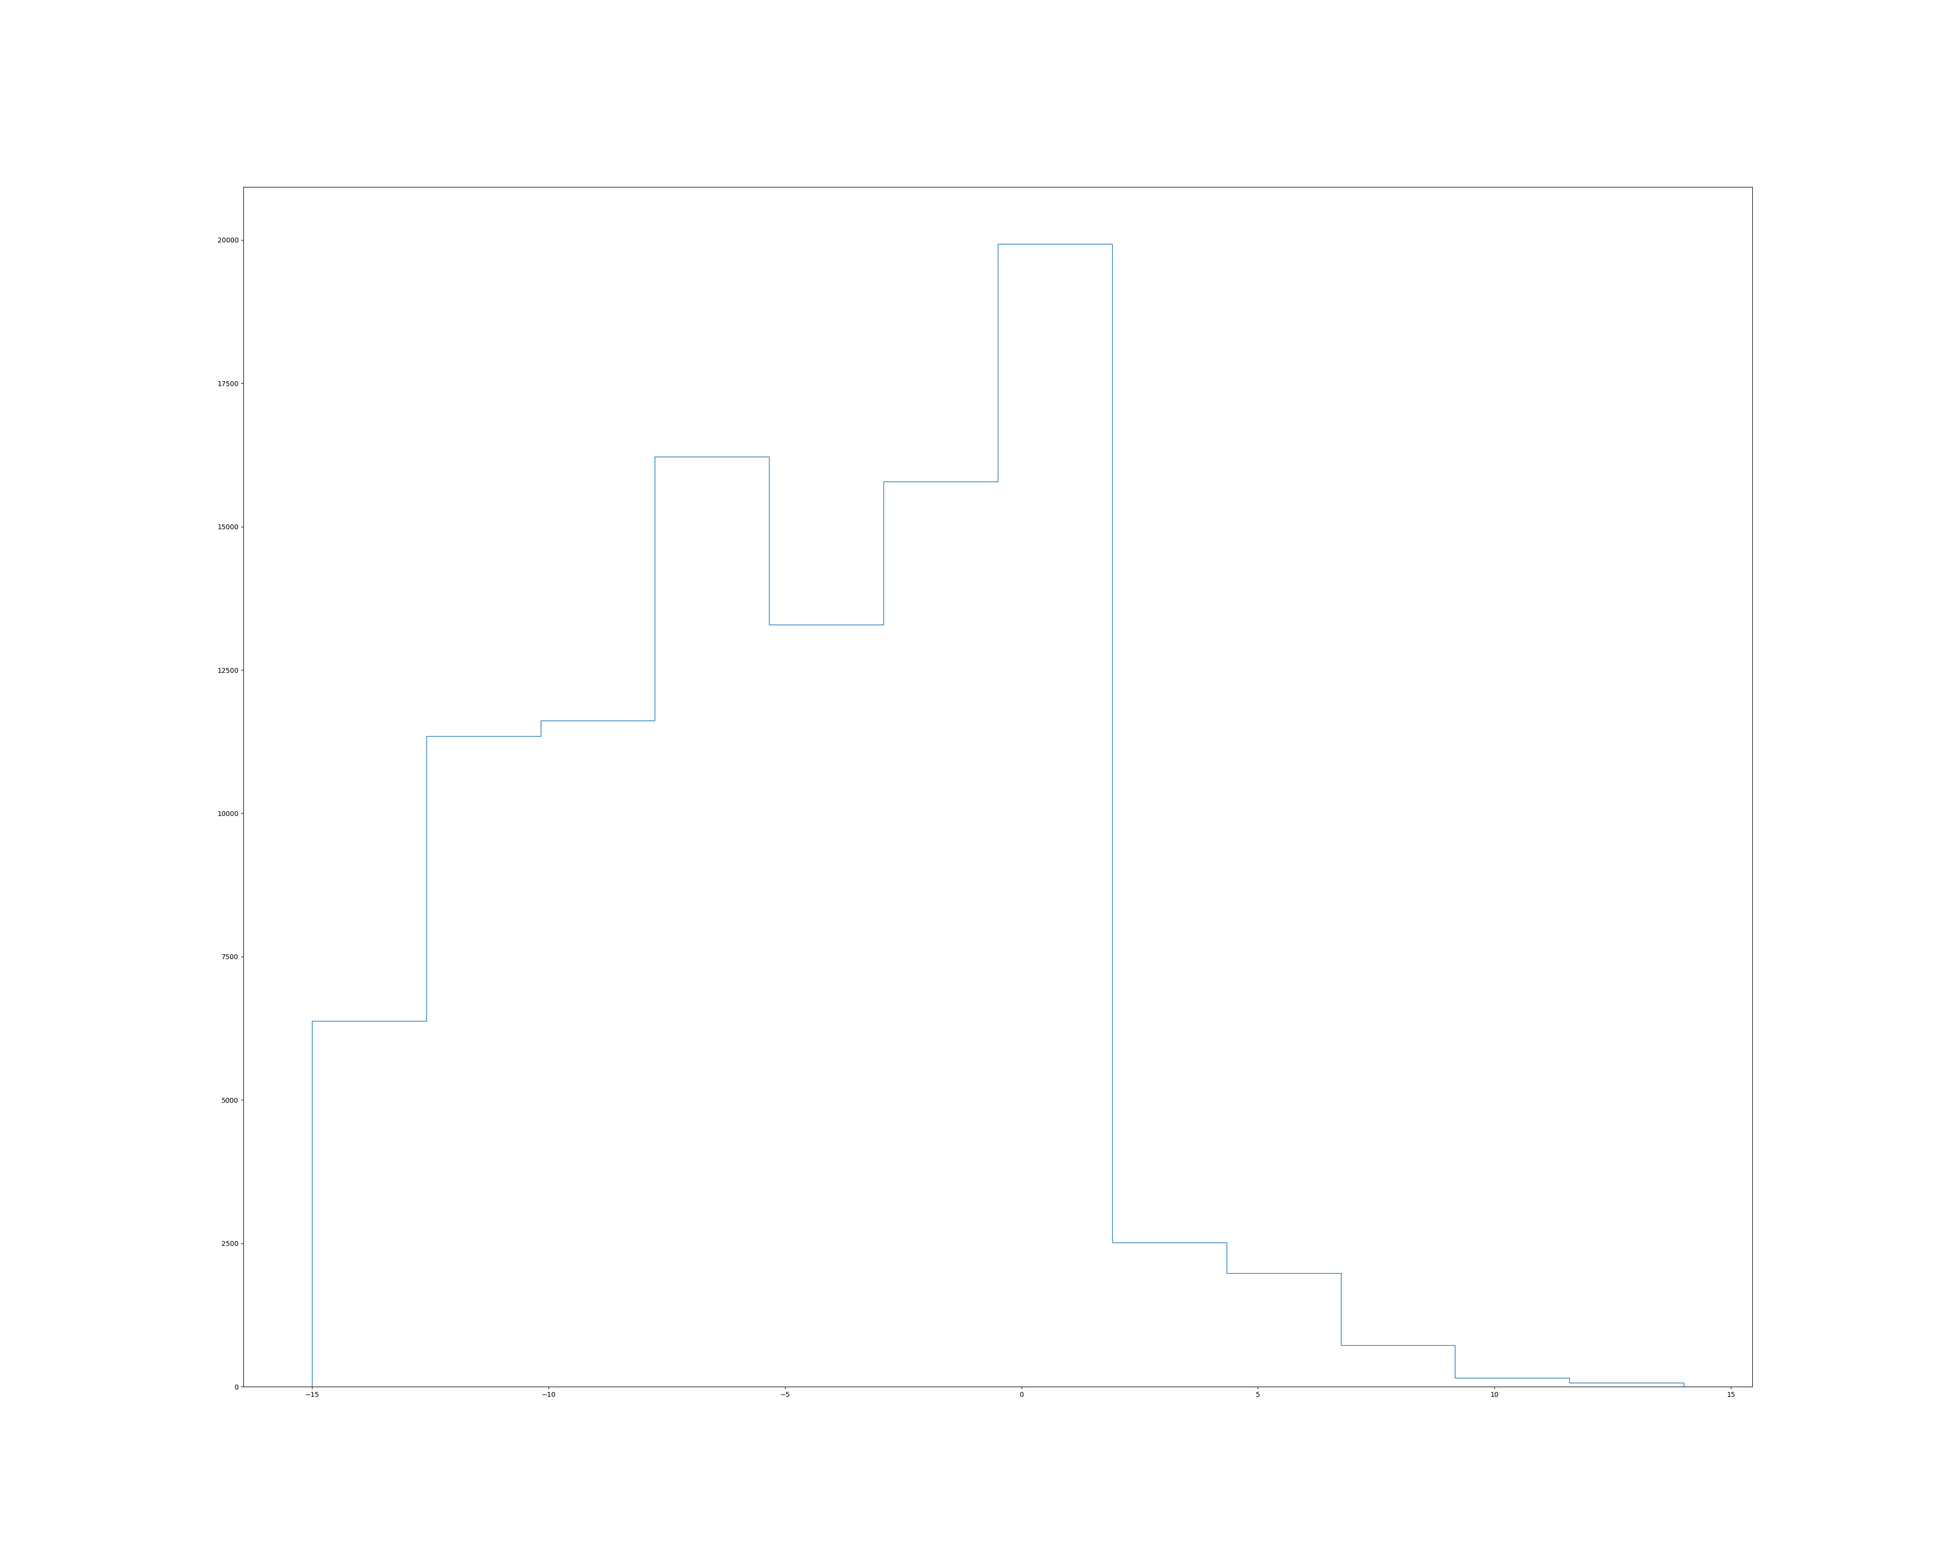Histogram/Table of results. On average it was -4 imps

Eval imp (-par):Mean: -4.0725 Stddev: 4.884899563962396 Median: -4.0

Unnecessary complicated rules: (P with all # of diamonds..)

| | |--- ♣ > 1.50

| | | | |--- ♦ <= 1.50

| | | | | |--- class: P

| | | | |--- ♦ > 1.50

| | | | | |--- class: P

→ move to using Quinlan’s C4.5 instead of Scikit-learn’s binary tree CART

Some of the recommended bids (removed with < 3 training examples):

11 12 13 14 15 16 17 18 19 20 21

5-35 P + P + P ▄ P ▂ P ▄ 2♠▁

5-44 2♦+ P + P ▇ 3N█ P ▂ P ▂

5-53 P + P + P ▇ P ▂ P ▃ P ▂

5125 P + P + P + 4♠+ 4♠+ 4♠▇ 4♠▄ 2♠▃ 2♠▁

5134 P + P + P + P + P + 4♠+ 4♠+ 4♠▆ 3N▃ 6N▂

5143 P + P + P + 3N+ 3N+ 3N+ 3N+ 4♠+ 6N▃ 6N▁

5152 2♦+ 2♦+ 2♦+ 3N+ 3N+ 3N+ 3N▄ 6N▁

5215 2♣+ 2♣+ 5♣+ 3N+ 3N+ 3N+ 3N█ 3N▄

5224 P + P + P + 3N+ 3N+ 3N+ 3N+ 3N+ 4♠+ 6N▂

5233 P + P + P + 3N+ 3N+ 3N+ 3N+ 3N+ 3N+ 6N▁

5242 2♦+ 2♦+ 2♦+ 3N+ 3N+ 3N+ 3N+ 3N+ 3N▆

5251 P + 2♦+ 2♦+ 2♦+ 2♠+ 2♠▇ 5♦▄ 5♦▁ 6N▂

53-5 5♣+ P ▇ P ▄ 2♥▃ 2♥▇ 2♥▂

5314 P + P + 3N+ 3N+ 3N+ 3N+ 3N+ 2♥▄ 2♥▂ 2♥▁

5323 3N+ 3N+ 3N+ 3N+ 3N+ 3N+ 3N+ 3N+ 3N+ 3♣▄

5332 P + P + 3N+ 3N+ 3N+ 3N+ 3N+ 3N+ 3N+ 3N▇

5341 P + 2♥+ 3N+ 3N+ 3N+ 3N+ 5♦+ 5♦▇ 3N▃ 3N▁

535- P ▇ 2♥+ 2♥+ 2♥▇ 3N▁ 5♦▁

54-4 4♥+ 4♥█ 2♣+ 2♣▃ 2♣▃ 2♥▄ 2♥▁

5413 P + 4♥+ 4♥+ 4♥+ 3N+ 3N+ 3N+ 3N▄ 3N▂ 3♣▁

5422 P + P + P + 4♥+ 4♥+ 3N+ 3N+ 3N+ 3N▃ 3N▃

5431 P + 2♥+ 2♥+ 2♥+ 2♥+ 3N+ 2♥█ 3N▄ 2♣▆

544- 2♥+ 2♥+ 2♥+ 2♥▇ 2♥▃ 2♥▂ 2♥▁

55-3 4♥+ 4♥█ 4♥▇ 4♥▄ 4♥▁ 4♥▁

5512 4♥+ 4♥+ 4♥+ 4♥+ 4♥+ 4♥+ 4♥+ 4♥▃

5521 4♥+ 4♥+ 4♥+ 4♥+ 4♥+ 4♥+ 4♥▂ 2♣▂ 2♣▂

553- 2♥▇ 2♥+ 2♥▄ 2♥▄ 2♥▄ 2♥▃

6-16

6-25 P ▆ P ▁ 3♠▂ 3♠▁

6-34 P ▇ P █ 4♠▃ 3♠▆

6-43 4♠+ 4♠+ 4♠▃ 4♠▃ 4♠▂

6-52 4♠▂ 4♠▄ 4♠▁ 4♠▁

The learning:

