Rmarkdown Sample 1

EKU R Users Group

January 20, 2016

This is an R Markdown document. Markdown is a simple formatting syntax for authoring HTML, PDF, and MS Word documents. For more details on using R Markdown see <http://rmarkdown.rstudio.com>.

An Rmarkdown file consists of three types of blocks. These are

1. The YAML header (Yet Another Markup Language)
2. Markdown (Document text)
3. Code chunks

## The YAML header

The YAML header is delineated is contained within two lines of dahses

---  
  
---

It is used to apply settings that set up the appearance and format of the document.

## Markdown

Markdown provides the narrative part of the document.

Markdown is a lightweight markup language with plain text formatting syntax designed so that it can be converted to HTML and many other formats using a tool by the same name. [Wikipedia reference](https://en.wikipedia.org/wiki/Markdown)

summary(cars)

## speed dist   
## Min. : 4.0 Min. : 2.00   
## 1st Qu.:12.0 1st Qu.: 26.00   
## Median :15.0 Median : 36.00   
## Mean :15.4 Mean : 42.98   
## 3rd Qu.:19.0 3rd Qu.: 56.00   
## Max. :25.0 Max. :120.00

You can also embed plots, for example:

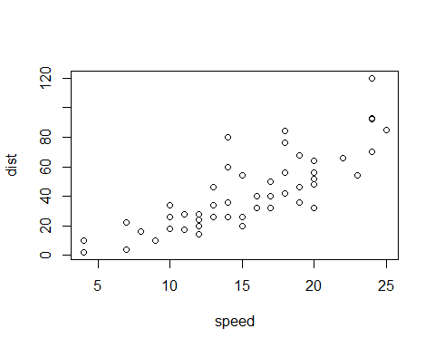  
 Note that the echo = FALSE parameter was added to the code chunk to prevent printing of the R code that generated the plot.