

**PGCP - Capstone Project Report**

on

**Project Title: AI-based Generative QA System.**

**(Email Subject Line Generation &**

**Question Answering on AIML Queries)**

**By:**

**AIML-B22-Group-15:**

Sirikonda Shilpa

Ravi Kanth Jami

Sudheendra Gopinath

Lohith Reddy Manchireddy

September 28, 2024

Hyderabad

INDEX

Introduction 4

Email Subject Generation 4

Dataset 4

Data Loading and Pre-Processing 4

Methodology 4

Zero Shot Inferencing 5

Finetuning Models 5

Model Prompts – Illustrations 7

Human Evaluation of Fine-tuned Models 8

Quantitative Evaluation of Fine-tuned Models 9

Granularity 9

Context 9

Summarization 9

Evaluation against given subject lines 10

Evaluation of Fine-tuning the pre-trained model 11

Tuning the hyperparameters 13

Observations & Key Learnings 13

Deployment 14

Artefacts 14

Question Answering 15

Model Approaches 15

Dataset and Data Preparation 15

Models' Selection 16

Model Loading 17

Environment Setup 17

Training 18

Prompt Structure and Formatting 18

Unsloth & QLora 19

Qualitative / Human Evaluation 20

Dataset-1 – GPT2 20

Dataset 1 - Llama 21

Dataset 1 - Gemma 21

Dataset-2 - Gemma 22

Issues noticed with Models’ behaviour 22

Repeated words in response 23

Number sequence in response 23

Zero Rouge score 23

Code in response 24

Fine Tuning Models 24

Final Prompt Structure 25

ROUGE Metrics 26

Fine Tuning Performance 26

Observations & Key Learnings 27

Save and Deploy 27

Artefacts 28

Introduction

GenAI QA System is a project to evaluate and compare the performance of various pre-trained generative AI models in NLP on two distinct tasks:

* given an email body, generate a succinct subject line for it
* answer technical questions on AI / ML.

Email Subject Generation

GenAI QA System identifies the most salient words, phrases and sentences from the given email body and abstracts the message contained in that set into a very short, impactful subject line.

Dataset

The pre-trained models are fine-tuned using the "[Annotated Enron Subject Line Corpus](https://github.com/ryanzhumich/AESLC)" dataset.

* The dataset consists of a subset of cleaned, filtered and deduplicated emails from the Enron Email Corpus which consists of employee email inboxes from the Enron Corporation.

Data Loading and Pre-Processing

* LangChain_community.Directory Loaders are used to load the email files and then converted to Pandas DataFrame.(LangChain document_loader was found to be organized, scalable, easy to use)
* Evaluation (dev, test) split of the data contains 3 annotated subject lines by human annotators. Multiple possible references facilitate a better evaluation of the generated subject, since it is difficult to have only one unique, appropriate subject per email
* Some dataset statistics:
  + Sizes of train / dev / test splits: 14,436 / 1,960 / 1,906
  + An email contains an average of 75 words
  + A subject contains an average of 4 words
* A subset of train dataset is created for finetuning language models, although full train data set is also used a couple of times.

Methodology

* On high level different Open Source language models are researched and assessed that suits the problem statement of extracting most important words / context / concise summarization. Transformer models and Bart models were found to be most apt for the given task other than the ChatGPT models.
* Couple of pretrained models were selected to test with zero-shot inferencing and further finetuning

Zero Shot Inferencing

* Several models were loaded directly from hugging face and random records were inferenced to see how the models were behaving.
* [facebook/bart-base](https://huggingface.co/facebook/bart-base), [FLAN-T5](https://huggingface.co/docs/transformers/en/model_doc/flan-t5#overview) [Gemma-7b](https://huggingface.co/unsloth/gemma-7b-bnb-4bit), [unsloth](https://huggingface.co/unsloth)/[mistral-7b](https://huggingface.co/unsloth/mistral-7b), Phi-3 models were tried.
* By testing with various models with the Zero Shot Inferencing, we could see that the model struggles to extract the same subject line compared to the human baseline subject, but it does pull out some important information from the email which indicates the models can be fine-tuned to the task at hand.

Below is an example with Flan-T5 Base model.

Finetuning Models

* Utilize the built-in Hugging Face/ SFTTrainer Trainer class. Pass the preprocessed dataset with reference to the original pretrained model. Several training parameters are tweaked and explored experimentally.
* Training a fully fine-tuned version of the basic/ small model takes a few hours on a GPU. To save time, several checkpoints were created, and the fully fine-tuned model were then initialized to use in the rest of experiments.

Some snapshots of the training process with the given data after pre-processing are below.

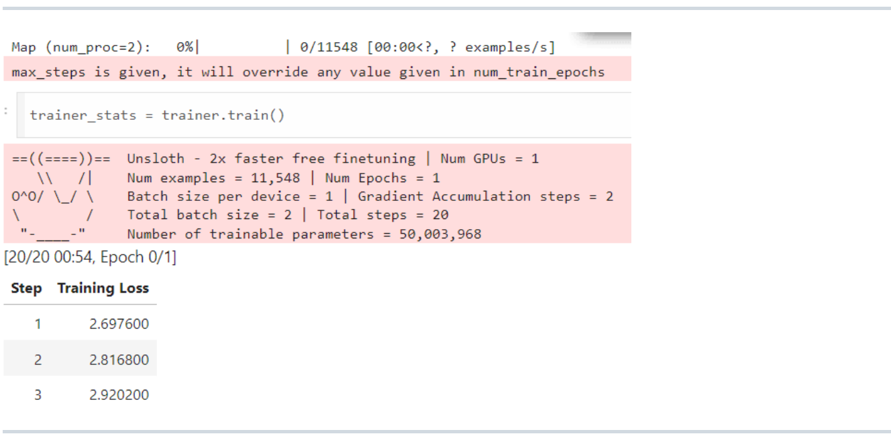

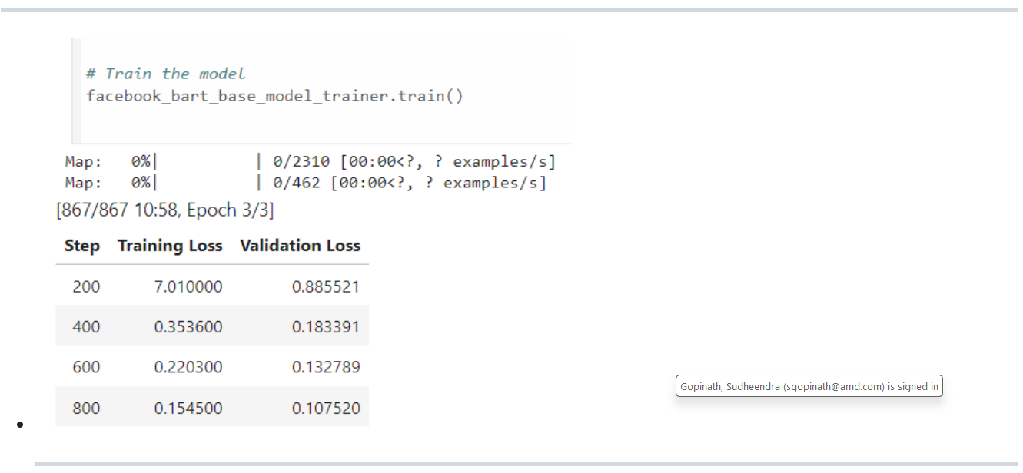

Model Prompts – Illustrations

|  |  |  |
| --- | --- | --- |
| **Model** | **Prompt** | |
| [FLAN-T5](https://huggingface.co/docs/transformers/en/model_doc/flan-t5) | Email-Subject (prompt-input-response) format is created as explicit instructions for the LLM. Prepend a prompt instruction to the start of email body and generate the subject with Suject as follows:  Training prompt (email):  prompt = f""" Generate a subject line for the following email.  Email: {email}  Subject:  """ | |
| [google-gemma-with-unsloth](https://www.analyticsvidhya.com/blog/2024/04/fine-tuning-google-gemma-with-unsloth/) | instruction = "Generate a subject line for the following email."  if x['body']:  formatted_text = f"""Below is an instruction that describes a task. \  Write a response that appropriately completes the request.  ### Instruction:  {instruction}  ### Input:  {x['body']}  ### Response:  {x['subject']}""" | Instruction = “Generate a subject line for the following email.”  If x[‘body’]:  formatted_text = f”””Below is an instruction that describes a task. \  Write a response that appropriately completes the request.  ### Instruction:  {instruction}  ### Input:  {x[‘body’]}  ### Response:  “”” |

Human Evaluation of Fine-tuned Models

The performance of the fine-tuned models was qualitatively by comparing their ability to generate a reasonable subject line against its original subject, to asses if they are behaving the way they are supposed to, and are able to understand the input. This approach confirmed that the fine-tuned models behave as expected.

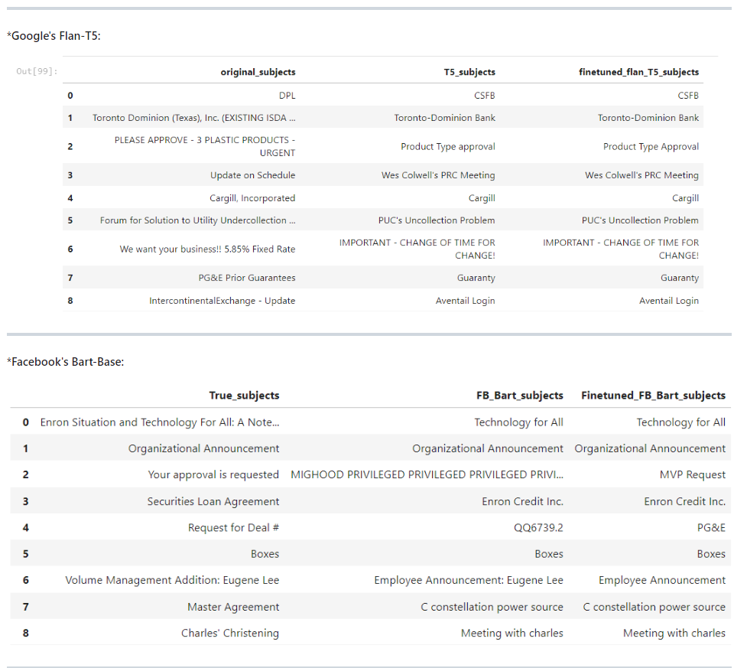

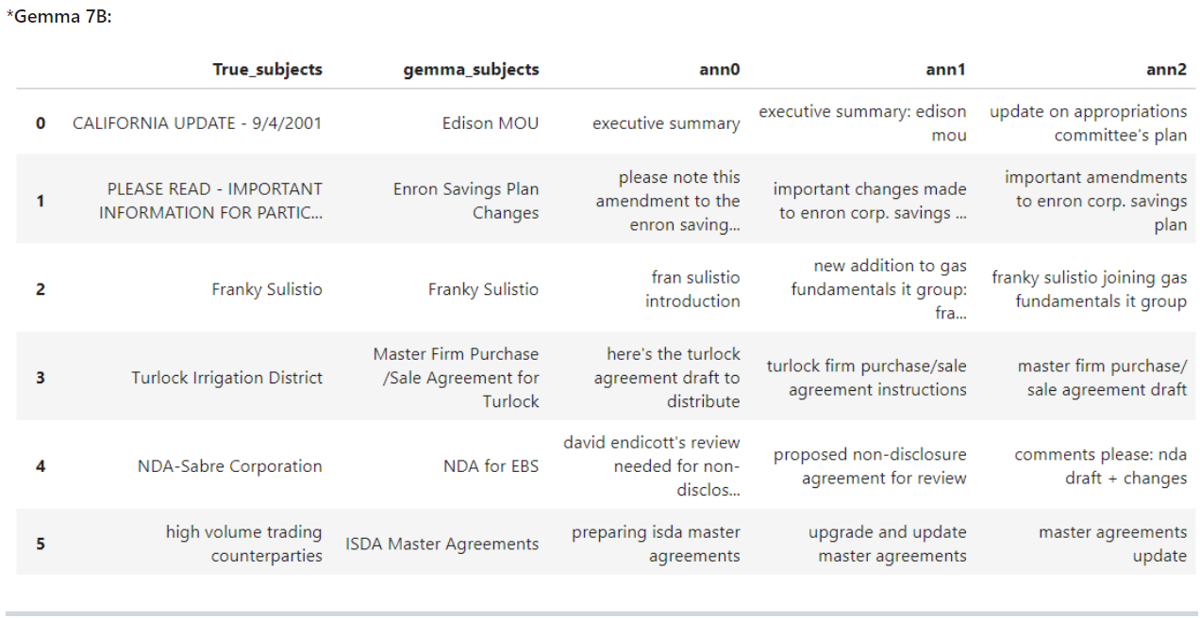

Quantitative Evaluation of Fine-tuned Models

The ROUGE metric helps quantify the validity of subject lines produced by models. It compares subjects to an "annotated baseline" subject which is usually created by a human. While not perfect, it does indicate the overall increase in subject line generation effectiveness that we have accomplished by fine-tuning. The quantification is done on several dimensions such as below.

Granularity

* ROUGE-1 focuses on individual words
* ROUGE-2 on word pairs
* ROUGE-L on the longest sequence of words

Context

ROUGE-2 captures context better than ROUGE-1 due to its consideration of word pairs, while ROUGE-L and ROUGE-Lsum capture the overall sentence structure.

Summarization

* ROUGE-Lsum is specifically designed for summarization, making it more relevant for evaluating the quality of summaries compared to ROUGE-L, which can be applied more generally.
* Bleu measures the precision: how much the words (and/or n-grams) in the machine generated summaries appeared in the human reference summaries.
* Rouge measures the recall: how much the words (and/or n-grams) in the human reference summaries appeared in the machine generated summaries.
* Rouge scores were evaluated for individual records and also as averages across all records.

Below table is evaluation for individual records.

Below are the average-wise scores with Facebook/Bart model.

Evaluation against given subject lines

The ROUGE scores were calculated w.r.t the original subjects and the three given human annotations.

Evaluation of Fine-tuning the pre-trained model

The absolute percentage improvement of finetuned model over the pretrained model was also calculated.

Tuning the hyperparameters

Below are the key arguments used for training Gemma-7b.

* **per_device_train_batch_size**: It is set to 1, meaning 1 examples will be processed per device in each step.
* **gradient_accumulation_steps:** Grad Accumulation steps before performing a parameter update. Increases the batch size by accumulating gradients over multiple steps. Here, it is set to 2, meaning gradients will be accumulated over 2 steps before updating the model parameters.
* **warmup_steps**: This sets the number of warm-up steps during training, gradually increasing the Learning Rate from 0 to the provided value. We set to 5, so the Learning Rate will linearly increase over the first 5 steps.
* **max_steps:** Total number of training steps to perform. Here, it is set to 50, meaning the training will stop after 50 steps.
* **learning_rate**: First Learning Rate used for training. We set it to 2e-4
* **fp16 and bf16**: Control the precision used for training. fp16 is for half-precision (16-bit) training, while bf16 is for bfloat16 training if GPU supported.
* **logging_steps**: Sets the interval at which training metrics and losses are logged. We set it to 1, so logs are printed after every training step.
* **optim:** Optimizer to use for training. We set it to ‘paged_adamw_8bit’, a specialized optimizer for memory-efficient training.
* **weight_decay**: Weight Decay Rate that we need for regularization. Set to 0.01.
* **lr_scheduler_type:** Learning Rate Scheduler to use during training, "linear“.

Observations & Key Learnings

* Fine-tuned models show performance improvement. They are effectively capturing key points and overall essence, with improved ROUGE-1 scores showing alignment with essential topics.
* The models demonstrated potential for **understanding nuanced details**, as indicated by ROUGE-2 scores, though there is room for improvement.
* Higher ROUGE-L and ROUGE-Lsum scores reflect good maintenance of subject length and relevance.
* Specific prompts, such as "generate a subject line" yield better results compared to combined prompts like "summarize the text“.
* Repetitive responses in pre-trained models (e.g., Mistral) are managed by applying a repetition_penalty of 1.5, but excessive penalties cause unusual outputs.
* Phi3 excels in text completion and GPT-style conversations but may produce hallucinations and less accurate results.

Deployment

* **Build the Gradio App**: Designed Gradio interface, defining how the user will interact with the model and ensuring the input and output specifications are clear.
* **Save the App and Dependencies**: Prepared our app script and ensure all necessary dependencies are listed in a requirements file, ready for deployment.
* **Publish on Hugging Face Spaces**: Created an account on Hugging Face, set up a new Space for our app, and push our code to this Space, making our app publicly accessible.

|  |  |  |  |  |
| --- | --- | --- | --- | --- |
| Task – 2: Question Answering  The QnA task is to generate free-form responses that require not only finding relevant information from its training knowledge but also synthesizing this information into multiple accurate answer sentences.  Model Approaches  Both **extractive** and **sequence-to-sequence** approaches were explored for the given problem statement and fine-tuning. After careful evaluation, the Sequence-to-Sequence (Seq2Seq) approach was selected for the task due to following reasons:   * AI/ML knowledge corpus usage was not recommended to use * Flexible Output Generation: Seq2Seq models generate new sequences, unlike extractive models, which are restricted to selecting text spans, making them ideal for tasks like summarization or translation.   Dataset and Data Preparation   * Input-Output Pairs: For Seq2Seq fine-tuning the model is provided with structured input-output pairs, where:   + Input: The question without a context   + Output: The target answer. * A total of 462 question-answer pairs were collaboratively prepared from the AIML course. The dataset was collated in the prescribed format in the CSV file. * A consolidated train/dev/test set was provided for further fine-tuning with the GPT variant model. * Dataset-1 has a question-and-answer pair for train set and, a question and two human annotated answers for the test and dev sets.   + Train set -(1316, 2)   + Test set (120, 3)   + Dev set (80, 3) * Dataset-2 has a question-and-answer pair   + Train set -(1985, 2)   + Test set -(249, 2)   + Dev set - (248, 2))   Models' Selection  GPT-2 medium, Gemma 7B and Llama 3 8B were used for finetuning. Below is a high level comparison of the models. |  |  |  |  |
| |  |  |  |  | | --- | --- | --- | --- | | **Feature** | **Gemma 7B** | **LLaMA 3 8B** | **GPT-2** | | **Model Size** | 7 billion parameters | 8 billion parameters | 1.5 billion parameters | | **Training Data** | Task-specific, proprietary data | General-purpose, large public datasets | Large-scale, web-based text data | | **Architecture** | Transformer-based, optimized for tasks | Meta’s LLaMA Transformer, efficient design | Transformer-based, decoder-only | | **Performance Focus** | Task/domain-specific fine-tuning | General-purpose NLP, high adaptability | Text generation and language modeling | | **Optimization** | Optimized for domain-specific tasks with custom fine-tuning, enhancing performance for targeted applications like QA and support. | Lightweight, efficient transformer architecture with high generalization, allowing broad task adaptability and lower resource use. | Focused on efficient text generation with a decoder-only architecture, optimized for long text dependencies and scalable training. | | **Use Case** | Specialized applications (e.g., QA, support) | Broad range (generation, summarization, etc.) | Text generation, language understanding | | **Hardware Requirements** | Lower resource requirements | Slightly higher, still efficient | Lower compared to larger models (like GPT-3) | | **Fine-tuning Flexibility** | Allows for **faster convergence** on specialized tasks like QA, reducing training time by focusing on narrow data. | **Highly flexible** and adaptable to various tasks, allowing fine-tuning across a broad range of NLP applications.  - Optimized for **efficient fine-tuning** even with smaller datasets, maintaining high performance with fewer resources. | Fine-tuning focuses on **text generation tasks**, adapting well to tasks like completion, summarization, or translation.  - Supports **moderate fine-tuning flexibility**, but primarily excels in generative use cases rather than specialized applications. |   Model Loading   * Load the pretrained model (Gemma 7B or LLaMA 8B) from Huggingface using FastLanguageModel/ SFTTrainer class * Create a PEFT model with the given parameters and load adapters - LoRA (Low-Rank Adaptation) for parameter-efficient fine-tuning with following parameters   + r=16, # LoRa Rank   + target_modules=["q_proj", "k_proj", "v_proj", "o_proj",   + "gate_proj", "up_proj", "down_proj",],   + lora_alpha=16,   + lora_dropout=0,   + bias="none",   + use_gradient_checkpointing=True     Environment Setup   * Necessary libraries (e.g., PyTorch, Hugging Face Transformers) were set up * Necessary GPU/TPU resources were made available for handling large models efficiently.   Training   * Perform backpropagation to adjust model weights based on the task-specific loss function. * Monitor model performance (validation loss, accuracy) during training to prevent overfitting. * TrainingArguments used as below   + per_device_train_batch_size = 1,   + gradient_accumulation_steps = 2,   + warmup_steps = 5,   + max_steps = 30,   + learning_rate = 2e-4,   + fp16 = not torch.cuda.is_bf16_supported(),   + bf16 = torch.cuda.is_bf16_supported(),   + logging_steps = 1,   + optim = "paged_adamw_8bit",   + weight_decay = 0.01,   + lr_scheduler_type = "linear",   + seed = 3407,   + output_dir = "outputs",   Prompt Structure and Formatting   * Added Clear Instructions: Specified format, tone, or length to guide the model’s response. * Provideed Context: Includeed relevant details to anchor the model's answer closer to the reference. * Useed Examples: Provided sample responses to show the desired structure and style. |  |  |  |  |
| Unsloth & QLora  There are many benefits in fine tuning the trained model with Unsloth and QLora.     * **Memory Efficiency:** Leveraging QLoRA and weight reduction techniques, FastLanguageModel minimizes memory consumption, enabling efficient fine-tuning on limited hardware. * **Enhanced Speed:** Unsloth's Flash Attention via xformers, along with the use of causal masks, significantly speeds up training, allowing faster convergence without sacrificing performance. * **Precision and Resource Optimization:** The Cross Entropy loss optimization in Unsloth reduces memory usage, ensuring high accuracy while maintaining computational efficiency. * **Scalability:** The combination of bfloat16 and adaptive learning rates ensures that fine-tuning scales seamlessly, even on large datasets, with minimal resource requirements. * **Cutting-edge Attention Mechanisms:** Unsloth integrates innovative attention techniques to further optimize transformer models, leading to improved model performance in a shorter time. |  |  |  |  |

Qualitative / Human Evaluation

Manually validate the model on a test set to check how its predictions compare with the actual answers.

Dataset-1 – GPT2

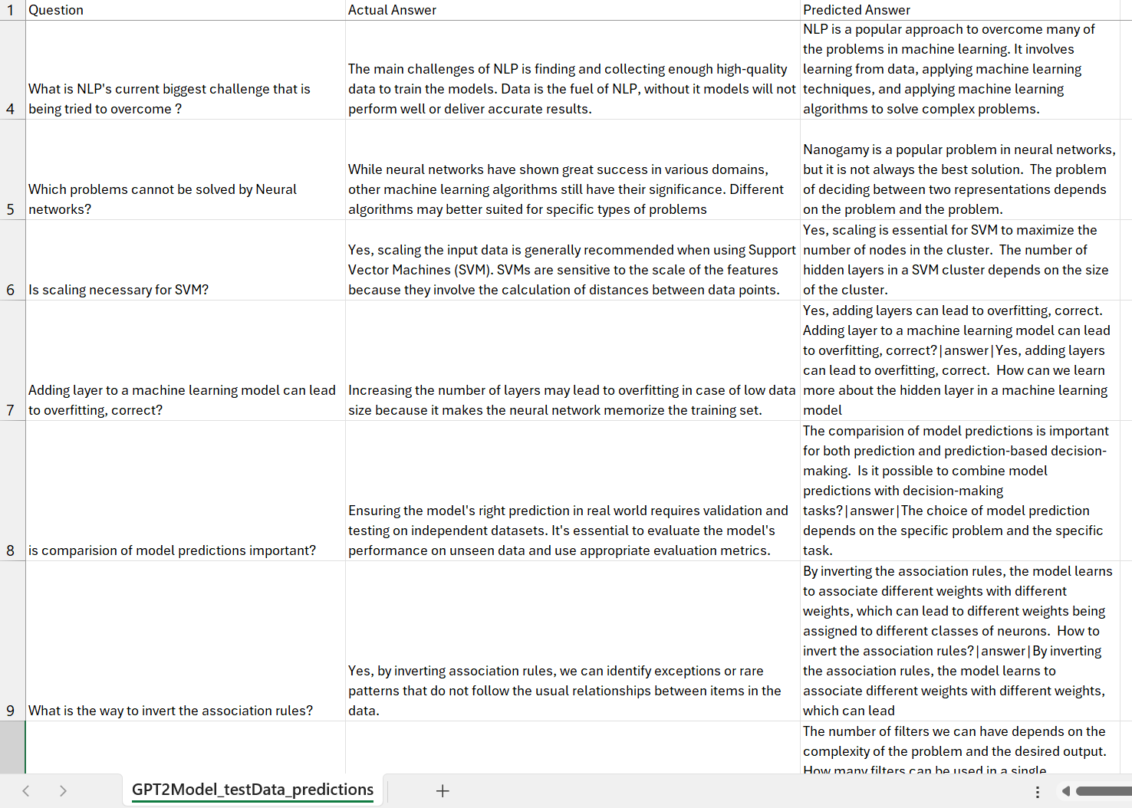

Dataset 1 - Llama

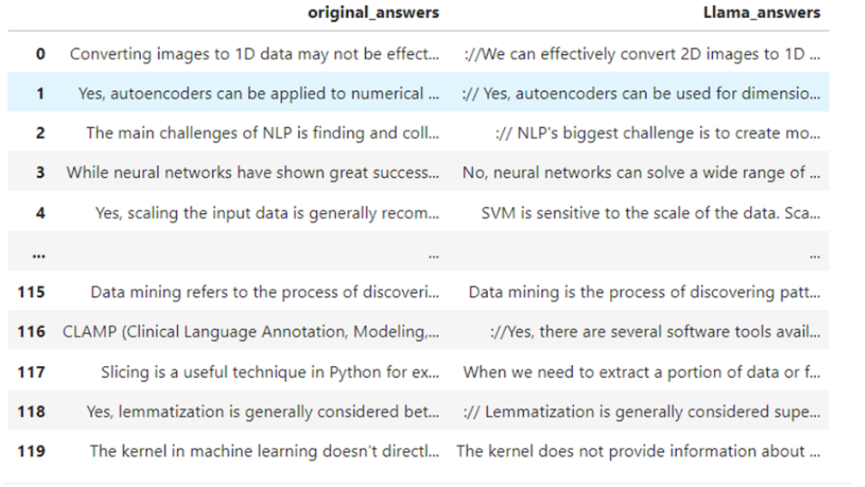

Dataset 1 - Gemma

Dataset-2 - Gemma

Issues noticed with Models’ behaviour

Some issues that were noticed with the behaviour of the models right after training with out dataset and before tweaking and fine-tuning the hyperparameters are listed below.

Repeated words in response

The answer to a question sometimes contains a set of words repeated many times. The phrase that is repeated, is also mostly irrelevant to the question asked.

Number sequence in response

Sometimes the answer to a question just contains numbers from 1 to 256, increasing monotonically.

Zero Rouge score

Sometimes the answer to a question is so off from the expected answer that the Rouge score is zero.

Code in response

Sometimes the answer contains code.

This is more likely when there is some word, like “HTML” in the prompt.

Fine Tuning Models

* Couple of hyperparameters were selected and tweaked such as learning rate, optim, max sequence length, lr_scheduler_type etc.,
* Perform backpropagation to adjust model weights based on the QA task-specific loss function.
* Monitor model performance (validation loss, accuracy) during training to prevent overfitting.
* Validate the model on a test set to check its performance and generalization ability
* Hyperparameters are adjusted and retrained until performance is improved
* Evaluate performances - Qualitative and Quantitative

The below tables depict how the various hyperparameters were tweaked to push the performance of the models higher.

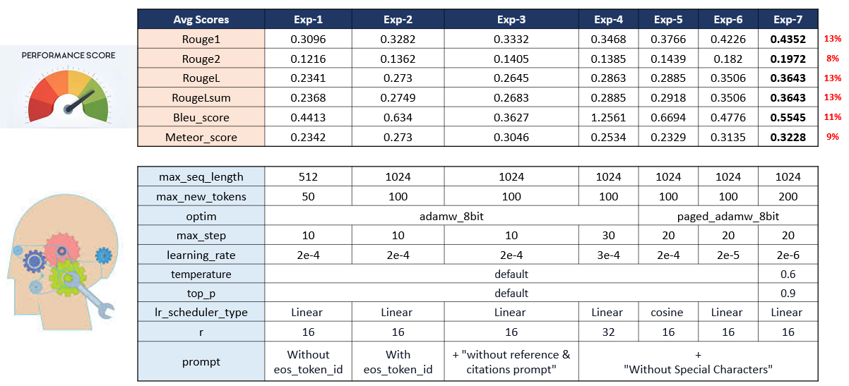

Final Prompt Structure

ROUGE Metrics

Fine Tuning Performance

Observations & Key Learnings

* GPT2LMHead Model doesn’t need a context to be provided to generate a response unlike GPT2ForQuestionAnswering.
* Compared to GPT2, advanced models like gemma, llama provide better answers as they have been trained on lot of data.
* Prompt given makes a difference in the predicted response.
* Llama model was generating answers with http links/ references from its earlier trained knowledge. Solved it with giving prompt instruction.
* TextStreamer was not respecting EOS_TOKEN for few questions in random before finetuning. Continuous answer generation was noticed. Debugged EOS Token initialized at right places.

Save and Deploy

* Build the Gradio App: Designed Gradio interface, defining how the user will interact with the model and ensuring the input and output specifications are clear.
* Save the App and Dependencies: Prepared our app script and ensure all necessary dependencies are listed in a requirements file, ready for deployment.
* Publish on Hugging Face Spaces: Created an account on Hugging Face, set up a new Space for our app, and push our code to this Space, making our app publicly accessible.

**Artefacts**

|  |  |  |  |  |
| --- | --- | --- | --- | --- |
| |  |  | | --- | --- | | **Description** | **Link** | | Github | <https://github.com/nutworker/qM-AI-L> | | Deployment | Task-1: Email Subject Line Generation  <https://huggingface.co/ssirikon/Gemma7b-bnb-Unsloth>  <https://huggingface.co/Lohith9459/gemma7b>  Task-2: Q&A Task  <https://huggingface.co/Lohith9459/QnAD2_gemma7b> | | Gradio | <https://huggingface.co/spaces/ssirikon/Gradio2-SubjectGen>  <https://huggingface.co/spaces/ssirikon/Gradio2-QnA> | |  |  |  |  |

**\*\* ** ** ** \*\***

**Summaries of three Research Papers**

**1. "Attention Is All You Need" (2017) by Vaswani et al.**

**Summary**: This paper introduced the Transformer architecture, which revolutionized natural language processing (NLP) and has since become the foundation for many state-of-the-art models (e.g., BERT, GPT, LLaMA). The key innovation is the self-attention mechanism, which allows the model to weigh the importance of different words in a sentence relative to each other, regardless of their position. Unlike previous models like RNNs and LSTMs, the Transformer eliminates the need for sequential data processing, enabling faster training and better scalability for large datasets.

**Impact**: It shifted the paradigm from recurrent networks to attention-based mechanisms, fundamentally changing how we approach NLP and sequence modeling tasks.

**2. "Generative Adversarial Nets" (2014) by Ian Goodfellow et al.**

**Summary:** This paper introduced Generative Adversarial Networks (GANs), a groundbreaking model that pits two neural networks against each other: a generator that creates data, and a discriminator that evaluates the authenticity of the generated data. This adversarial training enables GANs to produce highly realistic synthetic data, such as images, videos, and music.

**Impact:** GANs have become foundational for generative tasks in AI, influencing areas like image synthesis, data augmentation, and unsupervised learning, spurring a wave of innovation in creative AI applications.

**3** **"Language Models are Few-Shot Learners" (2020) by Brown et al. (GPT-3)**

**Summary:** This paper introduced GPT-3, a large-scale language model capable of generating coherent and contextually relevant text with minimal input. The paper highlighted the model’s ability to perform a wide range of language tasks (translation, summarization, question-answering) through few-shot learning, without the need for extensive task-specific training.

**Impact:** GPT-3 demonstrated the power of massive, pre-trained models, pushing the boundaries of what generative AI can achieve in tasks like writing, coding, and creative content generation. It paved the way for models like GPT-4 and other advanced generative AI systems.