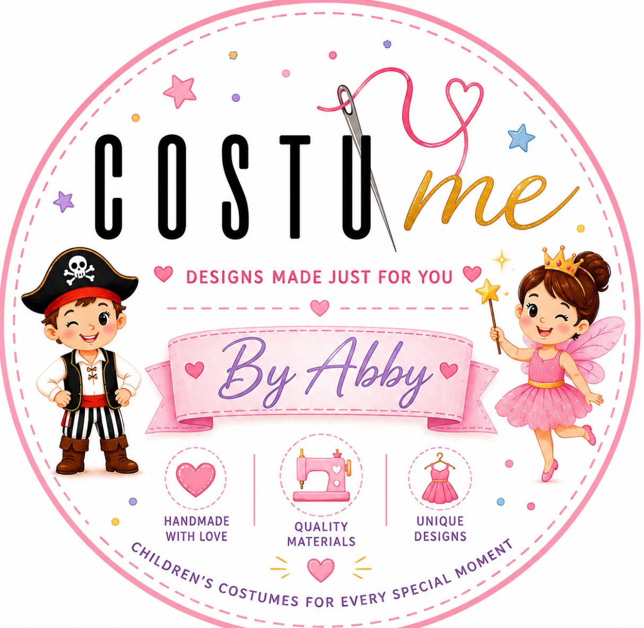

RECITAL PARTNERSHIP GUIDE
Your Dancers Deserve to Feel Confident
the Moment They Step onto the Stage.
Custom Designed · Made to Order · Worldwide Shipping

[ INSERT HERO PHOTO — Children on stage, beautiful recital, full emotion ]

Exclusively for Dance Studio Owners

WHY THIS MATTERS
You've Seen That Moment.
We Help You Create It Every Season.

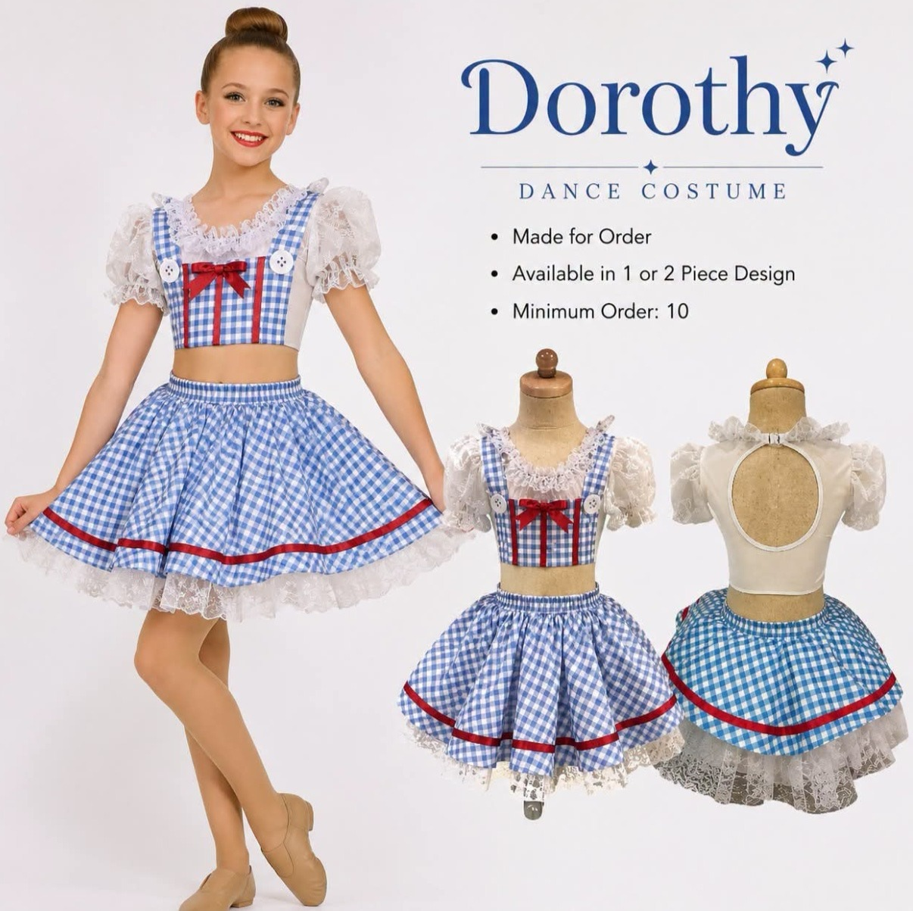  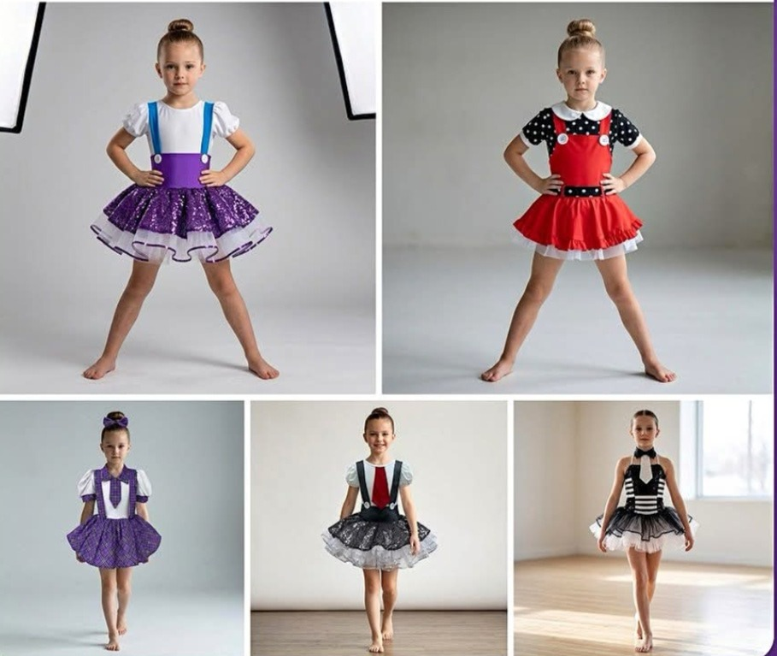 |  | The lights dim. The music begins.  And every parent in that auditorium holds their breath — waiting for their child to step into the spotlight.  That moment is everything.  But behind that moment is you — the studio director who spent weeks planning, organizing, communicating with parents, and making sure every single detail was perfect.  The costumes should be the easy part.  That's exactly what CostuMe by Abby was designed to do. We are a family-owned manufacturing partner that specializes in one thing: helping dance studios create beautiful recitals — without the stress.  One costume. One choreography. One unforgettable performance.

STUDIO TESTIMONIALS
Trusted by Dance Studios
Across the United States.

★★★★★  "The costumes arrived perfectly organized. Recital week became incredibly easy — I just handed each bag directly to the dancer."  — [Studio Owner Name]  Dance Studio · Texas | ★★★★★  "Communication was amazing from day one. Every dancer looked absolutely incredible on stage. Our parents couldn't stop talking about it."  — [Studio Owner Name]  Dance Studio · Arizona | ★★★★★  "The quality exceeded every expectation. We've tried other suppliers and nothing compares. CostuMe is our partner for every recital from now on."  — [Studio Owner Name]  Dance Studio · Florida

[ INSERT STUDIO PHOTO — happy dancers or recital performance ]

[ Replace placeholders above with real testimonials as you collect them ]

MANUFACTURING PARTNER
Why We Manufacture in Mexico

This is not a limitation.  It's a strategic advantage — for your studio.  ✓ Faster Than Asia — Shorter transit times mean your costumes arrive with time to spare before recital.  ✓ Lower Production Costs — Artisan-quality manufacturing at a fraction of what US-based production would cost you.  ✓ Premium Craftsmanship — Skilled artisans with decades of experience in performance wear and children's clothing.  ✓ Direct Communication — Your designer is in your time zone. WhatsApp responses within hours — not days.  ✓ Small Minimum Orders — US importers require large minimums. We work with studios starting at just 10 pieces.  ✓ Flexible Production — We adapt to your recital calendar — not a fixed factory schedule.  ✓ Close to the USA — Shorter customs processing, lower shipping costs, and faster delivery windows. |  | [ INSERT MAP GRAPHIC OR STUDIO PRODUCTION PHOTO ]  Same premium quality.  Better value for your studio.

HOW WE COMPARE
Why Studios Switch to CostuMe

TYPICAL SUPPLIER | COSTUME BY ABBY
Generic catalog designs — same look as every other studio | ✓ Fully custom designed around your recital theme
You sort and label costumes on recital week | ✓ Every costume arrives individually labeled and organized
Slow email responses or confusing portals | ✓ Direct WhatsApp to your personal designer
Limited colors and silhouettes | ✓ Unlimited themes, colors, and silhouettes
Fixed factory production schedule | ✓ Production planned around your recital date
Difficult communication across time zones | ✓ Same time zone · Fast response · Personal service
Large minimums — too many costumes you don't need | ✓ Small minimums — order exactly what your studio needs

Your studio deserves a partner who makes recital season easier — not harder.

BY THE NUMBERS
Why Studios Trust Us

XXX+  Costumes Produced | XX+  Productions Delivered | 3–16  Ages Served

10+  Min Order Size | 200+  Costumes per Project | 100%  Individually Packaged

[ INSERT PRODUCTION OR QUALITY PHOTO ] |  | Every number on this page represents a child who stepped onto a stage feeling confident, beautiful, and ready.  That's why studios come back to us season after season.  Replace the placeholder numbers above with your actual production data as it grows.

YOUR RECITAL SEASON
Less Stress.
More Time for Your Dancers.

1 You choose the theme  Send us a Pinterest board, a photo, your music, your colors — anything that inspires you.  ↓  2 Approve the design  Review every detail of your custom sketch. Nothing goes into production without your sign-off.  ↓  3 We handle the rest  Production, quality inspection, and individual packaging — all handled by our team.  ↓ |  | 4 Receive organized costumes  Every costume arrives vacuum sealed, labeled with the dancer's name, sorted by class.  ↓  5 Hand them directly to each dancer  No sorting. No chaos. Just hand each bag to the right child.  ↓  6 Enjoy recital day  You spent all season building this moment. We made sure the costumes were the easiest part of your day.

This is what recital season should feel like.
CostuMe by Abby takes costume stress off your plate — permanently.

WHAT YOU GET
Everything Your Studio Needs.
Nothing You Don't.

✓ Custom Designs — Your Vision  Your dancers won't look like anyone else on stage. Every costume is built from scratch around your recital.  ✓ Small Minimums — Perfect for Your Studio  Order exactly what you need. Studios as small as 10 dancers are welcome — and served beautifully.  ✓ Every Size, Every Dancer  From your 3-year-old preschoolers to your senior competition team — one order covers everyone.  ✓ Zero Sorting on Recital Week  Each costume arrives labeled with the dancer's name. You hand it directly to them. Done. |  | ✓ WhatsApp Direct Line  You message us. We respond. No portals, no ticketing systems, no waiting.  ✓ Shipped to Your Door  FedEx, UPS, or DHL — tracked from our studio in Mexico to your front door.  ✓ Performance-Grade Quality  Secure embellishments, reinforced seams, comfortable linings — built for active children.  ✓ Built Around Your Recital Date  We plan production backwards from your show date. Your deadline is our deadline.

We take care of the costumes.
You focus on your dancers.

OUR COMMITMENT
Our Promise to Your Studio.

We understand that you are placing the visual centerpiece of your recital — the thing parents photograph, children remember, and students wear with pride — in our hands.
We don't take that lightly.

◈ Design Accuracy
If the final costume doesn't match the design you approved, we will correct it — no questions asked, no extra charge.
★ Quality Standards
If any costume falls below our manufacturing standards, we remake it. Every piece that reaches your studio has passed inspection.
✓ Timeline Honesty
If we cannot meet your recital deadline, we will tell you before accepting your order. We will never take on a project we cannot deliver. That is not negotiable.
✉ Communication
You will always know where your order is. No silence. No surprises. Just clear, timely communication throughout.

Your confidence in us is something we earn — every order, every season.

COSTUME EXAMPLES
Designed for Stages Just Like Yours.

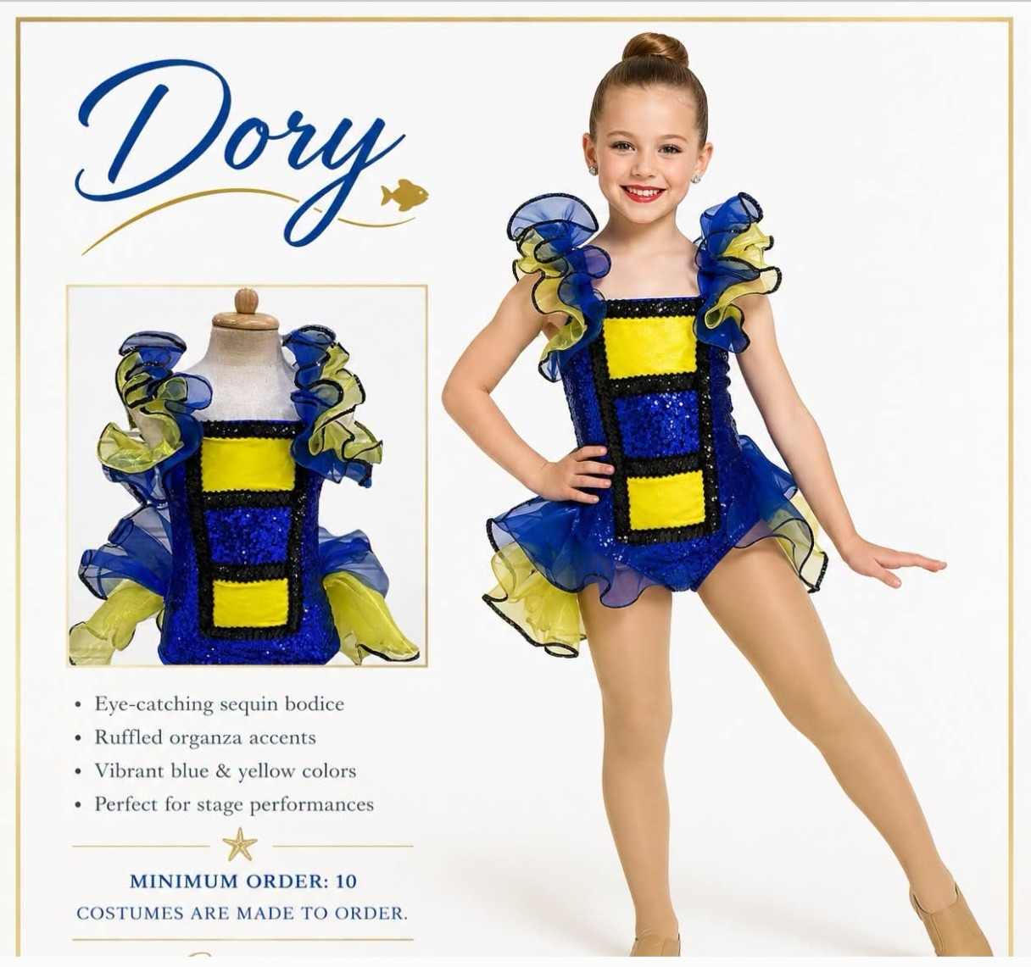  Preschool & Ballet | 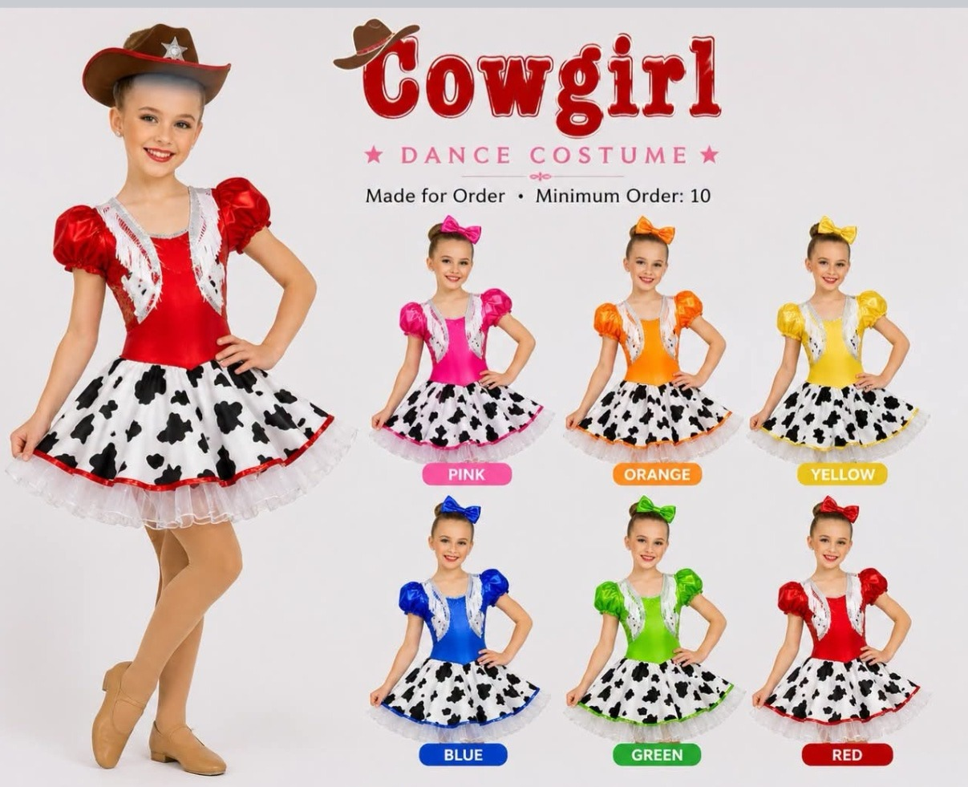  Jazz & Tap | 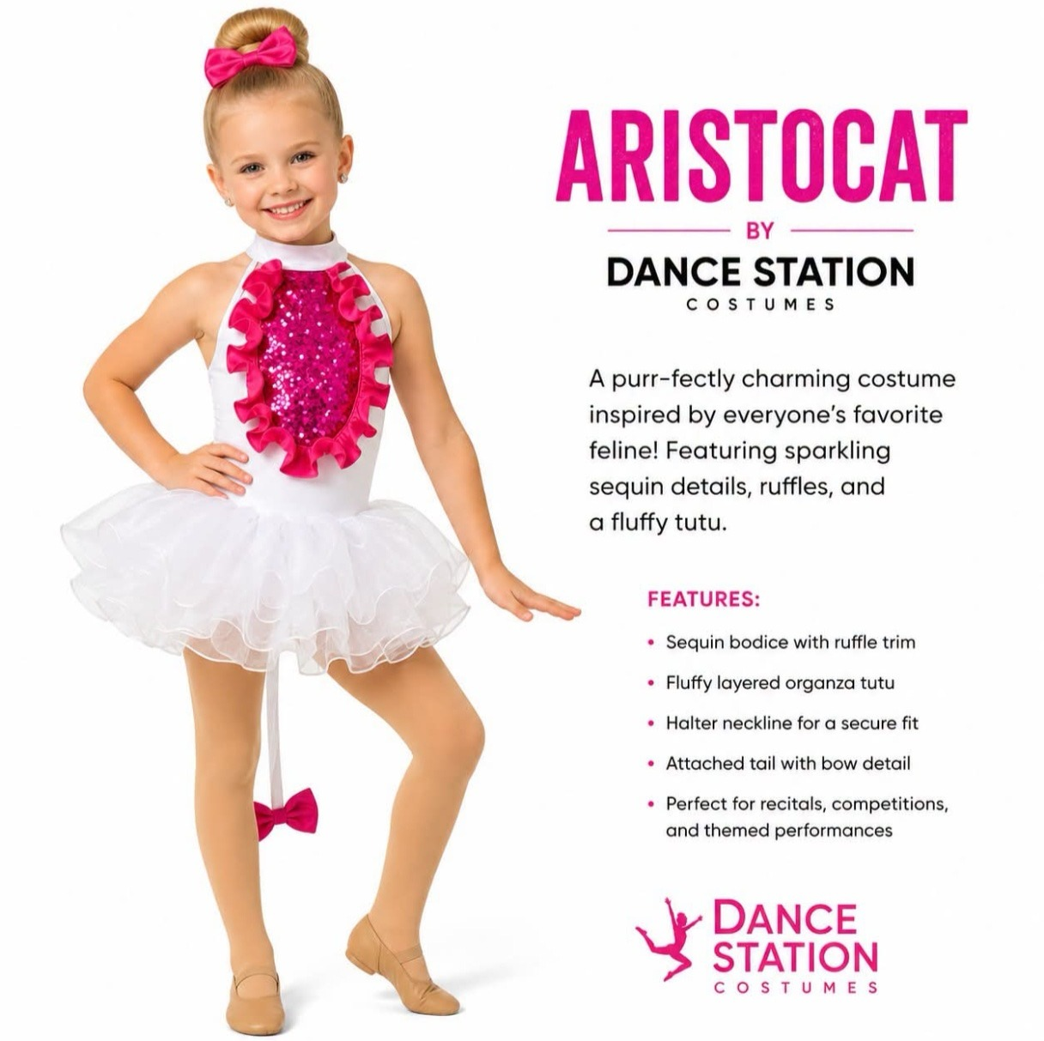  Lyrical & Contemporary

  Musical Theater & Holiday Shows | [ INSERT GROUP PHOTO — Competition Teams ]  Competition & Hip Hop  [ INSERT GROUP PHOTO — Tiny Tots / Preschool ]  Tiny Tots & Preschool

LIMITED AVAILABILITY
Become One of Our
Founding Studio Partners.

We are opening our doors to a select group of dance studios for our launch season.  Only the first 10 studios to join receive exclusive Founding Partner benefits:  ★ Priority Production — Your orders are scheduled first — always.  ◈ Founder Pricing — Exclusive launch pricing locked in for your first full season.  ✆ Direct Designer Access — Personal WhatsApp line to your dedicated designer.  ✓ Priority Scheduling — Your recital dates take precedence in our production calendar.  ♦ Early Access — First access to new designs, fabrics, and seasonal collections.  10 studios. First come, first reserved.  Once our founding slots are filled, this program closes permanently. |  | [ INSERT PREMIUM PHOTO — confident studio owner or group of dancers ]

[ INSERT HERO PHOTO — Children celebrating after a recital, pure joy ]

Let's Talk About
Your Next Recital.
No obligation. No pressure. Just a conversation about your studio and your next performance.

Message Us on WhatsApp  +1 (___) ___-____ |  | Send Us a Facebook Message  CostuMe by Abby

✓ Free design consultation ✓ No obligation ✓ We love discussing recital ideas

WhatsApp  +1 (___) ___-____ | Email  hello@costumebyabby.com | Instagram  @CostuMeByAbby | Facebook  CostuMe by Abby

[ [ INSERT QR CODE ] ]



CostuMe by Abby

The recital lasts one evening. The memories last a lifetime.
Let's make them unforgettable.

