

Department of Information and Communication Technology
Faculty of Technology
University of Ruhuna

Object Oriented Programming Practicum-ICT 2132
Mini Project

Group Name – Strivers
Group Number – 12
FOT Portal Management Information System (MIS)

Submitted to: Mr. Nuwan Laksiri.

Group Members :
K.G.M.R.BANDARA - TG/2023/1773
D.S.J. DE SILVA - TG/2023/1727
M.I.M. IRFAN- TG/2023/1756
U.G.A.N.KAUSHALYA - TG/2023/1736

Contents

1. Brief introduction to the Project.
2. Brief introduction to the solution.
3. ER diagram for the FOT Portal Management Information System (MIS)
4. Class diagram for FOT Portal Management Information System (MIS)
5. Database tables used in the FOT Portal
- User Table
- Student Table
- Lecturer Table
- Technical officer Table
- Courses Table
- Course Registration Table
- Assessment Types Table
- Student Marks Table
- Attendance Table
- Medical Table
- Notice Table
- Timetable Table
6. User Interfaces Design in Management Information System (MIS).
7. User Roles and Justification for each Role
8. Tools and technologies used in the project
9. Security Measures Implemented in the system
10.Challenges Faced during the Development
11. Solutions to Overcome Identified Challenges
12. System Architecture
13.Individual contribution to System development
14.GitHub Repository Link
15.References

1. Brief Introduction to the Problem

Managing academic and administrative activities manually in a faculty environment is inefficient and error-prone. Tasks such as:
- Managing user profiles
- Tracking attendance
- Handling marks and GPA
- Managing medical records
- Publishing notices and timetables
require a centralized system to ensure accuracy and efficiency.

2. Brief Introduction to the Solution
FOT Portal is a client–server based desktop application developed using:
- JavaFX (Frontend)
- Java Socket Programming (Backend)
- MySQL Database
The system supports four user roles:
✔ Administrator
✔ Lecturer
✔ Technical Officer
✔ Undergraduate
Authentication is handled using JWT tokens, ensuring secure communication between client and server.

3. ER diagram for the FOT Portal Management Information System (MIS)

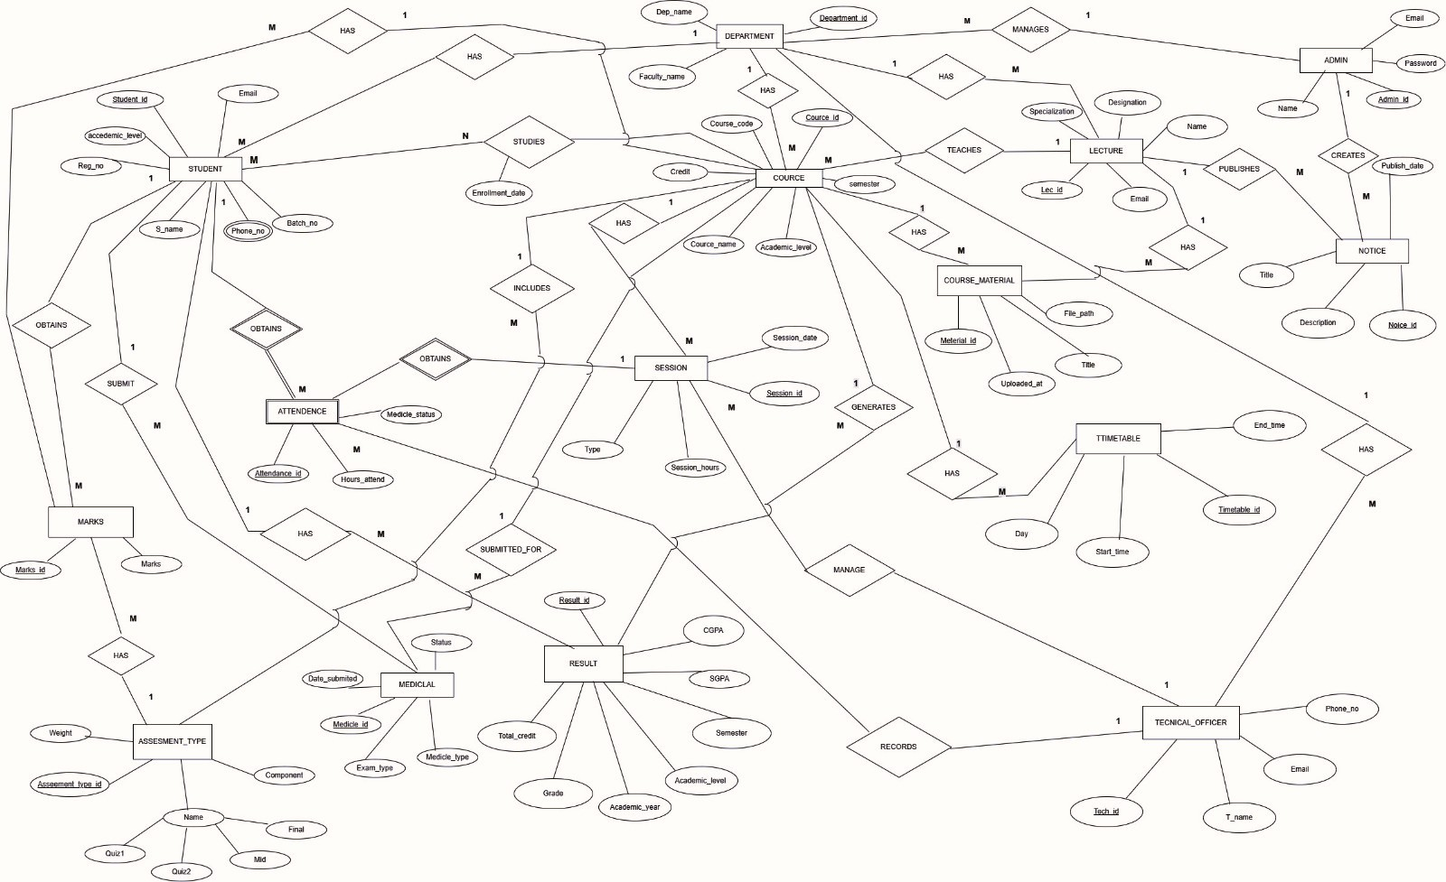

Class diagram for FOT Portal Management Information System (MIS)

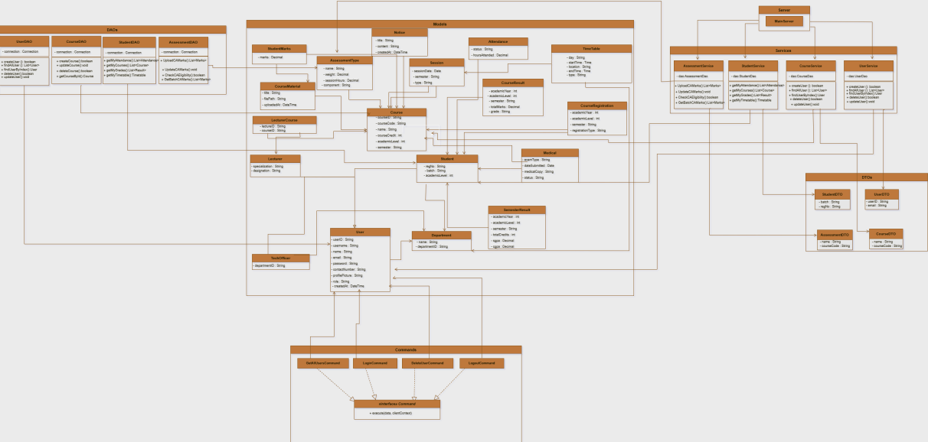

5. Database tables used in the FOT Portal MIS

The system uses a MySQL database to store and manage all information, including user profiles, course details, attendance records, medical submissions, marks, timetables, and notices. We designed the database with connected tables using primary and foreign keys to keep the data accurate, consistent, and easy to manage.

Users Table
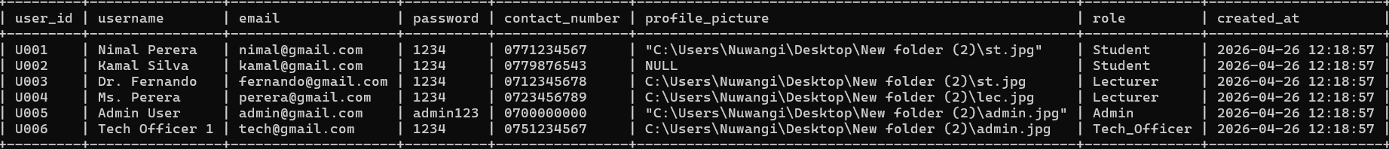

Students Table

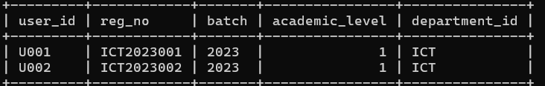

Lecturers Table
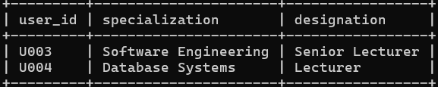

Tech Officers Table
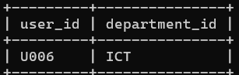

Courses Table

Course Registration Table
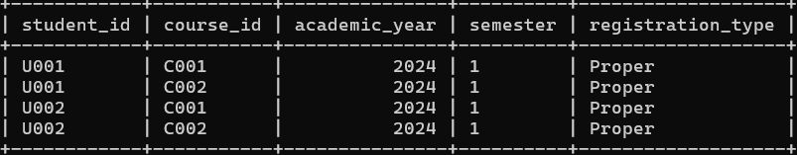

Assessment Types Table

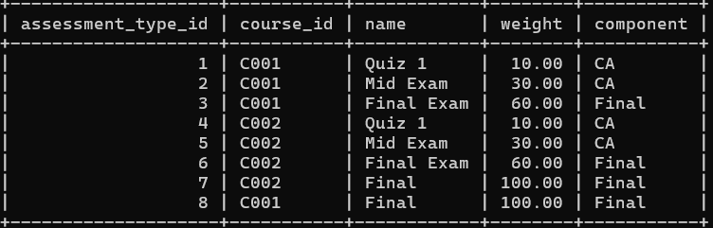

Student Marks Table
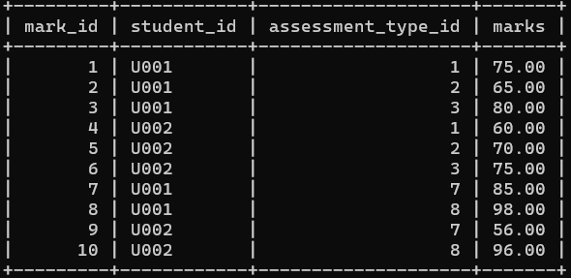

Attendance Table
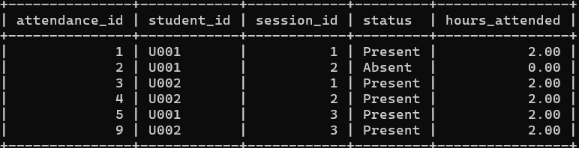

Medical Table
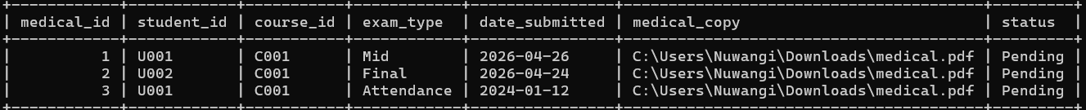

Notice Table

Timetable Table

Additionally, many to many relationship tables are included in MIS database. If users update their details then database is automatically updated.

6. User Interfaces Design in Management Information System (MIS).

Login Page
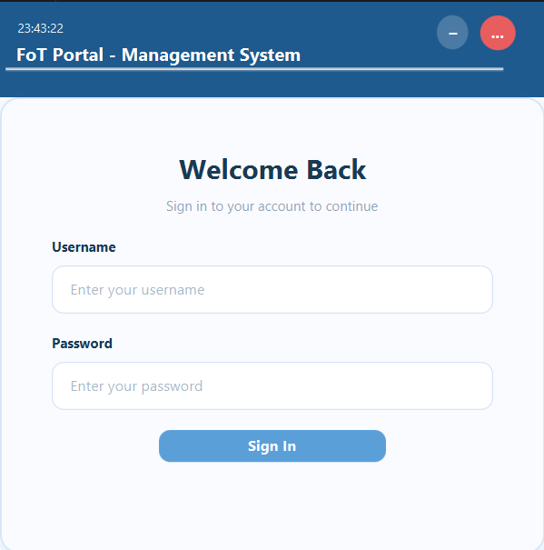

Admin Dashboard

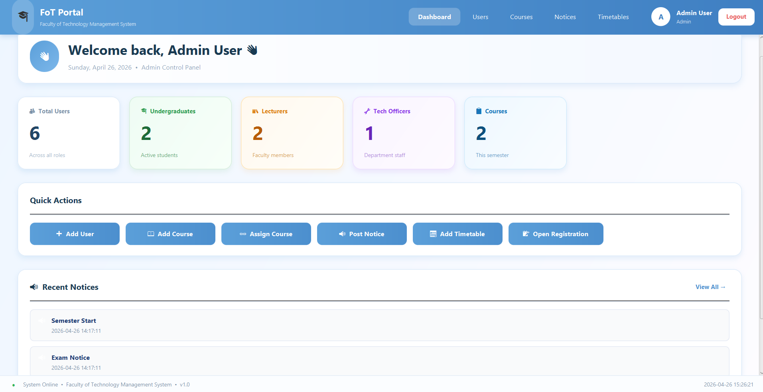

Student Dashboard

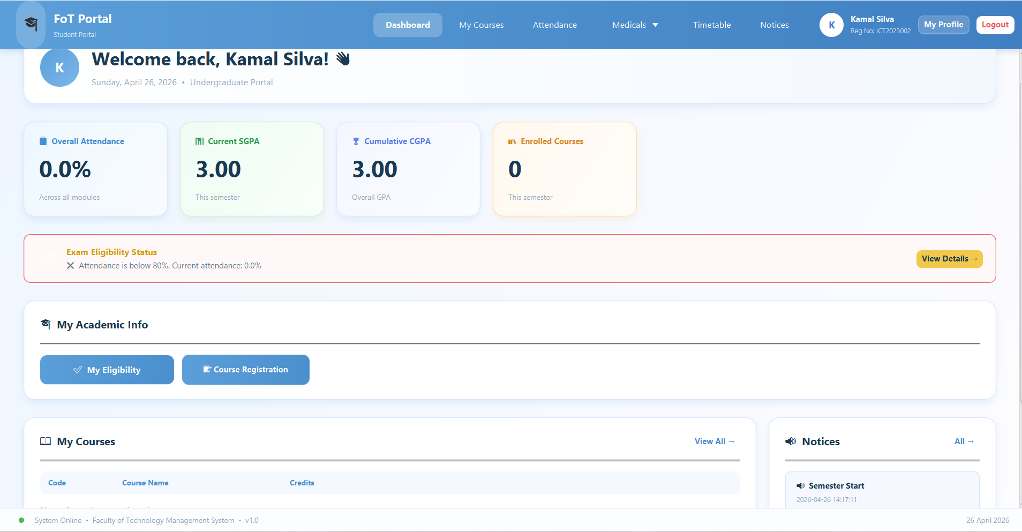

Lecturer Dashboard

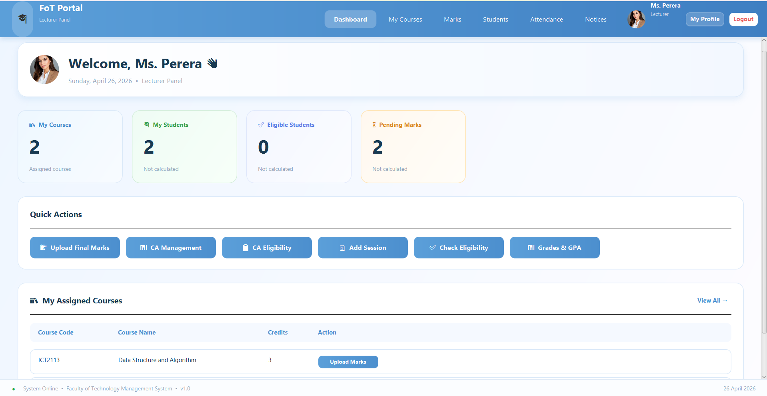

Technical officer

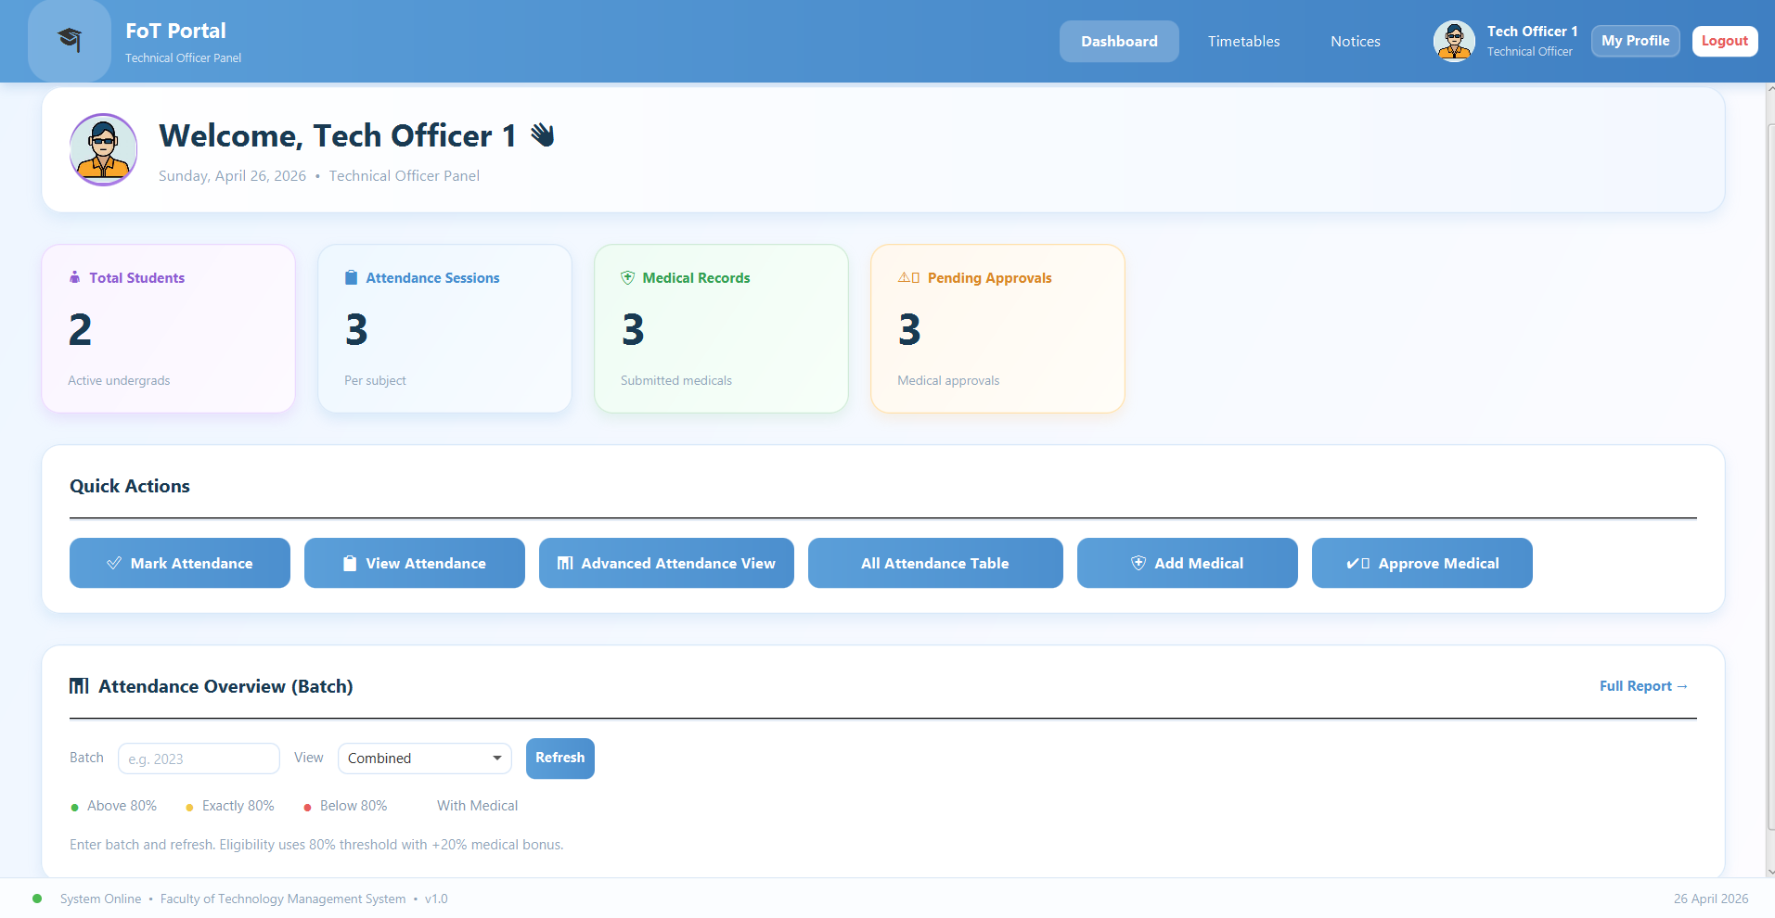

Time table

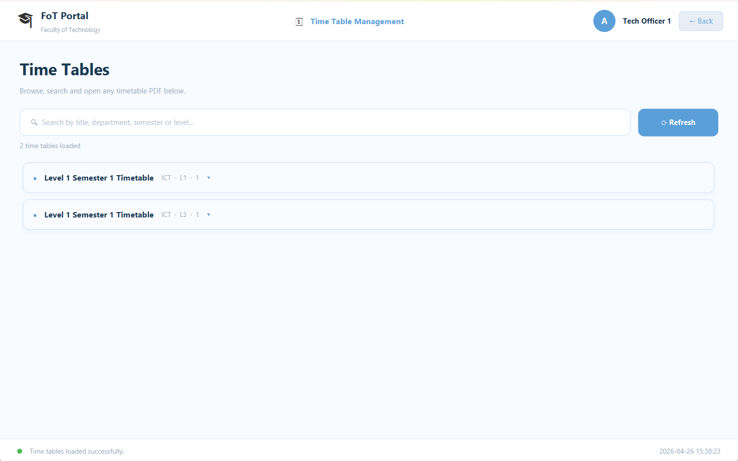

Notice

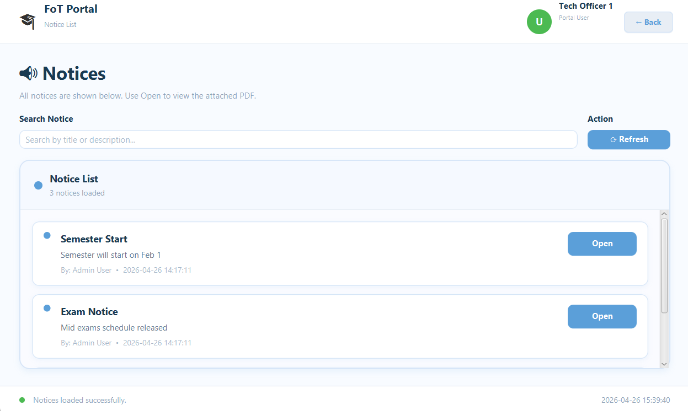

Courses

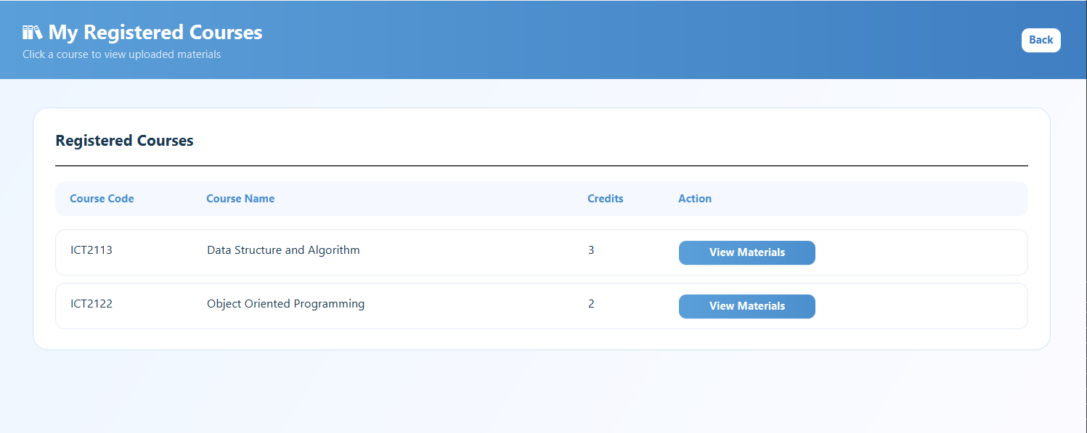

CA Management

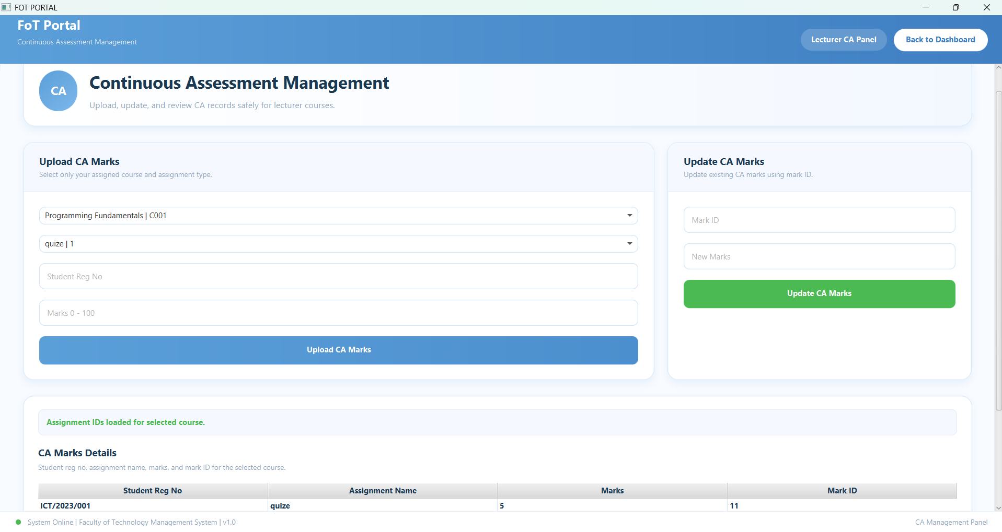

Medical Management

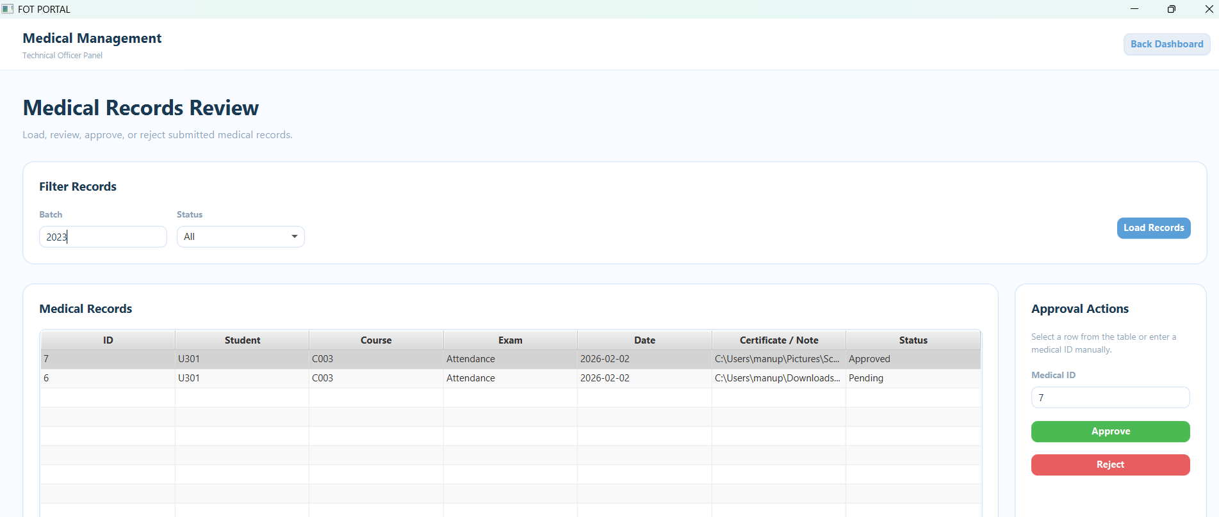

7. User Roles and Justification for each Role

Admin Management Requirements
- Manage users
- Manage courses
- Publish notices
- Manage timetables
- Approve medicals

Lecturer Management requirements
• Lecturer can update their profile except username and password.
• Lecturer can modify and add materials to courses.
• Lecturer can upload marks for all kind of exams.
• Lecturer can see student details.
• Lecturer can see student eligibility.
• Lecturer can see student marks, grades, and GPA.
• Lecturer can see attendance and medical records of students.
• Lecturer can see notices.

Technical Officer Management requirements

• Can add and maintain attendance details of students.
• Can add and maintain medical details of students.
• Can see notices.
• Can see timetables of their department

Undergraduate Management requirements
• Can update only contact details and profile picture of their profile.
• Can see attendance details. • Can see medical details.
• Can see their course details.
• Can see their grades and GPA.
• Can see their timetables.
• Can see notices.

8. Tools and technologies used in the project

• IntelliJ idea and javafx (scene builder)
To create and maintain GUI (Graphical User Interface)
To maintain java codes
To Connect the database using MySQL connectors

• MYSQL server
To create and manage database efficiency
To create table structures and data insertion

• Draw.io
Used to create ER diagram and Class diagram

• GitHub and GitHub Desktop
Served as the version control platform for tracking source code changes, collaborating within the team, and managing different versions of the system throughout development.

• Microsoft Word
Used in documentation processes, such as preparing the Final Project Report and the Software Requirements Specification (SRS) document.

9. Security Measures Implemented in the system.

- Role-Based Access Control (RBAC)
Access to system functionalities is granted based on the user’s role (Admin, Lecturer, Technical Officer, or Undergraduate). Each user is directed to their respective dashboard after login, restricting unauthorized access to sensitive modules.

- Credential Verification with Database Validation
Login credentials are securely verified in the MySQL database, preventing unauthorized access and ensuring only valid users can enter the system.

- Limited UI Access Based on User Type
Each interface is dynamically rendered based on the logged-in user's role, ensuring users can only interact with features relevant to their role, thereby minimizing exposure to unauthorized data.

- Data Validation and Input Sanitization
Input fields across the system are validated to prevent malformed entries and possible SQL injection attacks. This ensures data consistency and security.

- Secure Database Connectivity
The system uses secure and efficient MySQL connectors in Java to manage database interactions, reducing risks related to data leakage or interception.

- Version Control and Backup Using GitHub
Project code is maintained under GitHub with frequent commits, allowing version history tracking and restoring backups in case of system failure or accidental data loss.

10.Challenges Faced during the Development

• Database complexity: Mapping relationships among multiple entities (e.g., medical, attendance) was challenging.

• GUI synchronization: Ensuring that the user interface reflects real-time updates from the database .

• Team coordination: Dividing tasks and merging contributions without conflicts was time-consuming.

11. Solutions to Overcome Identified Challenges

• Database complexity: We created a detailed ER diagram to represent FOT Portal – Faculty Management System details.

• GUI Synchronization: We used a single main frame with multiple panels, switching panels inside the main frame based on user actions to keep the interface simple and organized.

• Team coordination: Used GitHub for version control, assigned tasks to project, and conducted regular group communication.

12. System Architecture

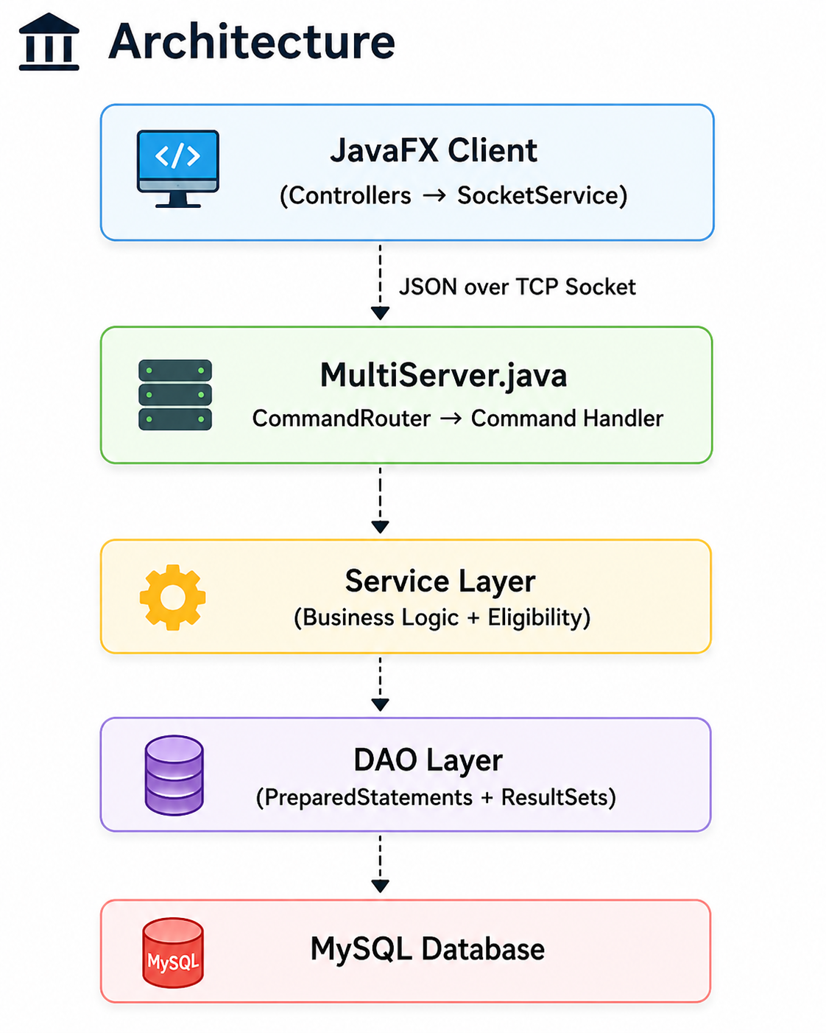

13.Individual contribution to System development

TG_no | Name | Individual contribution
TG/2023/1773 | K.G.M.R.BANDARA | Tech officer  - Mark Attendance  - View Attendance  - Medical Management  - Attendance Overall view  - Tech officer Dashboard  - Tech officer Profile  Student  - Medical section  Lecturer  - CA Managment  - CA Eligibility  Class diagram designing
TG/2023/1727 | D.S.J. DE SILVA | - My Course Management  - Marks management  - Grades and GPA generating  - Lecture dashboard  - ER Diagram designing  - Student view  - Attendance that lecturer’s course following student only.  - Generating Report GPA and Marks pdf
TG/2023/1756 | M.I.M. IRFAN | Admin  - User management  - Course management  - Add notice  - Add Time Table  - Course Registration  - Admin dashboard  Lecturer  - Add Session  - Check eligibility  - Profile section update  Student  - Course Registration  - Profile section update  System Designing
TG/2023/1736 | U.G.A.N.KAUSHALYA | Student  - My Course  -View Courses  -View Course material  - Attendance View  - Time table View  - Notice View  - My eligibility checking  - Students Dashboard for a student  -Overall Attendence  -Current GPA  -Calculate CGPA  -Enrolled Courses  - ER diagram designing

14. GitHub Repository Link

https://github.com/Manupriya144/JavaMiniProject.git

15.References

- Java oracle documentation
- Javafx documentation
- GitHub documentation
- Ai assistant (chatgpt)
- Ai assistant (claude)

