DIWE Final project

DIWE 73 – COL/A 051299

Nuwan Karunarathna

Online Library System

# Content

Acknowledgement ------------------------------------------------------------------------ 2

1. The problem -------------------------------------------------------------------------------- 3
2. The solution --------------------------------------------------------------------------------- 3
3. Site structure ------------------------------------------------------------------------------- 4
   1. Concept ------------------------------------------------------------------------------ 5
   2. Database structure ----------------------------------------------------------------5
   3. File structure ------------------------------------------------------------------------7
   4. Setting up the site to test --------------------------------------------------------8
4. Tools I used in project --------------------------------------------------------------------8
5. Code samples -------------------------------------------------------------------------------9
6. Common pages ----------------------------------------------------------------------------10
7. Resources -----------------------------------------------------------------------------------13

# Acknowledgement

First of all I wish to thank my parents for their tremendous contributions and support both morally and financially towards the completion of this project. I am also grateful to my Web Engineering lecture at Esoft Metro campus, Mr. Praveen Tissera without whose his help and guidance this project would not have been completed. Then I would like to thank the Esoft Institute managing director Dr. Dayan Rajapaksa who provide the facility and helped us all through this DIWE program. I also show my gratitude to my friends and all who contributed in one way or the other in the course of the project.

Thank you,

Nuwan Karunarathna

# 1.The Problem

These days in real world people have so much busy life. So for those who use libraries to read books, it’s a bit hard to manage all the books they obtain from the library and to remind all the due dates. Also they have a limited time to visit the library to obtain books. So they may miss valuable books and also it will be hard to find exactly what they want when they visit the library.

In the librarian’s perspective it’s hard to maintain all the data about books, book checkouts and details of readers.

# 2.The Solution

The solution is a web based system for a library to manage all the details of users and librarian.

1. It will give a way to the librarian to manage
   1. Books
   2. Authors
   3. Users
   4. Book checkouts
   5. Book check-ins.
2. It will give a way to the users of the library to,
   1. Maintain an online account and manage the details about the books they obtain.
   2. Due dates of the books they obtain.
   3. Explore books and authors without visiting library.
   4. Maintain a wish list.

# 

# 3.Site Structure

Project has these main modules.

* Homepage, sign in, register
  + Users who have already registered in the library can register for an online account.
  + Existing users can log into the system.
* Explore books
  + View all the books in the library.
* Book detail
  + View specific details about a book from
* Author detail
  + View details about an author
* User area
  + My books
    - Manage all the details about the books user has and a wish list.
  + Settings
    - User can change the details about them.
    - User can change username and password.
    - User can delete his/her user account.
* Admin area
  + Admin login
  + Admin panel
    - Manage books.
    - Manage authors.
    - Manage users.
    - Manage book checkouts.
    - Manage book check-ins.

## 3.1 Concept

Users who have already registered in the library can register for an online account from the web site itself. But it’s not mandatory for a user to have an online account.

When a user who has an online account visit the library and obtain books the librarian will add enter a new book checkout to the system and the obtained book will be automatically visible in the user’s book shelf area in ‘My Books’. Also the number of copies of the book will be decremented by one. User can change the state of the book from there (ex:- want to read, currently reading, completed). Also it will display whether book is overdue or not. When a user marks a book as ‘Completed’, the number of reads of that book will be incremented by one.

When the user submits back the book to the library the librarian will enter a new check-in to the system and the book will automatically get removed from the user’s book shelf and the number of copies of the book will be incremented by one.

Also user can search for books from and view details about them and also the user can give reviews about a book. User can add a book to his wish list from the book details page.

## 3.2 Database Structure

Database used for this project contains the following tables.

|  |  |
| --- | --- |
| Table name | Description |
| Admin | Details about admins |
| author | Details about authors |
| book | Details bout books |
| book_author | Build up relationship between books and authors |
| book_checkin | Details about book checkins |
| book_checkout | Details about book checkouts |
| genre | Details about genres of books |
| registered_user | Details about registered users |
| review | Details about reviews about books |
| user | Details about users with an online account |
| user_book_list | Detail about the wish list of a user |
| user_read | Details about books user obtain |

admin – ( admin_id , admin_name , admin_username , admin_password )

author – ( author_id , author_fname, author_lname , author_image)

book – ( isbn , book_title , book_description , published_year ,genre_id , num_of_reads , cover_image , num_of_copies , page_count , added_date )

book_author – ( isbn , author_id)

book_checkin – ( checkin_id , checkout_id , admin_id , date)

book_checkout – ( checkout_id , admin_id , user_reg_id , isbn , date , return_date , is_returned)

genre – ( genre_id , genre_title )

registered_user – ( user_reg_id , fname , lname , email)

review – ( review_id ,isbn , user_reg_id , content , rating , date)

user – ( user_reg_id , username , password , user_image)

user_book_list – ( isbn , user_reg_id )

user_read – ( user_reg_id , isbn , is_completed)

## 3.3 File Structure

1. 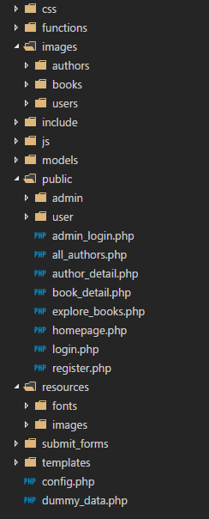css - Contains all the CSS files used for styling of the site.
2. functions – Contains all the php files with reusable functions.
3. Images – Contains all the images of books, users and authors.
4. Include – contains all the template parts for web pages.
5. Js – contains all the javascript files used in the site.
6. models – Contains all php class files used in the site.
7. Public – Contains all the web pages.
8. Resources – Contains all the resources used in the site
9. Submit_forms – Contains all the php files with logic.
10. Templates – Contains all the base templates for web pages
11. Config.php – Contains all the details about paths in the project. Other php files use this file to get paths to other files. So it’s easy to maintain.
12. Dummy_data – Contains all the functions to insert dummy data to the database

## 3.4 Setting up the site to test.

1. Copy the site folder to into the dashboard folder.
2. Use the backup sql file inside the site folder to add tables and data to the database.
3. Open the ‘config.php’ file inside the site folder.
4. Edit ‘$project_root’ variable to fit the current path of the site folder.
5. In the database array change the ‘database’ to the name of the database created above.
6. Open a web browser and navigate to the /site/public/homepage.php file.

In dummy data for users and admins password will be the username without any numbers + 1234. (ex:- if the username is ‘john2’, password is ‘john1234’)

# 4.Tools I used in project

* I used Microsoft Visual Studio Code as the code editor throughout the project.
* To edit/create graphics, I used Adobe Photoshop CC application.
* To test the site, I used Google Chrome and Microsoft Edge browsers.

# 5.Code Samples

Connection to the database.

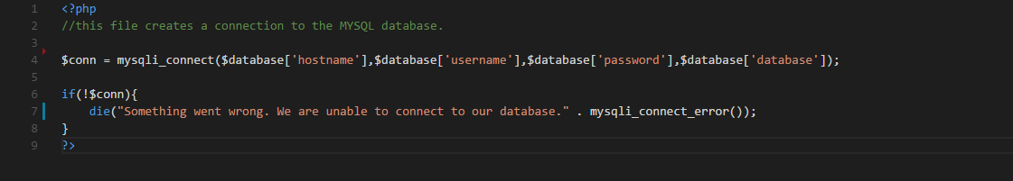

User login submit page

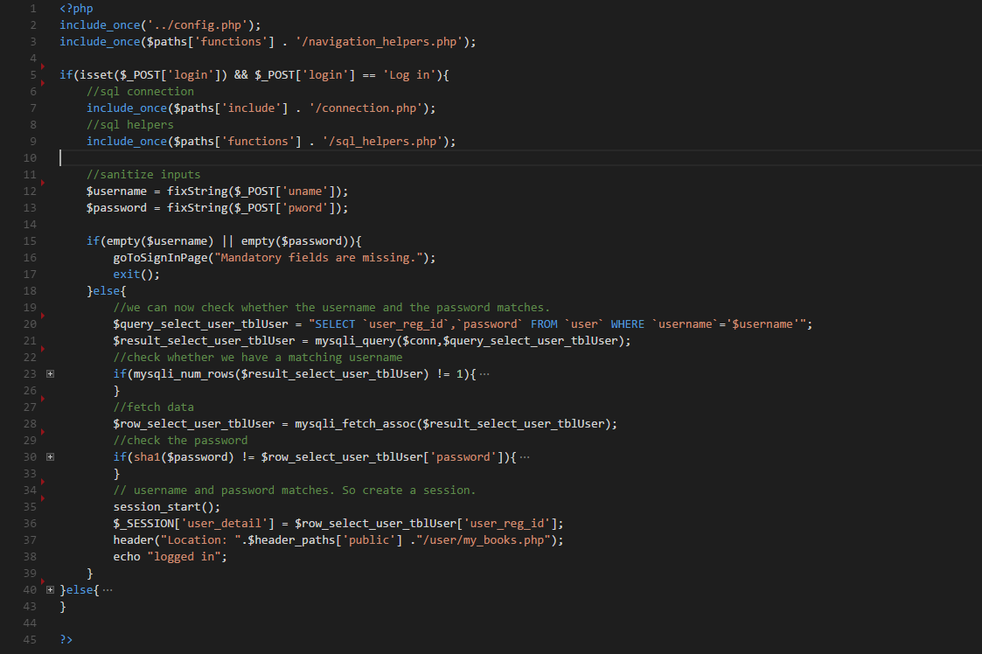

# 6.Common Pages

Homepage

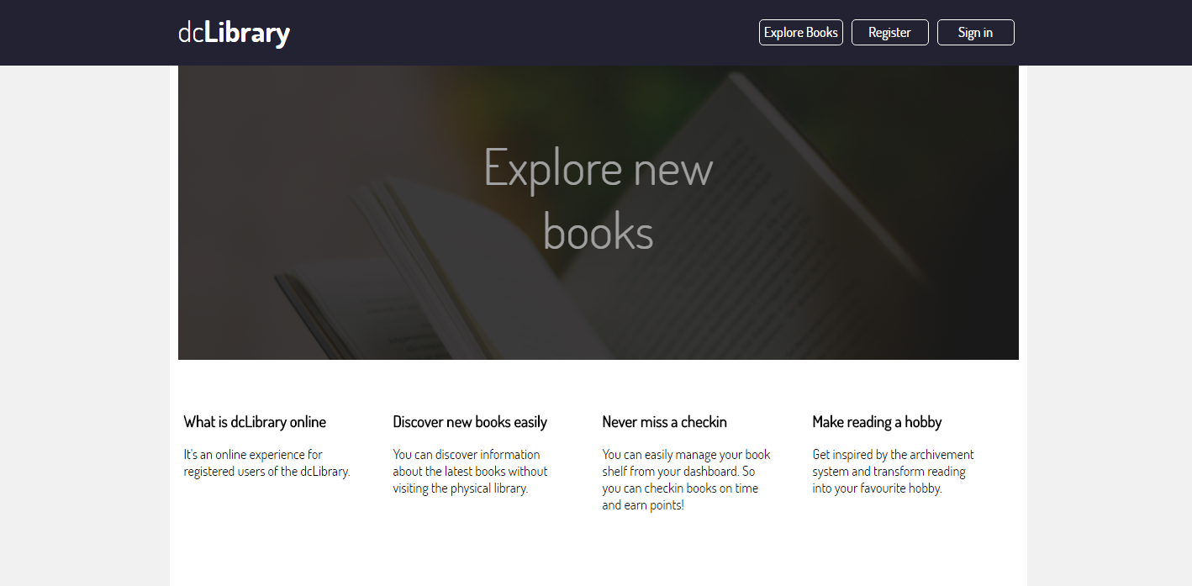

Sign in page

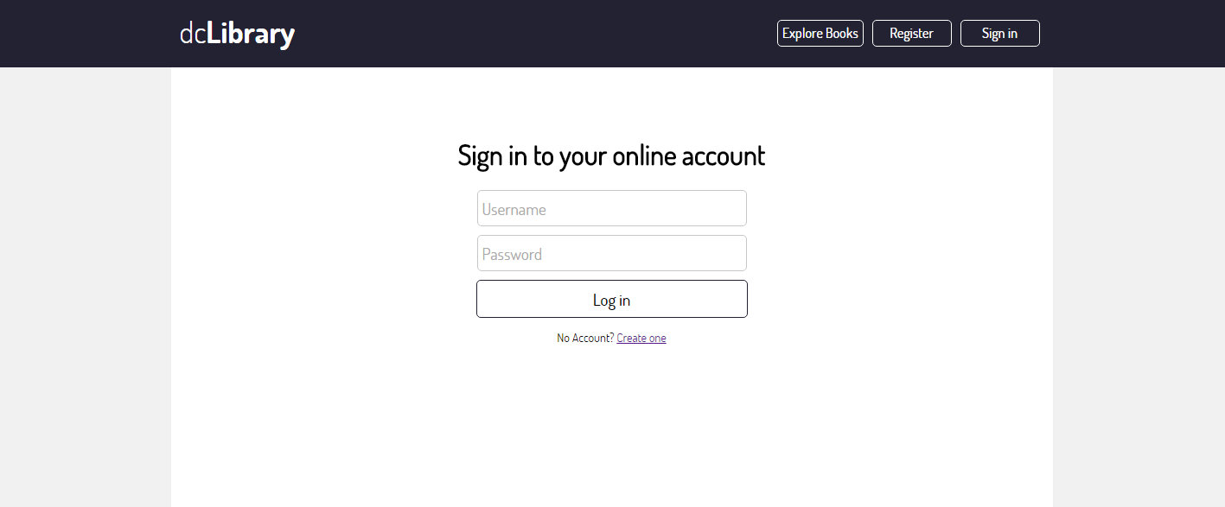

Explore page

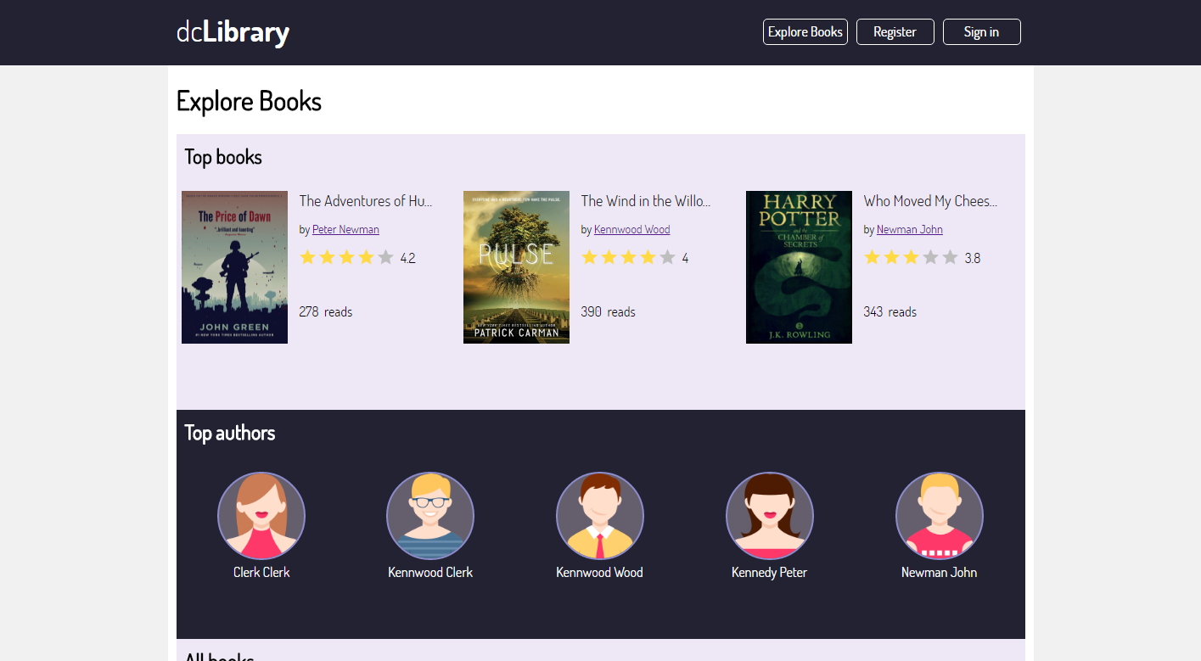

Book details page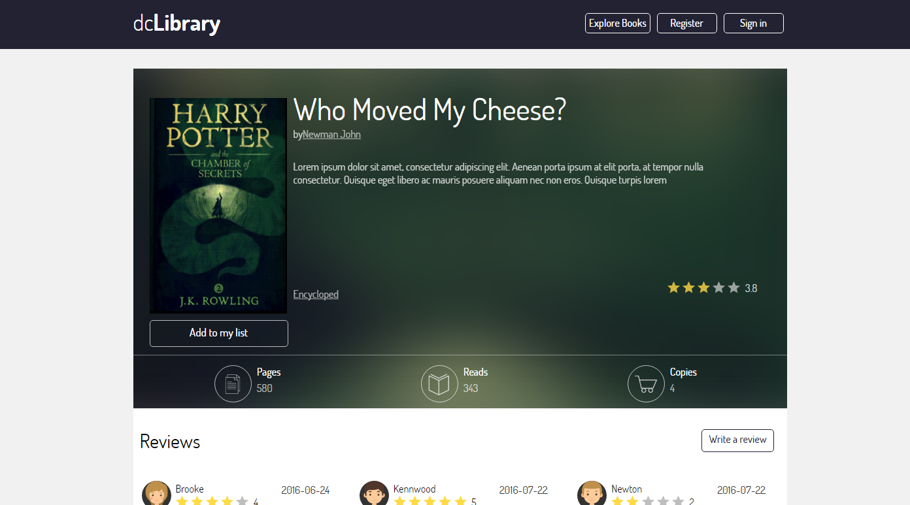

My books page (when the user is logged in)

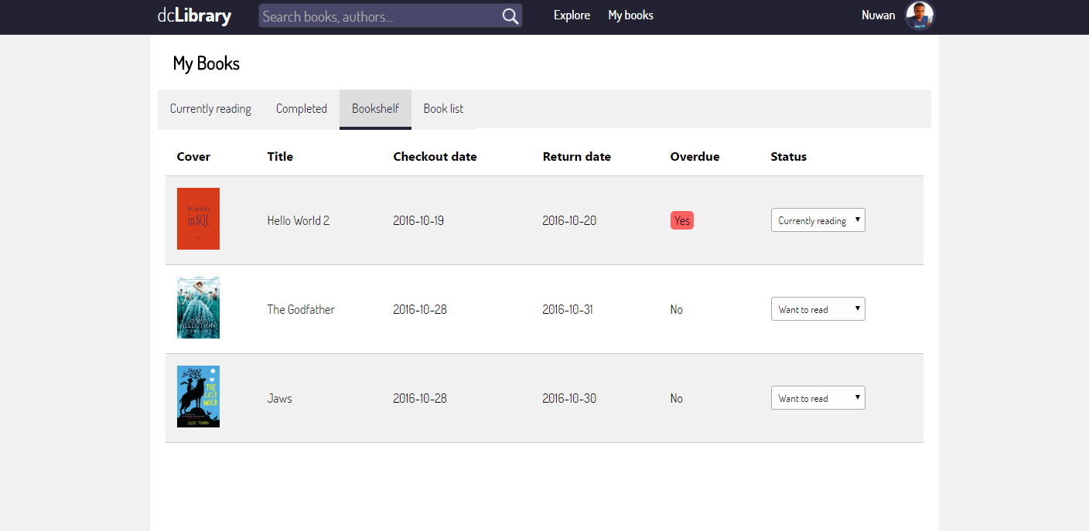

Administrator homepage

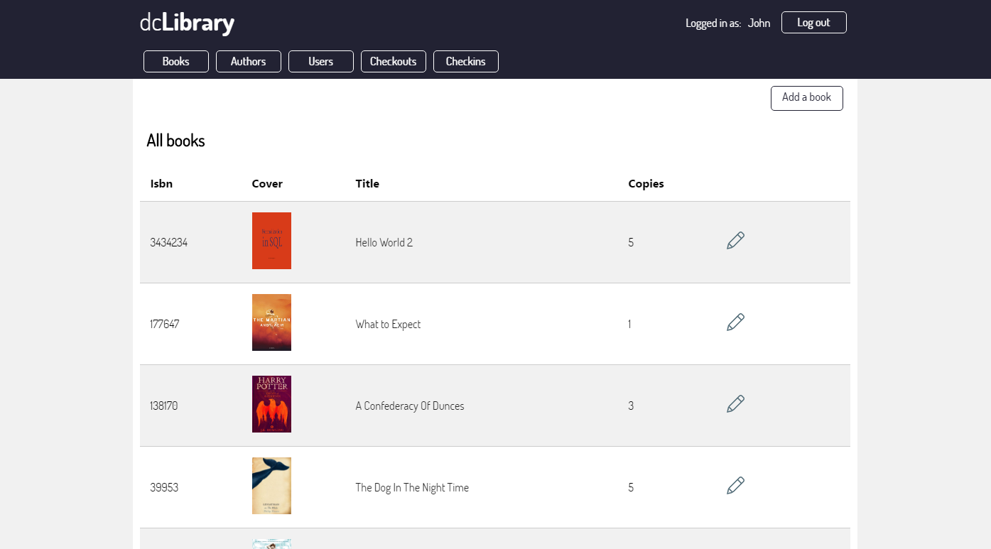

# 7.Resources

* All the images used in this project are images with free to use attributes. I used images from below sites.
  + <https://www.iconfinder.com/>
  + <https://www.pexels.com/>
* I used the following sites to get some help when I’m stuck with problems.
  + <http://www.stackoverflow.com>
  + http://www.w3schools.com
  + http://learn.shayhowe.com/advanced-html-css/complex-selectors/