

Configuration Documentation

Customer: Vectrus / VECT00100

CRIM Object: CRIM #225

External File / Activity Classes

Document Revision History

|  |  |  |  |
| --- | --- | --- | --- |
| Revision | Date | Author | Remarks |
| 1 | 2019-06-30 | T Bulino, C Putt, A Fakhar |  |
|  |  |  |  |
|  |  |  |  |
|  |  |  |  |
|  |  |  |  |
|  |  |  |  |

Table of Contents

1 Business Requirements and References 3

1.1 Business Requirements 3

1.2 Reference to Solution Scope 3

1.3 Sources and Dependencies 3

2 Detailed Requirements 4

2.1 Custom Enumeration [name] 4

2.2 Custom Field(s) [name] on [Logical Unit / Screen] 4

2.3 Custom Page [name] 5

2.4 Custom Tab [name] on [IFS Screen] 7

2.5 Custom Event [name] 7

2.6 Custom Menu [name] on [IFS Screen] 8

2.7 Custom Background Process [name] 9

2.8 Custom Lobby Element [name] 9

3 Solution Summary 10

3.1 Configuration Items and Deployment Guide 10

3.2 Worked Example 10

# Business Requirements and References

## Business Requirements

|  |  |
| --- | --- |
| Requirement | Description |
| ProjectActivityClassAct | External file to upload activity classes to the project activities in a project navigator. |

## Reference to Solution Scope

## Sources and Dependencies

|  |  |  |
| --- | --- | --- |
| Case, CRIM or Customization ID | Title or Description | Comments |
|  |  |  |

# Detailed Requirements

External file to upload the activity classes to the activities in the project navigator, activity class screen as shown below.

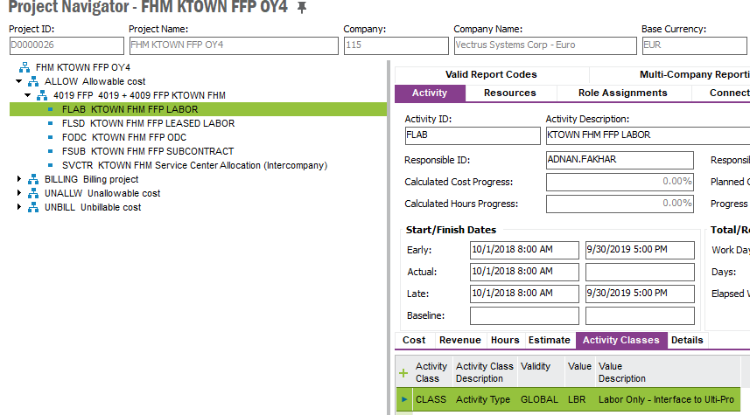

User will create the CSV file with the following columns:

* Activity short name
* Activity Class
* Value

A list of the activity short names will be entered in this external CSV file by user and the user will fill in the column of Activity class and value. After uploading the information in the CSV file to IFS, the highlighted fields in rectangular box pertaining to each activity should populate the same information as shown.

## Custom Enumeration [name]

## Custom Field(s) [name] on [Logical Unit / Screen]

Custom Field Screen/Location: ProjectActivityClassAct

## Custom Page [name]

## Custom Tab [name] on [IFS Screen]

## Custom Event [name]

## Custom Menu [name] on [IFS Screen]

## Custom Background Process [name]

## Custom Lobby Element [name]

# Solution Summary

## Configuration Items and Deployment Guide

|  |  |
| --- | --- |
| Configuration Item | Comments and Deployment Instructions |
|  |  |
|  |  |
|  |  |

## Worked Example