|  |
| --- |
| **Test Cases** |
| Case1 - Project activity or Activity Classes not exists in the system. |
| Case2 - Project activity and Activity Classes exist |
|  |
|  |
|  |

# Case1 - Project activity or Activity Classes not exists in the system.

This case will cause transfer error in external file transaction.

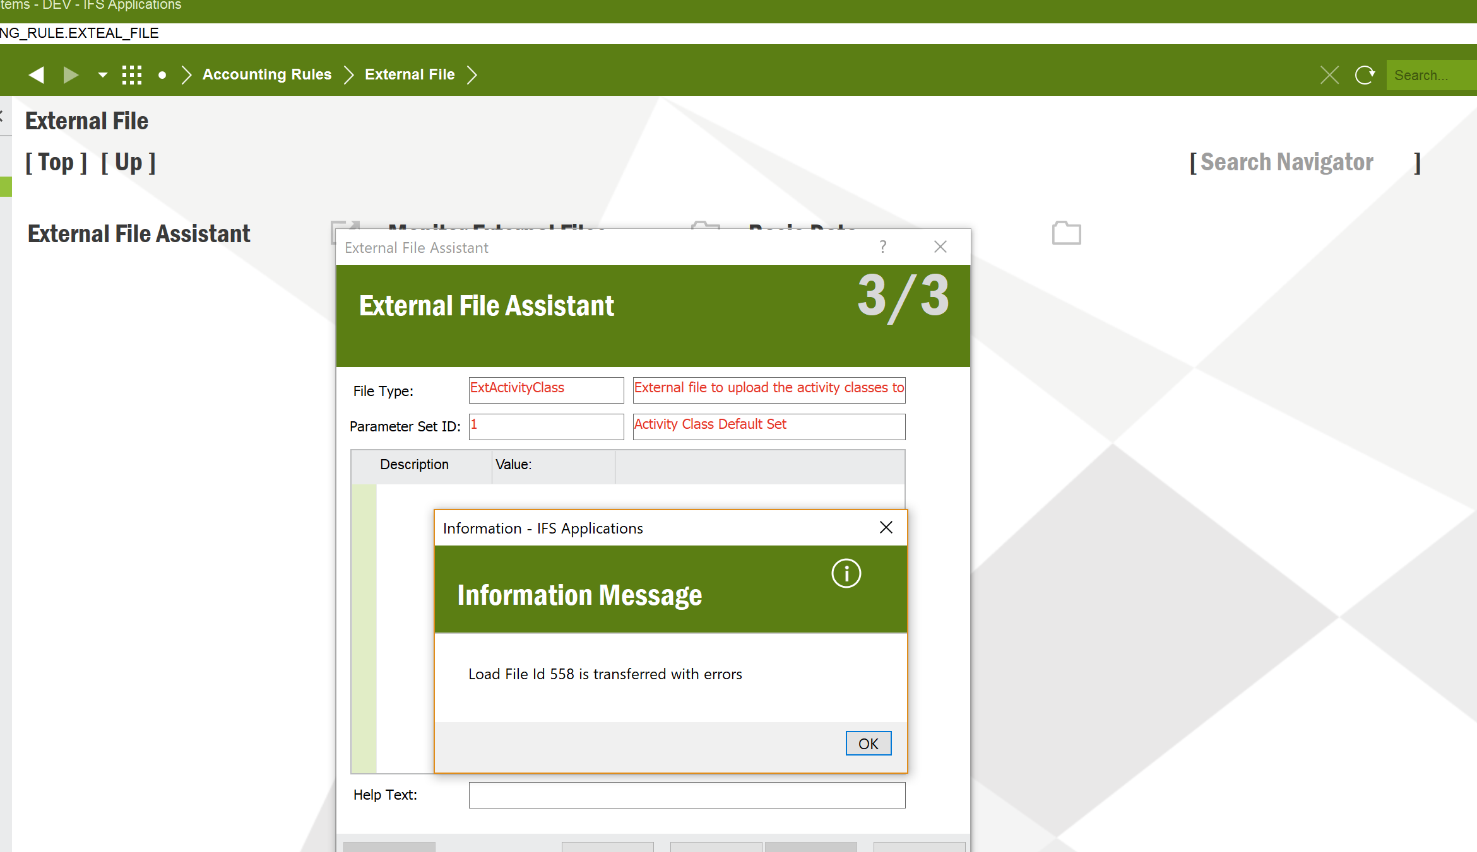



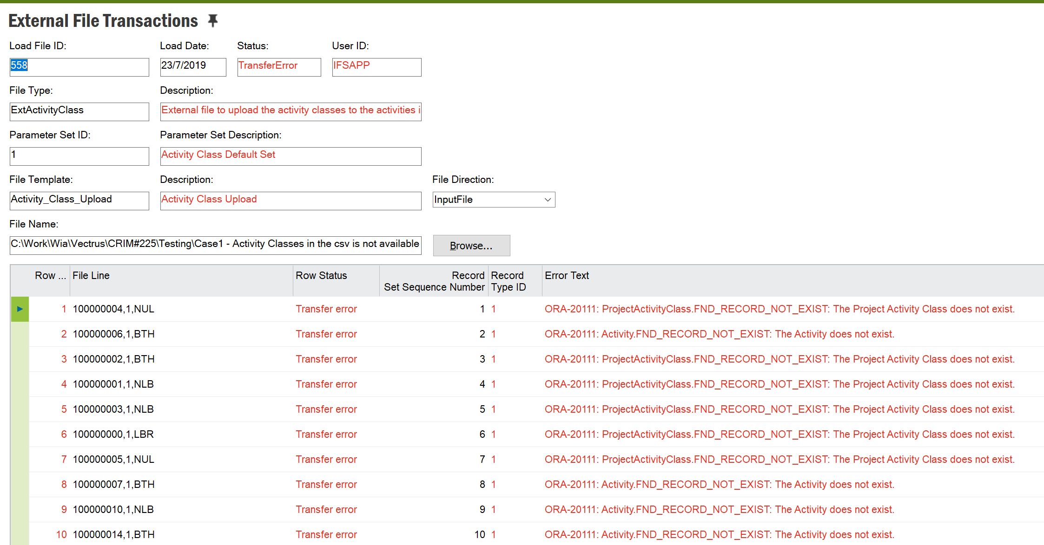

# Case2 - Project activity and Activity Classes exist

Sample csv

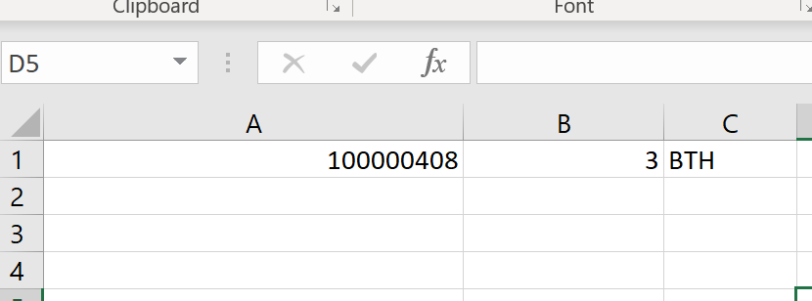

Activity class sec (Col A) and Activity class (Col B) are available in the system.

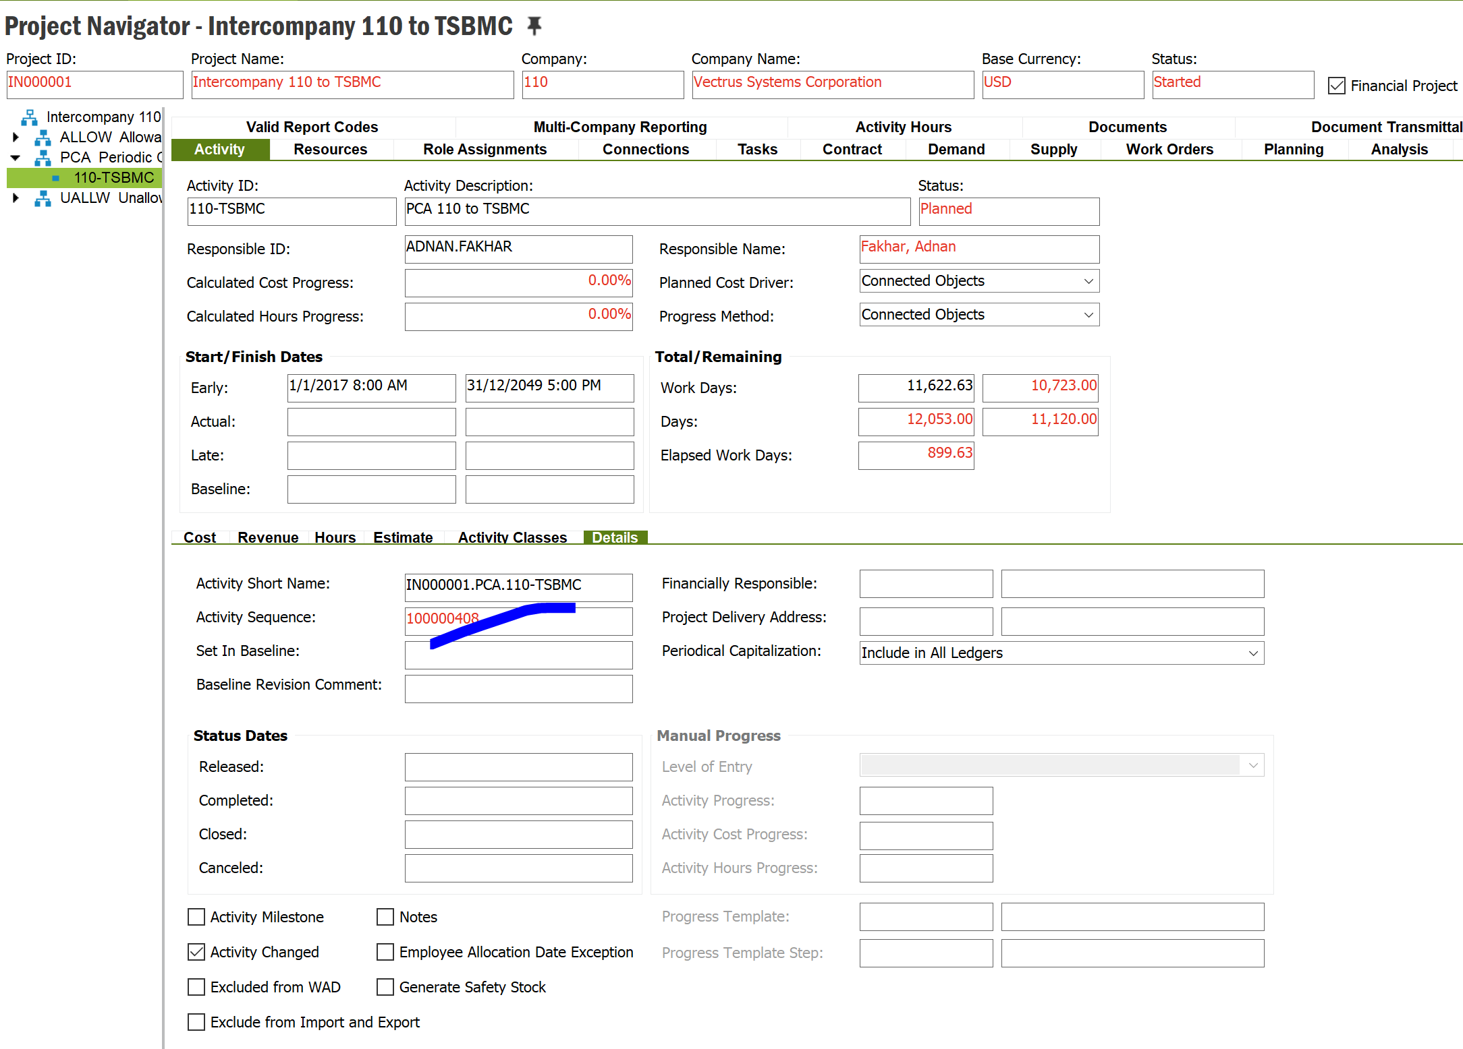

Currently system has activity class 3 only

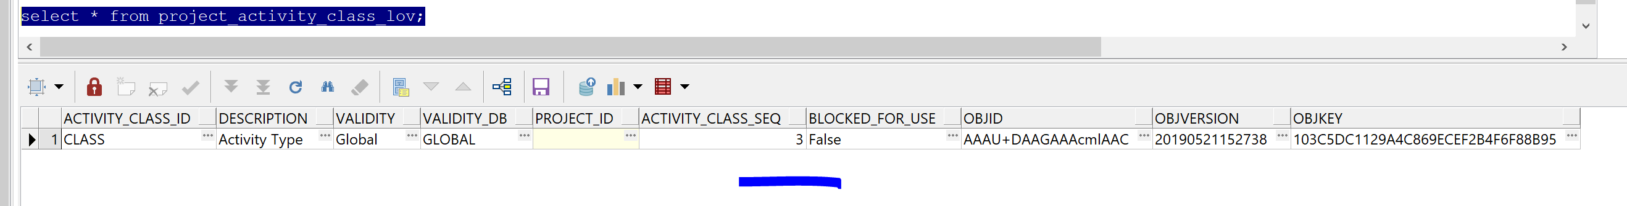

Before running the file image

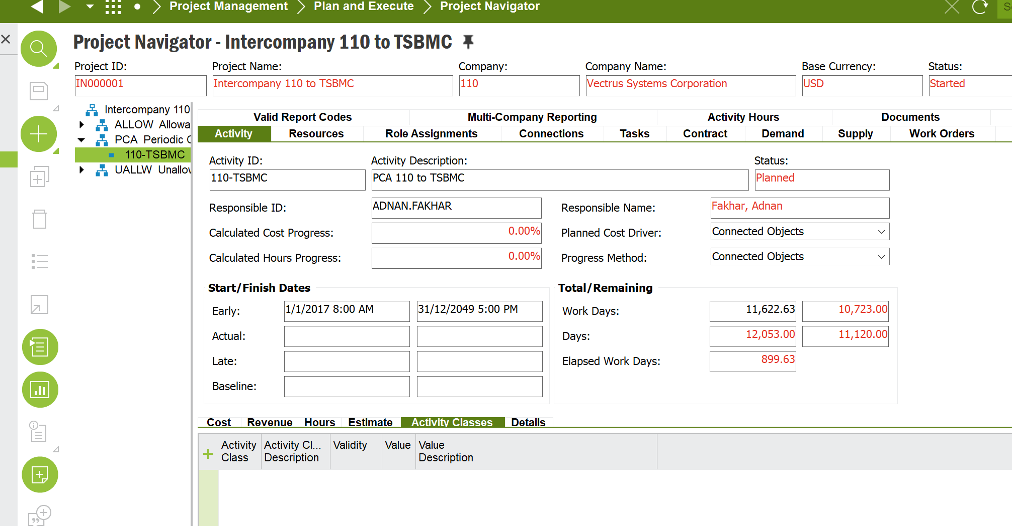

Process the file through External File Assistance wizard

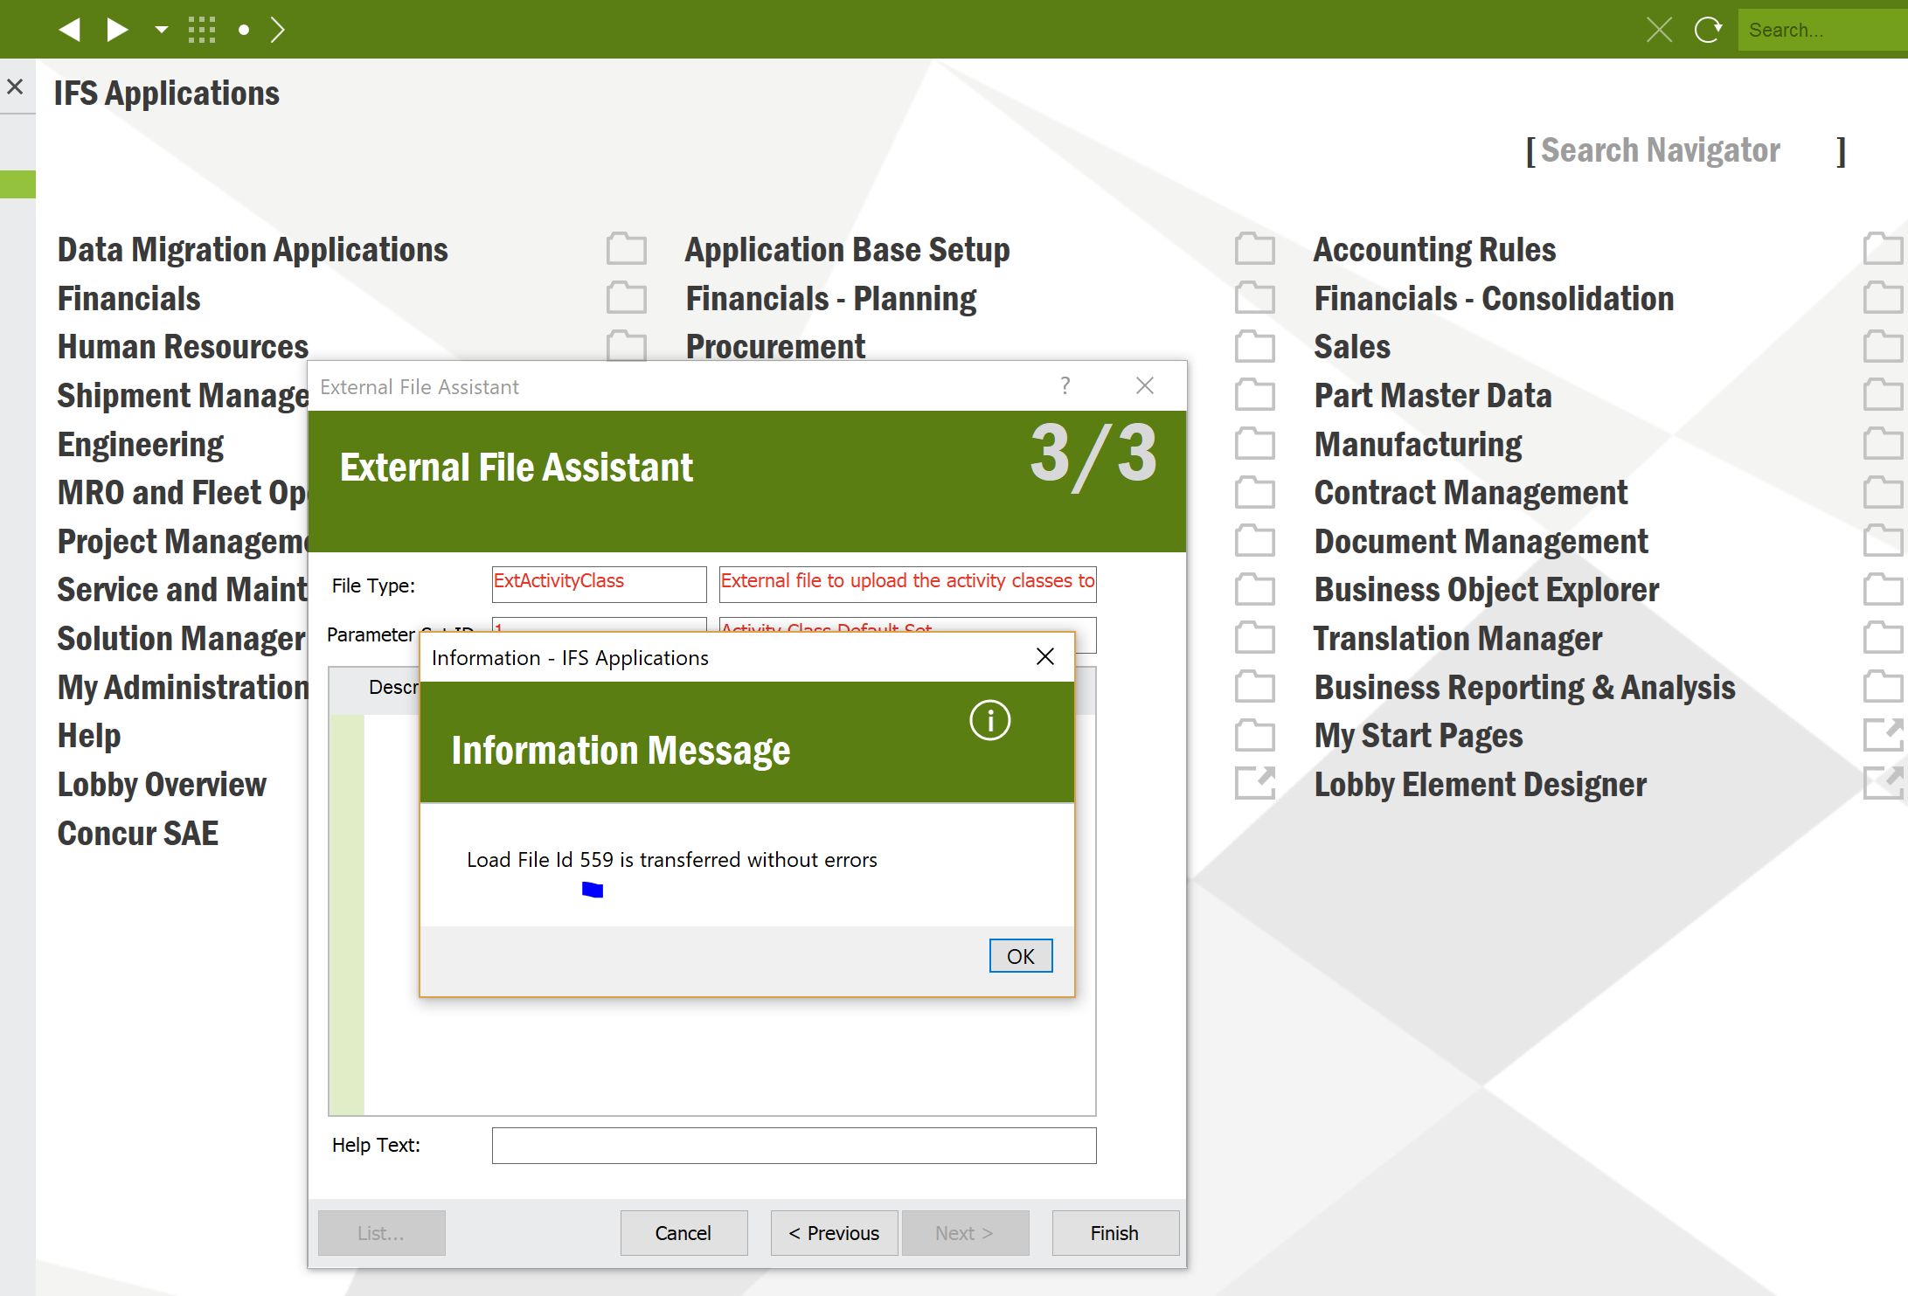

File load ID is created



File transaction status is Transferred

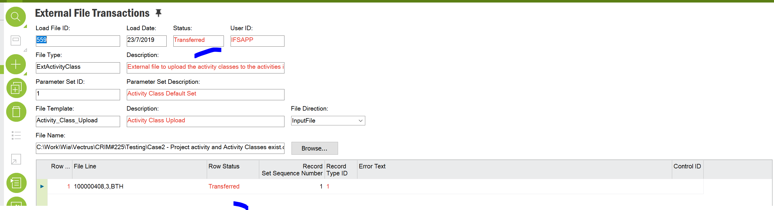

External file log shows the log status

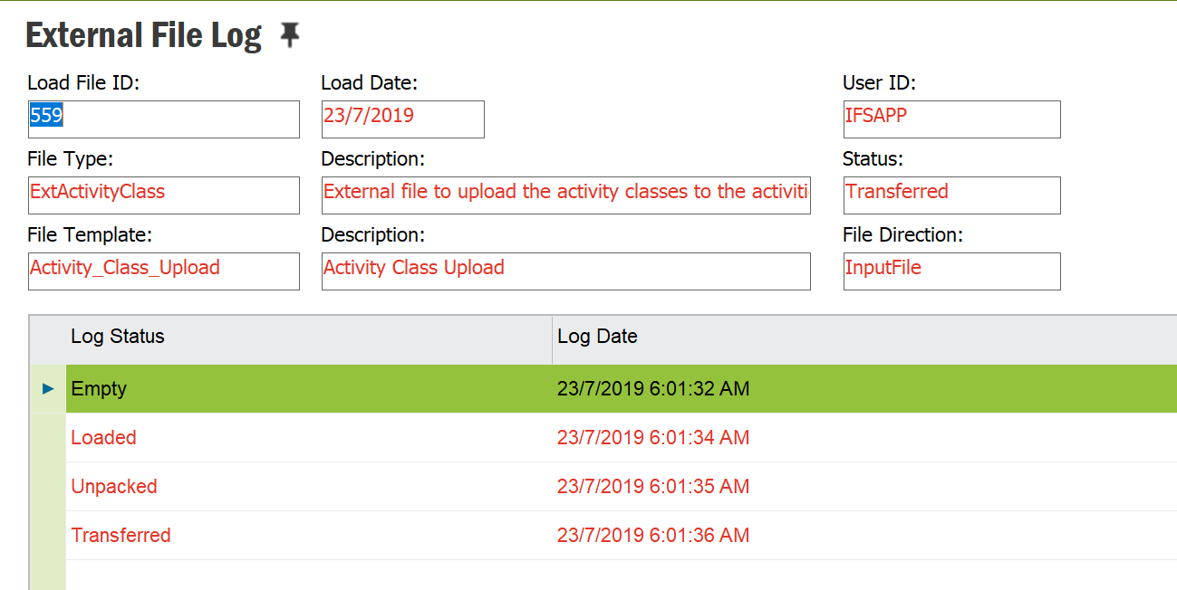

Activity Class is added in Activity Classes tab in Project Navigator

