What for..
- The aim of this document is to explain in detail the architecture of CPS Schemas and the flow of actions taken to show, edit and create instances of flexible types. It aspires to be useful both for developers and users.

CPSSchemas Architecture

General description of the main classes
- Flexible: A flexible is defined by several Schemas (semantic representation) and some Layouts (graphical representation).

Semantic Representation
- Schema: A Schema is a collection of Fields, these fields can be locals to a flexible or globals.
- DataModel: It's temporaly created by the document to access data. Contains every schema of the document and a StorageAdapter for every Schema. This schemas can be locals to document, locals to template or globals.
- DataStructure: This is a dictionary object used for data input and data rendering for view mode. It contains two dicctionaries, one for fields data and another for error data filled after a failed validation.
- Field: Describes semantically an object's attribute, the object can be a ZODB item or a directory entry. This field could be showed by a Widget or it can be stored using a StorageAdapter. Some sort of fields possible are: String, Password, StringList, Int, Long, DateTime, File, Image, etc.

Physical Representation
- StorageAdapter: This object is used by DataModel to retrieve or save data from its original source (SQL, ZODB, File system). A field is recovered by using an storage id and the namespace of the schema.
The document creates a good adapter for every given schema.

Graphical Representation
- Layout: It's an ordered colection of Widgets. It describes how widgets are going to be rendered depending on the layout_mode, which can be view, edit, create, search, etc. Widget modes are combined together with ACL properties, read-only, etc to fit layout mode.
- Widgets: They are the final managers to represent graphically and validate one or more fields. A Widget can be rendered in view or edit edit mode, the former parses the input from DataStructure.

Both Layout and Widgets can be rendered in several formats as pdf, stx, html, plain text, etc.

Class Diagram
- This diagram represents the arquitecture of CPSSchemas (conceptually).

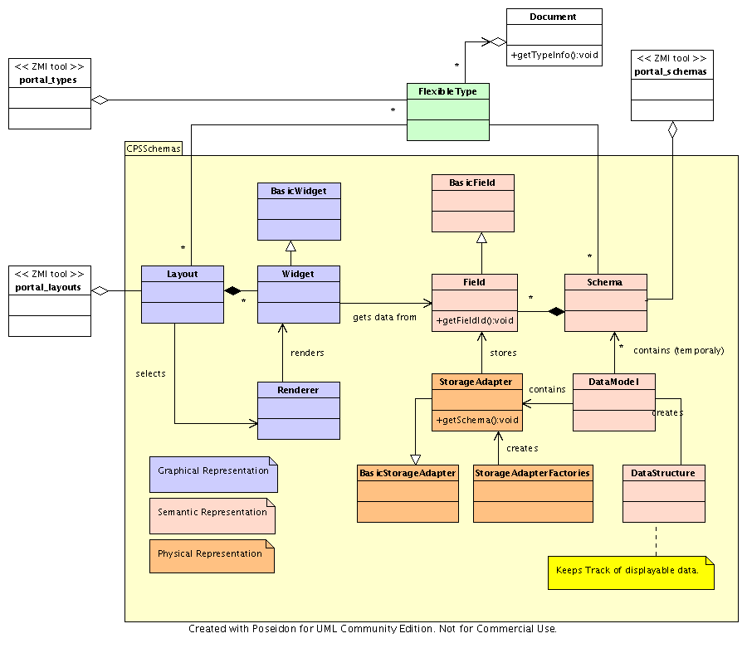

Documents Control Flow

Retrieving data
- A new document is created.
- Next, it creates a new datamodel with every schema (and every field of the schema).
- It creates storageadapters, one for every schema. We have a complete datamodel.
- Data can be retrieved from datastructure.

Displaying data
- cpsdocument_view.pt invokes document's render method, telling about render mode.
- A suitable layout retrieved (locally or globally).
- datamodel is created.
- A new datastructure is used to hold every field data. (prepareLayoutWidgets())
- datastructure dictionary filled in the last step is updated with data from REQUEST (if new field data are specified).
- The layout is rendered with the datastructure. This render action includes carrying out the method computesLayoutStructure().
- Validation and updating of datamodel. validateLayoutStructure().
- Every !Widget is rendered with its data and customized renderer. renderLayoutStructure()
- The final layout style is assembled renderLayoutStyle()

Data storing
- datastructure is updated from REQUEST field data, if specified. A flag indicates the modification (or not) of every field contained in the datastructured.
- datastructure is sent to datamodel and the validation is performed.
- Using the storageadapters data is written to the physical layer.

Validation process
- datastructure is updated from request to get values entered by users.
- Widgets validate data stored in the datastructure.
- If data is ok, widgets update the datamodel with new values. If not, they put an error flag on the datastructure, and datamodel is not commited.
- When all the data is valid, datamodel is commited using storage adapters

Page Templates
- These are the main page templates used to render documents.
- cpsdocument_view.pt: It's the main page template used to display documents. This template uses the content_lib_master.pt template to wrap portal items around the document's content. Main slot is filled with this rendered content.
The use of this template (cpsdocument_view.pt) can be manage in the Aliases tab of portal_types or in the same tab of the document type. Here we can specify for every document or portlet the method or template to deploy for every action taken. Actions can be: edit, view, edit_form, manage_themes, etc.
To render documents page templates specified in the layout properties are used, commonly they are: layout_default_view.pt, layout_default_edit.pt, layout_faq_view.pt, etc.
- layout_lib_div_view.pt: this page templates iterates through every row and every cell of a layout and shows the rendered widget adding the customized CSS class id.

CSS Styles
CSS styles for documents are taken out mainly from : CPSDefault/skins/cps_styles/default.css.dtml , CPSDocument/skins/cps_document/document.css.dtml This styles define widget positions, book items styles, etc.

CPSSchemas ZMI Administration

CPS Flexible Type Information properties
Title | Document type's title.
Description | Description about the document type, to show to the final user.
Icon | Icon to show wherever this type or an instance is showed. Commonly, this icon is showed next to title.
Product meta type
Product name
Product factory method
Initial view name | Name of the default view page template. Usually, cpsdocument_view.pt.
Implicitly addable?
Filter content types?
Allowed content types
Allow Discussion? | It means that users will be able to add comments to instances of this type of document. It's DEPRECATED. ¿What should be used now?
CPS Searchable | If it's on, it means the document will be included in portal searches.
CPS Proxytype
CPS Display as document in listing
CPS Portal Box
Schemas | List of document's schemas, usually: metadata, common y a customized one.
Layouts | List of default layouts to show document.
Layout clusters | It lets to specify layouts and schemas connection. The syntax is: [cluster:layout1,layout2,layout3... ]*
Flexible layouts | It lets to aply dynamically new layouts to the document. This would be useful to have attached files to documents. The syntax is: [Layout:Schema ]*
Storage methods
CPS Portlet

Factory-based Type Information Properties
Title
Description
Icon
Product meta type
Product name
Product factory method
Initial view name
Implicitly addable?
Filter content types?
Allowed content types
Allow Discussion?
CPS Searchable
CPS Proxytype
CPS Display as document in listing
CPS Portal Box

Field Common Properties
Default value expression | Defau lt value at creation time. TALES expression with a given namespace (field, user, portal, DateTime,nothing)
Indexed by SearchableText | Is the field indexed in SearchableText?
ACL: read permissions | List of permissions to access this field in read mode. If empty, the user must have one of the permissions on the object itself to get access to this field
ACL: read roles | Same idea as above. A notice in directory usage situation. The user should have the Owner local role for being able to modify his own entry. Ejemplo: Manager
ACL: read expression | TALES expression returning a boolean representing on which condition the user gets read access on the field. Ejemplo: python:(givenName + " " + sn).strip() or id
ACL: write permission | Same idea in here
ACL: write roles | Same idea in here too
ACL: write expression | Idem
Read: ignore storage | If checked, then the nothing is fetched from the storage. See below
Read: expression | If checked, the value from the storage is further processed. Namespace (Value (From storage, Data, Field, user, Portal, DateTime, nothing)
Read: expression dependent fields | If the above expression uses some other fields. Ejemplo givenName sn id
Write: ignore storage | if checked, nothing will be written on the storage
Write: expression | Same as read_process_expr namespace appart from value and data

Field File Properties
Suffix for field containing Text conversion
Suffix for field containing HTML conversion
Suffix for field containing HTML conversion subobjects

Layout Properties
Prefix for zpt | It's the prefix used to take out the suitable template for the layout mode. If the prefix is layout_portlet_, templates used for view, edit and create mode will be layout_portlet_view, layout_portlet_edit, layout_portlet_create, respectively. This templates can be found in CPSDocument/skins.
ZPT in charge of layout when in create mode | This is template overrides the default one specified in the previous property to be used in create mode.
ZPT in charge of layout when in edit mode | IDEM for edit mode.
ZPT in charge of layout when in view mode | IDEM for view mode.
Allowed widgets in flexible | Document's flexible widgets are listed here. Syntax of every token is widget:max, where widget is the widget id and max is the highest number of items allowed.
Validates layout values with the given expression | This expression should return 1 if the template data is right or 0 otherwise. The method used to validate data will do it over datastructure and will asign error messages to dictionary.

Widget Properties

Common
Title:
Fields: | It contains a list of fields to be showed by this widget.
Required widget: | If this option is cheched, it'll be mandatory to fill in this widget in edit mode.
Label in view layout mode: | Label to show in view mode :-)
Label in edit layout mode: | Label to show in edit mode :-)
Description: | An internal description about the widget.
Help: | An explanation to show to the final user. A question character (?) will be displayed next to widget so that user has some information about the data to put in.
Label is i18n: | Check this option if we want widget label to be translated to multiple languages. A new Localizer entry is added and ready to translate.
For every layout mode, specialized properties can be used.
Read-only in layout modes: | List all layout modes in wich widget will appear as read-only.
Hidden in layout modes: | List all layout modes in wich widget will not appear.
Hidden if readonly in layout modes: | List all layout modes in wich widget will not appeari if it's a read-only widget.
Hidden if empty:
Hidden if (TALES): | It should return 1 or 0, to show the widget or not.
Widget mode (TALES): | This expression should return the widget mode (e.g. view). ¿Does this mode overrides the choosen layout mode?
CSS class for view: | Inside any of default.css.dtml and document.css.dtml templates we can define a new CSS class and fill this property with the name of this class to use it for this widget.
CSS class (TALES): | Here we can return a CSS class id wich depends on, for instance, the value to be showed.
JavaScript (TALES): | ¿?

Attached File Widget
Deletable
Maximum file size
Allowed file suffixes (for example: .html .sxw)

Boolean Widget
False label
True label
Render format

CPS Catalog Navigation
Display width
Maximum input width
Target for the link
Widget render method
Popup title
Popup description
Layout for search
Schema for search
Allow configuration options
Layout for configuration options
Schema for configuration options
Macro to display an item in the popup
Macro to display an item in the document from the popup
Method to customize CatalogNavigation arguments

CPS Portlet Custom Widget, CPS Portlet Dummy Widget, CPS Email Widget
Display width
Maximum input width

CPS Portlet Visibility Widget, CPS ExtendedSelect Widget
Vocabulary
Is vocabulary translated on display

CPS CheckBox Widget
Display for true
Display for false

CPS Date Widget
View format (valor por defecto: %d/%m/%Y)
View format empty (valor por defecto: -)
Use Javascript

CPS DateTime Widget
View format (short, medium or long)
Enabling the setting of time of the day
default hour for time
default minutes for time

CPS Lines Widget
Width
Height
Format for empty list

CPS Directory Entry Widget
Vocabulary
Is vocabulary translated on display
Directory
id of the root if the directory is hierarchical
Optional directory used in view mode
Entry type (id or dn)
Skin name
browse or search

CPS Directory MultiEntries Widget
Vocabulary
Is vocabulary translated on display
Size
Format for empty list
Directory
id of the root if the directory is hierarchical
Optional directory used in view mode
Entry type
Skin name
display separator in view mode
Popup mode

CPS Document Language Select Widget

CPS Customizable Widget
Widget type

CPS File Widget, CPS Flash Widget
Deletable
Maximum file size

CPS Float Widget
Value must be in range
Range minimum value
Range maximum value
Thousands separator
Decimal separator
Number of decimals

CPS Generic MultiSelect Widget
Vocabulary
Is vocabulary translated on display
Size
Format for empty list
Render format
Accept blank values when validating

CPS Generic Portlet Widget
the zpt or py script method
Field types

CPS Generic Select Widget
Vocabulary
Is vocabulary translated on display
Render format
Provide an 'other' option
'other' option display width
'other' option maximum input width
Accept blank values when validating

FAQ

Bibliography
- CPSDocument/doc/control_flow.txt (It seems to be wrong.)
- CPSDocument/doc/objects.txt (It seems to be wrong.)
- CPSDocument/doc/cpsschemas-vs-archetypes.txt
- CPS 3.3.6 source code comments.
- CPS: Schemas, documents and directories. Julien Anguenot.
http://www.nuxeo.com/docs/europython2004/cps_schemas_and_directories.pdf

