Docusign Addon

Digital signature with Nuxeo & Docusign

# Prerequisites

|  |  |
| --- | --- |
| ❗ | You must use a Nuxeo instance with a public IP or domain name to receive the callbacks from DocuSign |

# Setup

## Sign Up for a Free Docusign Developer Account

Got to <https://secure.docusign.com/signup/developer>

## Configure a Test Application

Once you developer account is activated:

* Go to <https://appdemo.docusign.com/home>
* Switch to the Admin view

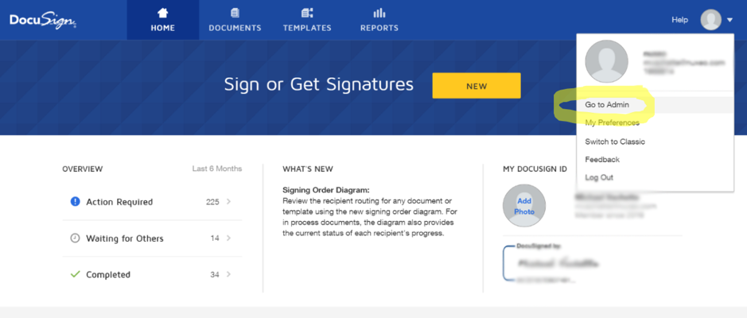

* Add a new Integrator Key

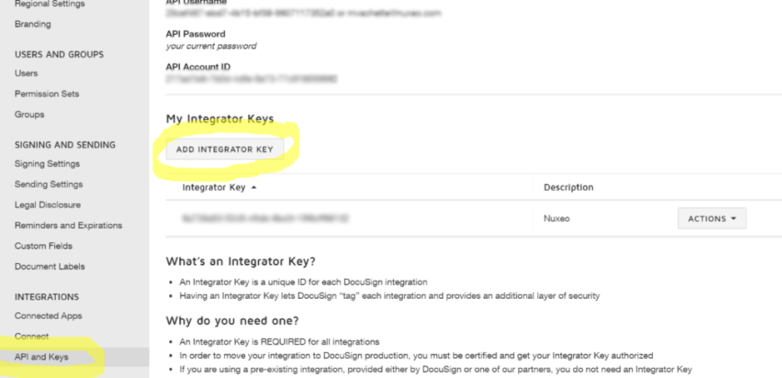

* Add a new Integrator Key

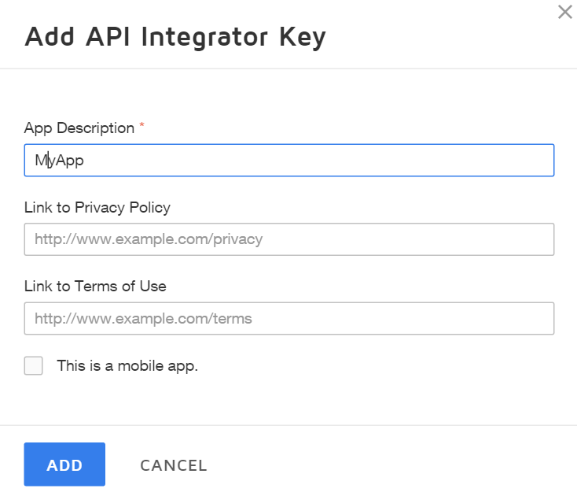

* Set the redirect URI (for oauth2) and generate a secret key
  + Redirect URI is https://myserver:myport/nuxeo/site/oauth2/docusign/callback
  + Copy the key somewhere as soon as it’s generated

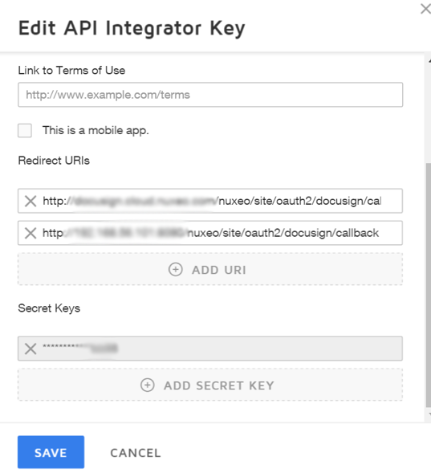

## Enable DocuSign Connect

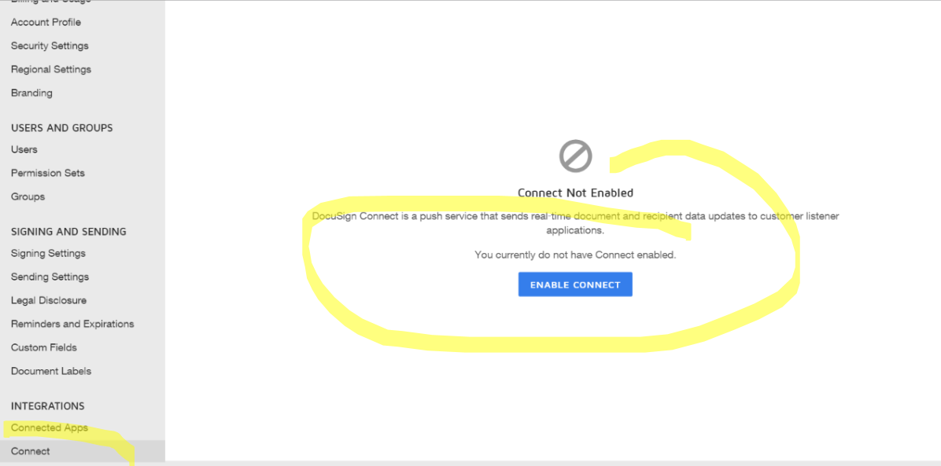

## Install the Package

* Install from Marketplace: <https://connect.nuxeo.com/nuxeo/site/marketplace/package/nuxeo-docusign>
* Build from the source <https://github.com/nuxeo-sandbox/nuxeo-docusign>

## Configure the Docusign Oauth Provider

* Click on **Administration > Cloud Services** menu

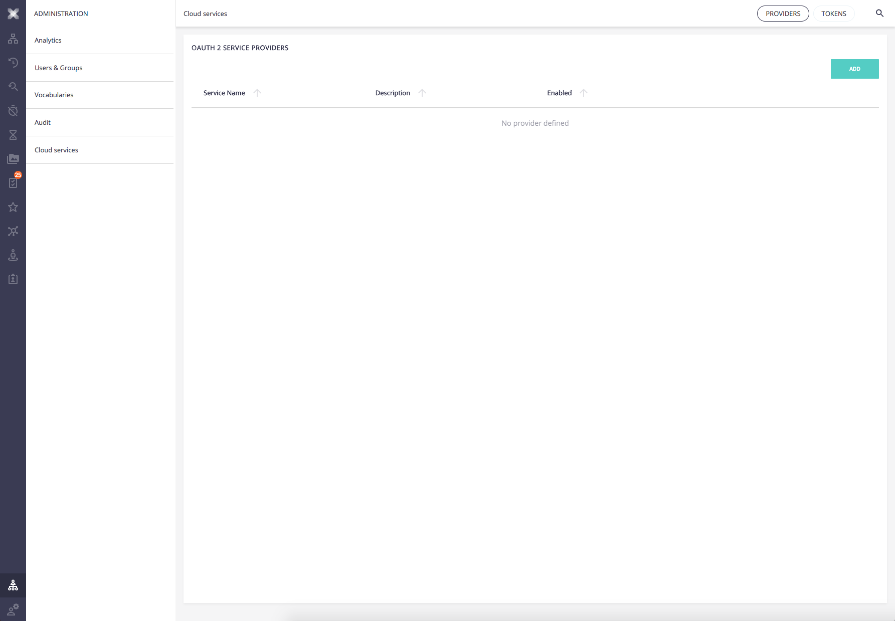

* Click on **ADD** button

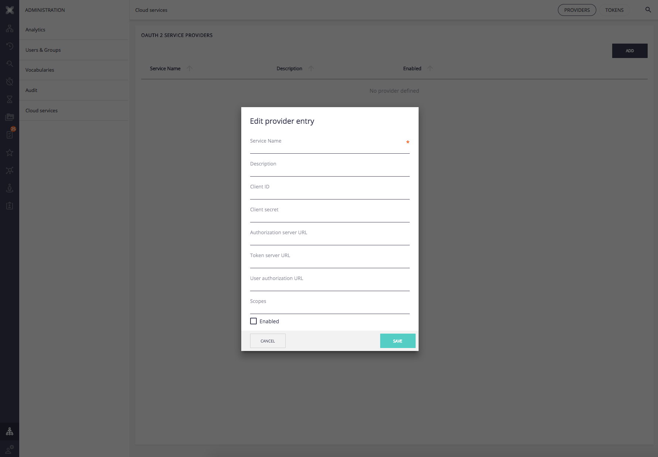

* Provide required information
  + **Service name**: docusign
  + **Description**: Docusign
  + **Client ID**: <*Integrator key*>
  + **Client Secret**: <*Secret key* in Edit API Integrator Key>
  + **Authorization Server URL**: <https://account-d.docusign.com/oauth/auth>
  + **Token Server URL**: <https://account-d.docusign.com/oauth/token>
  + **Enabled**: checked

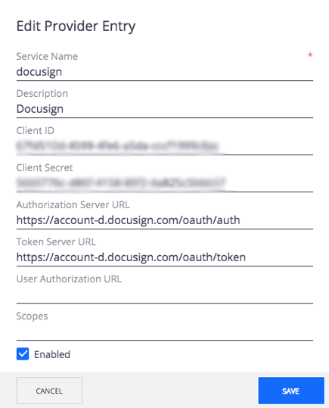

* Click on **SAVE** button

## Link your DocuSign account to Nuxeo

* Got to **Home > Cloud Services** in JSF (https://NUXEO_SERVER/nuxeo/nxhome/default@view_home?tabIds=USER_CENTER%3AOAuthTokens)
* Click on Connect to DocuSign

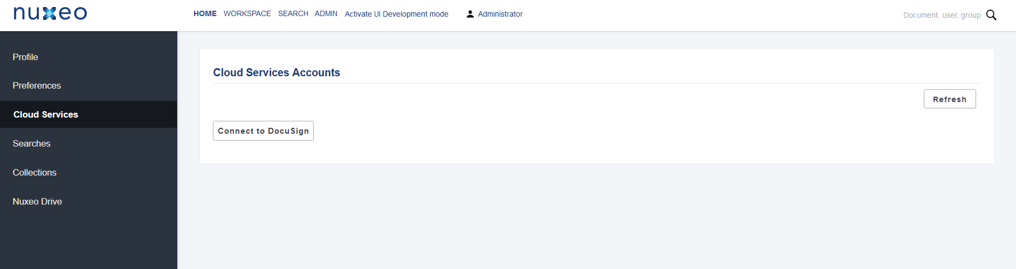

|  |  |
| --- | --- |
| ❗ | Once your environment is properly configured and up & running, you may find this error message in your **server.log** file:  Caused by: com.docusign.esign.client.ApiException: {  "errorCode": "**USER_AUTHENTICATION_FAILED**",  "message": "One or both of Username and Password are invalid. Invalid access token" }  You must **regenerate the DocuSign token** following these steps:   * Got to ***Home > Cloud Services*** menu in JSF (https://NUXEO_SERVER/nuxeo/nxhome/default@view_home?tabIds=USER_CENTER%3AOAuthTokens) * Click on ***Delete*** button * Click on ***Connect to DocuSign*** |