Nuxeo 5 is an innovative, standards-based, open source framework for ECM applications. Its component-based and service-oriented architecture makes it easy to customize and extend, making developers more efficient and ultimately, happier.

Nuxeo Core

Overview
Nuxeo Core is an embeddable document management core, based on Nuxeo Runtime. It provides all necessary low-level services to define, store, manage, audit, request and search content. It is the kernel of Nuxeo 5 and can also be embedded in third-party applications to provide advanced content management features. It can run on any Java platform, can be easily extended using plug-ins (thanks to Nuxeo Runtime) and implements JCA (Java EE Connector Architecture) to be easily plugged into existing applications or information systems.

Highlighted features
- Model: content management concepts definition
- Storage Manager: low-level content storage and retrieval (JCR-based)
- Schema Manager: XMLSchema based content schema definition and management
- Version Manager: versioning management
- Content Type Manager: content types management (a content type is a set of schemas)
- Query Engine: SQL-like unified query engine
- Security Manager: access rights manager and controller
- Life cycle management: define, deploy and applies life cycle on document types (JCR storage)
- Event Service: abstract event service to broadcast and receive events
- Local (POJO) and Remote (JavaEE) access using dedicated client sessions.
- Set of extension points allowing third party code to extend and customize the Nuxeo Core services
Nuxeo Core offers a light content/document management core providing all the services you need to manage content in any application.

Some | Other | Texts | In table cels

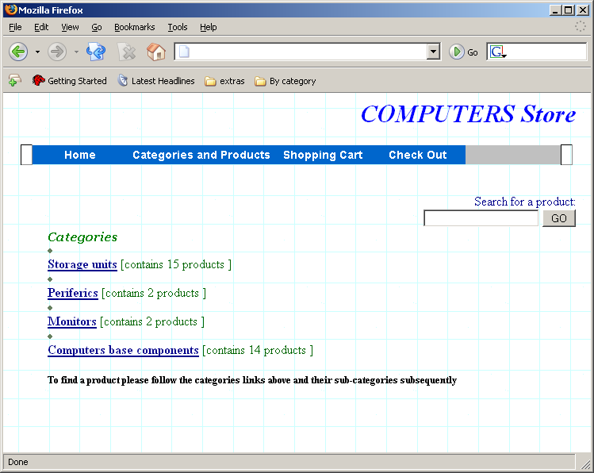

Some other words follow below.

