**Assignment on Time Series Analysis & Forecasting**

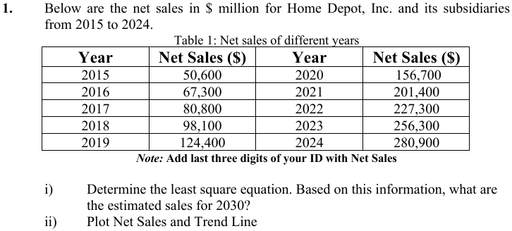

**Solution:**

|  |  |  |  |  |
| --- | --- | --- | --- | --- |
| Sl. No | Year(X) | Net Sales ($) (Y) | XY | XX |
| 1 | 2015 | 50600019 | 50600024 | 1 |
| 2 | 2016 | 67300019 | 134,600,048 | 4 |
| 3 | 2017 | 80800019 | 242,400,072 | 9 |
| 4 | 2018 | 98100019 | 392,400,096 | 16 |
| 5 | 2019 | 124400019 | 622,000,120 | 25 |
| 6 | 2020 | 156700019 | 940,200,144 | 36 |
| 7 | 2021 | 201400019 | 1,409,800,168 | 49 |
| 8 | 2022 | 227300019 | 1,818,400,192 | 64 |
| 9 | 2023 | 256300019 | 2,306,700,216 | 81 |
| 10 | 2024 | 280900019 | 2,809,000,240 | 100 |
| ∑x=55 | 20195 | 1543800190 | 1.072610132E+10 | 385 |

m = (n∑xy - ∑y∑x)/[n∑x2 - (∑x)2] Here, n=10; ∑x=55; ∑y=1543800190

∑xy = 1.072610132E+10; ∑x2 =385

m=(10*1.072610132E+10-1543800190*55)/ [10*385-552]

= 2.7*107

b = (∑y – m ∑x)/n

= (1543800190 -3*107*20195)/10

= -1.3*108

**y = 2.7*107x- 1.3*108**

**For x=2030 we get y = 5.46*1010 $**

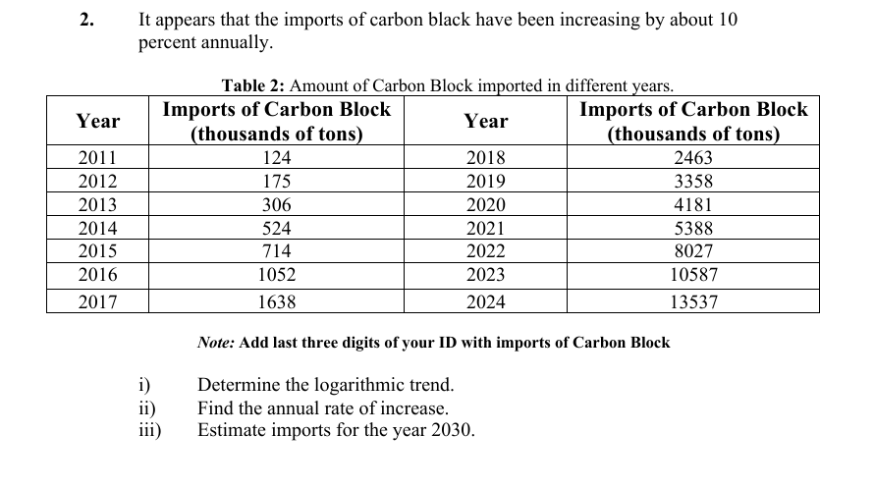

Solution:

|  |  |  |  |
| --- | --- | --- | --- |
| Sl No | Year(X) | Imports of Carbon Block (Thousands of tons) (Y) | log(Y) |
| 1 | 2011 | 124019 | 5.093 |
| 2 | 2012 | 175019 | 5.243 |
| 3 | 2013 | 306019 | 5.485 |
| 4 | 2014 | 524019 | 5.719 |
| 5 | 2015 | 714019 | 5.853 |
| 6 | 2016 | 1052019 | 6.022 |
| 7 | 2017 | 1638019 | 6.214 |
| 8 | 2018 | 2463019 | 6.391 |
| 9 | 2019 | 3358019 | 6.526 |
| 10 | 2020 | 4181019 | 6.621 |
| 11 | 2021 | 5388019 | 6.731 |
| 12 | 2022 | 8027019 | 6.904 |
| 13 | 2023 | 10587019 | 7.024 |
| 14 | 2024 | 13537019 | 7.131 |
|  |  |  |  |

**Here slope, m is the annual rate of increase. Which is m = 0.1571**

**The logarithmic trend equation is,**

**Log(y)=0.1571x – 310.71**

**For x = 2030 we get Log(y) = 8.203**

**Thus,** **Imports of Carbon Block (thousands of tons) in 2030 = 159587914.7**

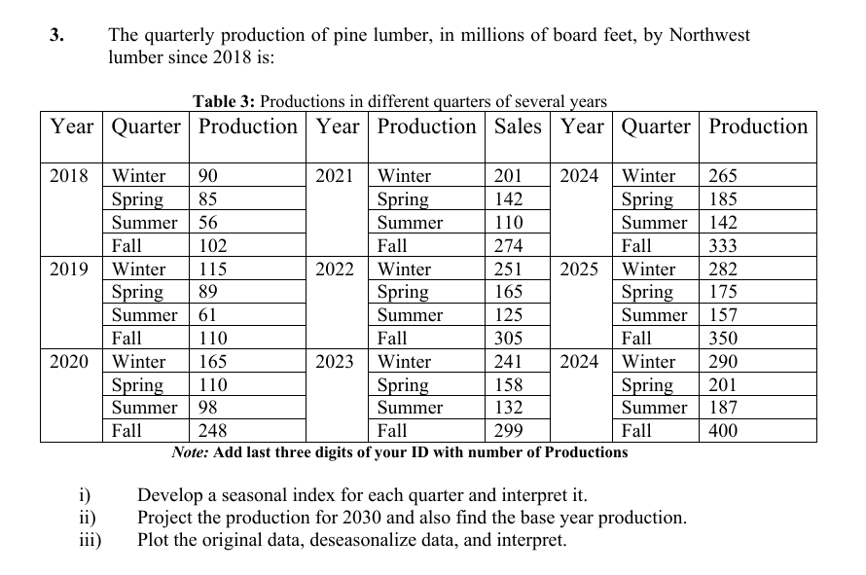

**Solution:**

|  |  |  |  |  |  |
| --- | --- | --- | --- | --- | --- |
| Year | Winter(production) | Spring(production) | Summer(production) | Fall(production) | Mean |
| 2018 | 90019 | 85019 | 56019 | 102019 | 83274 |
| 2019 | 115019 | 89019 | 61019 | 110019 | 93774 |
| 2020 | 165019 | 110019 | 98019 | 248019 | 155274 |
| 2021 | 201019 | 142019 | 110019 | 274019 | 181774 |
| 2022 | 251019 | 165019 | 125019 | 305019 | 211524 |
| 2023 | 241019 | 158019 | 132019 | 299019 | 207524 |
| 2024 | 265019 | 185019 | 142019 | 333019 | 231274 |
| 2025 | 282019 | 175019 | 157019 | 350019 | 241024 |
| 2026 | 290019 | 201019 | 187019 | 400019 | 269524 |

**Seasonal Index calculation:** Divide seasonal value of each year with the mean of each year. Then we get,

|  |  |  |  |  |
| --- | --- | --- | --- | --- |
| Year | Winter(production) | Spring(production) | Summer(production) | Fall(production) |
| 2018 | 1.081 | 1.0210 | 0.6727 | 1.2251 |
| 2019 | 1.226 | 0.94934 | 0.6507 | 1.1732 |
| 2020 | 1.0627 | 0.70857 | 0.6312 | 1.5973 |
| 2021 | 1.1059 | 0.78132 | 0.6052 | 1.5075 |
| 2022 | 1.1867 | 0.78016 | 0.5911 | 1.4420 |
| 2023 | 1.1614 | 0.761472 | 0.6361 | 1.4409 |
| 2024 | 1.1459 | 0.800019 | 0.6141 | 1.4399 |
| 2025 | 1.1701 | 0.726167 | 0.6514 | 1.4522 |
| 2026 | 1.0761 | 0.745847 | 0.6939 | 1.4841 |

Overall Seasonal Index:

|  |  |  |  |  |
| --- | --- | --- | --- | --- |
| Seasonal Index | Winter | Spring | Summer | Fall |
| SI | 1.1351 | 0.8082 | 0.6385 | 1.41806 |
| Sum of SI | 4 |  |  |  |

De-seasonalize data:

|  |  |  |  |  |
| --- | --- | --- | --- | --- |
| Year | Winter(production) | Spring(production) | Summer(production) | Fall(production) |
| 2018 | 79303.74486 | 105199.5393 | 87737.78045 | 71946.01688 |
| 2019 | 101326.657 | 110148.7196 | 95568.20549 | 77587.4912 |
| 2020 | 145372.4813 | 136131.9162 | 153513.3508 | 174902.9233 |
| 2021 | 177085.4749 | 175725.3587 | 172306.3709 | 193237.7149 |
| 2022 | 221131.2992 | 204183.1454 | 195797.646 | 215098.4279 |
| 2023 | 212322.1343 | 195522.0799 | 206751.2411 | 210867.3221 |
| 2024 | 233464.13 | 228929.047 | 222421.0912 | 234843.588 |
| 2025 | 248439.7103 | 216556.0962 | 245912.3663 | 246831.7209 |
| 2026 | 255487.0422 | 248725.7682 | 292894.9166 | 282081.9355 |

Production in 2030:

For winter

y = 22625x – 5E+07; for x = 2030 we get production = 35,928,750

For spring,

y = 18312x-4E+07; for x = 2030 we get production = 2826640

For summer,

y = 24066x-5E+07; for x = 2030 we get production =1146020

For fall,

y = 24764 X - 4E+07; for x=2030 we get production = 10270920