/ = give result "this is default"
/about = give result "mongodb express React and mongoose app,React runs in another application"

/addbooks = add book in mongoDB
/allbook= shows all added books
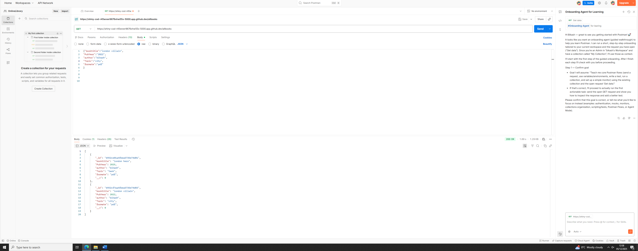

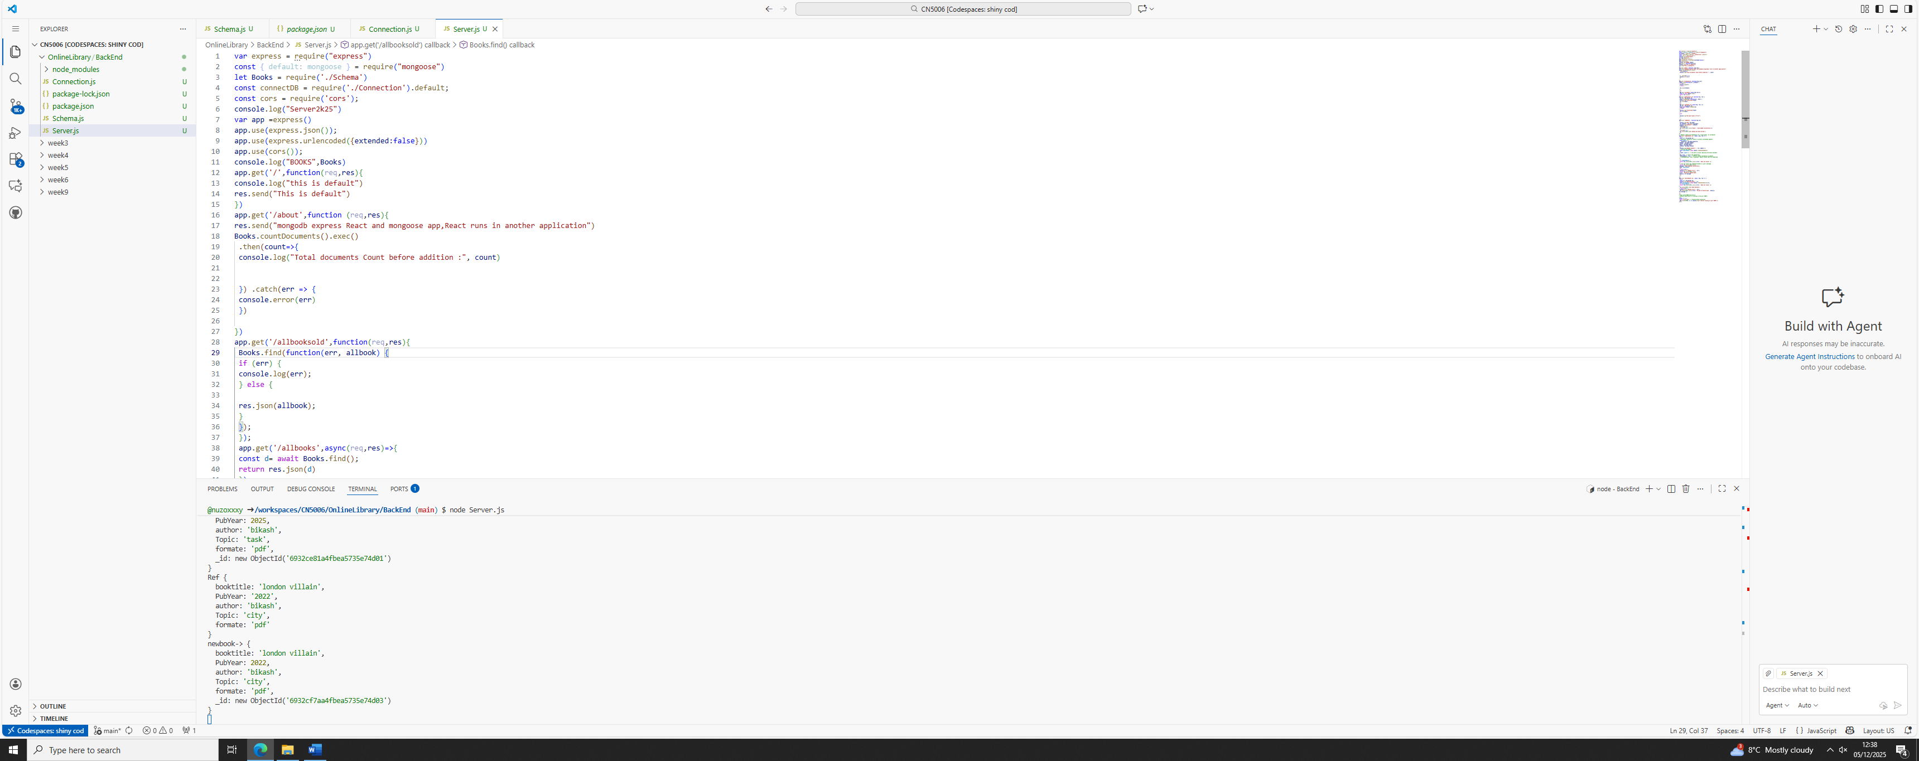

/deleteBook/:id = delete the book
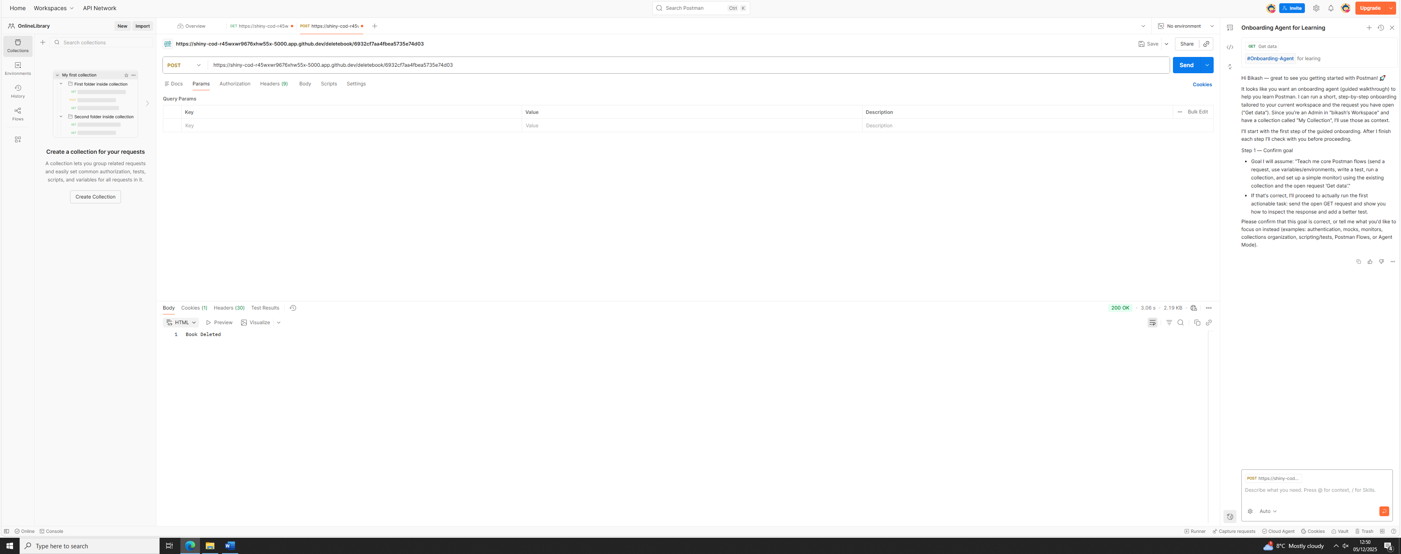

/updatebook/:id = update the details of the book
