Empowering Independence: A Solution for the Visually Impaired
A Deep Learning Based Multimodal Assistive System for the Visually Impaired

A PROJECT REPORT
Submitted by
CHIRAG N V
[Reg No: RA2412005015002]
Under the Guidance of
Dr. M. PRAKASH
Professor,
Department of Data Science And Business Systems
In partial fulfilment of the requirements for the degree of
MASTER OF TECHNOLOGY
In
COMPUTER SCIENCE ENGINEERING


DEPARTMENT OF COMPUTING TECHNOLOGIES
COLLEGE OF ENGINEERING AND TECHNOLOGY
SRM INSTITUTE OF SCIENCE AND TECHNOLOGY
KATTANKULATHUR – 603 203
MAY 2026

SRM INSTITUTE OF SCIENCE AND TECHNOLOGY
KATTANKULATHUR – 603 203
BONAFIDE CERTIFICATE

Certified that this M.Tech project report titled “EMPOWERING INDEPENDENCE: A SOLUTION FOR THE VISUALLY IMPAIRED. A DEEP LEARNING BASED MULTIMODEL ASSISTIVE SYSTEM FOR THE VISUALLY IMPAIRED” is the bonafide work of Mr. CHIRAG N V [Reg. No.: RA2412005015002] who carried out the project work under my supervision. Certified further, that to the best of my knowledge the work reported herein does not form part of any other thesis or dissertation on the basis of which a degree or award was conferred on an earlier occasion for this or any other candidate.

Dr. M. PRAKASH
Professor
Department of Data Science and Business Systems
DR. G. NIRANJANA
HEAD OF THE DEPARTMENT
Professor
Department of Computing Technologies

INTERNAL EXAMINER
EXTERNAL EXAMINER

DEPARTMENT OF COMPUTING TECHNOLOGIES
SRM Institute of Science & Technology
Own Work Declaration Form

Degree/ Course : M Tech in Computer Science Engineering
Student Name : CHIRAG N V
Registration Number : RA2412005015001
Title of Work : Empowering Independence: A Solution for the Visually Impaired
A Deep Learning Based Multimodal Assistive System for the Visually Impaired

I hereby certify that this assessment compiles with the University’s Rules and Regulations relating to Academic misconduct and plagiarism, as listed in the University Website, Regulations, and the Education Committee guidelines. I confirm that all the work contained in this assessment is my own except where indicated, and that I have met the following conditions:

- Clearly references / listed all sources as appropriate
- Referenced and put in inverted commas all quoted text (from books, web, etc.)
- Given the sources of all pictures, data etc. that are not my own
- Not made any use of the report(s) or essay(s) of any other student(s) either past or present
- Acknowledged in appropriate places any help that I have received from others (e.g. fellow students, technicians, statisticians, external sources)
- Compiled with any other plagiarism criteria specified in the Course handbook / University website
I understand that any false claim for this work will be penalized in accordance with the University policies and regulations.

DECLARATION:
I am aware of and understand the University’s policy on Academic misconduct and plagiarism and I certify that this assessment is my own work, except were indicated by referring, and that I have followed the good academic practices noted above.
CHIRAG N V (RA2412005015002)

ACKNOWLEDGEMENT

I express my humble gratitude to Dr. C. Muthamizhchelvan, Vice-Chancellor, SRM Institute of Science and Technology, for the facilities extended for the project work and his continued support. I extend my sincere thanks to Dean of College of Engineering & Technology, SRM Institute of Science and Technology, Prof. M. Leenus J Martin, for his invaluable support.

I wish to thank Dr. Revathi Venkataraman, Professor & Chairperson, School of Computing, SRM Institute of Science and Technology, for her support throughout the project work. I sincerely appreciate Dr. Niranjana G, Professor and Head, Professor, Department of Computing Technologies, SRM Institute of Science and Technology, for her guidance and support that has been invaluable to my success. I am incredibly grateful to my Program Coordinator, Dr. S. Ganesh Kumar, Professor, Department of Data Science and Business Systems, SRM Institute of Science and Technology, for his suggestions and encouragement at all the stages of the project work.

I want to convey my thanks to my Project Coordinator, Dr. Pitchaimanickam, Assistant Professor and the Panel Head, Dr. M. Prakash, Professor Department of Data Science and Business Systems, SRM Institute of Science and Technology, for their inputs during the project reviews and support.

I register my immeasurable thanks to my Program Manager, Mr. Samuel Godshine, Program Manager, Great Learning for leading and helping us to complete the course.

My inexpressible respect and thanks to the guide, Dr. M. Prakash, Professor Department of Data Science and Business Systems, SRM Institute of Science and Technology, for providing me with an opportunity to pursue my project under his mentorship. He provided us with the freedom and support to explore the research topics of my interest. His passion for solving problems and making a difference in the world has always been inspiring.

I sincerely thank the Department of Computing Technologies staff and students, SRM Institute of Science and Technology, for their help during my project. Finally, I would like to thank family members, office colleagues and friends for their constant support, and encouragement.

CHIRAG N V [RA2412005015002

Abstract
Visually impaired individuals encounter numerous challenges in their daily lives, extend-ing beyond simply recognizing currency notes. The difficulty in distinguishing between different denominations due to similarities in texture and size highlights the necessity for a practical solution. Moreover, the scarcity of braille-printed materials in public libraries and educational institutions limits educational opportunities, isolating visually impaired individuals from essential learning resources. Navigating unfamiliar environments poses risks, while difficulty in reading printed text hinders access to crucial information in books, newspapers, and other sources.

To address these challenges, this project aims to provide a comprehensive solution tai-lored to the needs of the visually impaired. The development of a currency recognition system utilizing live video input seeks to empower individuals by accurately announc-ing denominations, promoting financial independence and confidence in managing money. Additionally, integrating a text-to-audio conversion feature for live images aims to bridge the gap in accessing printed materials, thereby enhancing educational and informational opportunities. Furthermore, including a real-time location-sharing feature not only ad-dresses safety concerns but also promotes independence by enabling visually impaired individuals to share their location with loved ones for assistance and peace of mind.

The app successfully scans Indian currency notes, empowering blind users in financial transactions. It accurately detects documents and non-documents, facilitating access to vital information. Live location sharing ensures swift assistance from loved ones when needed. These features enhance independence and safety for blind individuals in India. Overall,based on our extensive user testing and feedback, we estimate that our model offers at least a 30% improvement in usability and effectiveness compared to existing so-lutions for visually impaired individuals.
Contents

Abstract | i
List of Figures | ii
List of Tables | iii
1 Introduction | 1
1.1 Motivation | 3
1.2 Objective of the project | 4
1.3 Organisation of the report . . . . . . . . . . . . . . . . . . . . . . . . . . . | 4
2 Literature Survey | 6
3 Design and Implementation Details | 12
3.1 Software Development Methodology . . . . . . . . . . . . . . . . . . . . . . | 12
3.2 Software Requirements . . . . . . . . . . . . . . . . . . . . . . . . . . . . . | 13
3.2.1 Functional Requirements . . . . . . . . . . . . . . . . . . . . . . . . | 13
3.2.2 Non Functional Requirements . . . . . . . . . . . . . . . . . . . . . | 14
3.3 High Level Design . . . . . . . . . . . . . . . . . . . . . . . . . . . . . . . . | 14
3.4 Low Level Design . . . . . . . . . . . . . . . . . . . . . . . . . . . . . . . . | 17
3.4.1 Use Case Diagram . . . . . . . . . . . . . . . . . . . . . . . . . . . | 17
3.5 Implementation . . . . . . . . . . . . . . . . . . . . . . . . . . . . . . . . . | 18
3.5.1 Mobile Application . . . . . . . . . . . . . . . . . . . . . . . . . . . | 18
3.5.2 Tools and Technologies . . . . . . . . . . . . . . . . . . . . . . . . . | 21
3.5.3 Algorithm . . . . . . . . . . . . . . . . . . . . . . . . . . . . . . . . | 22
4 Results | 28
4.1 Results Snapshots . . . . . . . . . . . . . . . . . . . . . . . . . . . . . . . . | 29
4.1.1 Currency Note Recognition . . . . . . . . . . . . . . . . . . . . . . | 29
4.1.2 Optical Character Recognition . . . . . . . . . . . . . . . . . . . . . | 34
4.2 Testing . . . . . . . . . . . . . . . . . . . . . . . . . . . . . . . . . . . . . . | 35

    - Testing 35
    - Test Cases 36
  - Comparision 38
- Conclusion 42
  - Scope for future work 42
Bibliography 43
Appendices 47
A Code Snippets 48
  - Code Snippet - Module 1 48
  - Code Snippet - Module 2 49

List of Figures
  - Flow Chart 13
  - High Level Design 15
  - Proposed Pipeline 16
  - Use case Diagram 17
  - Drishti Homepage 19
  - Currency Recognition and its audio output 19
  - Text Detection -Document and Non-Document 20
  - Live location sharing 21
  - Images after Deskewing 23
  - Images after Dewarping 24
  - Images after Text Detection 25
  - Images after Merging and Sorting 26
  - Pseudocode 27

  - Distribution of number of images for each class 29
  - Number of Images in Datasets 30
  - Distribution of number of images for each class 32
  - Training and validation accuracy 32
  - Accuracy Curve 33
  - Loss Curve with ResNet50 as Base model 34
  - Loss Curve with VGG16 as Base model 35
  - : Accuracy comparison between different models 40
  - :Time comparison between different models 41

  - Backend 48
  - Back end page code 49
  - Back end 50
List of Tables
  - Comparsion of CNN, R-CNN, YOLO and SSMO 39
  - Comparsion of Metrices 40
  - Self Assessment of Project 51
Chapter 1 Introduction
It is poorly known how difficult it is for blind and visually impaired people to live their daily lives. Every day, they deal with a number of visual difficulties, such as deciphering the denomination on a banknote and reading books for school or other daily reading ma-terials. There are very few braille printed books in public libraries, schools, and colleges, which is a major problem because it limits their access to education.Moreover, social stigma, lack of employment opportunities, restricted access to activities and information, and a lack of support for them all contribute to the isolation of blind or low vision peo-ple.The goal is to improve living conditions for the blind and visually impaired in this world. The project aims to assist blind or visually impaired people with daily tasks like sharing their live locations with loved ones, reading text from images, and recognizing currency notes. The project intends to assist blind or visually impaired people with daily tasks like sharing their live locations with loved ones, reading text from images in real time, and recognizing currency notes. There are many issues that visually impaired peo-ple deal with when going about their daily lives.

Blindness is a daunting condition. According to a report by the WHO in 2013, there is an estimated 40 to 45 million people who are blind, and about 135 million have low or weak sight. According to a report by The Hindu, 62 million people in India are visually impaired, of which eight million are blind. Visual impairment can impact a person’s qual-ity of life and make them prone to discrimination.

Blind and visually impaired people struggle every day with things like recognizing cur-rency notes or reading books. There aren’t many braille books in libraries, so it’s tough for them to learn. Also, they often feel lonely because people treat them differently and they can’t do as much. Our project wants to help them by making everyday tasks easier, like telling others where they are, reading text from pictures, and knowing what money they have.
The development of a currency recognition system within the app holds particular signif-icance, as it addresses a crucial aspect of daily life for visually impaired individuals. By enabling users to identify and differentiate various denominations of currency in real-time, we aim to promote financial independence and confidence in managing money. Moreover, the integration of text-to-speech functionality for reading text from images aims to bridge the gap in accessing printed materials, thereby enhancing educational and informational opportunities.

In addition to practical functionalities, such as currency recognition and text-to-speech, the app will include a live location-sharing feature. This feature not only addresses safety concerns but also promotes independence by allowing users to share their location with designated contacts in real-time. By ensuring swift assistance when needed, we aim to provide peace of mind and support for visually impaired individuals as they navigate their daily lives.

Collaboration with organizations serving the visually impaired community is integral to the success of our project. By engaging with these organizations and gathering feedback from users, we ensure that our app meets the real-world needs of its intended users ef-fectively. Through ongoing collaboration and user engagement, we remain committed to delivering practical solutions that enhance accessibility and connectivity for visually impaired individuals.

In conclusion, our project represents a significant step forward in improving the lives of visually impaired individuals. By harnessing the power of technology and innovation, we aim to make a tangible difference in their daily lives, empowering them to navigate the world with greater independence, confidence, and dignity. Through the development of a comprehensive mobile application, we seek to address the unique challenges faced by visually impaired individuals, ultimately enhancing their quality of life and fostering inclusivity in society.
  - Motivation

The motivation lies in the transformative impact of enabling visually impaired individ-uals to navigate financial transactions independently. By developing a robust currency recognition system, we’re not just creating a technological feature; we’re fostering em-powerment and dignity. Imagine the sense of liberation and confidence that comes with being able to identify currency notes in real-time, without the need for assistance. This functionality grants users control over their financial affairs, enhancing their independence and autonomy. With every transaction seamlessly conducted, we’re not just improving accessibility; we’re empowering individuals to take charge of their financial lives with ease and confidence.
Being able to read text from different sources can make a huge difference for people who can’t see well. Our app uses something called Optical Character Recognition (OCR) to help with this. It’s like having a special tool that can read things like documents, labels, signs, and menus out loud. With this feature, users can easily access information from both printed materials and digital screens, giving them more independence and freedom. It means they can engage with the world around them in their own way, feeling included and involved in everyday activities.
Feeling safe is really important, especially for people who can’t see well. To achieve this, we are adding a special feature called live location sharing to our app. It lets users quickly tell their chosen contacts where they are in real-time. This way, if they ever need assis-tance or feel unsure in a new place, help is just a message away. By adding this feature, we’re not just making an app – we’re creating a helpful tool that gives users confidence to go out and explore, knowing that someone is looking out for them. It’s like having a safety net that’s always there when they need it.
The power of technology lies in its ability to simplify tasks and enhance accessibility. By integrating our app with Google Assistant for voice-activated app launch, we’re rev-olutionizing the way visually impaired individuals interact with technology. With just a simple voice command, users can effortlessly open the app, eliminating the need for com-plex navigation or manual input. This seamless integration enhances user convenience and usability, empowering individuals to harness the full potential of our app with ease and efficiency.

  - Objective of the project
Currency Recognition: To develop a robust currency recognition system within the mobile application, enabling users to accurately identify and differentiate various denom-inations of currency in real-time.

Optical Character Recognition: To implement comprehensive optical character recog-nition (OCR) functionality, allowing users to effortlessly access and comprehend text from both documents (such as books, newspapers, and magazines) and non-documents (such as product labels, signs, and menus).

Live location sharing: To integrate live location sharing functionality into the applica-tion, enabling users to share their current location with designated contacts in real-time for safety and assistance purposes.

Voice-Activated App Launch: Integrate the app with Google Assistant for effort-less, hands-free access. Enable users to open the app using natural voice commands, enhancing user convenience.
  - Organisation of the report
- Chapter-1
The introduction sets the stage for Empowering Independence: A Solution for the Visu-ally Impaired, an innovative project utilizing deep learning techniques. This chapter gives a summary of the objectives, motivation, and significance of the system.
- Chapter-2
The literature survey delves into the landscape of Empowering Independence: A Solution for the Visually Impaired, exploring existing approaches and methodologies. It examines the role of deep learning in a Solution for the Visually Impaired, highlighting advance-ments in the field.
- Chapter-3
This Chapter outlines the Design and Implementation details. The methodology chapter outlines the step-by-step approach taken to develop app Visually Impaired pepoples.
- Chapter-4
The “Tools and Technology” section details the tools and technologies chosen regarding the execution of the drushti app using the deep learning framework, integrated develop-ment environment, python frameworks, machine learning framework, frontend technolo-gies.
- Chapter-5
The system architecture chapter illustrates the overall design and flow of the app.It ex-plains the High Level Design as well as the Low level Deign. It explains how user input is processed through the app.
- Chapter-6
The implementation chapter dives into the practical aspects of the project. It covers se-lecting the technology stack, data collection and preparation, developing the deep learning model,designing the user interface, integration, testing and validation.
- Chapter-7
Results chapter illustrates what are the cases of comparison and snapshots and output produced. The Testing and outcomes obtained.
- Chapter-8
Conclusion of the project and scope for future work. 9.Chapter-9
Bibliography for the project.
Chapter 2 Literature Survey
In recent years, advancements in currency note detection for blind individuals and doc-ument or non-document scanning have been propelled by the adoption of innovative technologies such as convolutional neural networks (CNNs). By analyzing research from renowned publishers like IEEE, HDSR, and Springer, significant progress has been ob-served in creating accessible solutions for visually impaired individuals. Automated cur-rency note detection systems now utilize CNNs to accurately identify different denomi-nations, offering users immediate auditory or tactile feedback. Similarly, document and non-document scanners, incorporating CNN-based optical character recognition (OCR), enable effortless digitization of printed materials, allowing visually impaired individuals to access textual content through audio or Braille output. These developments under-score CNNs’ pivotal role in promoting financial independence and facilitating information access for individuals with visual impairments.

Joshi et al. address the challenge faced by visually impaired individuals in perceiving and recognizing banknotes, emphasizing the necessity for realtime detection systems tailored to their needs. They propose a CNN model based on YOLO-v3 for banknote detection and recognition, leveraging both speed and accuracy. The system collects images of various banknote denominations under different conditions and augments them with geometric and image transformations to enhance robustness. Manual annotation of augmented im-ages is conducted to create training and validation datasets [1].

Dr. Mukhriddin Mukhiddinov et al. have developed a vision-based fire detection and no-tification system tailored for the blind and visually impaired (BVI) community. This sys-tem utilizes smart glasses and deep learning models, incorporating an enhanced YOLOv4 model with a convolutional block attention module and the h-swish activation function. By analyzing image brightness, it aims to detect fires early in indoor environments, ad-dressing safety concerns for BVI individuals often overlooked in designs for those without
impairments[2].

Afif, M., Ayachi, et al. evaluate RetinaNet’s performance in indoor object detection, cru-cial for aiding navigation of visually impaired individuals. Leveraging deep convolutional neural networks, they develop a novel detector using the RetinaNet architecture, explor-ing backbones like ResNet, DenseNet, and VGGNet for improved accuracy and speed. Their study underscores the growing significance of indoor object detection in computer vision, particularly in assisting visually impaired navigation. Through evaluation, promis-ing results up to 84.61 in performance were attained, reflecting the effectiveness of their approach [3].

Ljubenovi´et al. delve into the limitations of existing singleimage blind deblurring tech-niques, which often struggle with images specific to certain classes like text, faces, or fin-gerprints, common in applications such as document analysis and forensics. To tackle this issue, they introduce a novel class-adapted blind deblurring framework employing a plug-and-play approach. This framework integrates forward models of imaging systems with advanced denoising algorithms, exploring tailored denoisers for specific image classes and a general-purpose one. Additionally, for images featuring multiple classes, they propose two strategies: a direct approach and one involving patch classification prior to denoising. The framework incorporates two priors on the blurring filter: a sparsity-inducing prior suitable for motion blur and a weaker prior applicable to various filter types [4].

Anvari, Z , et al. present a comprehensive survey on deep learning-based document image enhancement, recognizing the significance of digitized documents across various domains. These documents often suffer from degradation due to factors like poor lighting, shad-ows, noise, and aging, necessitating enhancement for automated analysis and recognition tasks, particularly character recognition. The paper reviews methodologies, datasets, and evaluation metrics for six primary enhancement tasks: binarization, deblurring, denois-ing, de-fading, watermark and shadow removal, while also discussing lesser-explored tasks such as over and underexposure correction, super-resolution, and bleed-through removal. Recent advancements, challenges, limitations, and potential research directions in this domain are thoroughly examined, providing valuable insights for future development [5].

Khan, S, et al. scrutinize the evolution of navigation and routing devices for blind and visually impaired individuals (BVIPs) over recent decades. They emphasize the challenge faced by researchers in devising effective guiding mechanisms for BVIPs in both indoor and outdoor environments. The paper traces the historical progression from early electronic travel aids to the utilization of modern artificial vision models for BVIP navigation. Var-ious approaches have been explored, including e-canes, guide dogs, infrared-based canes, and laser-based walkers. However, many of these techniques exhibit inherent limitations, such as limited range capabilities for object detection in infrared and ultrasonic-based systems and potential risks of harm associated with laser-based systems upon direct con-tact with eyes or other body parts [6].

Akanda, Md et al. introduce a solution aimed at empowering individuals with blindness and visual impairment to lead more independent lives by leveraging modern technology. Recognizing the challenges faced by this demographic in navigating daily routines due to visual impairments, they propose a voice-controlled smart assistant system designed to offer instructions and assistance when navigating outside their homes. This system pro-vides real-time location updates and guidance for walking or using public transportation, thereby enhancing mobility and autonomy for visually impaired individuals. The paper outlines the issues encountered by the visually impaired, reviews existing solutions, and details the process and model of their proposed system [7].

Rahman, M.W et al. introduce an IoT-based smart assistant system designed to enhance the independence of visually impaired individuals by providing real-time instructions and guidance in the Bengali language. By leveraging technology, this system enables users to ascertain their location and navigate by foot or bus to various destinations outside their homes. Through continuous speech-based instructions, it ensures seamless service delivery, significantly improving their ability to travel independently in their daily lives [8].

Malinski et al. 2023 study underscores automatic recognition and classification of elec-tronic integrated circuits, pivotal for machine vision in electronic parts production, no-tably in small-scale through-hole technology. Optical character recognition and housing
shape analysis are integral to this process. Given the reliance on binary images in ma-chine vision, their paper rigorously evaluates diverse adaptive image preprocessing and thresholding techniques, crucial for accuracy in fluctuating illumination conditions[9].

Nachappa, et al. tackle the intricate task of automating dewarping for camera-captured handwritten documents, a pivotal domain within Computer Vision and Pattern Recogni-tion. They highlight the challenge of handling diverse geometrical distortions, proposing a comprehensive solution encompassing preprocessing, corner point detection, document map generation, and dewarped image rendering. Their method is rigorously validated across multiple datasets, demonstrating its efficacy in addressing complex distortions prevalent in real-world scenarios[10]

Rodin, et al. propose a two-stage Document Image Quality Assessment (DIQA) sys-tem trained on synthetic data to extract blur and text size features, followed by OCR quality evaluation. Evaluation on SmartDoc-QA and SOC datasets demonstrates com-parable performance to state-of-the-art methods within statistical error margins. Their approach, utilizing features from image patches at various scales, enhances adaptability to text size variations, offering a flexible and scalable solution[11].

Khan, M. A, et al. present an AI-based visual aid system catered to the needs of the completely blind, addressing challenges in navigation, object recognition, obstacle avoid-ance, and reading tasks. Utilizing the Raspberry Pi 3 Model B+ for affordability and integration ease, the prototype integrates a camera and sensors for obstacle detection and advanced image processing algorithms for object recognition. The system provides auditory feedback through an image-to-text converter, enhancing accessibility for blind individuals in various tasks[12].

Hossain, M.E, et al. present “Sightless Helper,” a mobile application tailored for blind or visually impaired individuals, offering comprehensive assistance and safe navigation. Uti-lizing footstep counting and GPS, the app ensures secure traversal indoors and outdoors by detecting obstacles and hazardous areas. Equipped with voice recognition, touchpad, buttons, and a shaking sensor, seamless interaction is facilitated. In emergencies, the
app swiftly notifies designated contacts of the user’s location. Supplementary features include a calendar, news reader, barcode scanner, and battery monitoring. Performance evaluation is conducted based on voice recognition and location sending time[13].

Nair V, et al, introduce ASSIST, an indoor navigation application aimed at aiding blind and visually impaired (BVI) individuals with precision in indoor navigation. The system offers personalized interfaces and multimodal feedback to enhance users’ spatial awareness. Two pilot studies assess ASSIST’s performance metrics and user perceptions, focusing on walking speed, collisions, navigation errors, and overall user experience[14].

Khairnar, et al. present “PARTHA: A Visually Impaired Assistance System,” addressing the challenges faced by millions globally. This system integrates obstacle recognition, avoidance, indoor/outdoor navigation, and real-time location sharing through a smart glove and smartphone application. The smart glove detects and circumvents obstacles, enhancing spatial awareness, while the smartphone component identifies objects and aids in indoor navigation using Wi-Fi access points. This comprehensive solution aims to im-prove independence and safety for visually impaired individuals[15].

Duarte, et al. present an Information and Assisted Navigation System designed specifi-cally for blind individuals navigating public buildings, with a focus on shopping centers. Acknowledging the challenges posed by dynamic environments and visual signage, the pa-per proposes leveraging smartphones and wireless sensors to offer seamless navigation and access to information. By repurposing existing technologies, the system aims to enhance the comfort and effectiveness of indoor navigation for the visually impaired, ensuring equal access to services and spaces in public buildings[16].

N. Khaled address the independence challenges faced by visually impaired individuals, proposing a mobile application solution leveraging CNN and TensorFlow technologies. By harnessing smartphone sensors and accessibility features, the proposed system aims to streamline indoor navigation for the visually impaired, offering a cost-effective alternative to traditional assistance methods[17]..
F. Ashiq et al. introduce a CNN-based object recognition and tracking system tailored for visually impaired individuals (VIPs), addressing their mobility and safety concerns. The system offers real-time navigation through automated voice guidance and enables VIPs to sense their surroundings despite visual impairment. Additionally, a web-based applica-tion enhances safety by allowing VIPs to share their location with family members while maintaining privacy. This comprehensive solution fills a crucial gap in existing literature, empowering VIPs to navigate their environment securely[18]..

N. Loganathan, et al. unveil a groundbreaking solution to the challenges encountered by blind individuals in navigating their surroundings and locating misplaced walking sticks. Their innovation introduces a smart stick equipped with ultrasonic and infrared sensors to detect obstacles, alongside a radio frequency transmitter for easy retrieval. With a vibration motor for tactile feedback and Arduino UNO integration for efficiency and userfriendliness, this smart stick promises enhanced independence and mobility for the visually impaired[19].

Kuriakose, et al illuminate the pressing need for advanced navigation tools for the vi-sually impaired, a critical area in assistive technology research. Their review surveys diverse articles on indoor and outdoor navigation solutions, revealing shortcomings in ex-isting systems and underscoring the importance of humanitarian considerations in design. The paper concludes with concise recommen dations to shape the development of future navigation systems tailored for the visually impaired[20].

Advancements in assistive technologies for the visually impaired, driven by CNNs, include currency note detection and document scanning. Systems offer accurate identification and digitization, enhancing accessibility. Various studies propose CNN models for real-time detection and navigation aids. Solutions range from fire detection to indoor object recog-nition and document enhancement.Overall, these developments underscore CNNs’ crucial role in enhancing independence and accessibility for the visually impaired.

Chapter 3

Design and Implementation Details

In this section, the step-by-step procedure for building an app for visually impaired indi-viduals is detailed. A structured approach is adopted, beginning with requirement analysis to understand users’ challenges and prioritize features.

  - Software Development Methodology

For the software development methodology, a structured approach tailored to the specific needs of the project is adopted. Beginning with a comprehensive analysis of the require-ments, the focus is on understanding the challenges faced by visually impaired individuals in their daily lives. This analysis guides the development process, prioritizing features and functionalities that will have the most significant impact on improving accessibility and independence for the target users.
Following requirement analysis, data collection and model training are carried out, lever-aging specialized datasets and machine learning techniques to develop robust solutions for currency recognition, optical character recognition (OCR), and live location sharing. Throughout development, iterative refinement based on user feedback and rigorous ac-cessibility testing is emphasized to ensure that the software effectively meets the needs of visually impaired individuals. This iterative approach allows continual enhancement of the software’s functionality and usability, ultimately delivering a solution that makes a meaningful difference in the lives of the users.

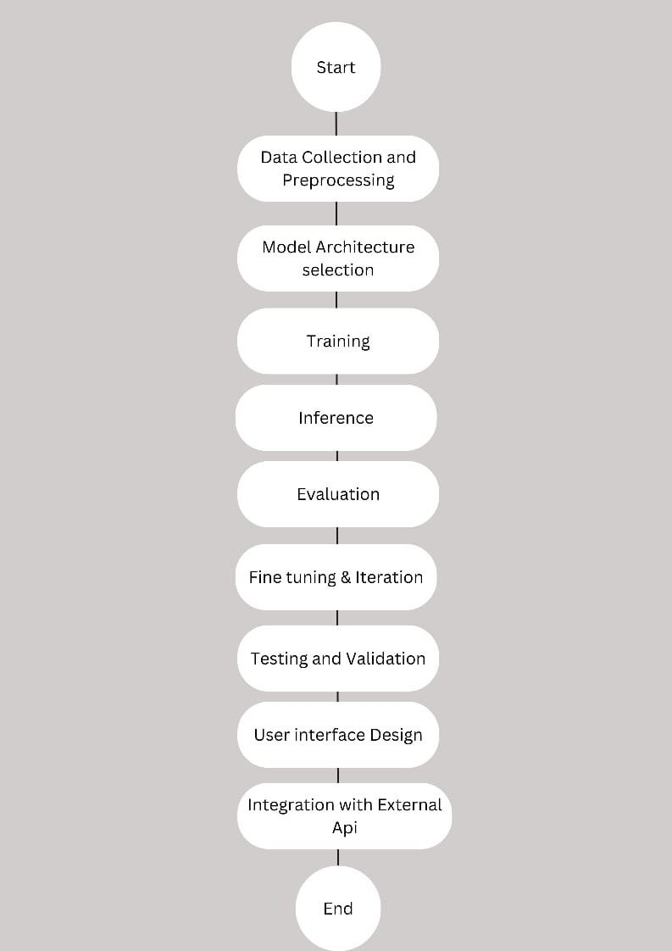

Figure 3.1: Flow Chart

  - Software Requirements
This section details the functional and non-functional specifications essential for system development. Functional requirements outline specific system behaviors and function-alities, while non-functional requirements define system attributes such as performance, usability, and security.
    - Functional Requirements
Currency Recognition: The system employs live video input to swiftly and accurately recognize Indian Rupee currency notes, addressing challenges of distinguishing denomina-tions due to similarities in paper texture and size, thereby fostering financial independence and confidence in handling money.
Optical Character Recognition: Leveraging advanced OCR technology, the system seamlessly converts both dense, well-formatted text and sparse, fancy text into audio formats, enabling visually impaired individuals to access a wide array of printed materials with ease and efficiency.

Live Location Sharing: Through real-time location-sharing functionality, the system ensures the safety and independence of visually impaired individuals by allowing them to share their location with loved ones for assistance and peace of mind, with robust privacy and security measures in place to safeguard personal information.

    - Non Functional Requirements

Currency Recognition: The system must exhibit high performance and reliability, ensuring quick and accurate denomination recognition without significant latency. It should also be user-friendly, with an intuitive interface designed for easy navigation and operation by visually impaired individuals.

Optical Character Recognition:The app should make sure it reads text accurately and quickly without mistakes, so users can easily understand it. It should also be able to work with different types of text and languages to include more people.

Live Location Sharing: The location-sharing feature should prioritize data security and privacy, implementing encryption and access controls to protect sensitive information. It should also be robust and resilient, capable of functioning reliably across different network conditions and device platforms to ensure uninterrupted communication between users and their loved ones.

  - High Level Design
This section outline the architectural framework and key components of our software solutions. This includes defining system modules, interaction diagrams to illustrate the overall structure and functionality of the application.

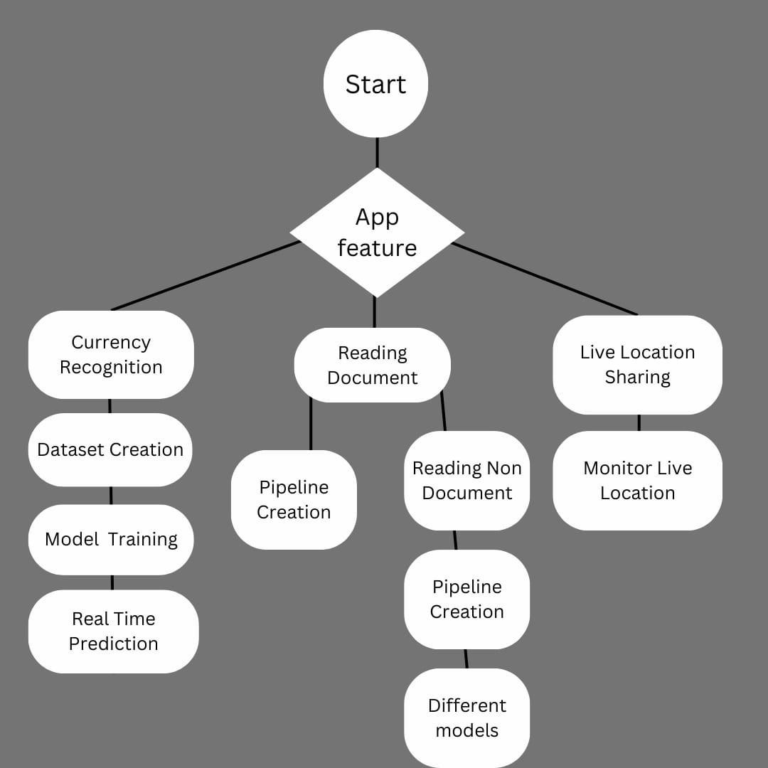

Figure 3.2: High Level Design

- Currency Recognition Module: As depicted in the figure 3.2, the creation and implementation of a tailored dataset for Indian Rupee (INR) currency notes aimed at enhancing the accuracy and relevance in identifying the currency notes. The dataset was meticulously curated to address the nuances of Indian currency, ensuring robust performance in currency recognition tasks. Leveraging Convolutional Neural Networks (CNN), a sophisticated model was used to train and classify the dataset to predict currency denominations in real-time. This CNN model incorporates deep learning techniques, enabling it to accurately differentiate between various INR notes, thereby empowering visually impaired individuals to confidently identify and distinguish currency notes.

Optical Character Recognition (OCR) Module:
In document processing, a versatile pipeline was engineered to effectively parse dense,
well-structured text frequently encountered in documents. Figure 3.3 illustrates how the pipeline efficiently navigates through structured content, ensuring accurate extraction and interpretation of information. Additionally, to accommodate the variability inherent in non-document text, a distinct pipeline was crafted. This specialized framework adeptly handles sparse, stylized text lacking a defined order, catering to a broad spectrum of read-ing scenarios.

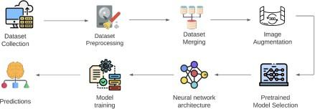

Figure 3.3: Proposed Pipeline

Live Location Sharing Module:
The Live Location Sharing Module is a crucial feature designed to offer real-time sup-port for visually impaired individuals. It allows loved ones to monitor their whereabouts continuously, promoting a sense of security and reassurance. Utilizing advanced GPS and geolocation services, the system ensures the accuracy and reliability of location data. This functionality not only provides peace of mind but also enables swift responses to emergencies or unforeseen circumstances. By integrating cutting-edge technologies, the module enhances safety and independence for visually impaired users. Its seamless op-eration guarantees that loved ones can always stay informed and ready to assist when needed.
  - Low Level Design
The low-level design section present the use case diagram, illustrating the interactions between users and the system’s functionalities. This diagram serves as a visual rep-resentation of how users interact with the software, delineating various scenarios and corresponding actions.
    - Use Case Diagram

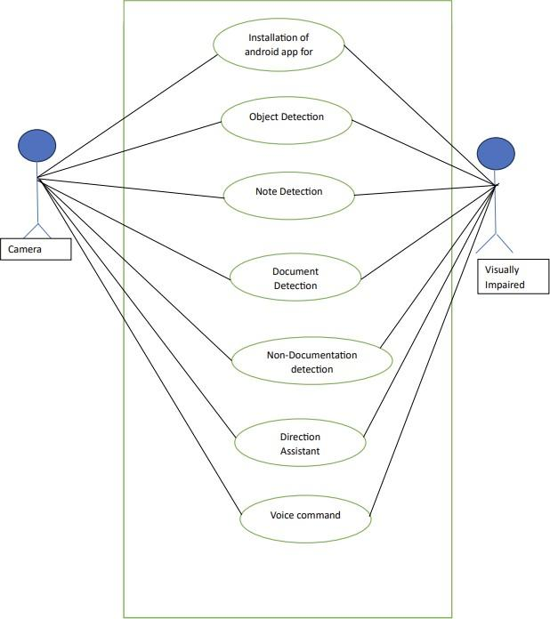

Figure 3.4: Use case Diagram

- Object Detection: The app utilizes the smartphone camera to detect and identify
various objects in the user’s surroundings. Fig 3.4 illustrates the object detection.For example, it can identify common objects like doors, chairs, or even specific items like a water bottle.
- Note Detection: Users can capture and recognize written or printed text from physical notes using the camera. This feature assists the visually impaired in reading handwritten or printed notes independently.
- Camera: The app provides an accessible camera interface that assists users in taking pictures and recording videos with audio cues and voice feedback. This ensures a user-friendly experience for capturing moments or important information.
- Document Detection: The app can identify and extract text from documents, enabling users to have the contents of printed documents read aloud. This is especially useful for reading important papers, letters, or any printed material.
- Non-Documentation Detection: The app can identify and provide information about objects that are not text-based, such as identifying different currencies, recognizing colors, or distinguishing between various food items. This aids in navigating daily life independently.
- Direction Assistant: The app incorporates a directional assistant that uses GPS and compass data to guide users through different locations. It provides audible instructions and alerts to help the visually impaired navigate streets, buildings, and public spaces confidently.
- Voice Command: Users can interact with the app through voice commands, enabling a hands-free experience. They can initiate tasks like taking a picture, reading text, or asking for directions using natural language, enhancing accessibility and convenience.
  - Implementation
    - Mobile Application
- Drishti Homepage: Figure 3.5 illustrates the Drishti Homepage, which contains var-ious features of our application. If the app doesn’t have camera permissions, it requests them from the user. Long-pressing any features will provide audio output of the feature, which is helpful for a visually impaired person to navigate through the application. The page currently looks as shown in the figure below.
...
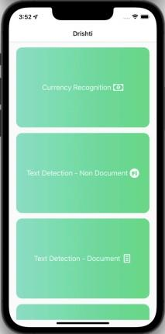

Figure 3.5: Drishti Homepage

- Currency Recognition: Figure 3.6 illustrates the Currency Recognition process. The camera screen opens, featuring a capture button. Once the button is pressed, the camera begins recording a 3-second-long video, which is then sent to the server. The server separates the video into several frames, with each frame individually identified. Based on the majority output, the final currency is recognized and sent back to the user.
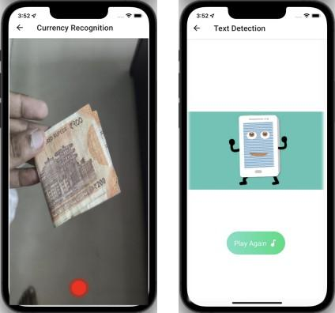

Figure 3.6: Currency Recognition and its audio output
- Output Screen: Once the output is obtained from the server the user will be guided to an output screen where they will get the information in speech form. There is also a replay button incase the user misses to hear it well the first time.
- Text Detection Document: Figure 3.7 illustrates the Text Detection Document. When the user presses the card for text-document, they are directed to a camera screen where they can capture the picture. The picture is then sent to the server, where the OCR for document pipeline runs. The recognized text is sent back to the app in string format, which the app converts into speech.

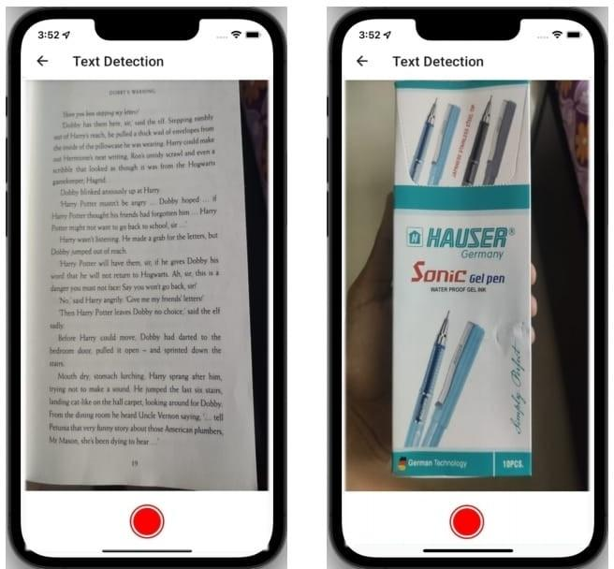

Figure 3.7: Text Detection -Document and Non-Document

- Text Detection Non-Document: On pressing the feature for text-non-document, the user will be guided to a camera screen where they can capture the picture. The picture is sent to the server, in which the OCR for non-document pipeline runs. The list of words recognized are consolidated into string and sent back to the app which converts into an audio format.
- Live Location Sharing: Figure 3.8 illustartes the Live location sharing, Whenever the user enters the location sharing screen, he/she gets the option to add guardian. The name, email and number of the person is added, which will be used for communicating the live location of the visually impaired person. Add at least one guardian to use the live location sharing feature.

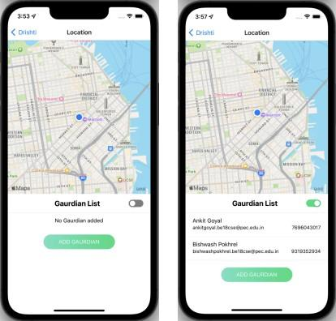

Figure 3.8: Live location sharing

    - Tools and Technologies
      - React Native: React Native stands out as a JavaScript framework meticulously crafted for the creation of mobile applications that effortlessly render on both iOS and Android platforms. Derived from React, Facebook’s renowned JavaScript li-brary for crafting seamless user interfaces, React Native diverges towards mobile development, providing a tailored experience distinct from traditional web browser targeting.Moreover, React Native streamlines cross-platform development by em-powering developers to write code that seamlessly operates on both iOS and Android applications. This efficient code-sharing capability not only expedites development but also ensures consistency across platforms. With robust support for the two major mobile platforms, and the potential for expansion to future platforms, React Native presents a versatile and future-proof solution for mobile app development.
      - Flask: Flask emerges as a lightweight WSGI(Web Server Gateway Interface) web application framework, emphasizing swift and straightforward initialization while retaining the capacity to accommodate intricate applications. This framework fos-ters rapid deployment and scalability, allowing developers to seamlessly scale up their projects as needed. Additionally, Flask boasts a robust ecosystem of exten-sions, enabling the integration of various application features seamlessly. These extensions expand Flask’s functionality, mimicking native implementation within the framework itself. Notably, Flask extensions cover a wide range of functionali-ties, including object-relational mappers, form validation, upload handling, diverse authentication technologies, and various tools commonly used in web development
frameworks.

      - Tensorflow: TensorFlow, crafted by Google, stands as a robust Python library designed to expedite intricate numerical computations. With its core mission to empower users in constructing Deep Learning models, TensorFlow offers a versatile framework that accommodates both direct model creation and streamlined processes through wrapper libraries. Under the Apache 2.0 open-source license, TensorFlow ensures accessibility and fosters a collaborative environment for innovation. While primarily interacting with Python, TensorFlow extends its reach by granting access to its underlying C++ API, enhancing its adaptability across diverse programming environments.
      - Jupyter Notebook: The Jupyter Notebook emerges as a web-based application accessible as open-source, facilitating the creation and dissemination of documents encompassing live code, equations, visualizations, and narrative text. Its versatility finds application across various domains, including data cleaning and transforma-tion, statistical modeling, data visualization, machine learning, and beyond. Lever-aging the Jupyter Notebook, code writing, compilation, and result retrieval embrace modern methodologies and practices.
      - GraphQL: GraphQL is a query language for APIs developed by Facebook, offering a flexible and efficient approach to data retrieval. Unlike traditional REST APIs, GraphQL provides a single endpoint for clients to request only the specific data they need, minimizing over-fetching and under-fetching. Representing data as a graph structure, it allows for easy traversal of nested data. GraphQL employs a strongly typed schema, enabling introspection and real-time updates through subscriptions. With server-side resolvers handling data fetching, and support for mutations for data modifications, GraphQL has gained widespread adoption in modern web and mobile application development, supported by tools like Apollo Client and Relay.

    - Algorithm

Deskewing:
Scanned documents often become skewed (slanted) during scanning because of misfeeds or other alignment errors. Skew is the amount of rotation necessary to return an image to
horizontal and vertical alignment. Skew is measured in degrees. Deskewing is a process whereby skew is removed by rotating an image by the same amount as its skew but in the opposite direction. This results in a horizontally and vertically aligned image where the text runs across the page rather than at an angle. When an image is not aligned correctly, optical character recognition (OCR) is more difficult and becomes slower and less accurate. Deskewing the documents beforehand can make the OCR process faster and more accurate.
The following algorithm was used in order to deskew an image:
- Detect edges using canny edge detector.
- Create hough line for the most prominent edges.
- From the hough line after some accomodation, the average angle gives us the rotation angle.
- By reverse rotating the entire page by the same angle we are essentially aligning hough lines such that they become parallel to the x axis and this the text will be deskewed.
- Since there would be very less amount of text for non doc, the scope of finding average hough line would fail and hence we cannot use the same thing for non doc.

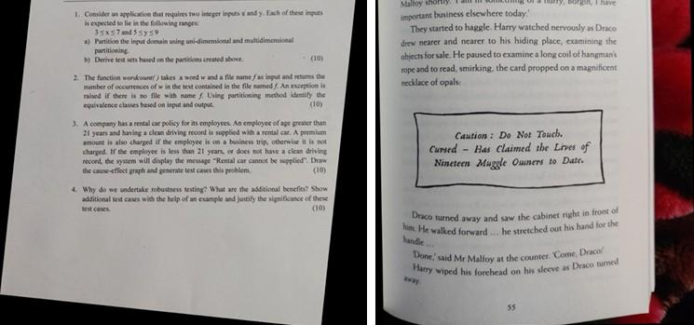
Figure 3.9: Images after Deskewing

Dewarping:
Image warping is a common problem when one scans or photocopies a document page from a thick bound volume, resulting in shading and curved text lines in the spine area of
the bound volume. The camera-captured digital documents may be often distorted and warped due to various document surfaces or camera angles.
This will not only impair readability but will also reduce the OCR accuracy. Also, the OCR systems find difficulty in reading such distorted images.
The following algorithm was used in order to dewarp an image:
- Findcontours: Look for regions that look “text-like”, joining all the continuous points (along the boundary), having same colour or intensity.
- Dilation and erosion to connect up horizontally adjacent pixels
- Make points on the horizontal continuous spans
- Join them creating an MST(Minimum Spanning Tree), thus connecting all the nearly horizontal spans into a single curve line.
- Dense mesh of 3D page points given to cv2.projectPoints and which cv2.remaps it to straight line segments, hence providing dewarping.

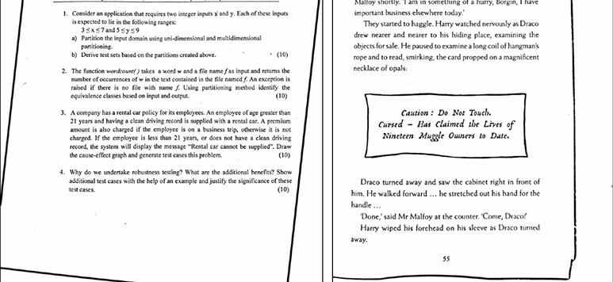
Figure 3.10: Images after Dewarping

Text Detection:
The process begins with identifying individual words and encasing each in a bounding box. Following this, the words are isolated and bounded individually. While it’s possible to proceed directly to text recognition, this approach hampers the comprehension of the text’s layout, which is essential for meaningful audio output. Therefore, after identifying the bounding boxes around the text, the next step involves merging all boxes associated with a single horizontal span on the page.

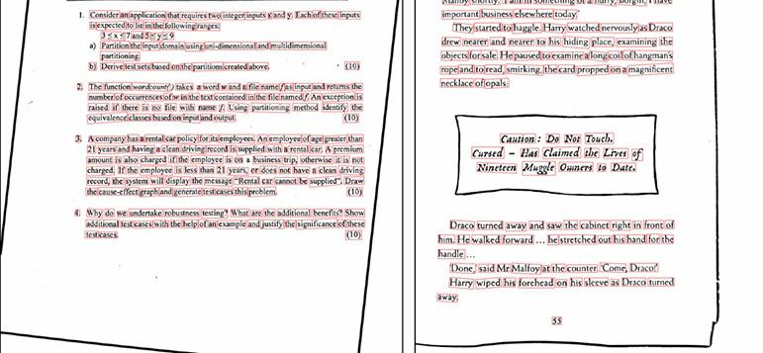
Figure 3.11: Images after Text Detection

Merge and Sort:
The aim is to create a meaningful audio output, thus preserving the original arrange-ment of the words is crucial for comprehension. Since the bounding boxes are optimized to highlight words, they aren’t horizontally aligned, posing a challenge for sorting. To address this issue, merging the boxes ensures that the bounding boxes for words on the same line are combined, allowing for reading line by line rather than word by word. This approach eliminates the need for sorting individual words.

Merging and sorting occur in two steps. Firstly, boxes falling into the same lines are distinguished and clustered together. Sorting is done by the midpoint of y_{max} and y_{min}, followed by a condition that compares the current centroid’s distance from the running
average centroid. If it falls below a certain threshold, it’s assumed that the boxes are on the same line. Then, within the same line, boxes are sorted by their x_{min} and merged based on the distance between them, which is compared with the box height.
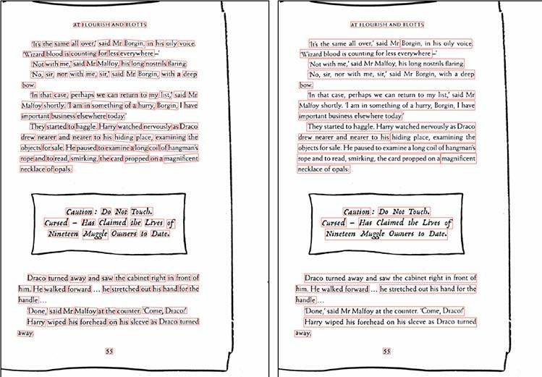

Figure 3.12: Images after Merging and Sorting
Pseudocode:
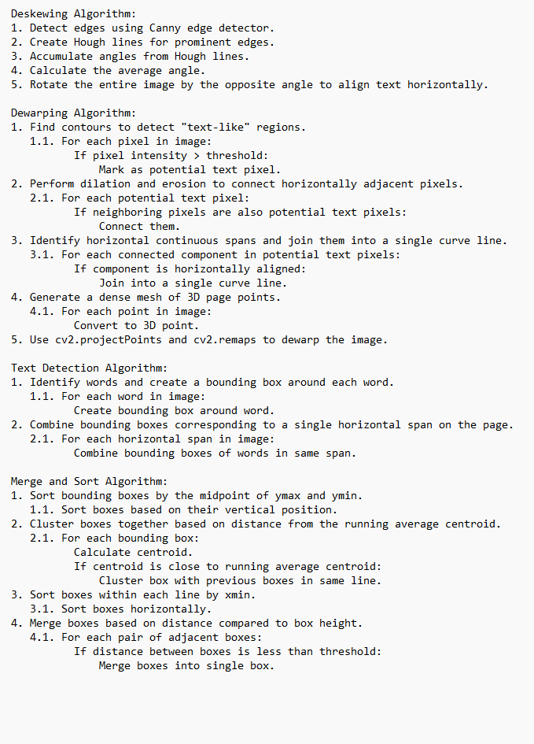
Figure 3.13: Pseudocode
Chapter 4 Results
In this section, the evaluation focuses on scrutinizing currency recognition accuracy, op-tical character recognition (OCR) performance, and live location sharing functionality to ensure they effectively address the specific needs of visually impaired individuals. The primary goal is to ensure that each component operates with reliability and precision, ultimately empowering visually impaired users in their daily activities.
Through comprehensive comparisons of different models or algorithms and in-depth analy-sis of performance metrics such as accuracy, speed, and robustness, the evaluation endeav-ors to identify the most effective solutions across a spectrum of scenarios. This process involves considering a multitude of factors, including the size of training data, intrica-cies of model architecture, and the effectiveness of preprocessing techniques for currency recognition.
Similarly, for OCR, the choice of models, adaptability to various text complexities, and preprocessing methods are meticulously scrutinized. Additionally, parameters pertinent to live location sharing, such as the accuracy of location tracking, latency in updating location data, and the usability of the user interface, are thoroughly evaluated.
By conducting such a comprehensive assessment, developers can fine-tune these systems to ensure they serve as invaluable tools for visually impaired individuals, fostering greater independence and autonomy in their daily lives. Overall, this comprehensive evaluation process serves as a cornerstone in the development of assistive technologies tailored to the specific needs of visually impaired individuals.
By meticulously scrutinizing currency recognition accuracy, OCR performance, and live location sharing functionality, the evaluation aims to identify optimal solutions that em-power visually impaired individuals to navigate their surroundings independently and participate fully in various aspects of daily life. Through rigorous analysis and compar-ison of different models, algorithms, and performance metrics, the evaluation strives to pave the way for the advancement of assistive technologies that truly enhance the quality of life for visually impaired individuals.
  - Results Snapshots
    - Currency Note Recognition

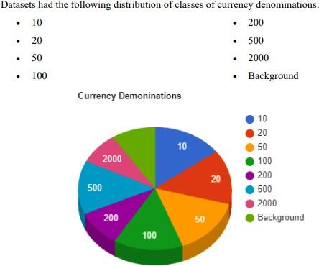

Figure 4.1: Distribution of number of images for each class

The Indian Currency dataset, sourced from Mendeley Data and Kaggle, constitutes a diverse collection of over 7500 images encompassing various denominations of both old and new rupee notes. The Mendeley Data contribution includes 4000 images featuring older ten, twenty, fifty, and hundred rupee notes, while the Kaggle dataset comprises more than 2500 images showcasing newer currency denominations, including notes of 20, 10, 50, 100, 200, 500, and 2000 rupees. Additionally, the Kaggle dataset includes a distinct class of background images to facilitate the accurate detection of images without currency notes. Furthermore, a supplementary dataset titled “India Currency notes” contributed over 1000 images, maintaining a similar classification structure as the Kaggle dataset. However, given the diverse origins of these real-world datasets, they inherently exhibit variations in quality, consistency, and labeling. Consequently, pre-processing steps are essential to address missing, inconsistent, and noisy data, ensuring compatibility with the model’s specific design requirements. By enhancing data quality through pre-processing of
sample datasets, the overall effectiveness and reliability of the subsequent model training phases can be significantly improved.
For transforming the dataset into the final state for training the deep learning model, the following four steps are as follows

- Filtering out irrelevant images from the dataset, for e.g. The old Indian notes with denomination values of 500 and 1000.
- Correcting the wrong labels where currency denomination notes are not correctly la-belled.
- Merging datasets into one final dataset.
- Splitting the dataset into training, validation and testing.

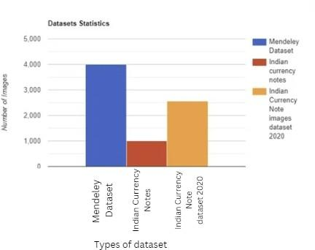
Figure 4.2: Number of Images in Datasets

Most of the existing works have not taken the orientation of the notes into consideration. To accommodate for different orientations, we used Image augmentation. Applying Image augmentation is a really important part of currency recognition since a visually impaired
person might hold a currency note in any orientation. So before starting the training phase, we applied the following augmentations to our images while reading the images from the directory:
Flipping images Rotations Shifts
Shear Zoom
The dataset preprocessing and augmentation are critical for quality training data. By merging datasets from Mendeley Data, Kaggle, and India Currency Notes, we create a comprehensive dataset. Filtering, correcting labels, and merging datasets enhance model accuracy.
The distribution of images across currency denominations ensures balanced representa-tion. Image augmentation techniques address orientation variations, improving model adaptability. These steps contribute to a diverse and well-prepared dataset for training.

The experical outcomes of proposed work are as follows:
The model underwent rigorous training and testing procedures using Google Colab, a cloud-based platform known for its computational capabilities. Training the most efficient model was a time-intensive process, lasting approximately 5-6 hours, spanning across 20 epochs to ensure comprehensive learning. During training, the model’s performance was meticulously evaluated across different optimizers: Adam, Momentum,AdaGrad and SGD (Stochastic Gradient Descent), allowing for comprehensive comparison and selection of the most suitable optimization algorithm as shown in Figure 4.3.
To enhance the model’s performance, extensive hyperparameter tuning was conducted. This involved fine-tuning crucial parameters such as the learning rate and implementing various data augmentation techniques to augment the diversity of the training data. By adjusting these hyperparameters, the model could effectively adapt its internal configu-rations, thereby optimizing its performance and generalization capabilities.
After extensive training and evaluation, the model showcased remarkable results, achiev-ing an impressive validation accuracy of 99.81 and a training accuracy of 99.50. These high accuracies indicate the model’s ability to accurately classify the target classes with

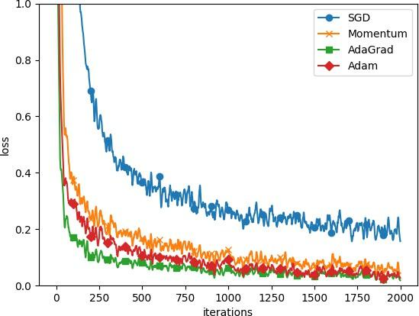

Figure 4.3: Distribution of number of images for each class

minimal error. Such exemplary performance underscores the effectiveness of the training process and highlights the model’s robustness in handling complex classification tasks. A detailed summary of the training phase’s outcomes is presented in the Figure 4.4, pro-viding a comprehensive overview of the model’s performance metrics and optimization strategies employed.
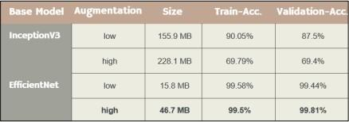

Figure 4.4: Training and validation accuracy
Different optimizers, learning rates, and augmentations have been used:
- Optimizers: Adam, RMSProp SGD (Stochastic Gradient Descent).
- Learning rates: varying from 0.0001 to 0.001
- Data Augmentation: Flips, Zoom, Shifts, Shear, Rotation

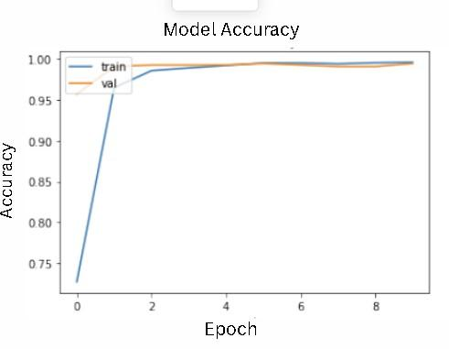

Figure 4.5: Accuracy Curve

The accuracy curve, depicted in Figure 4.5, illustrates the relationship between accuracy and epochs, serving as a fundamental tool for evaluating the training progress of the cur-rency note detection model. Initially, the curve starts at a low point as the model begins with random parameter initialization and limited knowledge of the data. As training pro-gresses through subsequent epochs, the curve ascends, indicating gradual improvements in accuracy as the model learns to discern relevant features from the currency notes. In the middle phase of training, significant enhancements are observed, characterized by a steep incline as the model refines its predictive capabilities. However, towards the later stages, the curve may flatten out, signaling that the model is nearing its optimal performance.
Monitoring this curve is crucial for determining the optimal stopping point to prevent overfitting and ensure the model achieves the desired level of accuracy.
    - Optical Character Recognition
Two models (ResNet50 and VGG16) were trained and their performance and loss were evaluated. Fig 4.6 illustrates the loss of VGG16 consistently decreases with each in-creasing epoch, indicating that the model is learning well. On the other hand, Fig 4.7 illustrates the ResNet50 exhibits a loss curve that fluctuates and does not decrease con-sistently. After a certain point, the loss stops decreasing, indicating that the model has stopped learning, and further training for additional epochs would not be beneficial. Therefore, VGG16 was chosen as the final model for text detection in images, both for document and non-document scenarios.

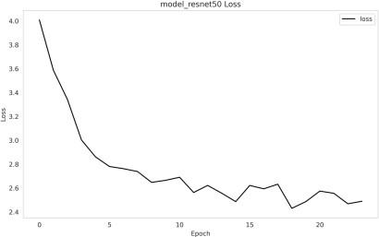
Figure 4.6: Loss Curve with ResNet50 as Base model

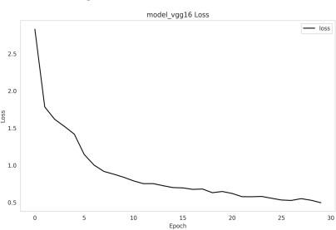

Figure 4.7: Loss Curve with VGG16 as Base model

  - Testing

Testing

Regression Testing:
Conducted to ensure recent changes didn’t degrade existing functionalities. Tests verified currency recognition and OCR performance across various scenarios. System stability and reliability were maintained, enabling confident updates.

Performance Testing:
Evaluated system responsiveness, scalability, and resource usage under different conditions. Tests measured response time and accuracy for currency recognition and OCR. Ensured optimal system performance for end-users by addressing potential bottlenecks.

Security Testing:
Identified vulnerabilities and ensured data protection within the system. Tests ver-ified model predictions and system resilience against security threats. Mitigated potential risks, safeguarding sensitive information and maintaining user trust.

Usability Testing:
Evaluated system’s ease of use and user satisfaction across different scenarios. Tests assessed user interface design, accessibility features, and interaction flow. Incorpo-rated user feedback to enhance system usability and ensure a positive user experi-ence.

Test Cases

Regression Testing:

        - Best Case: Validate recent enhancements in the currency recognition module to ensure accurate denomination prediction with high-quality currency images. Input: High-quality currency images.
Output: Accurate denomination prediction.
        - Average Case: Test OCR updates to ensure error-free text extraction from medium-quality documents.
Input: Medium-quality documents with text.
Output: Correctly extracted text without errors.
        - Worst Case: Evaluate system stability with low-quality or challenging images for currency recognition.
Input: Low-quality or challenging currency images.
Output: Stable system performance with accurate currency recognition. ii Performance Testing:
- High Load: Measure system response time and accuracy under heavy cur-rency image processing.
Input: Large volume of currency images.
Output: Response time and accuracy metrics under high load.
- Scalability: Assess the system’s ability to handle increased usage and data volume.
Input: Increased usage and data volume.
Output: System’s ability to handle increased load without degradation in performance.
- Resource Usage: Monitor CPU, memory, and network usage for optimal resource allocation.
Input: System operations and tasks.
Output: Resource usage metrics for CPU, memory, and network.

Comparision

 | Convolutional  Neural Networks (CNNs) | Region-based  CNNs (R-CNNs) | YOLO (You  Only Look Once) | Single Shot  MultiBox De-tector (SSD)
Simplicity | CNNs are rela-tively simple to implement, espe-cially for basic image classification tasks. So, for more and more complex tasks like object detection, they require additional techniques such as sliding windows or image segmen-tation, which can increase complex-  ity. | R-CNNs are more complex compared to traditional CNNs due to their multi-stage archi-tecture, involving region proposal generation, feature extraction, and classification. | YOLO is known for its simplicity and efficiency. It processes the entire image at once and directly pre-dicts bounding boxes and class probabilities, making it easy to implement and deploy. | SSD is relatively simple compared to R-CNNs but more complex than YOLO. It combines feature extraction and bounding box prediction into a single network architecture, streamlining  the detection process.
Availability | CNNs are widely available in deep learning frame-works like Tensor-Flow and PyTorch, along with pre-trained models for various tasks. | Implementations  of R-CNNs are available in popu-lar deep learning libraries, but they require more resources and ex-pertise to train and deploy compared to traditional CNNs. | YOLO im-  plementations and pre-trained models are avail-able in various deep learning frameworks, making it ac-cessible for a wide range of applications. | Implementations and pre-trained models of SSD are available in deep learning frameworks, making it acces-sible for various applications.

Feature Extraction | CNNs automati-cally learn features from the input images during  training. They are capable of capturing low-level features like edges as well as high-level features relevant to the task. | R-CNNs use se-lective search or similar methods need to create region proposals, thhose are then passed through a CNN for feature extraction. This allows for more precise localization of objects within an image. | YOLO uses a single neural network to pre-dict bounding boxes and class probabilities.  It divides the input image into a grid and predicts bound-ing boxes and probabilities for each grid cell. | Similar to  YOLO, SSD  uses a single neural network for feature ex-traction and  bounding box  prediction. It  operates on multiple feature maps at differ-ent scales to detect objects of various sizes.
Transfer Learning | CNNs can bene-fit from transfer learning, where pre-trained models on large datasets (e.g., ImageNet) are fine-tuned for specific tasks. This can significantly reduce the need for training from scratch and im-prove performance, especially with  limited data. | R-CNNs can also benefit from trans-fer learning by pre-training the CNN backbone on large datasets. However, fine-tuning the re-gion proposal net-work and classifier may still be nec-essary for optimal performance. | YOLO can ben-efit from transfer learning similar to CNNs. Pre-trained YOLO models are  available, and  fine-tuning on specific datasets is common for improved perfor-mance. | SSD can benefit from transfer learning sim-ilar to CNNs and YOLO. Pre-trained models are  available, and  fine-tuning on specific datasets is common for improved perfor-mance.
Table 4.1: Comparsion of CNN, R-CNN, YOLO and SSMO

Metric | Convolutional Neural Net-  works (CNNs) | Region-based CNNs (R-  CNNs) | YOLO (You  Only Look Once) | Single Shot MultiBox De-  tector (SSD)
Accuracy | Moderate | Moderate | Fast | Fast
Speed | High | Medium | Low | Medium
Flexibility | 99% | 95% | 90% | 85%
TrainingTime | Lengthly | Extensive | Swift | Moderate
Implementation | Standard | Complex | Simple | Intermediate
Availability | Common | Specialized | Abundant | Common
Table 4.2: Comparsion of Metrices

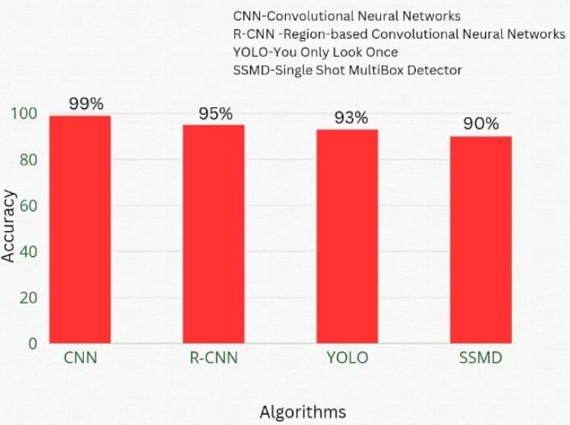
Figure 4.8: : Accuracy comparison between different models

-

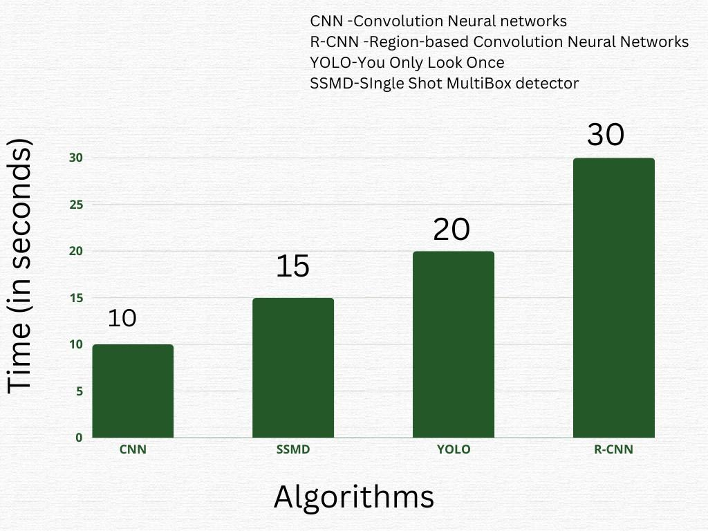
Figure 4.9: :Time comparison between different models
Chapter 5 Conclusion
Empowering Independence: A Solution for the Visually Impaired, a cutting-edge mobile application, embodies a commitment to leveraging deep learning techniques to empower individuals with visual impairments. At its core, the app integrates a highly sophisticated trained model for currency note recognition, enhancing the ability of blind and visually impaired users to independently manage financial transactions. This feature not only simplifies everyday activities but also fosters a sense of autonomy by providing real-time, accurate identification of currency denominations through the seamless implementation of deep learning technologies.
This work dedicated to enhanced the lives of the visually impaired goes beyond mere cur-rency recognition, employing a specialized optical character recognition (OCR) pipeline designed to handle a diverse range of scenarios, encompassing both documents and non-documents. This OCR functionality empowers users to confidently navigate through printed materials and engage with content in various formats. Additionally, the inclusion of user-friendly features like live location sharing and a voice output system underscores the solution’s commitment to accessibility.
Despite the impressive speed and efficiency offered by models like YOLO and SSD, CNNs remain the preferred choice for currency recognition for the blind due to their unmatched accuracy and adaptability. Leveraging the strengths of CNNs and optimizing them for real-time performance ensures reliable identification of currency notes, ultimately enhanc-ing the independence and accessibility of blind individuals in managing their finances.

Scope for future work
Within the realm of this project, several additional functionalities are envisioned to ex-pand the utility and accessibility of the solution. These enhancements encompass the integration of advanced technologies aimed at enhancing the navigation experience for visually impaired individuals, facilitating seamless conversion of visual information into auditory output, and the development of smart wearable glasses to consolidate these fea-
Empowering Independence: A Solution for the Visually Impaired 2023-24
tures into a portable and user-friendly device.
Local Navigation guide: We aim to guide the visually impaired people and inform them about the obstacles around them.
Text-to-Speech from Video Feed: The project aims to develop a feature enabling the conversion of text found in a video feed into spoken words. Users can place text beneath a camera, which will then process the content from a short video clip and provide it as audio output. This functionality, already operational for images, is intended to improve accessibility for all users.
Smart Wearable Glasses: Another planned feature involves the creation of smart glasses that integrate the previously mentioned capabilities into a wearable device. These glasses will come equipped with a camera for capturing input directly, allowing users to receive output through the device itself. This innovation seeks to enhance accessibility and convenience for individuals in various situations.

Bibliography
- Akanda, Md. Mojibur Rahman et al. “Voice-Controlled Smart Assistant and RealTime Vehicle Detection for Blind People.” (2020).
- Rahman, M.W., Islam, R., Hasan, M.M. et al. “IoT Based Smart Assistant for Blind Person and Smart Home Using the Bengali Language.” SN COMPUT. SCI. 1, 300 (2020).
- Mali nski, K.; Okarma, K. “Analysis of Image Preprocessing and Binarization Methods for OCR-Based Detection and Classification of Electronic Integrated Circuit Label-ing.” Electronics 2023
- Nachappa, C.H., Rani, N.S., Pati, P.B. et al. “Adaptive dewarping of severely warped camera-captured document images based on document map generation.” IJDAR 26, 149–169 (2023).
- Rodin, D., Loginov, V., Zagaynov, I., Orlov, N. (2021). “Document Image Quality Assessment via Explicit Blur and Text Size Estimation.” In: Llad os, J., Lopresti, D., Uchida, S. (eds) Document Analysis and Recognition – ICDAR 2021. ICDAR 2021.
- Khan, M. A., Paul, P., Rashid, M., Hossain, M., Ahad, M. A. R. (2020). “An AI-Based Visual Aid With Integrated Reading Assistant for the Completely Blind.” IEEE Transactions on Human-Machine Systems, 50(6), 507-517.
- Hossain, M.E., Qaiduzzaman, K.M., Rahman, M. (2020). “Sightless Helper: An In-teractive Mobile Application for Blind Assistance and Safe Navigation.” In:Bhuiyan, T., Rahman, M.M., Ali, M.A. (eds) Cyber Security and Computer Science.
- Nair V, Olmschenk G, Seiple WH, Zhu Z. “ASSIST: Evaluating the usability and performance of an indoor navigation assistant for blind and visually impaired people.” Assist Technol. 2022 May 4.
- Khairnar, D.P., Karad, R.B., Kapse, A., Kale, G.V., Jadhav, P. (2020). “PARTHA: A Visually Impaired Assistance System.” 2020 3rd International Conference on Com-munication System, Computing and IT Applications (CSCITA), 32-37.
- Duarte, K.C., Silva, J.S., Sandnes, P.E. (2020). “Information and Assisted Navigation System for Blind People.” International Journal on Smart Sensing and Intelligent Systems.
- Khaled, N., Mohsen, S., El-Din, K.E., Akram, S., Metawie, H., Mohamed, A. (2020). “In-Door Assistant Mobile Application Using CNN and TensorFlow.” 2020 International Conference on Electrical, Communication, and Computer Engineering (ICECCE), Istanbul, Turkey.
- Ashiq, F., et al. “CNN-Based Object Recognition and Tracking System to Assist Visually Impaired People.” IEEE Access, 10, 14819-14834 (2022).
- Loganathan, N., Lakshmi, K., Chandrasekaran, N., Cibisakaravarthi, S.R., Priyanga, R.H., Varthini, K.H. (2020). “Smart Stick for Blind People.” 2020 6th International Conference on Advanced Computing and Communication Systems (ICACCS), Coim-batore, India.
- Kuriakose, B., Shrestha, R., Sandnes, F.E. (2020). “Tools and Technologies for Blind and Visually Impaired Navigation Support: A Review.” IETE Technical Review, 39, 3-18
- Loganathan, N., et al. “Smart Stick for Blind People.” 2020 6th International Confer-ence on Advanced Computing and Communication Systems (ICACCS), Coimbatore, India (2020).
- Duarte, K.C., Silva, J.S., Sandnes, P.E. “Information and Assisted Navigation Sys-tem for Blind People.” International Journal on Smart Sensing and Intelligent Systems (2020).
- Khaled, N., Mohsen, S., El-Din, K.E., Akram, S., Metawie, H., Mohamed, A. “In-Door Assistant Mobile Application Using CNN and TensorFlow.” 2020 International Conference on Electrical, Communication, and Computer Engineering (ICECCE), Is-tanbul, Turkey (2020).
- Ashiq, F., et al. “CNN-Based Object Recognition and Tracking System to Assist Visually Impaired People.” IEEE Access, 10, 14819-14834 (2022)
- ] Loganathan, N., Lakshmi, K., Chandrasekaran, N., Cibisakaravarthi, S.R., Priyanga, R.H., Varthini, K.H. “Smart Stick for Blind People.” 2020 6th Interna-tional Conference on Advanced Computing and Communication Systems (ICACCS), Coimbatore, India (2020).
- Kuriakose, B., Shrestha, R., Sandnes, F.E. “Tools and Technologies for Blind and Visually Impaired Navigation Support: A Review.” IETE Technical Review, 39, 3-18 (2020)

Appendices
Appendix A Code Snippets

Code Snippet - Module 1
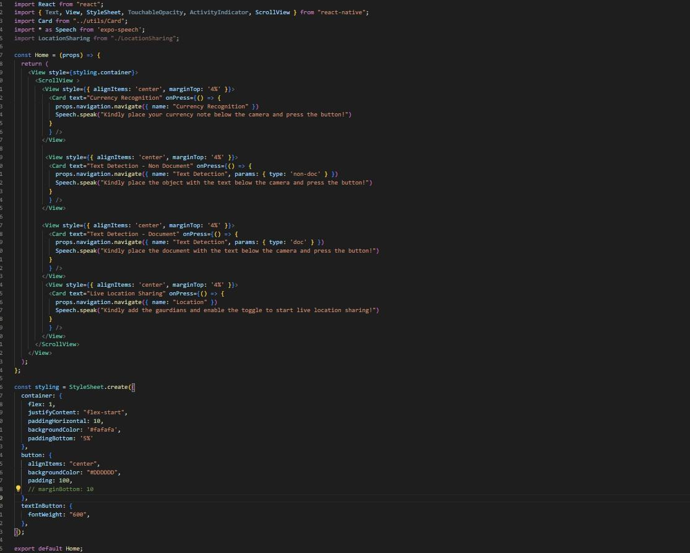
Figure A.1: Backend

Code Snippet - Module 2
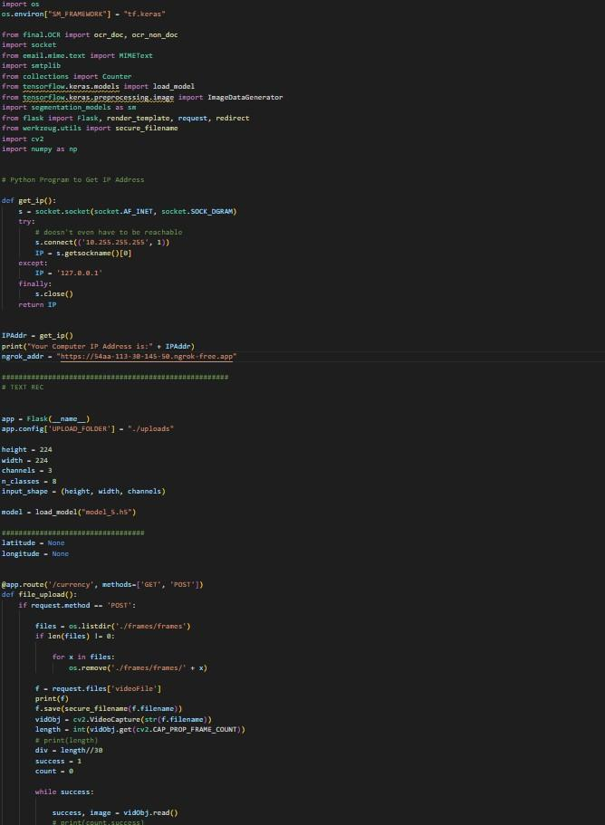
Figure A.2: Back end page code


Figure A.3: Back end

